Lab 2: Distributed Consistency
and Consensus in the Cloud

Student Name:
Omar Mohamed Hussein Said

Group:
SE3

Date:
April 25, 2026

Lab Overview
In this lab, we explored how distributed systems handle consistency, availability, and consensus under different failure conditions. We used two tools: Redis to demonstrate replication and eventual consistency, and etcd to explore the Raft consensus protocol and leader election.

Tool | Purpose | Concept Demonstrated
Redis | Key-value store with master-replica replication | Eventual consistency, CAP theorem (AP)
etcd | Distributed key-value store for config | Raft consensus, leader election, CP behavior

Task 1: Redis Replication and CAP Theorem
In this task we launched two Redis nodes — node1 as the master and node2 as a replica — and tested how data replicates between them, and what happens during a simulated network partition.

Step 1 & 2 — Write to node1, Read from node2
We wrote the key 'mykey' with value 'hello from node1' to redis-node1, then immediately read it from redis-node2 to verify replication was working.

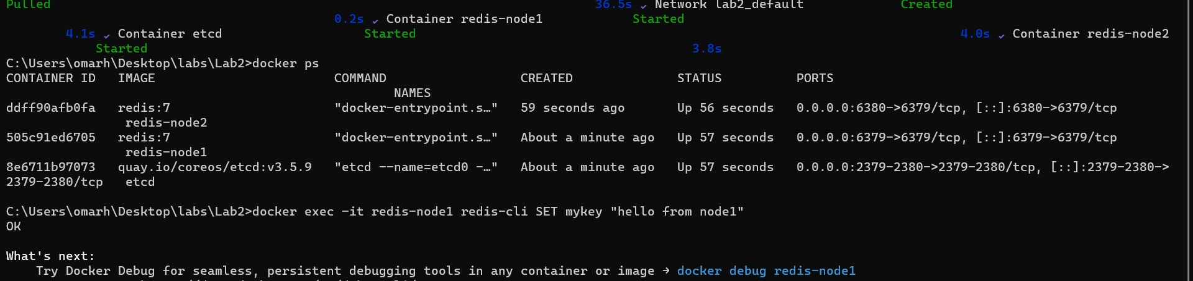
Figure 1 — SET command on redis-node1 returns OK; GET on redis-node2 returns the replicated value

Observation: The value written to node1 was immediately available on node2, confirming that Redis replication is active and working. This is eventual consistency — node2 does not store data independently, it mirrors whatever node1 has.

Step 3, 4 & 5 — Simulate Network Partition
We stopped redis-node2 to simulate a network partition, wrote a new key 'partitionkey' to node1 while node2 was offline, then restarted node2 and verified it caught up automatically.

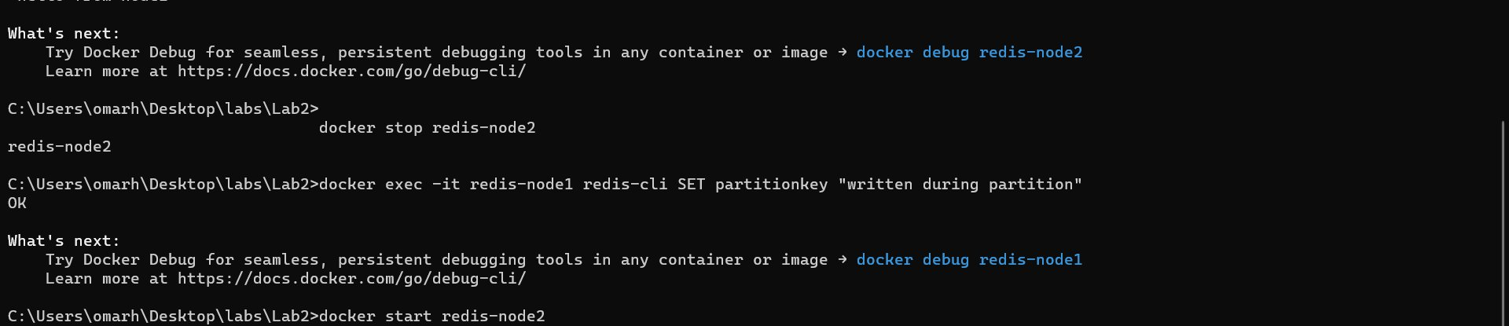
Figure 2 — node2 stopped, write succeeds on node1, node2 restarted and reads the missed key

Observation: Node1 continued accepting writes even when node2 was completely offline. When node2 came back online, it automatically re-synced and was able to return 'written during partition' — proving eventual consistency recovery. This demonstrates the AP behavior of Redis in the CAP theorem: it chooses Availability and Partition Tolerance over strict Consistency.

CAP Theorem Analysis — Redis
Property | Redis Behavior | Explanation
Consistency | Sacrificed | During partition, node2 returns stale/no data
Availability | Maintained | Node1 keeps accepting reads and writes
Partition Tolerance | Maintained | System continues functioning despite node2 being offline

Task 2: Raft Consensus with etcd
In this task we used etcd — a distributed key-value store that uses the Raft consensus algorithm — to write data, inspect the cluster leader, simulate a node failure, and observe recovery.

Step 1 & 2 — Write and Read a Key
We wrote the key 'foo' with value 'bar' to etcd using etcdctl, then read it back to confirm it was stored correctly.

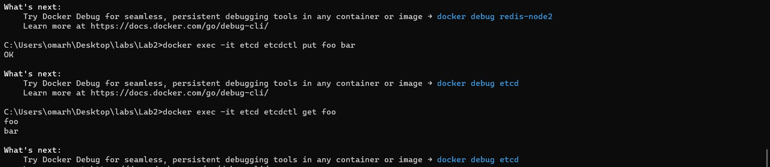
Figure 3 — etcdctl put foo bar returns OK; get foo returns the key and value; endpoint status shows IS LEADER = true

Observation: The write succeeded immediately and the read returned the correct value. The endpoint status table shows IS LEADER = true, RAFT TERM = 2, and RAFT INDEX = 5, confirming our single etcd node has been elected as the Raft leader and is fully operational.

Step 3 — Stop etcd and Observe Failure
We stopped the etcd container to simulate a complete node failure, then attempted to read the key 'foo' to observe what happens when there is no leader available.

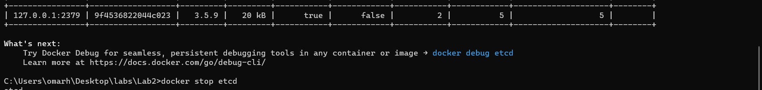
Figure 4 — docker stop etcd succeeds; subsequent etcdctl get foo fails with 'container is not running' error

Observation: When etcd was stopped, all read and write operations immediately failed with an error. Unlike Redis which kept serving requests during a partition, etcd refuses to serve any data without a quorum. This is the CP behavior of etcd — it chooses Consistency over Availability. No data is served rather than risk returning stale results.

Step 4 — Restart and Verify Recovery
We restarted the etcd container and waited for it to re-elect a leader, then read the key 'foo' again to confirm the data survived the failure.

Figure 5 — After docker start etcd, etcdctl get foo successfully returns foo and bar again

Observation: After restarting, etcd re-elected itself as leader and the data 'foo = bar' was fully recovered. This proves that etcd persists data to disk and survives container restarts. The Raft log ensured no committed data was lost.

CAP Theorem Analysis — etcd
Property | etcd Behavior | Explanation
Consistency | Maintained | All reads return the latest committed value via Raft
Availability | Sacrificed | No requests served when leader is down — error returned
Partition Tolerance | Maintained | System recovers and re-elects leader after partition heals

Redis vs etcd — Full Comparison
Feature | Redis (AP) | etcd (CP)
CAP Type | AP — Available + Partition Tolerant | CP — Consistent + Partition Tolerant
Consistency Model | Eventual consistency | Strong consistency via Raft
During failure | Still serves reads/writes (may be stale) | Refuses all requests until leader returns
Data recovery | Auto re-sync when replica reconnects | Raft log replay on restart
Best used for | Caching, sessions, real-time leaderboards | Config management, service discovery, locks
Consensus algorithm | None (simple master-replica) | Raft protocol

Discussion

What is Eventual Consistency?
Eventual consistency means that if no new writes happen, all replicas will eventually converge to the same value. Redis demonstrated this — when node2 was offline and missed a write, it did not have the latest data immediately. But once it reconnected, it re-synced automatically and eventually became consistent with node1. The system never refused to serve requests, but it briefly served potentially stale data.

What is the Raft Consensus Algorithm?
Raft is a consensus algorithm designed to ensure all nodes in a distributed cluster agree on the same data. It works by electing a single leader node that handles all writes. The leader replicates each write to a majority of nodes before confirming it. If the leader fails, the remaining nodes hold an election and a new leader is chosen. In our experiment, etcd used Raft — when the leader was stopped, no data could be served, and when it restarted it re-elected itself and recovered all committed data.

Why does etcd refuse requests when the leader is down?
etcd prioritizes consistency over availability. Serving a read without quorum could return stale data, which is unacceptable for its use case — storing critical cluster configuration for systems like Kubernetes. It is safer to return an error than to return wrong data. This is the CP trade-off: sacrifice availability to guarantee correctness.

When would you choose Redis over etcd?
Redis is the better choice when high availability and low latency matter more than strict consistency — for example, caching web sessions, storing real-time counters, or powering leaderboards. A brief moment of stale data is acceptable in these cases. etcd is the better choice when data must be strictly correct at all times, such as for distributed locks, leader election, or service discovery in a Kubernetes cluster.

Cleanup
After completing all tasks, the lab environment was shut down cleanly using:
docker-compose down
This stopped and removed all containers and the lab2_default network.

