Lab 4 Report
Microservices and Cloud-Native Design

Cloud and Mobile Computing — Week 4
Student Name: Omar Mohamed Hussein Said
Group: SE3
Date: April 25, 2026

1. Lab Overview
This lab involves building a small cloud-native system from scratch using two microservices and Docker Compose. The system implements a mini e-commerce backend with a product-service and an order-service. The lab demonstrates 12-factor app design principles, microservice containerization, synchronous service-to-service communication, health checks, and basic resilience through failure injection and restart policies.

Architecture

Component | Technology | Responsibility
product-service | Python Flask | Returns product data from an in-memory catalog. Exposes /health and /products/<id>.
order-service | Python Flask + requests | Receives order requests, calls product-service to validate the product, returns order response.
Docker Compose | Container orchestration | Builds and runs both services with health checks, environment variables, and restart policies.

Part A — Project Structure
The project was created in a folder named Lab4 containing two service subfolders and the Docker Compose configuration file. Each service has its own independent Dockerfile, requirements file, and application code, following the microservice principle of independent deployment units.
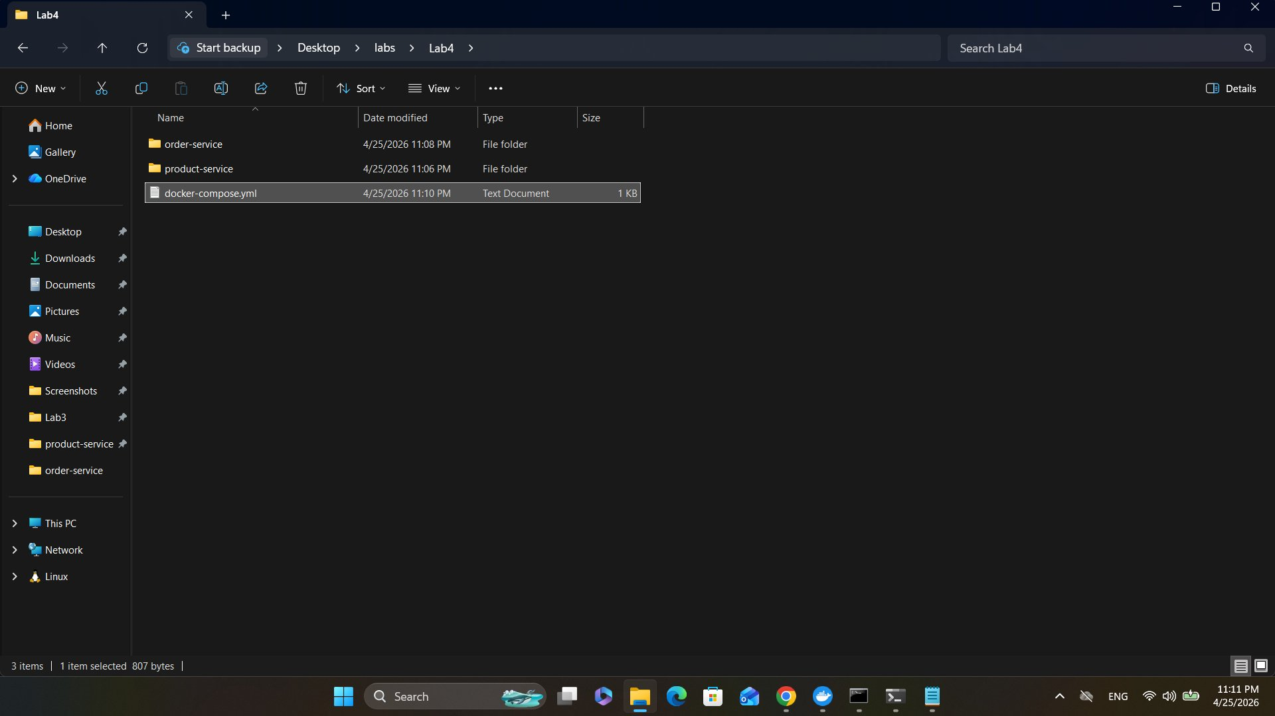
Figure 1: order-service folder containing app.py, Dockerfile, and requirements.txt
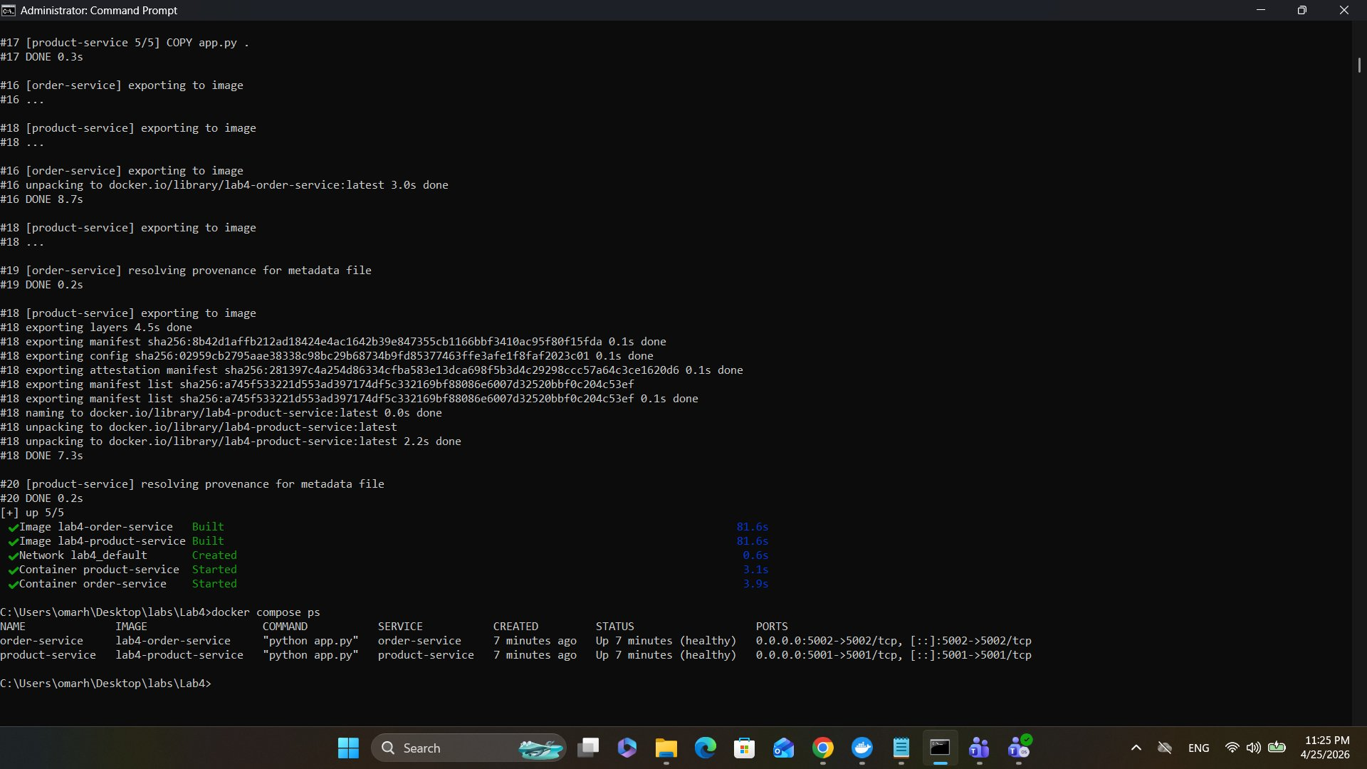
Figure 2: Lab4 root folder structure showing both service subfolders and docker-compose.yml
The final structure achieved was:
Lab4/
├── docker-compose.yml
├── product-service/
│ ├── app.py
│ ├── requirements.txt
│ └── Dockerfile
└── order-service/
├── app.py
├── requirements.txt
└── Dockerfile

Part B & C — Service Implementation

product-service
The product-service exposes two endpoints using Python Flask. It maintains an in-memory product catalog with three items: Laptop ($1200), Phone ($650), and Headphones ($120). The /health endpoint returns the service status for orchestration monitoring. The /products/<id> endpoint returns product JSON or a 404 error if not found. The service is stateless as it does not depend on local mutable files, making it suitable for horizontal scaling.

order-service
The order-service accepts POST requests to /orders with a product_id and quantity. It calls product-service synchronously using the requests library. Two cloud-native patterns are implemented: the service URL is read from the PRODUCT_SERVICE_URL environment variable rather than being hardcoded, and the fetch_product() function implements a retry mechanism with a 2-second timeout and 2 retries with 1-second delay between attempts. This allows the service to degrade gracefully when product-service is temporarily unavailable.

Docker Compose Configuration
The docker-compose.yml defines both services with the following cloud-native features: each service has a health check that polls its /health endpoint every 10 seconds, order-service uses depends_on to declare startup ordering, environment variables pass the product-service URL to order-service, both services use restart: unless-stopped for basic resilience, and both services are connected through the default Compose network using their service names as hostnames.

Part D — Build and Run
Both images were built successfully using docker compose up --build -d. The build process pulled python:3.12-slim as the base image, installed Flask (and requests for order-service) via pip, and copied the application code. Both containers started and passed their health checks within approximately 30 seconds.
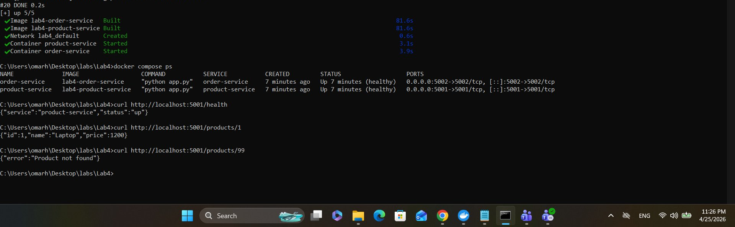
Figure 3: docker compose up --build completing successfully; docker compose ps showing both containers Up and healthy on ports 5001 and 5002

Part E — Functional Testing

product-service Tests
Three curl requests were used to verify product-service behavior: the health endpoint confirmed the service was up, the products/1 endpoint returned the Laptop product correctly, and the products/99 endpoint correctly returned a 404 error with a "Product not found" message.
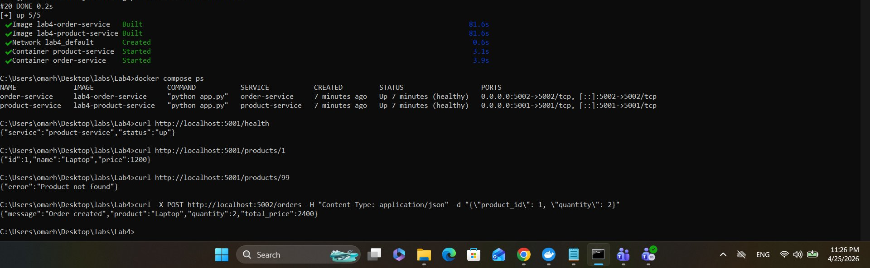
Figure 4: curl tests showing /health returning status up, /products/1 returning Laptop at $1200, and /products/99 returning error 404

order-service Test
A POST request was sent to order-service with product_id 1 and quantity 2. The order-service called product-service internally, retrieved the Laptop product, calculated the total price (1200 x 2 = 2400), and returned a successful order response with HTTP 201.
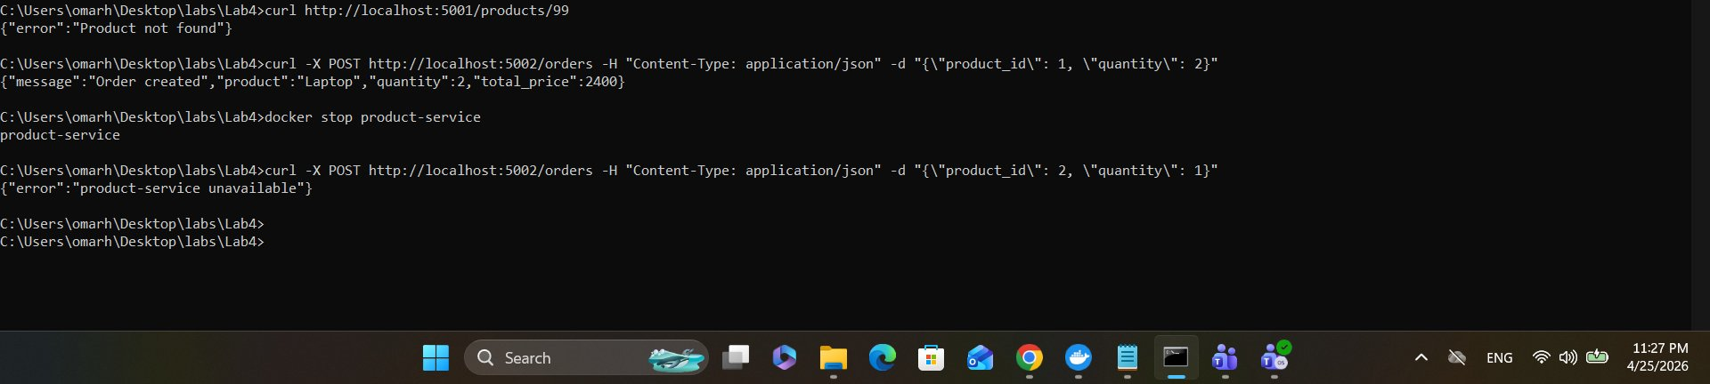
Figure 5: POST /orders with product_id 1, quantity 2 returning Order created with total_price 2400

Test | Endpoint | Expected | Result
Health check | GET /health (port 5001) | {"service":"product-service","status":"up"} | ✅ Pass
Valid product | GET /products/1 | {"id":1,"name":"Laptop","price":1200} | ✅ Pass
Invalid product | GET /products/99 | {"error":"Product not found"} | ✅ Pass
Create order | POST /orders (port 5002) | {"message":"Order created","total_price":2400} | ✅ Pass

Part F — Failure Injection and Resilience

Simulating product-service Failure
product-service was stopped using docker stop product-service. An order request was immediately sent to order-service. The fetch_product() function attempted to contact product-service, timed out after 2 seconds, retried twice with 1-second delays, and after all attempts were exhausted returned None. order-service then responded with HTTP 503 and the error message "product-service unavailable".
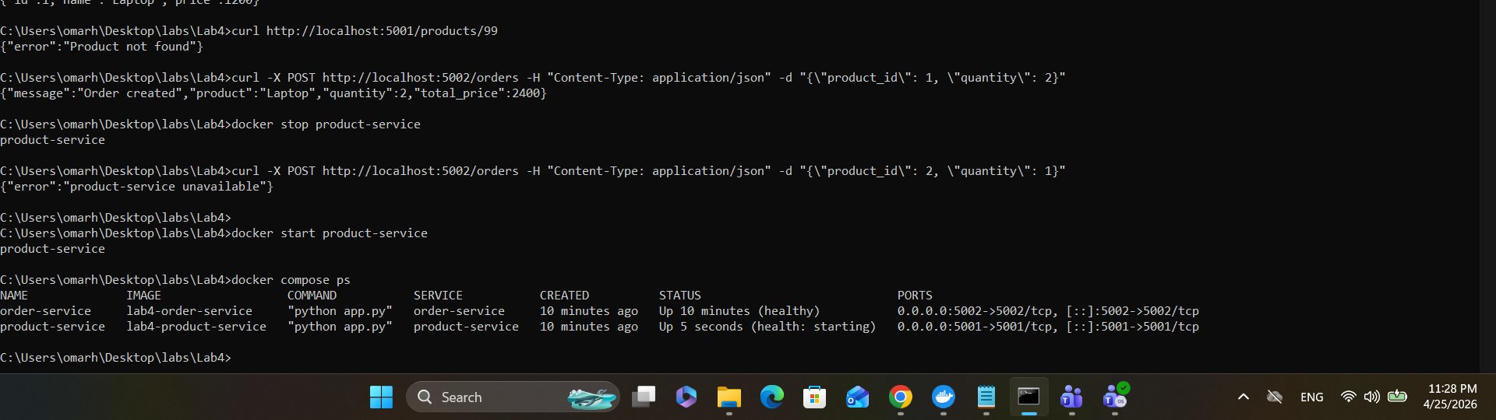
Figure 6: docker stop product-service followed by POST /orders returning {"error":"product-service unavailable"} — demonstrating graceful degradation

Service Recovery
product-service was restarted using docker start product-service. Docker Compose detected the restart and the health check began polling the /health endpoint. After approximately 30 seconds the container passed the health check and returned to healthy status. Both services were confirmed healthy via docker compose ps.
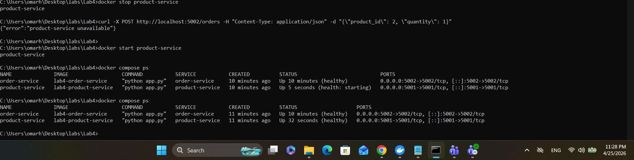
Figure 7: docker start product-service; docker compose ps showing product-service transitioning from "health: starting" to healthy (Up 32 seconds)

Part G — Architecture Reflection
1. Which parts of this lab show the benefits of microservices over a monolith?
Each service is independently deployable: product-service and order-service were built, started, and stopped independently without affecting the other's code or container. In a monolith, stopping one feature would bring down the entire application. The services can also be scaled independently — if product lookups are more frequent than orders, only product-service needs more replicas. Additionally, each service uses its own requirements file, so dependency upgrades in one service do not risk breaking the other.
2. Which new complexities were introduced by splitting the system into two services?
Network communication replaced simple in-process function calls, introducing latency and the possibility of timeout failures. The order-service now has a hard dependency on product-service availability, requiring timeout and retry logic that would not be needed in a monolith. Configuration management became more complex: the product-service URL must be passed as an environment variable and kept consistent across environments. Debugging also became harder since a failed order request may be caused by issues in either service, requiring log inspection across two separate containers.
3. What would break if network latency increased or one service became slow?
If product-service became slow, order-service would block for up to 2 seconds per attempt times 3 attempts, causing each order request to take up to 6 seconds before returning a 503. Under high load this would exhaust order-service threads or connections. Without a circuit breaker, order-service would keep retrying a known-slow dependency instead of failing fast. High latency would also cause health check timeouts (5-second timeout in the Compose config), potentially causing Docker to restart containers unnecessarily.
4. Which 12-factor app principles are visible in this implementation?
Factor III (Config): the PRODUCT_SERVICE_URL is stored in an environment variable, not hardcoded. Factor IV (Backing services): product-service is treated as an attached resource accessed over the network. Factor VI (Processes): both services are stateless — no session data or files are stored locally. Factor VII (Port binding): each service exports its own port (5001 and 5002). Factor VIII (Concurrency): services can be scaled independently. Factor IX (Disposability): the restart: unless-stopped policy and health checks support fast startup and graceful shutdown.

Deliverables Summary
Deliverable | Description | Status
Source code | product-service and order-service app.py and Dockerfiles | ✅ Completed
docker-compose.yml | Compose file with health checks, env vars, restart policy | ✅ Completed
Successful API calls | Screenshots of all curl tests (Figures 4 & 5) | ✅ Completed
Failure simulation | Screenshot of 503 response and recovery (Figures 6 & 7) | ✅ Completed
Reflection report | All 4 architecture reflection questions answered | ✅ Completed

