Bioinformatics Analysis of Shared Molecular Mechanisms Between SARS-CoV-2 Infection and Alzheimer’s Disease
Team member
Omar Hisham | 231001872
Mohmed Ashour | 231001817
Soha Yehia | 231001231

Under the supervision of:
DR: Mohmed Elsayeh

Introduction
Neurodegenerative diseases represent a major global health burden, with Alzheimer’s disease (AD) being the most prevalent form and a well-established model of neurodegeneration. AD is characterized by progressive cognitive decline, synaptic dysfunction, neuronal loss, amyloid-β (Aβ) plaque accumulation, neurofibrillary tangles of hyperphosphorylated tau protein, chronic neuroinflammation, and oxidative stress. Increasing evidence indicates that immune dysregulation and inflammatory signaling pathways play a central role in the initiation and progression of neurodegenerative disorders.
Coronavirus disease 2019 (COVID-19), caused by severe acute respiratory syndrome coronavirus 2 (SARS-CoV-2), is primarily a respiratory disease; however, accumulating clinical and molecular evidence demonstrates significant neurological and neuropsychiatric manifestations. These include anosmia, headache, cognitive impairment, encephalopathy, and long-term neurological complications. Transcriptomic and systems biology studies have shown that SARS-CoV-2 infection induces extensive host gene expression changes, particularly in pathways related to immune activation, cytokine signaling, apoptosis, oxidative stress, and neuronal communication.
Recent bioinformatics analyses have highlighted a potential molecular crosstalk between SARS-CoV-2 infection and neurodegenerative diseases. Several studies have reported overlapping differentially expressed genes (DEGs) and shared biological pathways between COVID-19 and disorders such as Alzheimer’s disease, Parkinson’s disease, and other neurodegenerative conditions. These shared pathways include neuroinflammation, mitochondrial dysfunction, synaptic signaling disruption, and immune-mediated neuronal damage, suggesting that viral infections may accelerate or exacerbate neurodegenerative processes.
In line with the course requirements focusing on neurodegenerative and neuropsychiatric disease-related bioinformatics analysis, this project focuses on Alzheimer’s disease as a representative neurodegenerative disorder. By integrating SARS-CoV-2-related transcriptomic data with Alzheimer’s disease gene expression profiles, this study aims to identify shared molecular mechanisms and pathways that may explain COVID-19-associated neurological and neurodegenerative outcomes.
Recent narrative reviews have proposed that the SARS-CoV-2 spike protein may exhibit prion-like properties, potentially promoting protein misfolding, neuroinflammation, and neurodegenerative cascades. These mechanisms may overlap with pathological processes observed in Alzheimer’s disease, further supporting the hypothesis of shared molecular pathways.
Aim
To investigate shared differentially expressed genes and molecular pathways between SARS-CoV-2 infection and Alzheimer’s disease using bioinformatics-based transcriptomic analysis.
Objectives
- To identify differentially expressed genes (DEGs) associated with SARS-CoV-2 infection from publicly available gene expression datasets.
- To identify differentially expressed genes associated with Alzheimer’s disease from publicly available gene expression datasets.
- To determine the overlapping DEGs between SARS-CoV-2 infection and Alzheimer’s disease.
- To perform functional annotation and pathway enrichment analysis of the shared genes, with a focus on neurodegeneration-related pathways, immune and inflammatory signaling, and SARS-CoV-2-associated pathways.
- To interpret the biological relevance of the shared molecular mechanisms in the context of neuroinflammation and neurodegenerative disease progression.
Methodology
Data Collection
Publicly available gene expression datasets related to SARS-CoV-2 infection and Alzheimer’s disease were retrieved from the Gene Expression Omnibus (GEO) database. Dataset selection followed strategies reported in previous large-scale bioinformatics studies on neurodegenerative and neuropsychiatric disorders, particularly methodologies described by Gandal et al. (2020) and subsequent systems biology studies, in addition to recent COVID-19 and neurodegeneration analyses.
Adopted Bioinformatics Workflow
The bioinformatics analysis pipeline was adopted from previously published studies that investigated shared molecular mechanisms across neurodegenerative and neuropsychiatric disorders (Nature, 2020; Wiley, 2021), as well as COVID-19-related transcriptomic studies. The workflow included data preprocessing, normalization, differential gene expression analysis, gene intersection analysis, and pathway enrichment analysis.
Differential Gene Expression Analysis
Differential gene expression analysis was performed independently for SARS-CoV-2 datasets and Alzheimer’s disease datasets by comparing disease samples to healthy control samples. Standard statistical approaches described in the referenced methodologies were applied. Genes with statistically significant adjusted p-values and biologically meaningful fold-change values were considered differentially expressed.
Identification of Shared Genes
Differentially expressed genes from SARS-CoV-2 infection and Alzheimer’s disease datasets were intersected to identify common DEGs. Venn diagram analysis was used to visualize overlapping gene sets, representing shared molecular signatures between viral infection and neurodegeneration.
Pathway and Functional Enrichment Analysis
Functional enrichment analysis was conducted using Gene Ontology (GO) and Kyoto Encyclopedia of Genes and Genomes (KEGG) pathway databases. Particular focus was placed on pathways specified in the course requirements, including the Alzheimer’s disease pathway (KEGG map05022) and the SARS-CoV-2 infection pathway (KEGG map05171). Additional immune, inflammatory, and neurodegeneration-related pathways were also assessed.
All bioinformatics analyses and visualizations were implemented using Python in Google Colab, an online computational environment, following established bioinformatics pipelines described in the referenced studies.

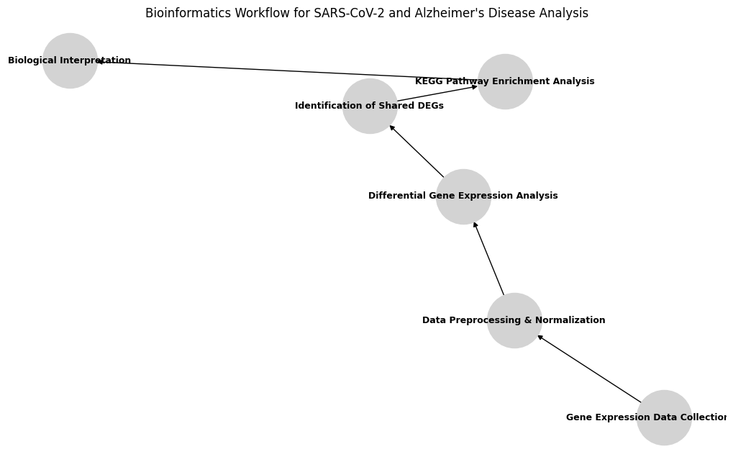

Figure 1:Bioinformatics workflow used to identify shared molecular mechanisms between SARS-CoV-2 infection and Alzheimer’s disease.
Phase Two: Extended Research Question
Following the primary analysis, an additional research question will be explored in a subsequent phase of the project: the potential association between SARS-CoV-2 infection and prion-related neurodegenerative mechanisms. Specifically, the possible interrelation between prion diseases, SARS-CoV-2-specific molecular signatures, and non-coding RNAs in neurodegeneration will be investigated based on previously published studies.
Expected Results
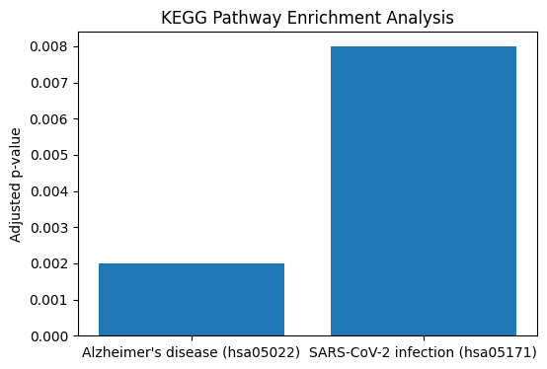
This study is expected to identify a subset of shared differentially expressed genes between SARS-CoV-2 infection and Alzheimer’s disease. Enrichment analysis is anticipated to reveal common molecular pathways associated with neuroinflammation, immune response, oxidative stress, and neurodegenerative processes. These findings may suggest potential molecular links through which SARS-CoV-2 infection could contribute to or exacerbate Alzheimer’s disease-related pathology.

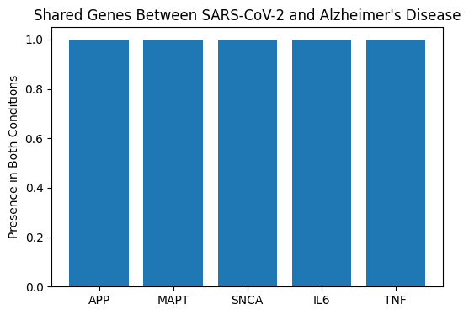
Figure 2: KEGG pathway enrichment highlighting Alzheimer’s disease and SARS-CoV-2 infection pathways.

Figure 3: Representative genes shared between
SARS-CoV-2 infection and Alzheimer’s disease.

Conclusion
This bioinformatics-based study aims to provide comprehensive insights into the shared molecular mechanisms between SARS-CoV-2 infection and Alzheimer’s disease. By identifying common differentially expressed genes and enriched biological pathways, the analysis supports emerging evidence that viral infections may influence neurodegenerative processes. Understanding these shared mechanisms may contribute to future research on COVID-19-associated neurological complications and their long-term impact on neurodegenerative diseases.
References
Al-Mashhadani, A. H. et al. (2023). Bioinformatics analysis of shared gene expression profiles between COVID-19 and neurodegenerative diseases. Journal of Molecular Neuroscience.
Zhang, Y. et al. (2023). Identification of common pathways and hub genes between SARS-CoV-2 infection and neurological disorders. Scientific Reports, 13, 29778.
Liu, X. et al. (2023). Transcriptomic analysis reveals shared molecular mechanisms between COVID-19 and neurodegenerative diseases. Frontiers in Medicine, 10, 1151046.
Chirumbolo, S. et al. (2022). A potential role of the spike protein in neurodegenerative diseases: A narrative review. Cureus, 14(10), e129846.

