# Step 1: Install Jupyter Notebook

Skip if you have Jupyter Notebook installed. If you don't have Jupyter Notebook installed, you can follow these steps to install it:

a. Open your terminal or command prompt.

b. If you have Python 3 installed, you can install Jupyter Notebook using pip (Python package manager) by entering the following command and pressing Enter:

Copy code

pip install jupyter

c. Wait for the installation to complete.

# Step 2: Download the Project

a. Go to the repository where the "Sentiment-Analysis-Using-Vader" project is hosted.

b. Look for a "Download" or "Code" button on the repository page and click it.

c. Select "Download ZIP" to download the project files to your computer.

d. Extract the downloaded ZIP file to a location of your choice.

# Step 3: Open the Project in Jupyter Notebook

a. Open your terminal or command prompt.

b. Use the "cd" command to navigate to the folder where you extracted the project files. For example:

cd path/to/project/folder

Here is an example of how to copy folder path

Click on the copy “folder” as pathname option

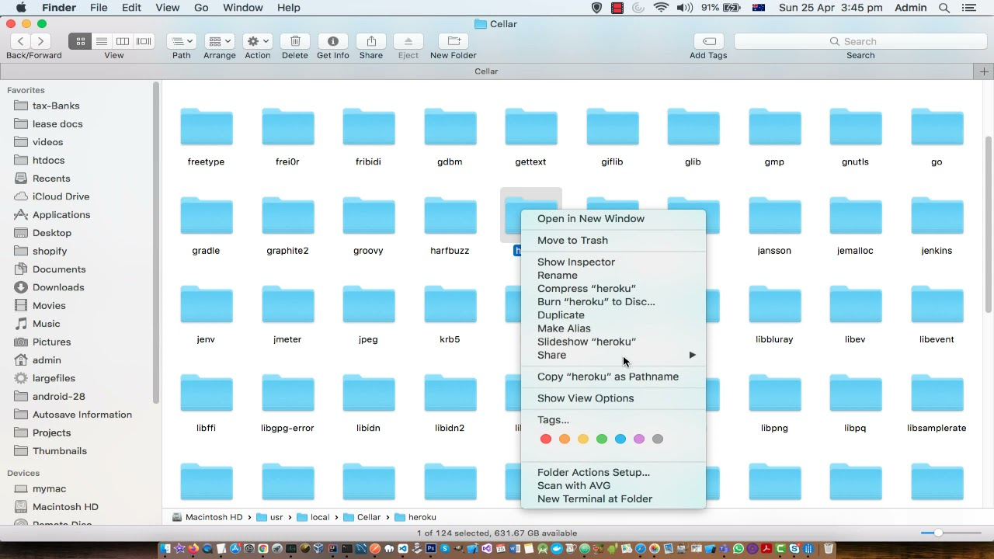

c. Once you are in the folder path on your terminal “Install the necessary Python packages using the requirements.txt file” type: pip install -r requirements.txt in the terminal

d. Launch Jupyter Notebook from the folder in the terminal by entering the following command and pressing Enter:

Copy code

jupyter notebook

e. This will open a new tab in your web browser with the Jupyter Notebook interface.

# Step 4: Running the Notebook

a. In the Jupyter Notebook interface, you will see the folder where you extracted the project files.

b. Look for the notebook file named "Sentiment-Analysis-Using-Vader.ipynb" and click on it to open it.

c. Inside the notebook, you will find code cells that require certain libraries and packages. These are usually mentioned at the beginning of the notebook.

Step 5: Run the Notebook

a. Once you have installed the required dependencies, you can start running the notebook cells one by one. b. To execute a cell, click on it to select it, and then press Shift + Enter. The output of the cell will be displayed below it.

c. Follow the instructions and comments in the notebook to perform sentiment analysis using the Vader sentiment analysis tool.

d. Continue running the cells in sequence to generate the results and visualize the sentiment analysis.

Remember that Jupyter Notebook allows you to run code cells interactively, and you can modify the code or experiment with different inputs as you go along.