**CircleCI PROJECT**

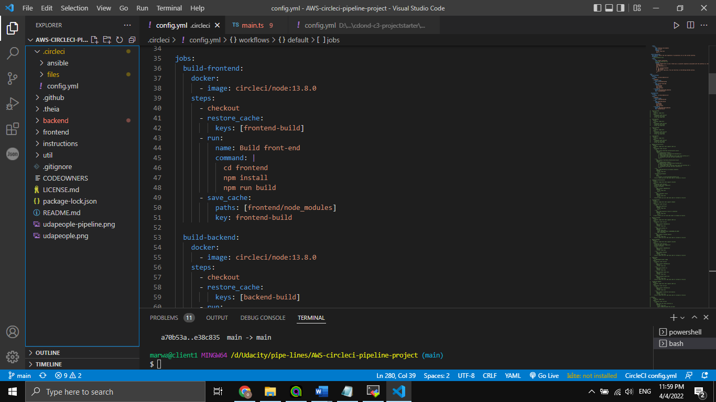

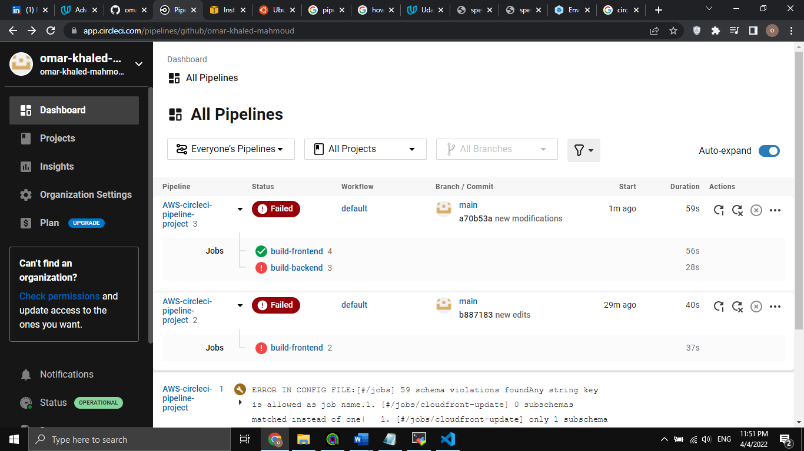

**SCREENSHOT 01**

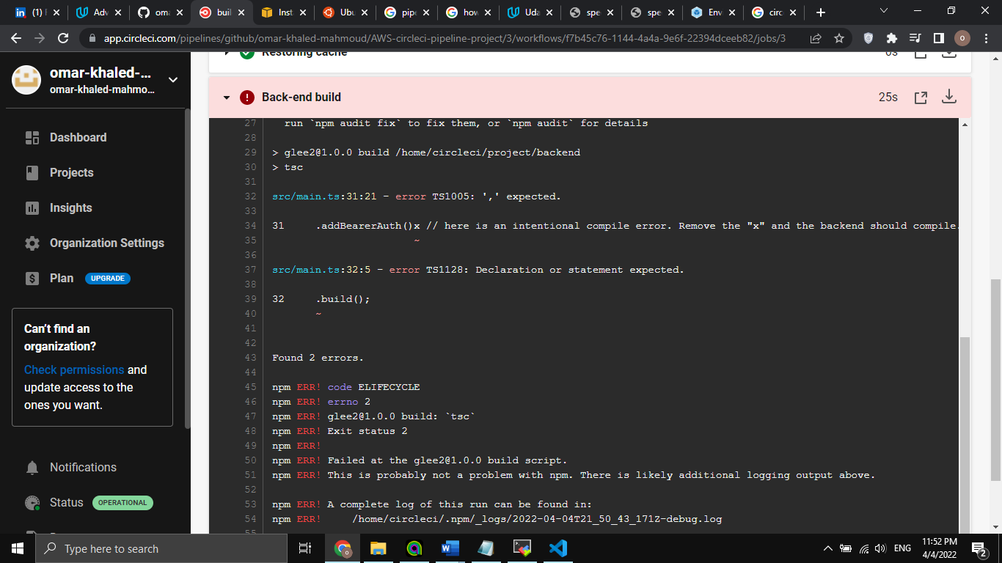

**The X is now removed from the code:**

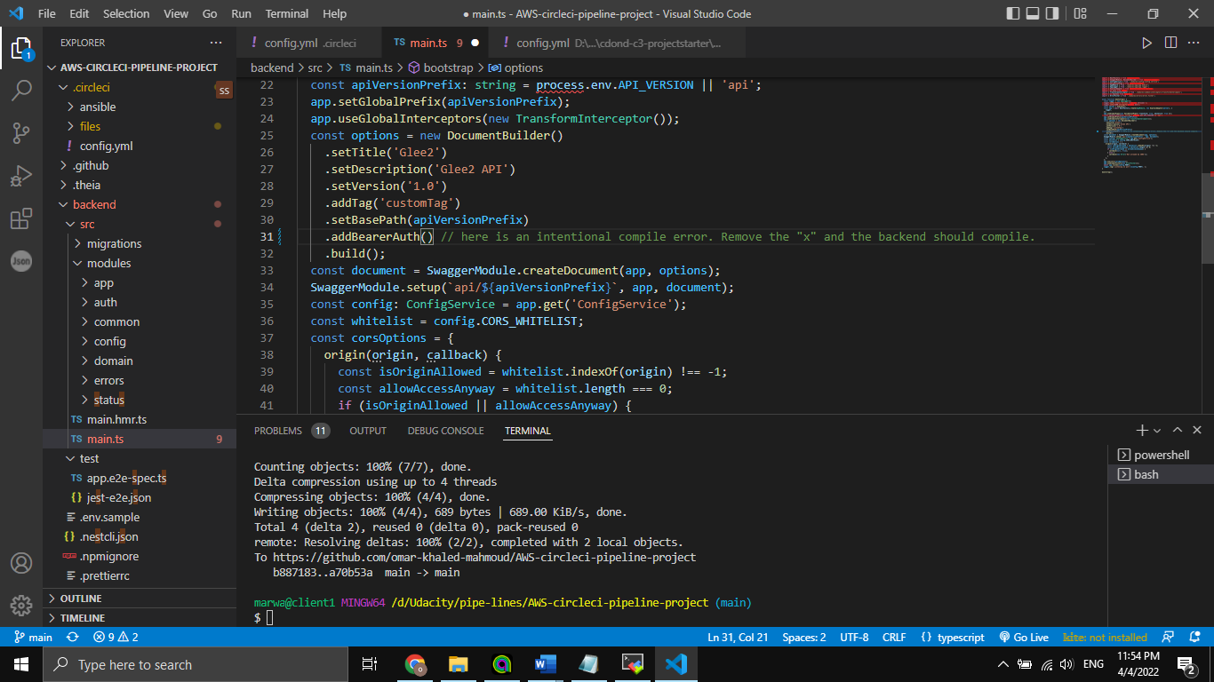

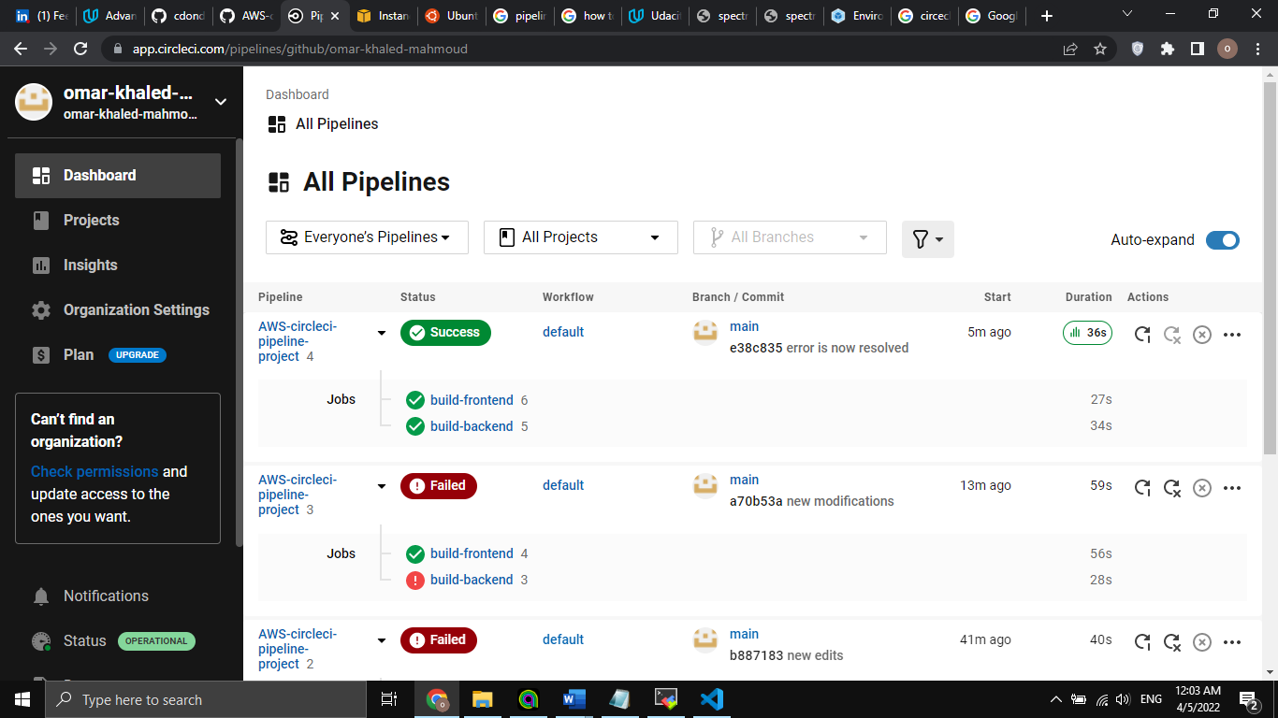

**Screenshot 02**

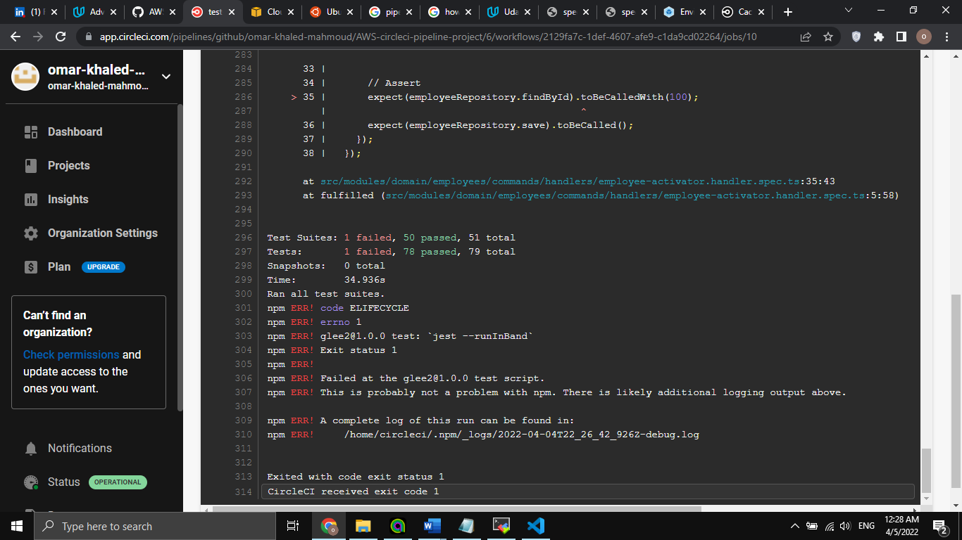

**After resolving the issue :**

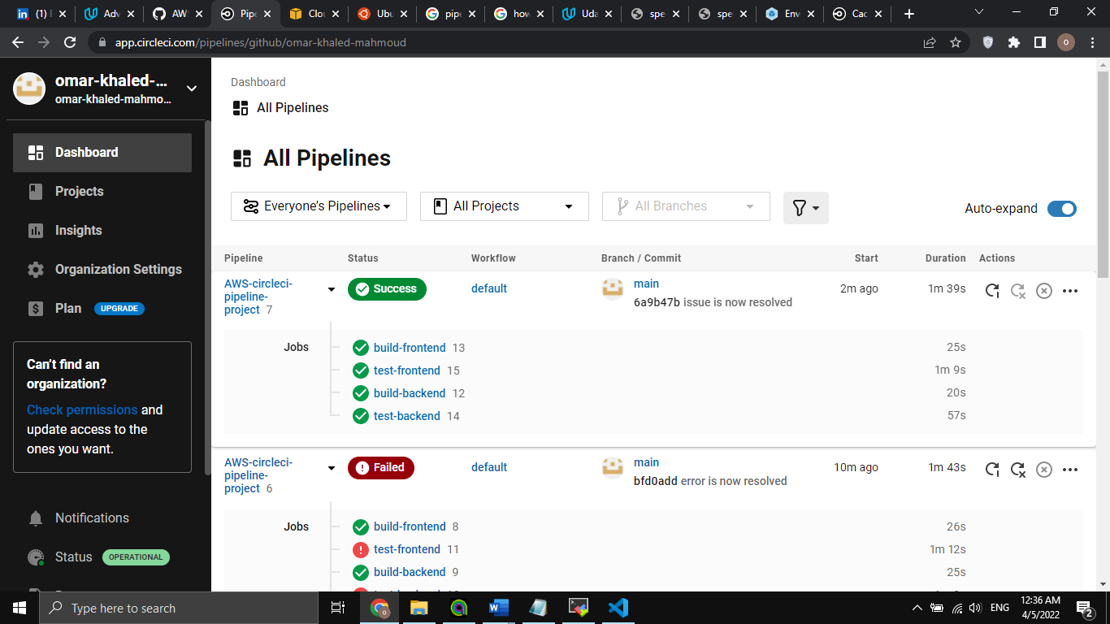

**Screenshot 03**

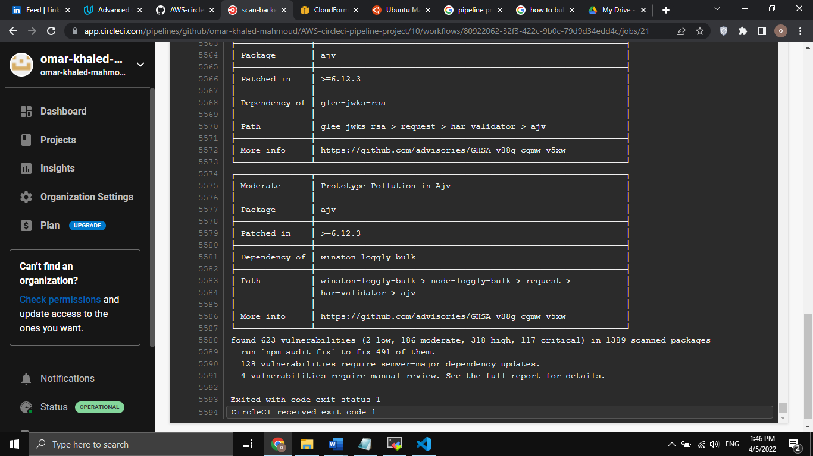

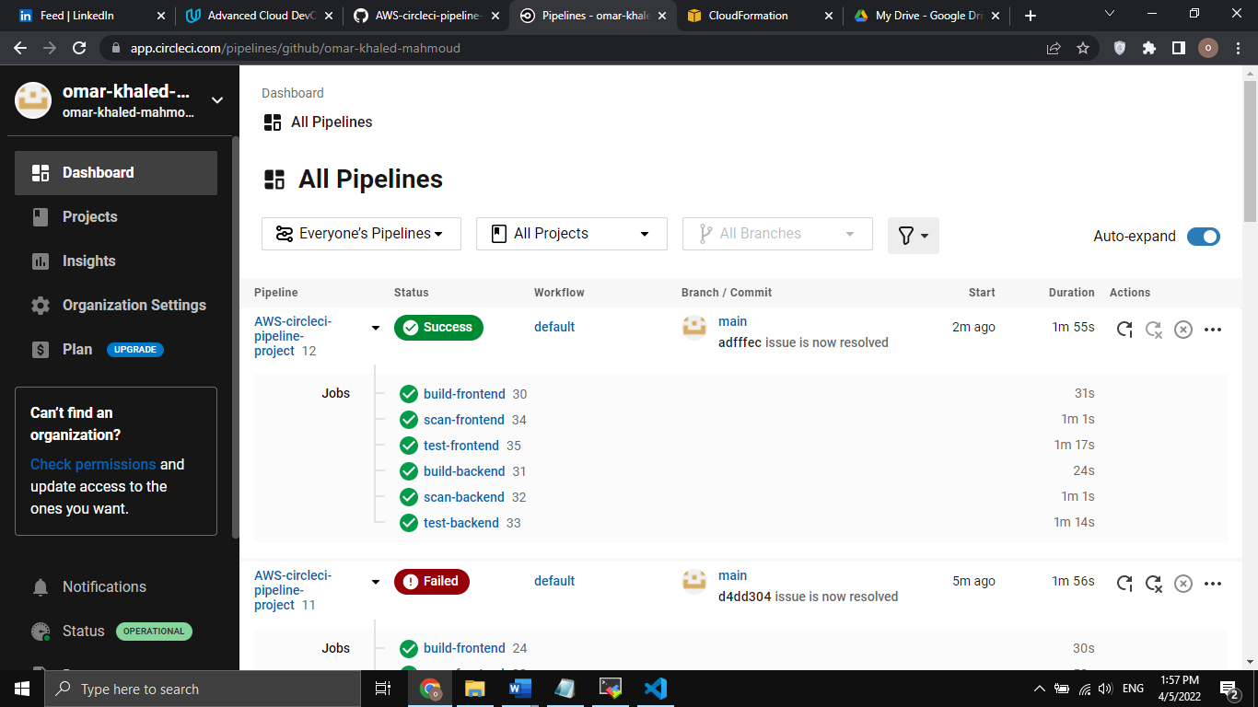

**After connecting circleCI with slack**

  deploy:

    docker:

      - image: circleci/node:12.18.0

    resource_class: medium

    steps:

      - trigger_slack_notification

      - checkout

      - run:

          name: Install packages

          command: npm install

      - run:

          name: Installing Firebase-Tools

          command: npm install firebase-tools

      - run:

          name: Firebase Set Project Id

          command: ./node_modules/.bin/firebase use default --token $FIREBASE_DEVELOP_DEPLOY_TOKEN

      - run:

          name: Build App

          command: npm run build:app

      - run:

          name: Deploy All

          command: ./node_modules/.bin/firebase deploy --token $FIREBASE_DEVELOP_DEPLOY_TOKEN --only functions,hosting,storage --force

      - notify_slack_error

      - notify_slack_pass

**Screenshot 04**

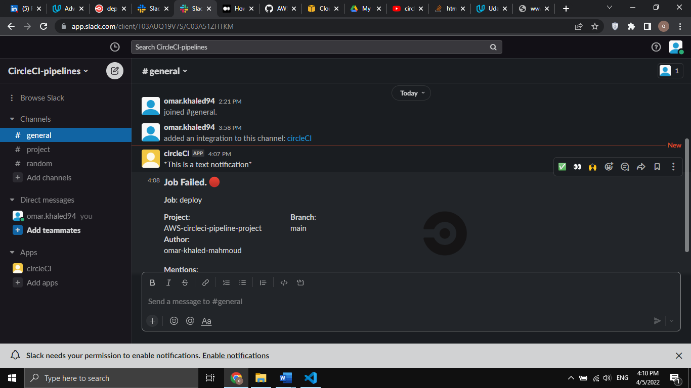

**Screenshoot 04 (email)**

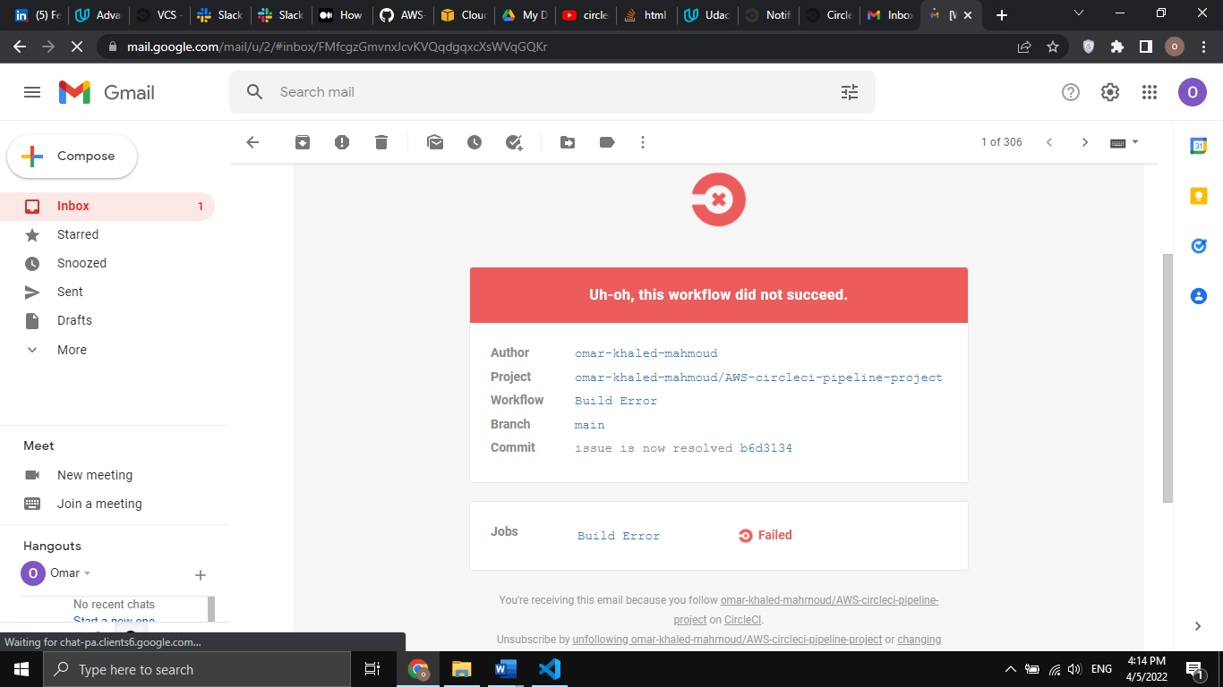

**The slack notification part will be removed, to make code cleander, All errors are now fixed.**

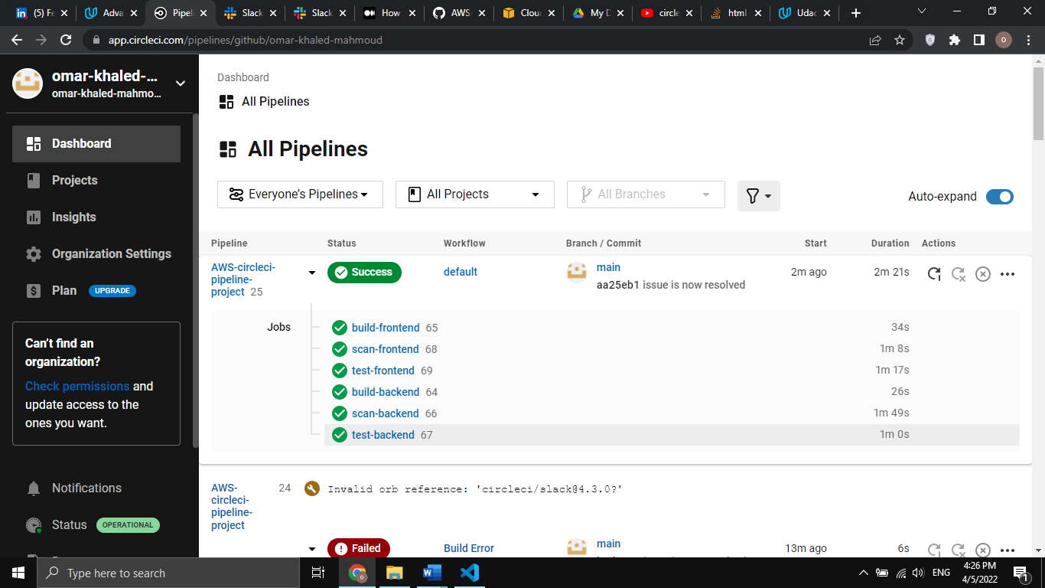

**S3 bucket is now created along with cloudfront**

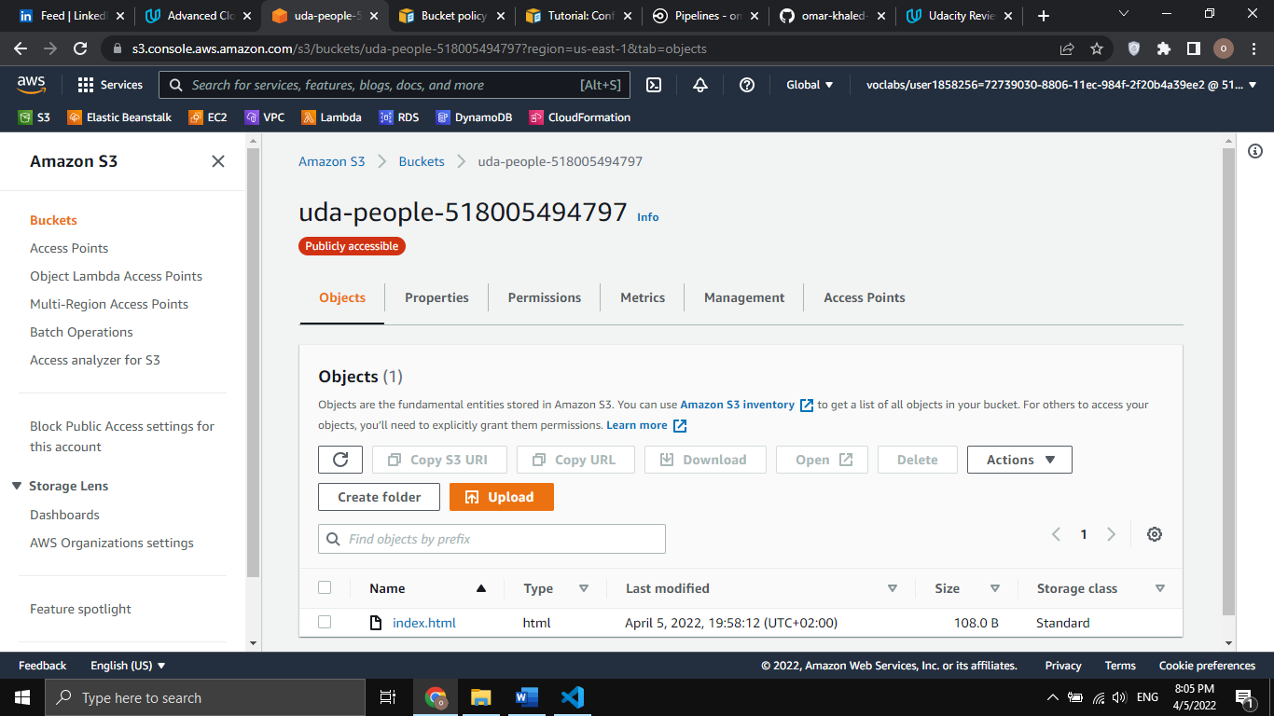

**Screenshot 05**

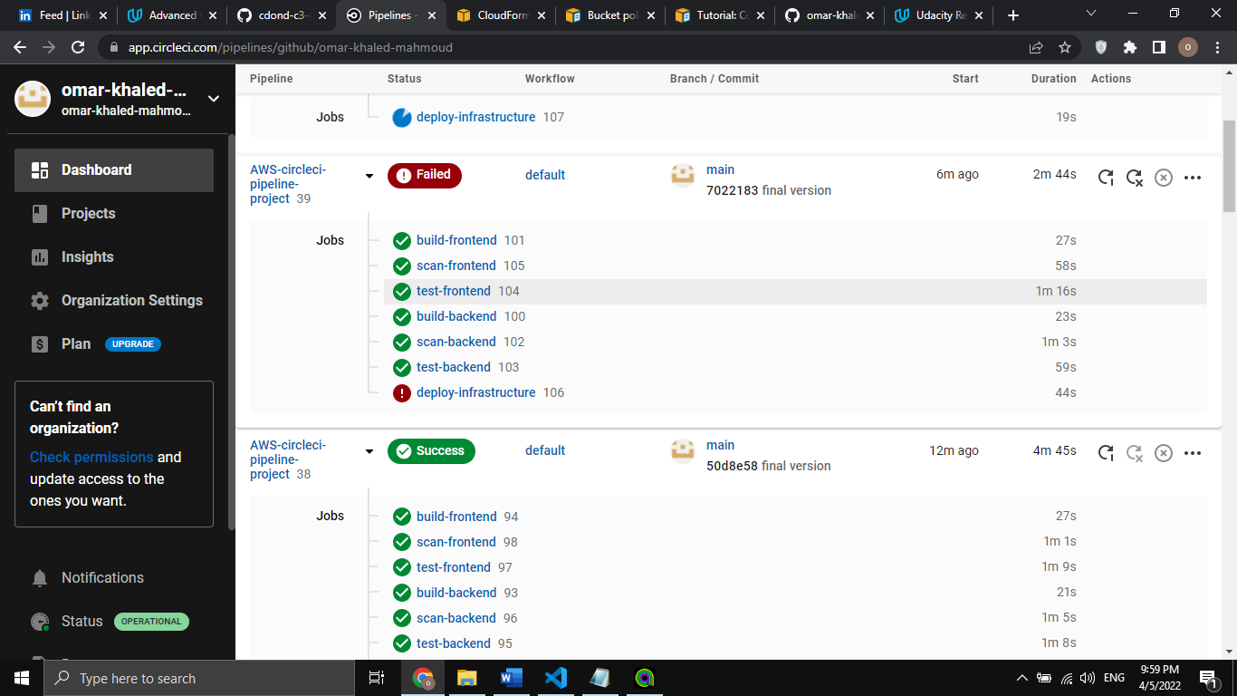

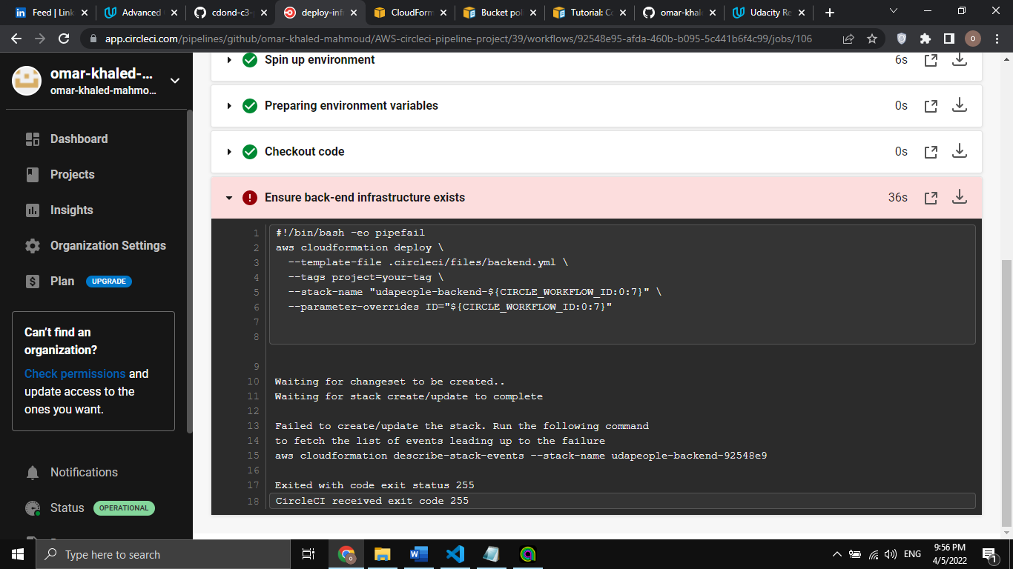

**Keyname and imageid is corrected**

**URL of my REPO:** ***https://github.com/omar-khaled-mahmoud/AWS-circleci-pipeline-project***

**Configure infrastructure using ansible succeded**

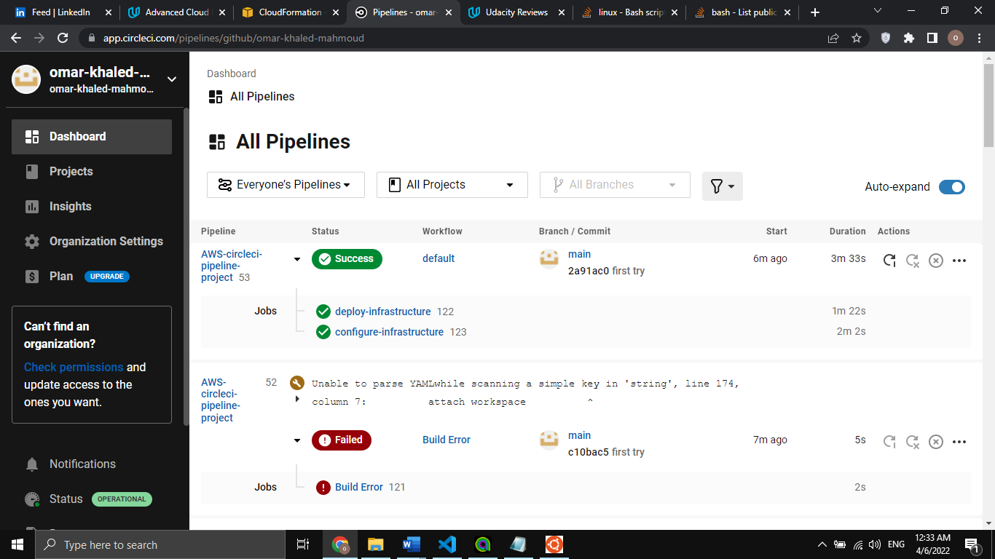

**Database migration succeeded:**