|  |  |  |
| --- | --- | --- |
| **Title** | **Actual result** | **Expected Result** |
| **Rating filter shows non-rated restaurants.** | **Restaurants that are newly added and have no ratings are displayed in the filtered results.** | **Only restaurants with actual ratings should appear in the filtered results. Newly added restaurants with no ratings should be ignored.** |

|  |  |  |  |  |  |
| --- | --- | --- | --- | --- | --- |
| **Version** | **Device** | **OS Version** | **Network** | **Severity** | **Priority** |
| **12.18.0** | **Samsung Galaxay A22** | **Android 13** | **WIFI** | **Medium** | **High** |

**Open Talabat APP - Tap on Food**  
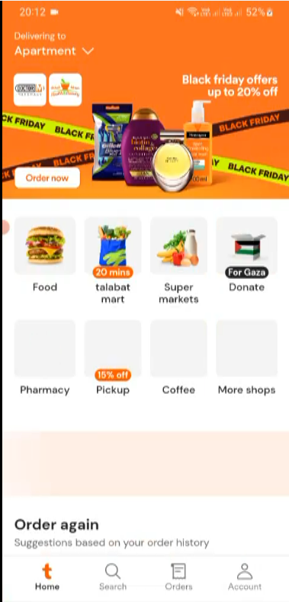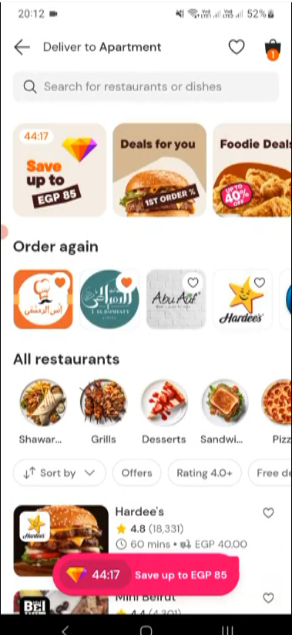  
  
  
  
  
  
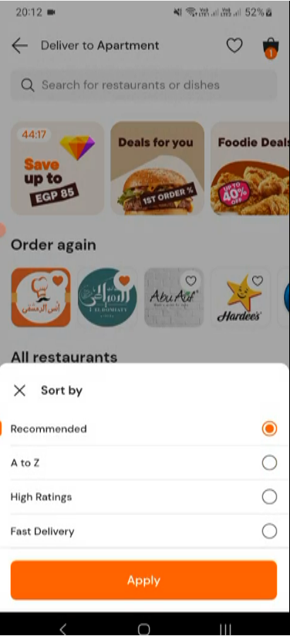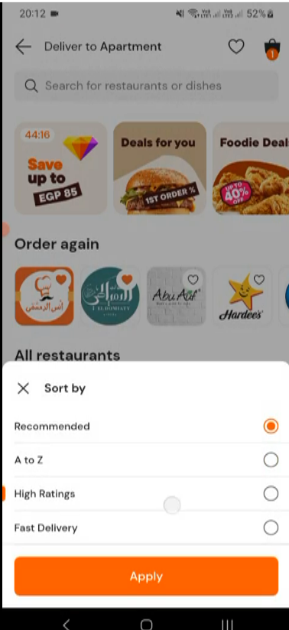  
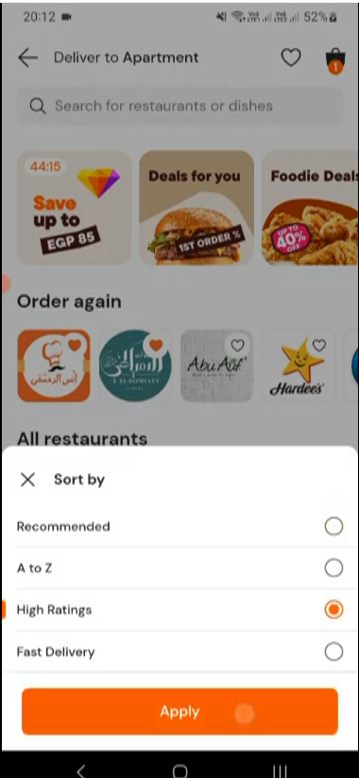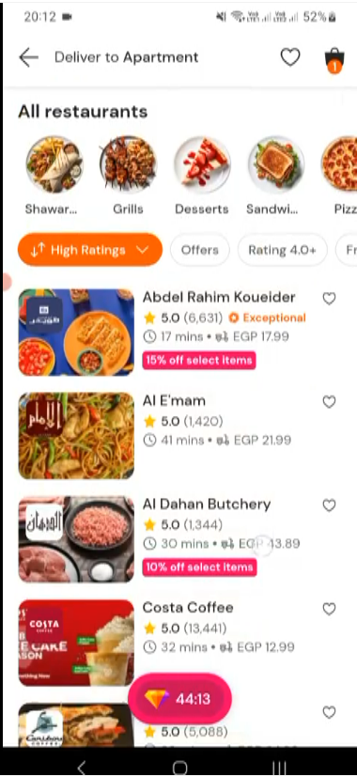  
  
  
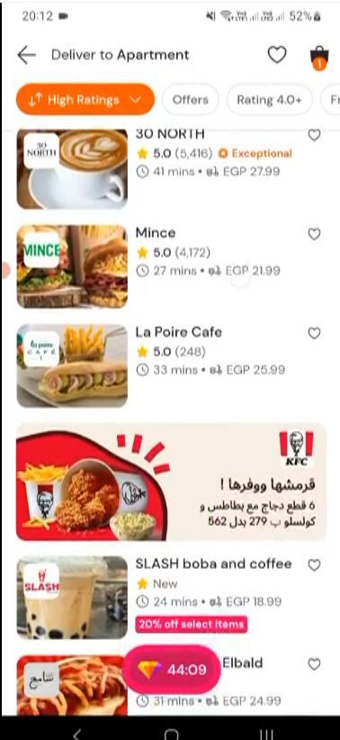

**Tap on Sort By**

**Select High Ratings**

**Scroll Down**

**Tap on Apply**

**Tap on SLASH boba and coffe**