|  |  |  |
| --- | --- | --- |
| **Title** | **Actual result** | **Expected Result** |
| **Negative Amount Accepted in Tip Field Without Validation or Error Message** | **The app accepts a negative tip amount without validation, and the total remains unchanged after tapping Apply.** | **The app should prevent negative amounts in the tip field and show an error message if entered. The total should update with a valid tip amount.** |

|  |  |  |  |  |  |
| --- | --- | --- | --- | --- | --- |
| **Version** | **Device** | **OS Version** | **Network** | **Severity** | **Priority** |
| **12.18.0** | **Samsung Galaxay A22** | **Android 13** | **WIFI** | **High** | **High** |

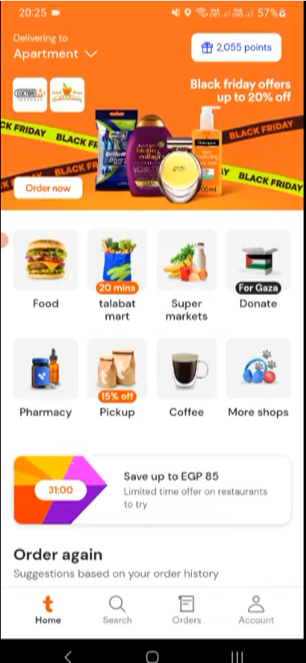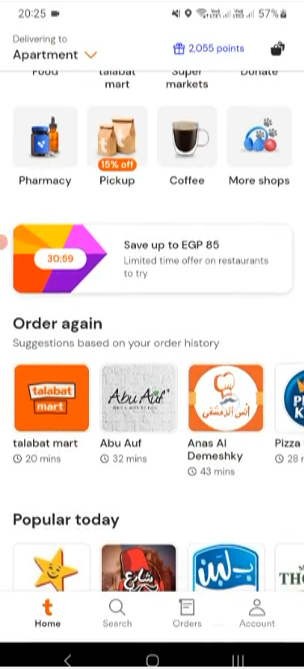  
  
  
  
  
  
  
  
  
  
  
  
  
  
  
  
  
  
  
  
  
  
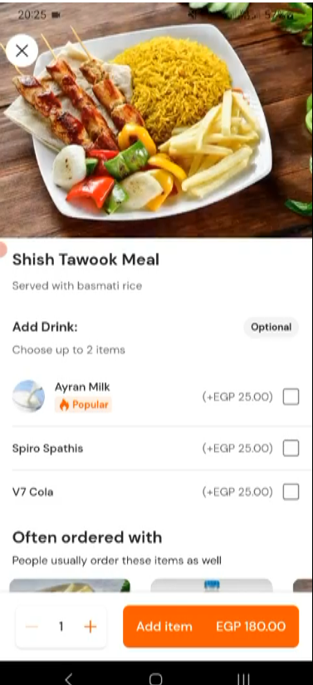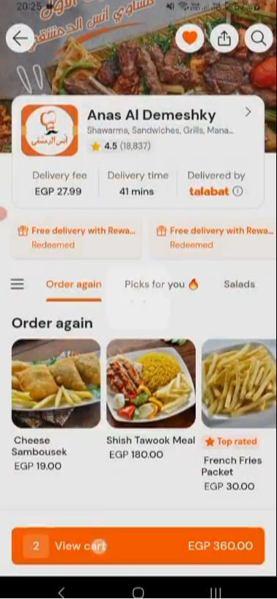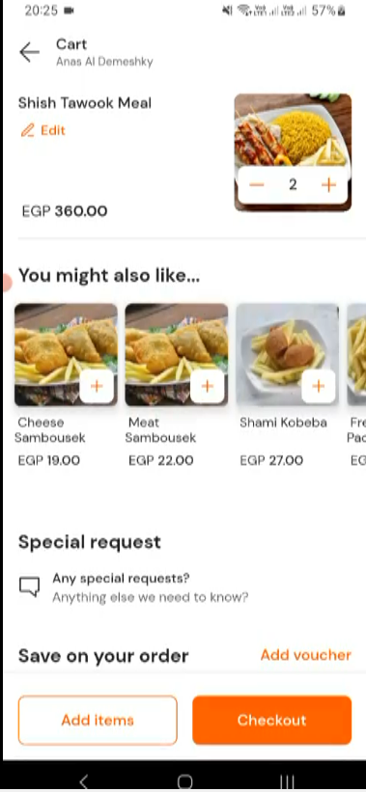  
  
  
  
  
  
  
  
  
  
  
  
  
  
  
  
  
  
  
  
  
  
  
  
  
  
  
  
  
  
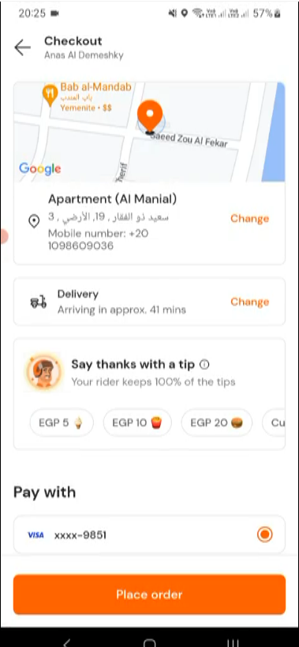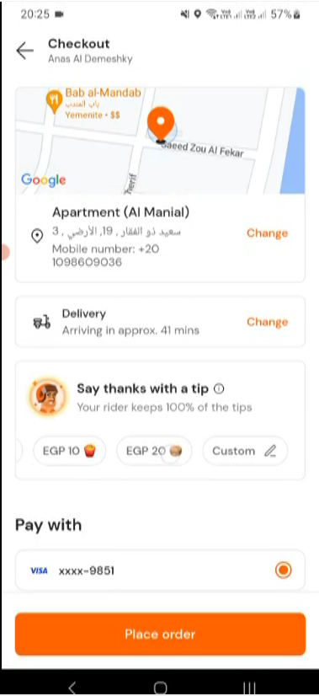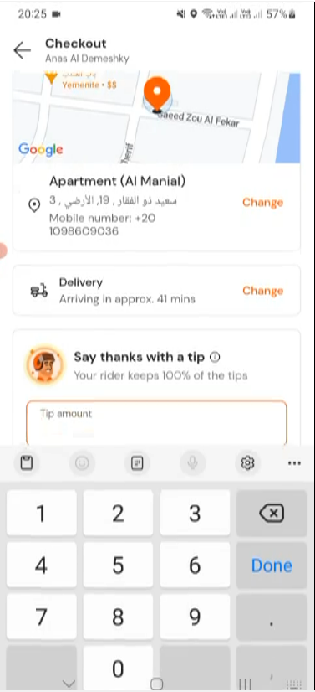  
  
  
  
  
  
  
  
  
  
  
  
  
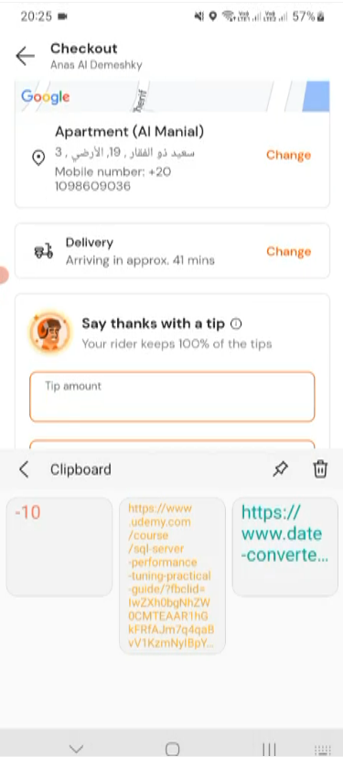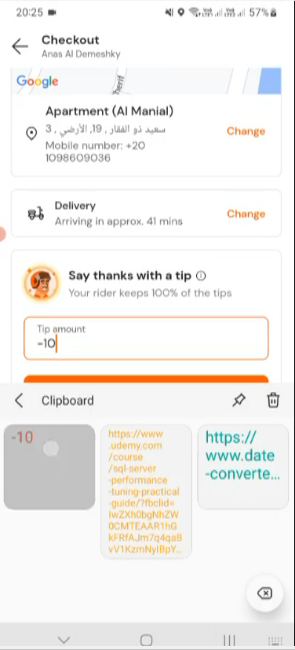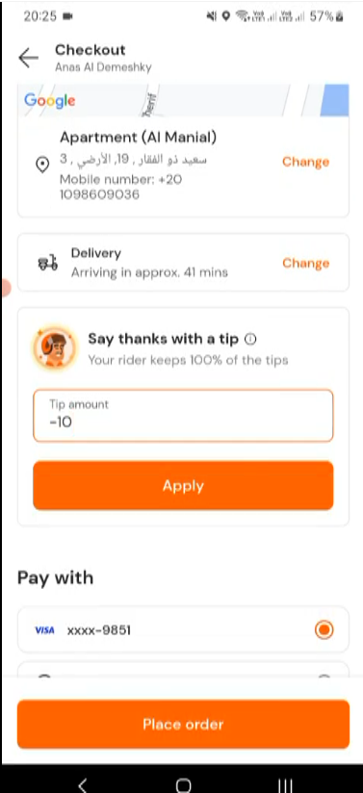  
  
  
  
  
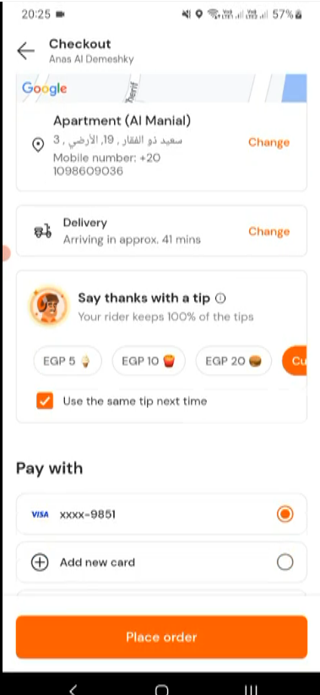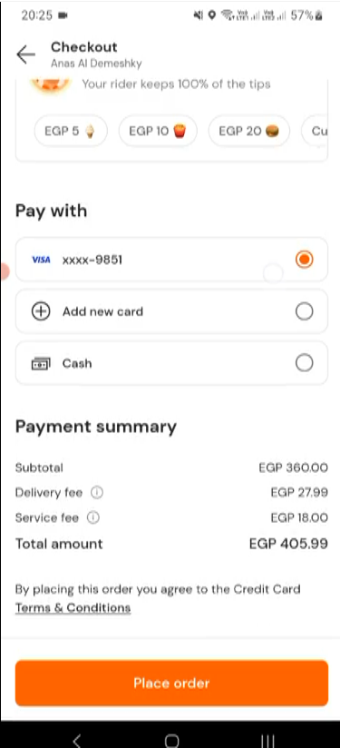

**Tap on Shish Tawook Meal**

**Tap on “Anas Al Demeshky”**

**Open Talabat APP**

Tap on “Checkout”

Tap on View cart

Tap on “Add item”

Tap on Clipboard Icon

Tap on “Custom”

Swipe Right Tip amount

Tap on back button

Tap on “Apply”