

**Airline Booking System (Phase-1)  
  
27/3/2024  
  
Team 9**

|  |  |
| --- | --- |
| **Name** | **ID** |
| **Omar Alomair** | **202046100** |
| **Kumail Aljassem** | **202031300** |
| **Ali Elmatrawy** | **202045300** |

## **Conceptual Diagram (EER Model)**

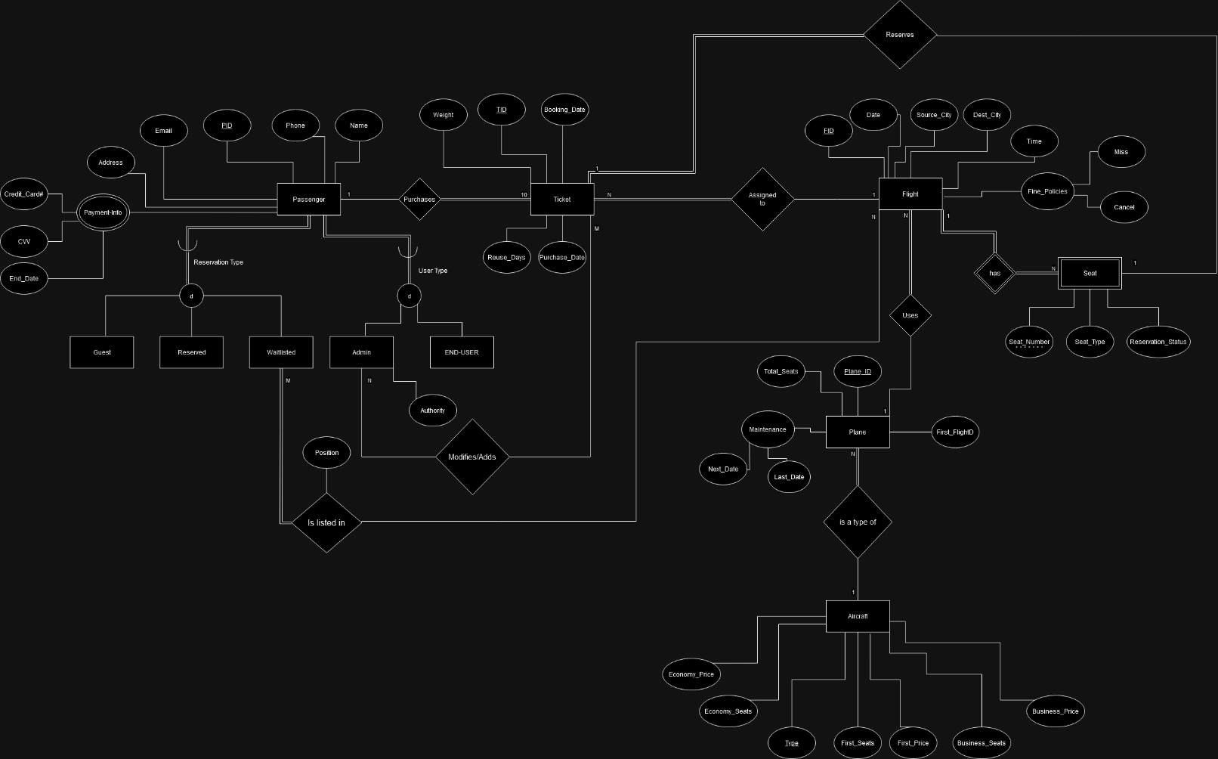

For a higher [quality image](https://drive.google.com/file/d/1tVpLNvUkwPquRLceobhBFsOEEICFJkKb/view?usp=sharing)

https://drive.google.com/file/d/1tVpLNvUkwPquRLceobhBFsOEEICFJkKb/view?usp=sharing

## **Logical Schema**

For a higher [quality image](https://drive.google.com/file/d/170Jkyon5JTN6F41HBLvtt1KaVt-9_fYR/view?usp=drive_link)

https://drive.google.com/file/d/170Jkyon5JTN6F41HBLvtt1KaVt-9_fYR/view?usp=drive_link

# **Assumptions**

* Each flight has a unique Flight_ID (FID), and it serves as the primary key for the Flight entity.
* Each plane has a unique Plane_ID, and it serves as the primary key for the Plane entity.
* Each aircraft has a unique Type, and it serves as the primary key for the Aircraft entity (Example Boeing 707 is not repeated).
* The Payment-Info attribute in the Passenger entity is used to store payment details for each passenger.
* Assuming a passenger can have multiple credit cards.  
    
  Seats are linked to individual flights. (Example Flight A393BV has seat A7, same with others).
* The Reservation Status attribute in the Ticket entity indicates whether a seat is reserved, booked, or cancelled.
* The Waitlist relation tracks waitlisted passengers.
* The passenger entity is divided by reservation type into guest, reserved, and waitlisted passengers, also a passenger can be divided by user-type into admin or end-user.
* The system manages fines for flight cancellation or missed flights, which can be identified based on specific business rules.
* The system can send notifications to passengers for seat bookings and successful ticket purchases, although the specific notification mechanism is not defined in the diagram.
* Assuming planes have seats of that are a multiple of 6.
* Assuming normal users can’t edit their ticket just cancel it.
* Assuming correct payment for demo purposes

# **Contribution**

|  |  |  |  |
| --- | --- | --- | --- |
| Name | EER | Logical | Assumptions |
| Omar Alomair | 34% | 33% | 33% |
| Kumail Aljassem | 33% | 34% | 33% |
| Ali Elmatrawy | 33% | 33% | 34% |

All members contributed about equally in each task.