**How One Intelligent Machine Learned to Recognize Human Emotions**

*Omar Ozgur* – University of California, Los Angeles

**Abstract**

|  |
| --- |
| In recent years, new machine learning techniques have been successfully used to quickly recognize complex patterns that would be nearly impossible for humans to do alone. In this paper, I give a summary of a recent study performed at Shanghai Jiao Tong University, in which machines were used to study human emotions. |
|  |
|  |

**1. Introduction**

With the development of new machine-learning algorithms, researchers are now able to quickly find complex patterns in large data sets. At the Shanghai Jiao Tong University, Wei-Long Zheng and his team employed the use of software to gauge the emotional state of various test subjects. The hope was that the software would be able to find consistent patterns in recorded data, which proved to be a nearly impossible task for humans alone.

**2. Procedure**

In order to begin the study, 15 students were asked to watch 15 videos that were meant to invoke positive, negative, or neutral emotions. While watching each video, 62 electrodes were used to monitor the subject’s brain activity as part of an electroencephalogram (EEG). After each video, the subjects were asked to categorize their emotional response, as well as to rate the level of emotion on a scale from 1 to 5.

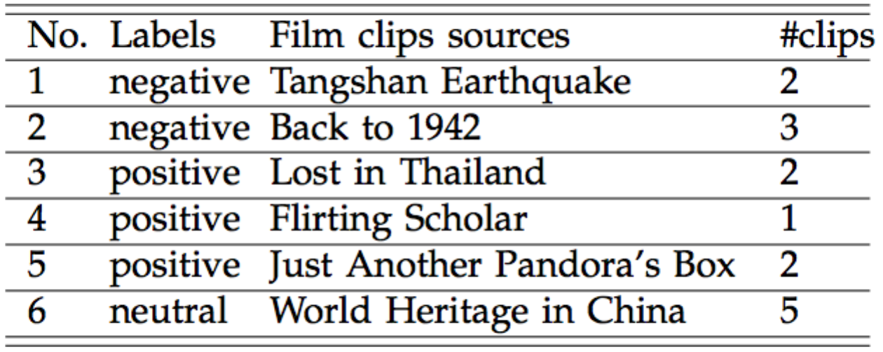

Figure 1: Film Clips Used: This chart displays the number of clips that were used from various sources. The films were labeled as “negative”, “positive”, or “neutral”.

After obtaining the desired data, the researchers used machine-learning techniques to train a neural network to autonomously output correct emotional classifications based on data from an EEG.

**3. Feature Classification**

Based on signal analysis of data gathered from the electrodes, 5 recorded frequency bands (delta, theta, alpha, beta, and gamma) were used to gather information about 6 different features. These features were power spectral density, differential entropy, differential asymmetry, rational asymmetry, asymmetry, and differential caudality. According to the researchers, their previous experience shows that these features can be used to effectively categorize human emotions.

**3. Categorization**

In order to use the extracted data to classify emotions, a “Graph regularized Extreme Learning Machine” (GELM) was used along with a feedforward neural network.

A typical feedforward neural network passes input data to layers of “neurons”. Each neuron performs a weighted summation of its inputs, and the result is passed to an activation function “σ”, which is typically the sigmoid function (1).

(1)

This process of weighted summation and applying the activation function is repeated at every neuron, in the “hidden” layers between the input and output layers. The weighted summation of the outputs in the final hidden layer provides the output of the network.

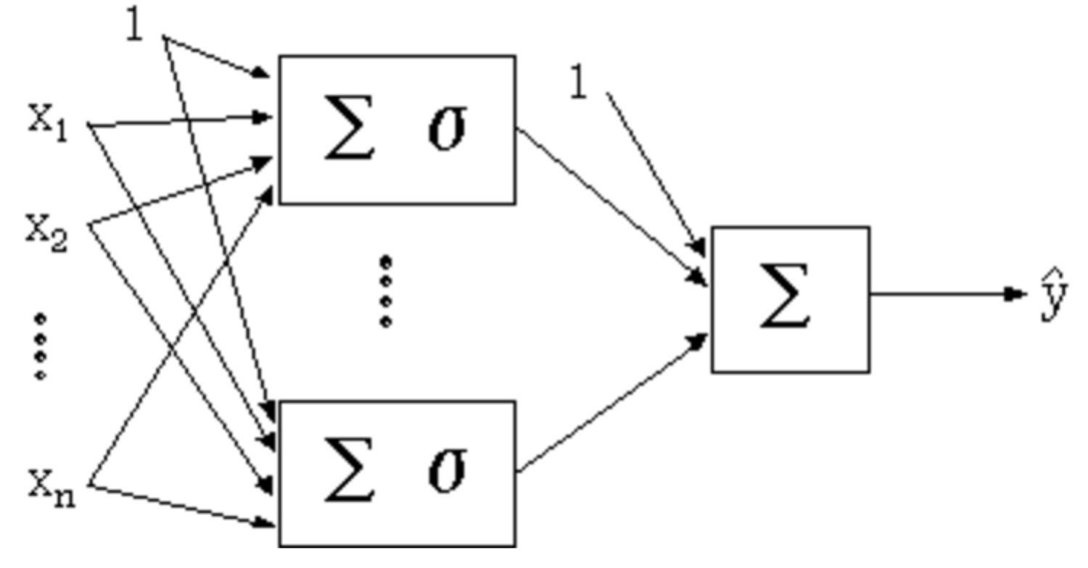

Figure 2: Diagram of a Feedforward Network: This diagram shows the inputs *xi* that are fed into neurons in a single hidden layer. After a weighted summation and application of an activation function, the data is passed to a final neuron to calculate the output *ŷ.*

This type of neural network relies on a method of “supervised learning”. The first time that data is passed through the network, the output is likely to be inaccurate. After comparing the outputs to the desired outputs, the weights of inputs to neurons can be adjusted. After sufficient “training”, the weights can be adjusted so that the neural network provides accurate results, even on complex data.

There are many ways that neural networks can be made to adjust input weights to neurons. In this particular study, the GELM method was used, which generates a “weight matrix” based on the idea that similar input samples should produce similar outputs. The weights in the generated matrix were used to adjust the network in order to improve accuracy.

**4. Results**

After performing feature extraction based on EEG information, and sufficiently training a neural network based on the provided emotional responses from test subjects, Zheng and his team were able to effectively determine a person’s emotional state based solely on their brain activity with approximately 80% accuracy. The accuracy of the classifications in this study demonstrates the effectiveness of machine learning algorithms when applied to complex problems.

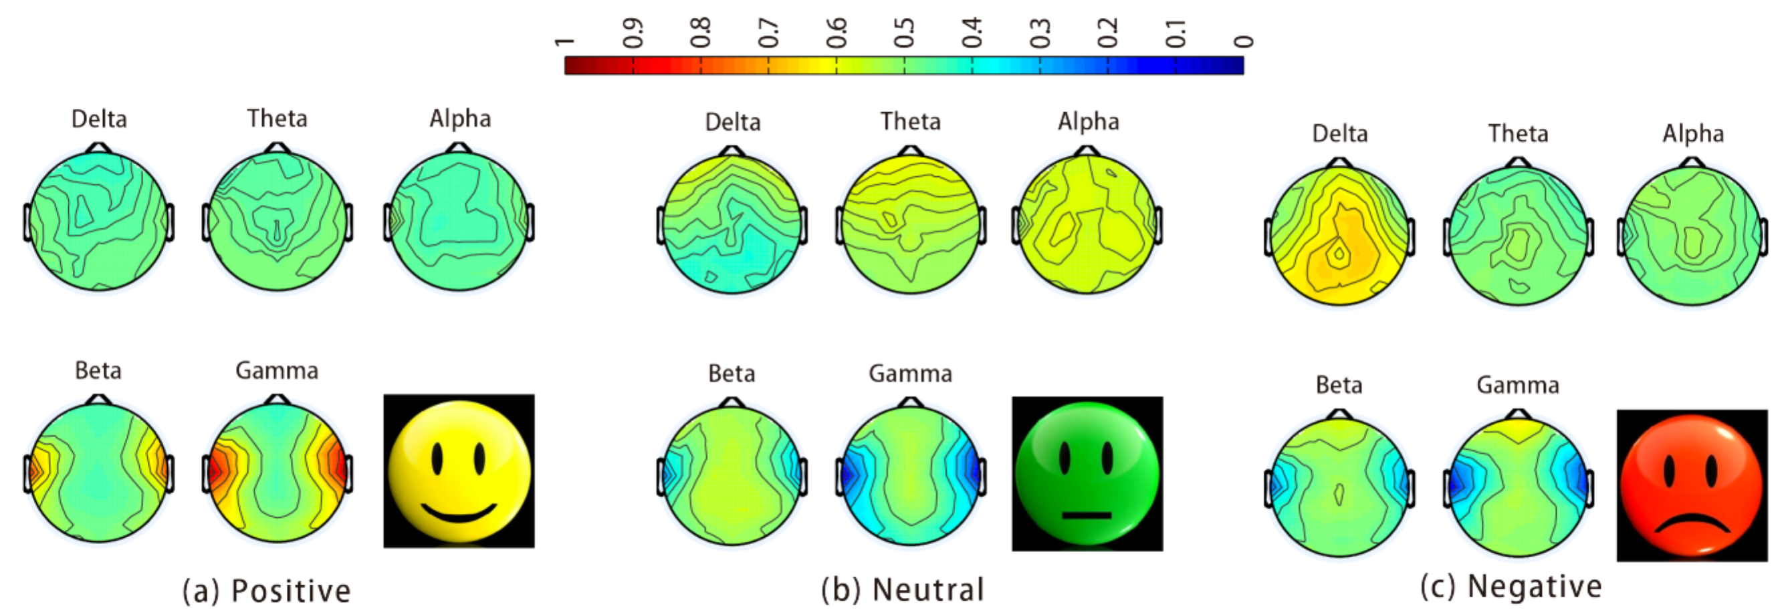

Figure 3: Average Neural Activity for Emotions: This image displays the average neural activity observed for positive, negative, and neutral emotions.

**5. Conclusion**

With the further development of machine-learning methods and artificial intelligence, new scientific discoveries can be made in countless fields. By creating algorithms that learn about data in similar ways that mimic the human brain, computers can be made to analyze and solve problems with minimal human intervention. The same techniques that were applied in this study can be used to study topics such as neuroscience and human behavior in ways that humans have never been able to accomplish before. The continued development of innovative machine-learning techniques can be used to improve the lives of people all around the world.

**6. References**

[1] Peng, Y., Wang, S., Long, X., Lu, B. (2013). “Discriminative graph regularized extreme learning machine and its application to face recognition”. *Science Direct.* [doi:10.1016/j.neucom.2013.12.065](http://www.sciencedirect.com/science/article/pii/S0925231214011357)

[2] Emerging Technology From the arXiv (2016). “How One Intelligent Machine Learned to Recognize Human Emotions”*. MIT Technology Review.* Retrieved from [*http://www.technologyreview.com/view/545986/how-one-intelligent-machine-learned-to-recognize-human-emotions/*](http://www.technologyreview.com/view/545986/how-one-intelligent-machine-learned-to-recognize-human-emotions/)

[3] Zheng, W., Zhu, J., Lu, B. (2016). “Identifying Stable Patterns over Time for Emotion Recognition from EEG”. *Cornel University Library*. Retrieved from <http://arxiv.org/pdf/1601.02197v1.pdf>

[4] “Neural Networks Documentation”. *Wolfram Mathematica Documentation Center.* Retrieved from <http://reference.wolfram.com/applications/neuralnetworks/NeuralNetworkTheory/2.5.1.html>