Used Car Price Prediction problem
ML problem type: regression
Features:
Problem with dataset collection:
I noticed a little mistake in the data, which probably occurred because of the way data was collected or processed after collection. Car brands that have 2 or more words in the brand name are stored incorrectly. Only the first word is stored as brand name, rest goes into model.
I solved this problem before going into EDA.
Exploration:
Shape>>>> (4009,12)
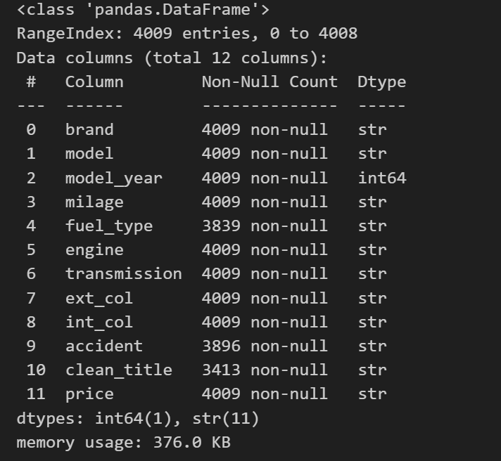
Problems:
No duplicates
In data types
(price,milage) must be numerical not str, I turned them into integers for data validation
In missing values
fuel_type 170
accident 113
clean_title 596
For fuel_type, I replaced the null with the mode.
For accident, I replaced the null with the mode.
For clean_title, it was only Yes and null so, initially, I replaced the null with No for variability.

EDA:
Numerical Data
['model_year', 'milage', 'price']
Outliers:
model_year has outlier 67
milage has outlier 69
price has outlier 244
for model_year: drooped outliers for logic conflict and noise preventing, lower was 2000(very old) and upper was 2032(yet to come)
now shape is (3942, 12)

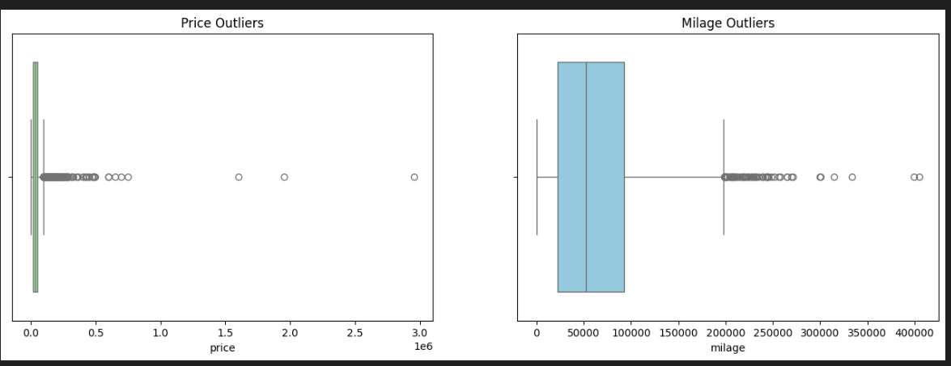
For price: transformed price into log(price) to consider very expensive cars,
now shape is (3942, 13)
For millage: : transformed millage into log(millage) to consider very high millage taken by cars,
now shape is (3942, 14)

Plots:
Correlations:
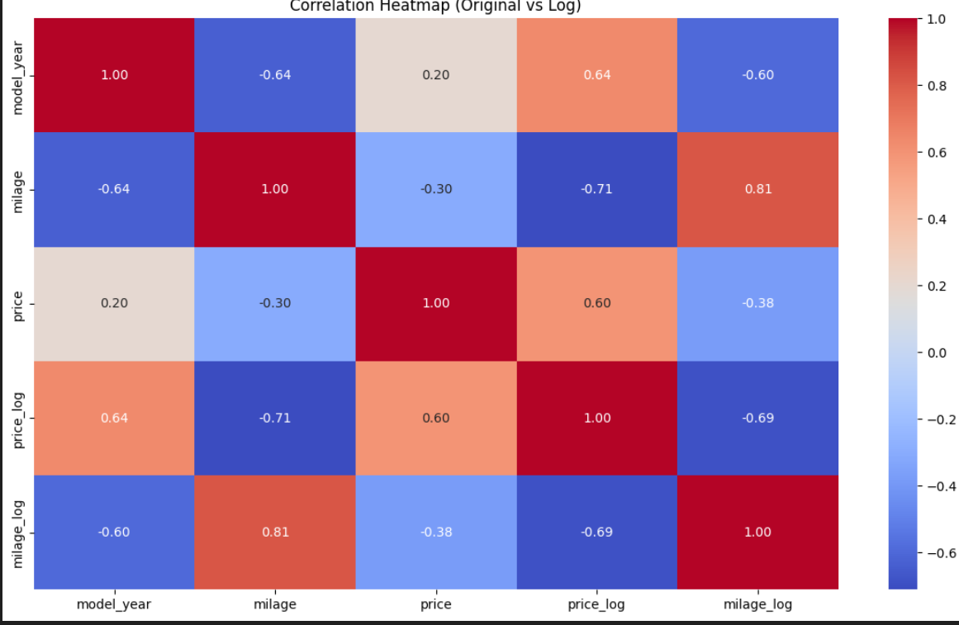
Pair plot:
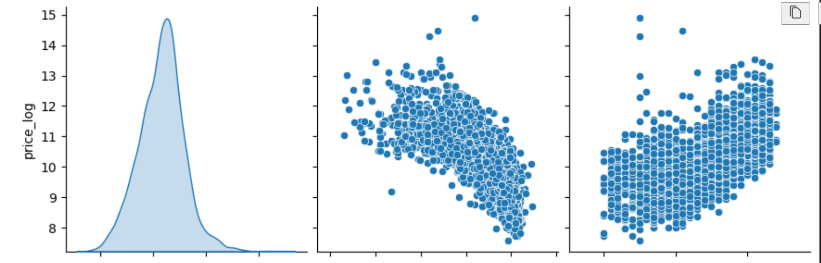
Model_year

Milage_log

1-there is a noisy reverse linear correlation between milage_log and price_log.
2-there is a noisy directional linear correlation between model_year and price_log.

Categorical Data
Unique values:
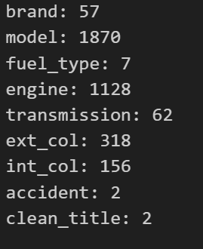
1-Clean_title:
Count:
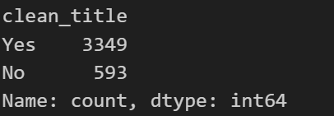
Average price for each category:
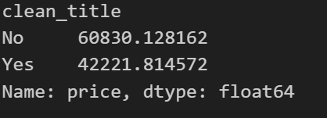
This means that when I imputed the missing values in this column with No, there might be an error in my hypothesis

How did I solve this problem?
if df['accident'] == 'None reported' and df['clean_title'].isna(), then I will impute with Yes,
else with Unknown.
Count:
Yes 3901
Unknown 41
Average price:
Unknown 34641.731707
Yes 45130.174827
Intuitive!!!

2-accident:
Count:
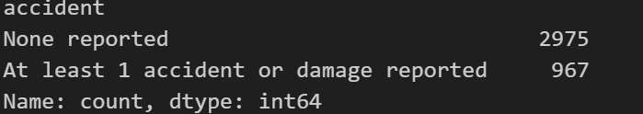
Average price for each category:
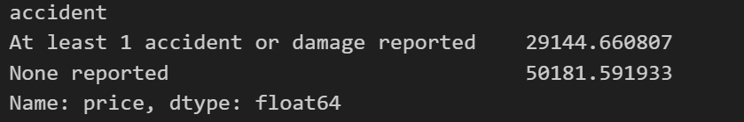
Intuitive!!!
3-fuel_type:
Count:
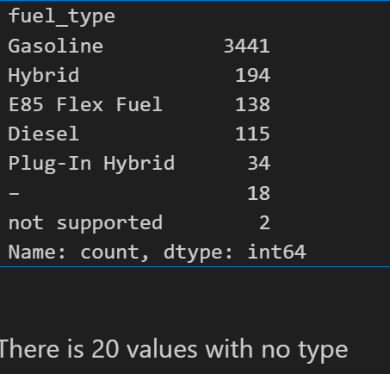
I replaced these 20 – values with Gasoline.
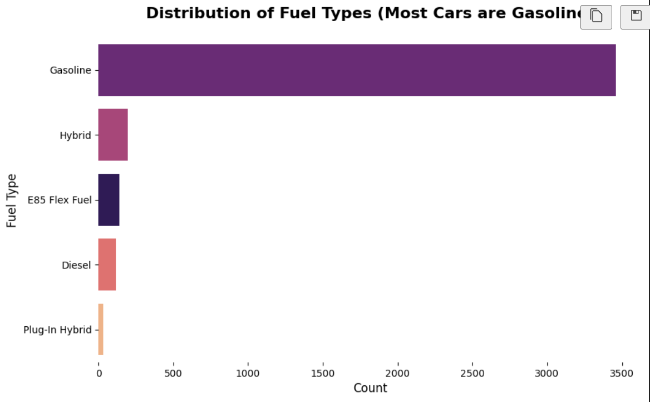

Average price for each category:
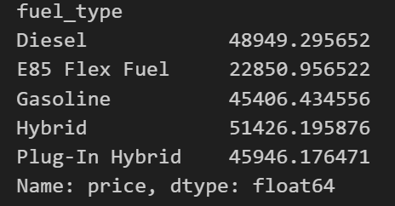
This is a very important feature for the price!

