TestCases:

4

2, 3, 7, 9, 11, 13

1, 10, 15

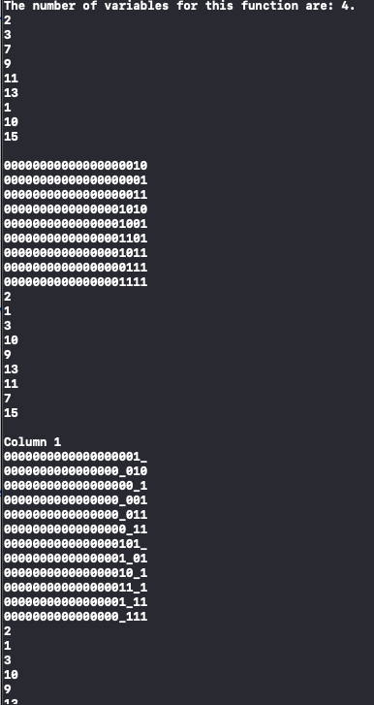

4

4, 8, 10, 11, 12, 15

9, 14

4

0, 3, 5, 6, 7, 10, 12, 13

2, 9, 15

4

1, 2, 6, 7, 8, 13, 14, 15

3, 5, 12

4

0, 1, 2, 3, 4, 5

10, 11, 12, 13, 14, 15

4

4, 6, 9, 10, 11, 13

2, 12, 15

4

0,1,2,3,9,10

4,5,6

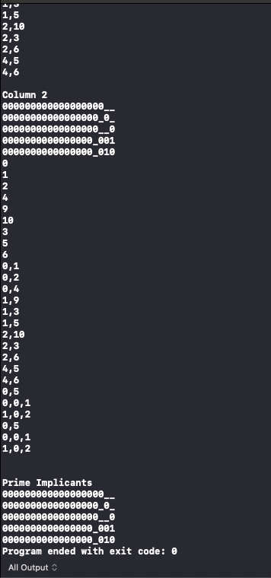

4

6, 7, 8, 9

10, 11, 12, 13, 14, 15

4

1, 3, 5, 7, 9

6, 12, 13

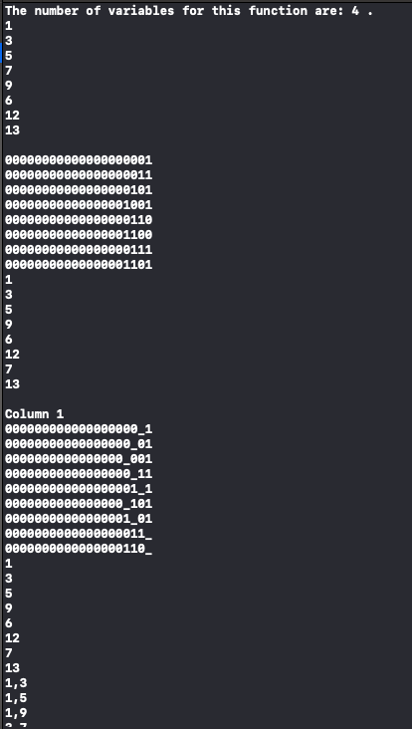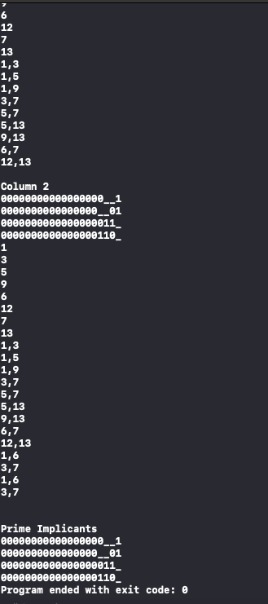

4

1, 2, 3, 5, 9, 12, 14, 15

4, 8, 11

