**Financial statement analysis of (Amazon and Walmart)**

**Abstract**

This study conducts a comprehensive financial performance analysis of Amazon and Walmart, two top non-financial companies in their sectors, using various financial analysis techniques. The annual reports of both companies for the past 10 years are downloaded from their respective websites, and data is summarized on a sheet. Common Size Analysis, Common Year Analysis, Combined Analysis, and Ratio Analysis are conducted to evaluate the financial performance of both companies. The results are presented in tables and figures, and benchmarking is performed to compare the performance of Amazon and Walmart. The implications of the findings are discussed in the discussion section, and the study concludes with a summary of the key findings.

**Keywords**: Amazon, Walmart, financial performance analysis, Common Size Analysis, Common Year Analysis, Combined Analysis, Ratio Analysis, benchmarking, Profitability Ratios, Cashflow analysis, , Liquidity Ratios, Debt Ratios , E-commerce, Cash Conversion Cycle, Net Trading Cycle, Operating Cash Flow Ratio, Profit Margin, Operating Income.

**Introduction:**

Amazon is a global E-commerce company headquartered in the United States, known for its focus on technology, artificial intelligence, digital streaming, and cloud computing. It was founded by Jeff Bezos and started as an online bookstore in 1997. However, it has since grown to become a leader in the online retail industry, with a market value estimated at $1.14 trillion (Klebnikov, 2020).

Walmart is a global E-commerce corporation based in the United States, known for its operation of grocery stores and hypermarkets with both physical and online presence. It was founded by Sam Walton in 1962. What sets Walmart apart from other retailers is its extensive physical presence, with over 11,496 locations in 27 countries, in addition to its online website accessibility. Walmart is also known for its competitive pricing, offering products at relatively low prices compared to other retailers (REIFF, 2020).

Amazon and Walmart are two of the largest and most influential companies in the retail industry, known for their global dominance and market share. Over the years, they have revolutionized the retail landscape and transformed the way consumers shop, setting new standards in the e-commerce and brick-and-mortar retail spaces. As major players in the highly competitive retail industry, the financial performance of Amazon and Walmart is of significant interest to investors, analysts, and stakeholders.

The purpose of this study is to conduct a comprehensive financial performance analysis of Amazon and Walmart, utilizing various financial analysis techniques, to gain insights into their financial health, strengths, and weaknesses. By analyzing their financial performance over the past 10 years, we aim to provide a comparative assessment of their financial performance and identify key trends and patterns.

The retail industry is dynamic and constantly evolving, with companies facing various challenges and opportunities. Changing consumer preferences, intense competition, technological disruptions, regulatory changes, and global economic fluctuations are some of the factors that can impact the financial performance of retail companies. Therefore, it becomes crucial to evaluate their financial performance using robust financial analysis techniques to understand their financial position, profitability, efficiency, liquidity, and solvency.

The financial analysis techniques used in this study include Common Size Analysis, Common Year Analysis, Combined Analysis, and Ratio Analysis. Common Size Analysis allows for the comparison of financial statement items as a percentage of a common base, providing insights into the composition of a company's financials. Common Year Analysis involves comparing financial statement items of a company for a particular year with the same item from a previous year, identifying year-over-year changes. Combined Analysis combines different financial analysis techniques to provide a comprehensive assessment of a company's financial performance. Ratio Analysis involves calculating various financial ratios that provide insights into a company's liquidity, profitability, efficiency, and solvency.

Previous studies on financial performance analysis have highlighted the importance of using multiple financial analysis techniques to obtain a holistic view of a company's financial performance. By combining these techniques, we can gain a comprehensive understanding of the financial health of Amazon and Walmart, and compare their performance over time. This study aims to contribute to the existing literature on financial performance analysis in the retail industry by providing a detailed analysis of the financial performance of Amazon and Walmart and identifying key trends and patterns in their financial data.

Financial analysis is a widespread practice in the corporate realm as it enables the assessment of a company's current financial health. This process helps identify factors that impact the success and productivity of the business (Leyes et al., 2020). By conducting financial ratio analysis, companies can evaluate their fund management and actual financial performance (Gulec & Beektas, 2019). This analysis also determines a firm's ability to obtain funding from stakeholders and investors, providing valuable insights into the company's financial standing.

The findings of this study are expected to provide valuable insights for investors, analysts, and stakeholders interested in the financial performance of Amazon and Walmart. The comparative analysis of their financial performance can help identify areas of strength and weakness, and provide benchmarking opportunities for these companies. Additionally, the results of this study may have implications for strategic decision-making, risk assessment, and performance evaluation for Amazon, Walmart, and other companies operating in the retail industry.

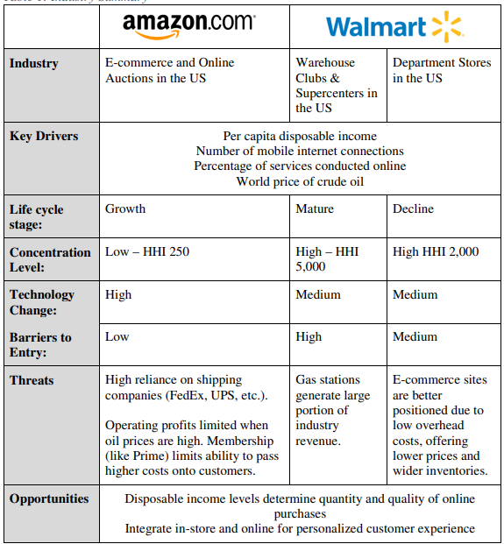

(Introduction about ratio analysis with some Literature review):

Financial ratios have been developed since the late 19th century, and they play a crucial role in evaluating the financial performance of companies, including giants like Amazon and Walmart. These ratios are essential for current and potential investors, creditors, and employees. Investors, who own shares in the companies, are exposed to risks and expect returns in the form of dividends and share price increases (Rashid, 2018). A company that is financially strong can generate higher returns for its investors, while a financially weak company may pose a risk to investors' investments (Almansoor et al., 2021).

Creditors, who supply products to companies on credit, also rely on financial ratios to assess a company's performance. They need assurance that the company can meet its liabilities using available resources when they become due (Alali et al., 2021). Additionally, employees are interested in the financial performance of their companies as it directly affects their livelihoods. By analyzing financial ratios derived from income statements, balance sheets, and cash flow statements, the health of a company can be determined, providing valuable insights to various stakeholders, including investors, creditors, and employees, in assessing the financial performance of companies like Amazon and Walmart.

Decisions, particularly those related to shareholders, are highly significant, and shareholders have a range of tools at their disposal to evaluate equity investments. One effective way to assess stock performance is through various metrics, including profitability ratios, liquidity ratios, debt ratios, price ratios, and efficiency ratios of the company. This approach can provide valuable insights into the financial health and performance of the company (Maverick, 2022).

**Literature review**

Although Walmart has been in existence for three decades longer than Amazon, these two companies are now major competitors targeting the same market. In recent years, Amazon has closed the gap on Walmart's market capitalization, achieving parity after 18 years, and doubling it two years later (Molla & Del Rey, 2017).

Amazon and Walmart are renowned companies with strong brand names and market positions. However, there are distinct differences between these two corporations. For instance, Amazon is renowned for its exceptional customer service, consistently ranking first in customer satisfaction. On the other hand, Walmart has focused on widespread availability, with a store located within 10 miles of almost every block in the US and other countries (Arishekar, 2020).

In response to the intense competition between these two companies, both have introduced additional services and features over the years, with plans for further expansion. Amazon launched Amazon Prime in 2005, a membership subscription that costs $12.99 per month and includes a 30-day free trial. Prime offers benefits such as free delivery, same-day delivery on a wide range of products, and access to Prime music, videos, and games, which are not available with Walmart+ (Rayome, 2020).

Amazon is the largest internet-based retailer in the United States. The company operates through three segments, namely North America, International, and Web Services. In the second quarter of 2015, Amazon reported $23 billion in sales, with North America accounting for 60%, International 32%, and Web Services 8%. Amazon offers over 300 million products across various categories and has multiple business models. The company's retail operation includes Amazon Retail, where it purchases and stores inventory in one of its 743 distribution centers in the US, Amazon Marketplace, which allows third-party sellers to list items on Amazon's website for a fee, and Amazon Web Services, a cloud-based service.

Amazon, being a pioneer in the e-commerce industry, has a complex system for providing services to customers worldwide. In this study conducted by Sameer Kumar, Jessica Eidem, and Diana Noriega delves into the technical workings of Amazon.com. The online platform provides an extensive range of products, including music, books, and electronics. Amazon has earned a reputation for being a reliable service provider due to its sophisticated operating system. The system classifies customers into three categories, which are as follows:

1. Regular Customers: This group includes customers who visit the website to make purchases. The system enables them to view product prices, sales, and expected delivery dates. Customers can also subscribe to Amazon Prime, which offers more frequent discounts and free two-day shipping.
2. Seller Customers: This option enables users to sell their products on the Amazon website. Amazon offers a distribution service to sellers and charges them a fixed fee for their products.
3. Developer Customers: This category is for users who are actively creating and developing products. Amazon provides a platform for these users through its technology infrastructure and application software. (Amazon, 2008; Kumar, Eidem, & Noriega, 2012). Overall, Amazon's technicality and diverse services have contributed to its success in the e-commerce industry.

Walmart has three operating segments, which are Sam's Club, Walmart US, and International. In the second quarter of 2015, Walmart had sales of $119 billion, with Walmart US contributing 62%, International 26%, and Sam's Club 12%. Walmart generates most of its sales through its 11,526 physical stores located worldwide. While Walmart also operates its website Walmart.com, less than 3% of its sales come from online sources. Walmart is now transitioning from a traditional brick-and-mortar retail store to an omni-channel model, which includes online sales, to compete in the digital space.

Walmart is affiliated with 26 investment companies and has 14 lead investors. Recently, on July 12, 2021, Flipkart, Walmart's e-commerce division, announced that it has secured $3.6 billion in new funding, with an estimated value of $37.6 billion. Flipkart is the biggest e-commerce company in India, boasting 350 million users, and has experienced the fastest growth in the global e-commerce market in 2021. It is expected to expand into the US market soon. Interestingly, this is not SoftBank's first investment in Flipkart. In fact, in August 2017, SoftBank invested $2.5 billion in Flipkart through its Vision Fund, and as a result, became the company's largest shareholder with almost 20% stake. Walmart later purchased 77% of Flipkart for $16 billion in May 2018, and SoftBank earned roughly $4 billion in profits.

The financial statements contain various elements that are recorded for analysis purposes, including cash flows, balance sheets, profit and loss statements, and capital changes. These recordings provide valuable information to company managers, especially those involved in developing or changing financial policies (Fatihudin & Jusni, 2018). Financial analysis is a process that aims to determine the operational and financial characteristics of an organization, with a focus on efficiency and effectiveness. Profitability and liquidity are common metrics used in this analysis (Bhunia & Mukhuti, 2011).

Different organizations have different financial performance indicators, such as banks, which need to ensure financial stability and growth. Ratio analysis is a recommended technique to accurately measure the financial performance of banks, including indicators such as profitability and dividend payout ability (Puspitaningtyas, 2019). Trust has been identified as a core element for investors in assessing the financial performance of banks, as it indicates if the banks are capable of sustainable and optimal performance (Puspitaningtyas, 2019).

Financial ratios are commonly used by managers, shareholders, and investors to assess the financial stability and condition of organizations, but they are not limited to these parties. Customers, suppliers, competitors, and individuals in academia also utilize financial ratios. Ratio analysis can reveal the strengths and weaknesses of a company (Mheiri, et al., 2021).

**Data and methodology**

The data utilized for the analysis was collected from the comprehensive financial statements of two industry giants, Amazon and Walmart, spanning the period from 2013 to 2022. These financial statements provided a wealth of information, which was meticulously compiled into a structured table, capturing the essential financial ratios required for a comprehensive analysis of the companies' performance. The figures in the table were denominated in thousands of dollars, ensuring precision and consistency in the analysis.

The Data sources where collected from :

1) Amazon : <https://ir.aboutamazon.com/annual-reports-proxies-and-shareholder-letters/default.aspx>

2) Walmart :<https://stock.walmart.com/financials/annual-reports/default.aspx>

The collected data served as the foundation for calculating a wide array of financial ratios, including profitability, liquidity, solvency, efficiency, and more, providing a comprehensive picture of the financial health and performance of Amazon and Walmart over the ten-year period. The meticulous analysis of the financial ratios shed light on various aspects of the companies' financial performance, highlighting strengths, weaknesses, trends, and potential areas of improvement.

**Table 1a: Financial Data (Amazon)**

|  |  |  |  |  |  |  |  |  |  |  |
| --- | --- | --- | --- | --- | --- | --- | --- | --- | --- | --- |
| Item/Year | 2022 | 2021 | 2020 | 2019 | 2018 | 2017 | 2016 | 2015 | 2014 | 2013 |
| Current Assets | 146,791 | 161,580 | 132,733 | 96,334 | 75,101 | 60,197 | 45,781 | 35,705 | 31,327 | 24,625 |
| Current Liabilities | 155,393 | 142,266 | 126,385 | 87,812 | 68,391 | 57,883 | 43,816 | 33,887 | 28,089 | 22,980 |
| Inventories | 34,405 | 32,640 | 23,795 | 20,497 | 17,174 | 16,047 | 11,461 | 10,243 | 8,299 | 7,411 |
| Cash | 53,888 | 36,220 | 42,122 | 36,092 | 31,750 | 20,522 | 19,334 | 15,890 | 14,557 | 8,658 |
| Receivables | 42,360 | 32,891 | 20,816 | 24,542 | 16,677 | 13,164 | 8,339 | 5,654 | 5,612 | 4,767 |
| Total Assets | 462,675 | 420,549 | 321,195 | 225,248 | 162,648 | 131,310 | 83,402 | 64,747 | 54,505 | 40,159 |
| Payables | 79,600 | 78,664 | 72,539 | 47,183 | 38,192 | 34,616 | 25,309 | 20,397 | 16,459 | 15,133 |
| Long Term Debt | 67,150 | 48,744 | 31,816 | 23,414 | 68,391 | 57,883 | 7,694 | 8,227 | 8,265 | 3,191 |
| Total Liabilities | 282,304 | 316,632 | 227,791 | 163,188 | 119099 | 103,601 | 64,117 | 51,363 | 43764 | 30413 |
| Total Equity | 138,245 | 146,043 | 93,404 | 62,060 | 43,549 | 27,709 | 19,285 | 13,384 | 10,741 | 9,746 |
| Sales | 513,983 | 469,822 | 386,064 | 280,522 | 232,887 | 177,866 | 135,987 | 107,006 | 88,988 | 74,452 |
| Cost of Goods Sold | 288,831 | 272,344 | 233,307 | 165,536 | 232,887 | 111,934 | 88,265 | 71,651 | 62,752 | 54,181 |
| EBIT | 12,248 | 24,879 | 22,899 | 265,981 | 220,466 | 173,760 | 131,801 | 104,773 | 88,810 | 73,707 |
| Interest income (loss) | 989-  (2,367) | 448-  (1,809) | 555 -  (1,647) | 832-(1,600) | 440 – (1,417) | 202-  (848) | 100-  (484) | 50-  (459) | 39 -  (210) | 38 -  (141) |
| Net Income (loss) | (2,722) | 33,364 | 21,331 | 11,588 | 10,073 | 3,033 | 2,371 | 596 | (241) | 274 |
| Operating Cash Flow | 46,752 | 46,327 | 66,064 | 38,514 | 30,723 | 18,365 | 16,443 | 11,920 | 6,842 | 5,475 |

All numbers in thousands, Source: Annual Reports (**Amazon**)

**Table 1b: Financial Data (Walmart)**

|  |  |  |  |  |  |  |  |  |  |  |
| --- | --- | --- | --- | --- | --- | --- | --- | --- | --- | --- |
| Item/Year | 2022 | 2021 | 2020 | 2019 | 2018 | 2017 | 2016 | 2015 | 2014 | 2013 |
| Current Assets | 81,070 | 90,067 | 61,806 | 61,897 | 59,664 | 57,689 | 60,239 | 63,278 | 61,185 | 59,940 |
| Current Liabilities | 87,379 | 92,645 | 77,790 | 77,477 | 78,521 | 66,928 | 64,619 | 65,253 | 69,345 | 71,818 |
| Inventories | 56,511 | 44,949 | 44,435 | 44,269 | 43,783 | 43,046 | 44,469 | 45,141 | 44,858 | 43,803 |
| Cash | 14,760 | 17,741 | 9,465 | 7,722 | 6,756 | 6,867 | 8,705 | 9,135 | 7,281 | 7,781 |
| Receivables | 8,280 | 6,516 | 6,284 | 6,283 | 5,614 | 5,835 | 5,624 | 6,778 | 6,677 | 6,768 |
| Total Assets | 244,860 | 252,496 | 236,495 | 219,295 | 204,522 | 198,825 | 199,581 | 203,490 | 204,751 | 203,105 |
| Payables | 55,261 | 49,141 | 46,973 | 47,060 | 46,092 | 41,433 | 38,487 | 38,410 | 37,415 | 38,080 |
| Long Term Debt | 2,803 | 3,115 | 43,714 | 43,714 | 3,738 | 2,256 | 2,745 | 4,791 | 41,771 | 38,394 |
| Total Liabilities | 152,969 | 164,965 | 154,943 | 139661 | 123700 | 123700 | 115970 | 117553 | 123412 | 121367 |
| Total Equity | 91,891 | 87,531 | 81,552 | 79,634 | 80,822 | 80,535 | 83,611 | 85,937 | 81,339 | 81,738 |
| Sales | 572,754 | 559,151 | 523,964 | 514,405 | 500,343 | 485,873 | 482,130 | 485,651 | 476,294 | 468,651 |
| Cost of Goods Sold | 429,000 | 420,315 | 394,605 | 385,301 | 373,396 | 361,256 | 360,984 | 365,086 | 358,069 | 352,297 |
| EBIT | 24,181 | 36,074 | 25,255 | 21,957 | 20,437 | 22,764 | 24,105 | 27,147 | 26,872 | 27,725 |
| Interest | 1,836 | 2,194 | 2,410 | 2,129 | 2,178 | 2,267 | 2,467 | 2,348 | 2,216 | 2,063 |
| Net Income | 13,940 | 13,706 | 15,201 | 7,179 | 10,523 | 14,293 | 15,080 | 17,099 | 16,695 | 17,756 |
| Operating Cash Flow | 24,181 | 36,074 | 25,255 | 27,753 | 28,337 | 31,673 | 27,552 | 28,564 | 23,257 | 25,591 |

All numbers in thousands, Source: Annual Reports (**Walmart**)

**Describe the methodology and ratios formulas**

There are several ratios used in financial analysis, each of which provides insight into different aspects of a company's financial health

**Profitability Ratios:**

* **Gross Profit Margin** = (Gross Profit / Net Sales) * 100: This ratio measures the percentage of sales revenue that remains after deducting the cost of goods sold, and indicates the company's ability to generate profits from its core operations.
* **Operating Margin Ratio** = (Operating Income / Net Sales) * 100: This ratio measures the percentage of operating income relative to net sales, and reflects the company's profitability from its core operations before considering non-operating expenses and taxes.
* **Net Profit Margin** = (Net Income / Net Sales) * 100: This ratio measures the percentage of net income relative to sales revenue, and reflects the company's overall profitability after considering all expenses and taxes.
* **Return on Assets (ROA)** = (Net Income / Average Total Assets) * 100: This ratio measures the company's ability to generate profits from its total assets, and indicates how efficiently the company is utilizing its assets to generate profits.
* **Return on Equity (ROE)** = (Net Income / Average Shareholders' Equity) * 100: This ratio measures the company's ability to generate profits from the shareholders' equity, and indicates the return earned by shareholders on their investment in the company.
* **Return on Investment (ROI)** = (Net Profit / Average Total Assets) * 100: This ratio measures the company's ability to generate profits from its total assets, and indicates the return earned on the company's investment in its assets.

**Static Liquidity Ratios:**

* These liquidity ratios can help assess a company's ability to meet its short-term obligations and manage its liquidity position. However, it's important to interpret these ratios in the context of the specific industry and company's financial situation, and consider other factors along with financial ratios for a comprehensive analysis.
* **Cash Ratio**: The cash ratio measures a company's ability to cover its short-term obligations using only its cash and cash equivalents. It is calculated by dividing the total cash and cash equivalents by the total current liabilities. The formula for the cash ratio is:(Ernayani and Sari, 2017)

Cash Ratio = ((Cash + Cash Equivalents) / Current Liabilities )* 100

A higher cash ratio indicates a higher level of liquidity, as the company has a larger proportion of cash and cash equivalents to cover its short-term obligations.

* **Current Ratio**: The current ratio is a widely used liquidity ratio that measures a company's ability to meet its short-term obligations using its current assets. It is calculated by dividing the total current assets by the total current liabilities. The formula for the current ratio is:

Current Ratio = (Current Assets / Current Liabilities) * 100

A current ratio of 1 or higher is generally considered acceptable, as it indicates that a company has sufficient current assets to cover its current liabilities. A higher current ratio may indicate a higher level of liquidity and lower risk of default.

* **Quick Ratio**: The quick ratio, also known as the acid-test ratio, is a more stringent measure of liquidity that excludes inventory from current assets. It is calculated by subtracting inventory from current assets and then dividing the result by current liabilities. The formula for the quick ratio is:(Wijaya and Sedana, 2020)

Quick Ratio = ( (Current Assets - Inventory) / Current Liabilities) *100

The quick ratio provides a more conservative measure of a company's liquidity, as it excludes inventory which may not be as easily converted to cash in the short-term. A quick ratio of 1 or higher is generally considered acceptable, as it indicates that a company has sufficient liquid assets (cash, cash equivalents, and accounts receivable) to cover its current liabilities.

**Dynamic Liquidity Ratios:**

can provide insights into the financial health and operational effectiveness of the business.

Note : We will consider Number of Days =365 days

* **Inventory Cycle**: Also known as Inventory Turnover Ratio or Inventory Days, this ratio measures how efficiently a company manages its inventory. It is calculated as follows:(Farooq, 2019)

Inventory Cycle = Cost of Goods Sold (COGS) / Inventory

A lower Inventory Cycle indicates that inventory is sold quickly, which may suggest efficient inventory management.

* **Receivable Cycle**: Also known as Days Sales Outstanding (DSO), this ratio measures the average number of days it takes for a company to collect payments from its customers after a sale has been made. It is calculated as follows:(Amanda, 2019)

Receivable Cycle = Accounts Receivable / (Sales / Number of Days)

A lower Receivable Cycle indicates that the company collects payments from customers more quickly, which may suggest efficient credit management.

* **Payable Cycle**: Also known as Days Payable Outstanding (DPO), this ratio measures the average number of days it takes for a company to pay its suppliers after receiving goods or services. It is calculated as follows:

Payable Cycle = Accounts Payable / (COGS / Number of Days)

A higher Payable Cycle indicates that the company takes longer to pay its suppliers, which may suggest favorable payment terms or negotiation power with suppliers.

* **Operating Cycle**: This ratio measures the average number of days it takes for a company to convert its inventory into cash. It is calculated as the sum of the Inventory Cycle and the Receivable Cycle:

Operating Cycle = Inventory Cycle + Receivable Cycle

A lower Operating Cycle indicates that the company is able to convert inventory into cash more quickly, which may suggest efficient operations.

* **Cash Conversion Cycle**: This ratio measures the average number of days it takes for a company to convert its inventory and receivables into cash, while also considering the time it takes to pay its suppliers. It is calculated as follows:

Cash Conversion Cycle = Operating Cycle - Payable Cycle

A lower Cash Conversion Cycle indicates that the company is able to convert inventory and receivables into cash quickly and delay payments to suppliers, which may suggest efficient cash management.

* **Net Trade Cycle**: This ratio measures the average number of days it takes for a company to convert its net trade receivables and payables into cash. It is calculated as follows:

Net Trade Cycle = (Accounts Receivable - Accounts Payable) / (Sales / Number of Days)

A lower Net Trade Cycle indicates that the company is able to collect payments from customers and pay suppliers more quickly, which may suggest efficient management of receivables and payables.

**Debt Ratios**

* **Cash Coverage Ratio**: This ratio is used to measure a company's ability to cover its interest payments with its operating cash flows. It is calculated as follows:

Cash Coverage Ratio = (Operating Cash Flows / Total Interest Payments)* 100

A higher cash coverage ratio indicates that a company has a stronger ability to meet its interest obligations using its operating cash flows.

* **Times Interest Earned Ratio**: This ratio measures a company's ability to meet its interest payments with its earnings before interest and taxes (EBIT). It is calculated as follows:

Times Interest Earned Ratio = (EBIT / Total Interest Payments)* 100

A higher times interest earned ratio indicates that a company has a stronger ability to meet its interest obligations using its earnings.

* **Debt Ratio**: The Debt Ratio, also known as the Total Debt to Total Assets Ratio, measures the proportion of a company's total assets that are financed by debt. It indicates the percentage of a company's assets that are funded by debt, as opposed to equity. A higher Debt Ratio indicates a higher proportion of debt in the company's capital structure, which may pose higher financial risk.

Debt Ratio = (Total Debt / Total Assets) * 100

* **Debt to Equity Ratio**: The Debt to Equity Ratio measures the proportion of a company's total debt to its total equity. It indicates the relative contribution of debt and equity in financing a company's assets. A higher Debt to Equity Ratio indicates a higher level of debt relative to equity, which may indicate higher financial leverage and risk.

Debt to Equity Ratio = (Total Debt / Total Equity)* 100

* **Long-Term Debt to Total Assets Ratio**: The Long-Term Debt to Total Assets Ratio measures the proportion of a company's long-term debt to its total assets. It indicates the extent to which a company's long-term debt is used to finance its assets. A higher Long-Term Debt to Total Assets Ratio may indicate higher financial risk due to a larger proportion of long-term debt in the company's capital structure.

Long-Term Debt to Total Assets Ratio =( Long-Term Debt / Total Assets)* 100

* **Long-Term Debt to Total Equity Ratio**: The Long-Term Debt to Total Equity Ratio measures the proportion of a company's long-term debt to its total equity. It indicates the relative contribution of long-term debt to a company's equity. A higher Long-Term Debt to Total Equity Ratio may indicate higher financial risk due to a larger proportion of long-term debt relative to equity.

Long-Term Debt to Total Equity Ratio = (Long-Term Debt / Total Equity)* 100

**Results and Discussion**

**Table 2a.1: Common size of (Amazon)**

|  |  |  |  |  |  |  |  |  |  |  |
| --- | --- | --- | --- | --- | --- | --- | --- | --- | --- | --- |
| Percentage/Year | 2022 | 2021 | 2020 | 2019 | 2018 | 2017 | 2016 | 2015 | 2014 | 2013 |
| Sales | 100% | 100% | 100% | 100% | 100% | 100% | 100% | 100% | 100% | 100% |
| Cost of Goods Sold | 56% | 58% | 60% | 59% | 100% | 63% | 65% | 67% | 71% | 73% |
| EBIT | 2% | 5% | 6% | 95% | 95% | 98% | 97% | 98% | 100% | 99% |
| Interest income (loss) | 0% | 0% | 0% | 0% | 0% | 0% | 0% | 0% | 0% | 0% |
| Net Income (loss) | -1% | 7% | 6% | 4% | 4% | 2% | 2% | 1% | 0% | 0% |

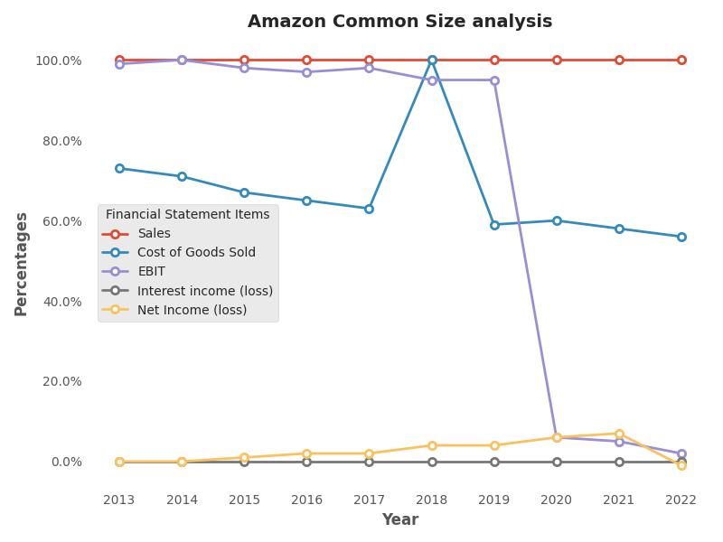

* **Cost of Goods Sold (COGS)**: COGS as a percentage of sales has shown some fluctuations over the years, ranging from 56% in 2022 to 73% in 2013. There is a declining trend in COGS as a percentage of sales, indicating that Amazon has been able to manage its cost of goods sold effectively over the years.
* **Earnings Before Interest and Taxes (EBIT)**: EBIT as a percentage of sales has varied significantly, from 2% in 2022 to 98% in 2015 and 2016. There seems to be a declining trend in EBIT as a percentage of sales in recent years, indicating that Amazon's operating profitability has decreased.
* **Interest Income (Loss)**: Interest income (loss) as a percentage of sales has consistently remained at 0% for all years, indicating that Amazon has not generated any significant interest income or incurred any interest losses during the period.
* **Net Income (Loss)**: Net income (loss) as a percentage of sales has shown some fluctuations over the years, ranging from -1% in 2022 to 7% in 2021. There seems to be a declining trend in net income as a percentage of sales in recent years, indicating that Amazon's overall profitability has decreased.

**Table 2a.1: Common year of (Amazon)**

|  |  |  |  |  |  |  |  |  |  |  |
| --- | --- | --- | --- | --- | --- | --- | --- | --- | --- | --- |
| Percentage/Year | 2022 | 2021 | 2020 | 2019 | 2018 | 2017 | 2016 | 2015 | 2014 | 2013 |
| Sales | 690% | 631% | 519% | 377% | 313% | 239% | 183% | 144% | 120% | 100% |
| Cost of Goods Sold | 533% | 503% | 431% | 306% | 430% | 207% | 163% | 132% | 116% | 100% |
| EBIT | 17% | 34% | 31% | 361% | 299% | 236% | 179% | 142% | 120% | 100% |
| Interest income (loss) | 1347% | 1321% | 1060% | 746% | 968% | 627% | 373% | 397% | 166% | 100% |
| Net Income (loss) | -993% | 12177% | 7785% | 4229% | 3676% | 1107% | 865% | 218% | -88% | 100% |

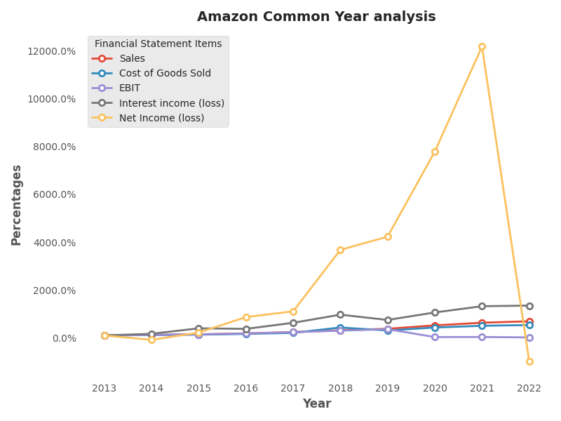

* Amazon's COGS has also increased over the years, though at a slightly slower pace compared to sales. The percentage increase in COGS ranges from 100.00% in 2013 to 533% in 2022. This indicates that while the company has been able to grow its sales, it has also incurred higher costs of goods sold to support that growth.
* Amazon's EBIT shows some variation over the years. The percentage increase in EBIT ranges from 120% in 2013 to 361% in 2019, indicating fluctuating profitability. However, in 2020 and 2021, the company experienced a decline in EBIT, with percentages of 31% and 34% respectively. It's worth noting that in 2019, the company's EBIT showed an exceptionally high percentage increase, which may have skewed the overall trend.
* Amazon's interest income (loss) has shown significant variation over the years, with the percentage increase ranging from 166% in 2013 to 1347% in 2022. This indicates that the company's interest income (loss) has been subject to fluctuations, with some years showing substantial growth and others showing decline.
* Amazon's net income (loss) has also shown significant variation over the years, with the percentage increase ranging from -88% in 2013 to 12177% in 2021. It's important to note that in 2021, the company reported an exceptionally high percentage increase in net income, which may have been influenced by various factors, including accounting adjustments and one-time events.

**Table 2b.1: Common size of (Walmart)**

|  |  |  |  |  |  |  |  |  |  |  |
| --- | --- | --- | --- | --- | --- | --- | --- | --- | --- | --- |
| Percentage/Year | 2022 | 2021 | 2020 | 2019 | 2018 | 2017 | 2016 | 2015 | 2014 | 2013 |
| Sales | 100% | 100% | 100% | 100% | 100% | 100% | 100% | 100% | 100% | 100% |
| Cost of Goods Sold | 75% | 75% | 75% | 75% | 75% | 74% | 75% | 75% | 75% | 75% |
| EBIT | 4% | 6% | 5% | 4% | 4% | 5% | 5% | 6% | 6% | 6% |
| Interest income (loss) | 0% | 0% | 0% | 0% | 0% | 0% | 1% | 0% | 0% | 0% |
| Net Income (loss) | 2% | 2% | 3% | 1% | 2% | 3% | 3% | 4% | 4% | 4% |

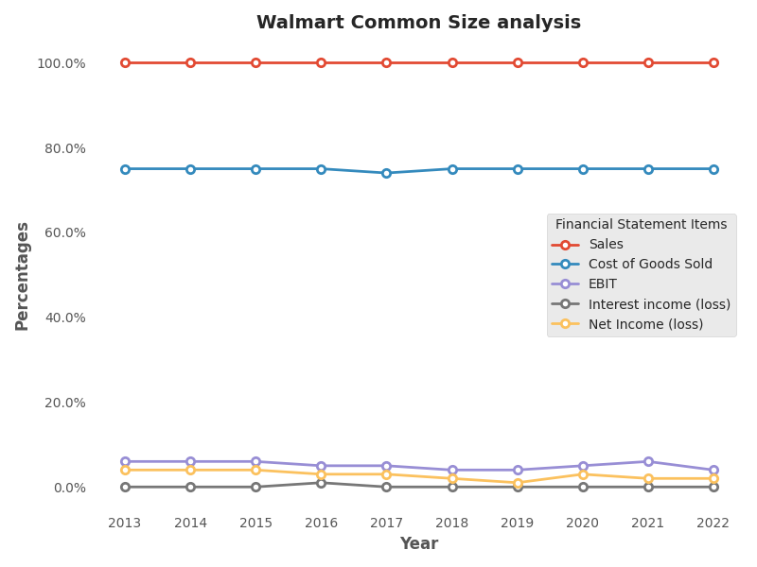

* Walmart's cost of goods sold is at 75% for most years, indicating that the company has been able to maintain a consistent cost structure. The cost of goods sold is a significant expense for retailers like Walmart, and it is essential to keep it in check to maintain profitability.
* Walmart's EBIT has been between 4% to 6% over the years. This indicates that the company has been able to maintain a consistent level of profitability from its operations.
* Walmart's interest income (loss) has been at 0% for most years, indicating that the company has not earned any significant interest income from its investments or has not incurred any significant interest expenses.
* Walmart's net income has remained relatively stable, ranging from 1% to 4% over the years. This indicates that the company has been able to maintain profitability despite the competitive retail environment.

**Table 2b.2: Common year of (Walmart)**

|  |  |  |  |  |  |  |  |  |  |  |
| --- | --- | --- | --- | --- | --- | --- | --- | --- | --- | --- |
| Percentage/Year | 2022 | 2021 | 2020 | 2019 | 2018 | 2017 | 2016 | 2015 | 2014 | 2013 |
| Sales | 122% | 119% | 112% | 110% | 107% | 104% | 103% | 104% | 102% | 100% |
| Cost of Goods Sold | 122% | 119% | 112% | 109% | 106% | 103% | 102% | 104% | 102% | 100% |
| EBIT | 87% | 130% | 91% | 79% | 74% | 82% | 87% | 98% | 97% | 100% |
| Interest income (loss) | 89% | 106% | 117% | 103% | 106% | 110% | 120% | 114% | 107% | 100% |
| Net Income (loss) | 79% | 77% | 86% | 40% | 59% | 80% | 85% | 96% | 94% | 100% |

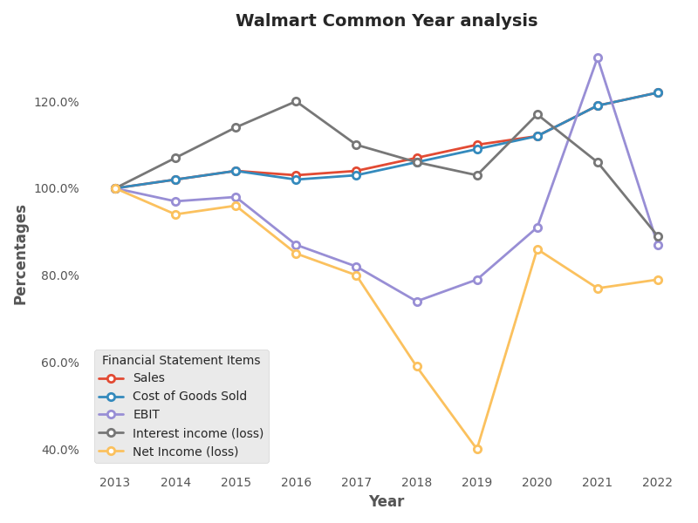

* Walmart's COGS has also increased at a similar rate to its sales, indicating that the company is able to maintain its profit margins. However, if the COGS grows faster than sales, it could indicate potential issues with cost management.
* Walmart's EBIT has been volatile over the years, with a high of 130% in 2021 and a low of 74% in 2018. This could be due to various factors such as changes in competition, pricing strategy, and cost management.
* Walmart's interest income has been fluctuating over the years, with a high of 120% in 2016 and a low of 89% in 2022. This could be due to changes in interest rates and the company's investment strategy.
* Walmart's net income has also been volatile over the years, with a high of 96% in 2015 and a low of 40% in 2019. This could be due to various factors such as changes in competition, pricing strategy, and cost management.

**Table 3a: Static Liquidity Ratios of (Amazon)**

|  |  |  |  |  |  |  |  |  |  |  |
| --- | --- | --- | --- | --- | --- | --- | --- | --- | --- | --- |
| Percentages/Year | 2022 | 2021 | 2020 | 2019 | 2018 | 2017 | 2016 | 2015 | 2014 | 2013 |
| Current Ratio | 94% | 114% | 105% | 110% | 110% | 104% | 104% | 105% | 112% | 107% |
| Quick Ratio | 72% | 91% | 86% | 86% | 85% | 76% | 78% | 75% | 82% | 75% |
| Cash Ratio | 35% | 25% | 33% | 41% | 46% | 35% | 44% | 47% | 52% | 38% |

**Figure 1: Current Ratio of Amazon**

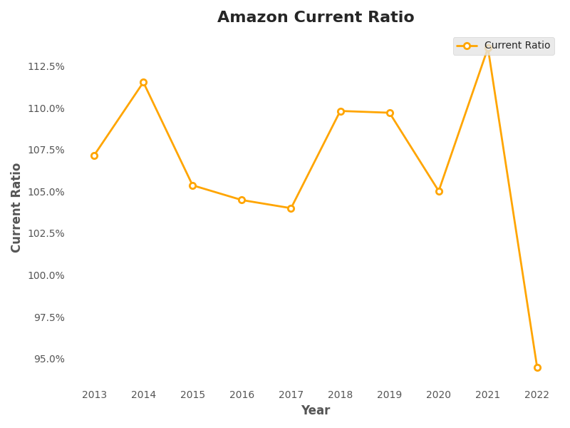

* Amazon's current ratio has fluctuated over the past 10 years, ranging from 94% in 2022 to 107% in 2013. This ratio shows that Amazon has had sufficient current assets to cover its short-term liabilities during this period.

**Figure 2: Cash Ratio of Amazon**

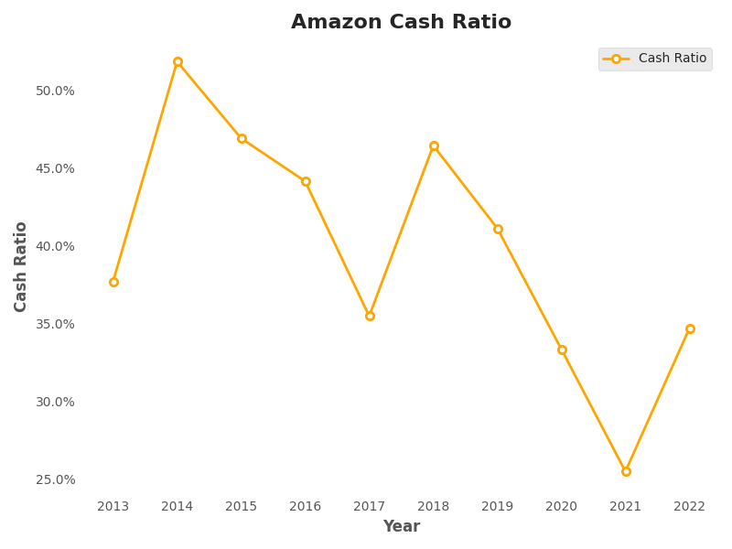

* Amazon's cash ratio has ranged from 25% in 2021 to 52% in 2014. This ratio shows that Amazon has had enough cash on hand to pay off a significant portion of its current liabilities during this period.

**Figure 3: Quick Ratio of Amazon**

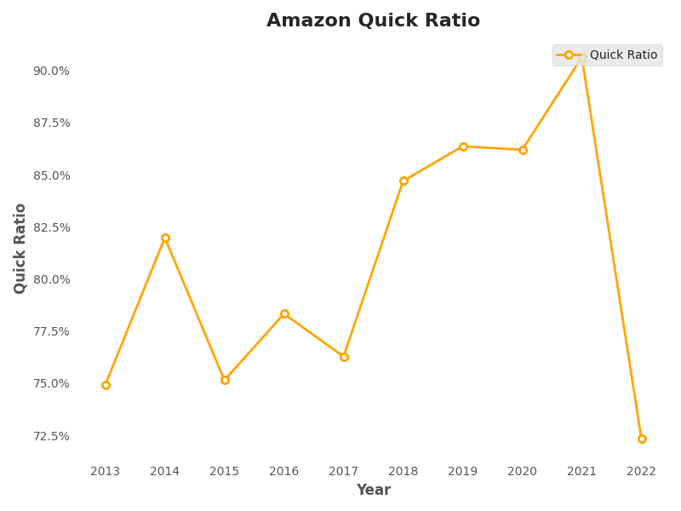

* Amazon's quick ratio has ranged from 72% in 2022 to 91% in 2021. This indicates that Amazon may have had some difficulty meeting its short-term obligations in 2022, but was better positioned in 2021.

**Table 3b: Static Liquidity Ratios of (Walmart)**

|  |  |  |  |  |  |  |  |  |  |  |
| --- | --- | --- | --- | --- | --- | --- | --- | --- | --- | --- |
| Percentages/Year | 2022 | 2021 | 2020 | 2019 | 2018 | 2017 | 2016 | 2015 | 2014 | 2013 |
| Current Ratio | 93% | 97% | 79% | 80% | 76% | 86% | 93% | 97% | 88% | 83% |
| Quick Ratio | 28% | 49% | 22% | 23% | 20% | 22% | 24% | 28% | 24% | 22% |
| Cash Ratio | 17% | 19% | 12% | 10% | 9% | 10% | 13% | 14% | 10% | 11% |

**Figure 1: Current Ratio of Walmart**

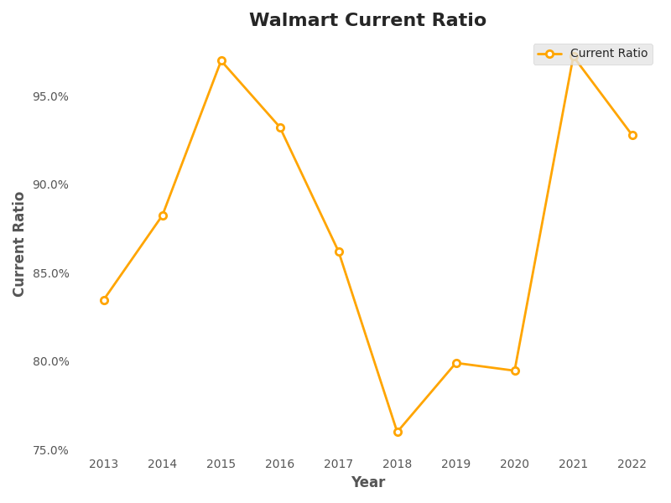

* Walmart's current ratio has decreased from 97% in 2021 to 93% in 2022, which indicates a slight decrease in the company's ability to pay its short-term liabilities. However, it is still above the industry average of 1.5, which is a positive sign. This may be due to an increase in Walmart's short-term debt, which has not been offset by an increase in current assets.

**Figure 2: Cash Ratio of Amazon**

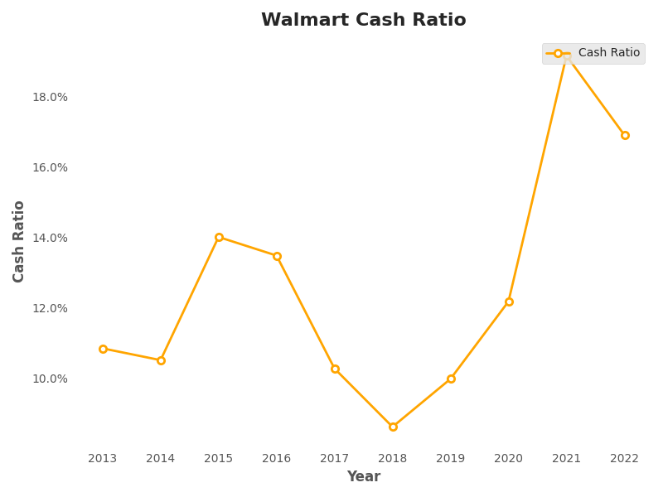

* Walmart’s cash ratio has also decreased from 19% in 2021 to 17% in 2022. This indicates a decrease in the company's ability to pay its short-term obligations with its most liquid asset, i.e., cash. However, it is still above the industry average of 0.3, which is a positive sign. The decrease in the cash ratio may be due to an increase in short-term debt and a decrease in cash and cash equivalents.

**Figure 3: Quick Ratio of Walmart**

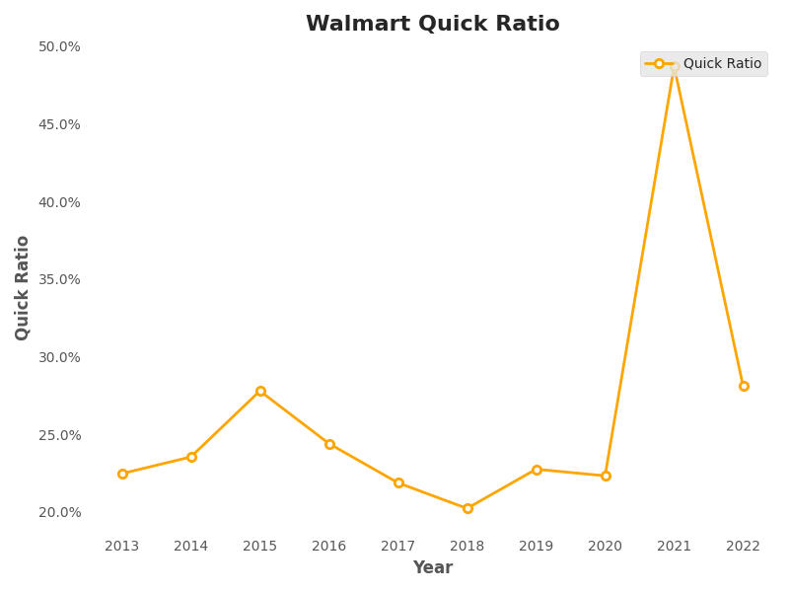

* Walmart’s quick ratio of has decreased from 49% in 2021 to 28% in 2022. This indicates a decrease in the company's ability to meet its short-term obligations with its most liquid assets. It is also below the industry average of 1.0, which is a negative sign. The decrease in the quick ratio may be due to a decrease in inventory turnover, which has led to an increase in the inventory levels and a decrease in the cash on hand.

**Table 4a: Dynamic Liquidity Ratios of (Amazon)**

|  |  |  |  |  |  |  |  |  |  |  |
| --- | --- | --- | --- | --- | --- | --- | --- | --- | --- | --- |
| Ratio/Year | 2022 | 2021 | 2020 | 2019 | 2018 | 2017 | 2016 | 2015 | 2014 | 2013 |
| Net Trade Cycle | -26.45 | -35.56 | -48.9 | -29.46 | -33.72 | -44.02 | -45.55 | -50.29 | -44.49 | -50.82 |
| Asset Cycle | 0.9 | 0.9 | 0.83 | 0.8 | 0.7 | 0.74 | 0.61 | 0.61 | 0.61 | 0.54 |
| Inventory Cycle | 0.12 | 0.12 | 0.1 | 0.12 | 0.07 | 0.14 | 0.13 | 0.14 | 0.13 | 0.14 |
| Days Sales of Inventory Cycle | 43.48 | 43.74 | 37.23 | 45.2 | 26.92 | 52.33 | 47.39 | 52.18 | 48.27 | 49.93 |
| Receivables Cycle | 0.08 | 0.07 | 0.05 | 0.09 | 0.07 | 0.07 | 0.06 | 0.05 | 0.06 | 0.06 |
| Days Sales Outstanding Cycle | 30.08 | 25.55 | 19.68 | 31.93 | 26.14 | 27.01 | 22.38 | 19.29 | 23.02 | 23.37 |
| Operating Cycle | 0.2 | 0.19 | 0.16 | 0.21 | 0.15 | 0.22 | 0.19 | 0.2 | 0.2 | 0.2 |
| Payables Cycle | 0.28 | 0.29 | 0.31 | 0.29 | 0.16 | 0.31 | 0.29 | 0.28 | 0.26 | 0.28 |
| Days Payable Outstanding Cycle | 100.59 | 105.43 | 113.48 | 104.04 | 59.86 | 112.88 | 104.66 | 103.91 | 95.73 | 101.95 |
| Cash Conversion Cycle | -27.03 | -36.13 | -56.58 | -26.91 | -6.8 | -33.54 | -34.88 | -32.44 | -24.44 | -28.65 |

* Amazon's negative net trade cycle indicates that Amazon is able to sell its inventory and collect payments from its customers faster than it pays its suppliers. In 2022, Amazon's net trade cycle improved to -26.45 days, compared to -35.56 days in the previous year. This suggests that Amazon is becoming more efficient in managing its working capital, which could result in increased cash flows.
* Amazon's asset cycle has remained relatively stable over the past ten years, ranging between 0.54 to 0.9. This suggests that Amazon is effectively managing its assets to generate cash flows.
* Amazon's inventory cycle has remained stable over the years, ranging between 0.07 to 0.14. This indicates that Amazon is able to sell its inventory at a consistent pace.
* Amazon's days sales of inventory cycle has varied over the years, ranging between 26.92 to 52.33 days. This ratio can be influenced by changes in customer demand or fluctuations in sales. A higher days sales of inventory cycle could indicate slower sales or excess inventory.
* Amazon's receivables cycle has remained relatively stable over the years, ranging between 0.05 to 0.09. This suggests that Amazon is effective in managing its accounts receivable.
* Amazon's days sales outstanding cycle has varied over the years, ranging between 19.29 to 31.93 days. This ratio can be influenced by changes in customer payment behavior or the effectiveness of a company's credit policies.
* Amazon's operating cycle has remained relatively stable over the years, ranging between 0.15 to 0.22. This suggests that Amazon is effectively managing its working capital to generate cash flows.
* Amazon's payables cycle has remained relatively stable over the years, ranging between 0.26 to 0.31. This suggests that Amazon is effectively managing its payables to optimize cash flows.
* Amazon's days payable outstanding cycle has varied over the years, ranging between 59.86 to 113.48 days. This ratio can be influenced by changes in payment terms negotiated with suppliers or the availability of cash.
* Amazon's cash conversion cycle has improved over the years, indicating that the company is effectively managing its working capital. A negative cash conversion cycle indicates that the company is able to collect cash from customers before paying its suppliers, which is a positive sign for the company's financial health.

**Table 4b: Dynamic Liquidity Ratios of (Walmart)**

|  |  |  |  |  |  |  |  |  |  |  |
| --- | --- | --- | --- | --- | --- | --- | --- | --- | --- | --- |
| Ratio/Year | 2022 | 2021 | 2020 | 2019 | 2018 | 2017 | 2016 | 2015 | 2014 | 2013 |
| Net Trade Cycle | -29.94 | -27.82 | -28.34 | -28.93 | -29.53 | -26.74 | -24.88 | -23.77 | -23.56 | -24.39 |
| Asset Cycle | 0.43 | 0.45 | 0.45 | 0.43 | 0.41 | 0.41 | 0.41 | 0.42 | 0.43 | 0.43 |
| Inventory Cycle | 0.13 | 0.11 | 0.11 | 0.11 | 0.12 | 0.12 | 0.12 | 0.12 | 0.13 | 0.12 |
| Days Sales of Inventory Cycle | 48.08 | 39.03 | 41.1 | 41.94 | 42.8 | 43.49 | 44.96 | 45.13 | 45.73 | 45.38 |
| Receivables Cycle | 0.01 | 0.01 | 0.01 | 0.01 | 0.01 | 0.01 | 0.01 | 0.01 | 0.01 | 0.01 |
| Days Sales Outstanding Cycle | 5.28 | 4.25 | 4.38 | 4.46 | 4.1 | 4.38 | 4.26 | 5.09 | 5.12 | 5.27 |
| Operating Cycle | 0.15 | 0.12 | 0.12 | 0.13 | 0.13 | 0.13 | 0.13 | 0.14 | 0.14 | 0.14 |
| Payables Cycle | 0.13 | 0.12 | 0.12 | 0.12 | 0.12 | 0.11 | 0.11 | 0.11 | 0.1 | 0.11 |
| Days Payable Outstanding Cycle | 47.02 | 42.67 | 43.45 | 44.58 | 45.06 | 41.86 | 38.92 | 38.4 | 38.14 | 39.45 |
| Cash Conversion Cycle | 6.34 | 0.61 | 2.03 | 1.81 | 1.84 | 6.01 | 10.31 | 11.82 | 12.7 | 11.2 |

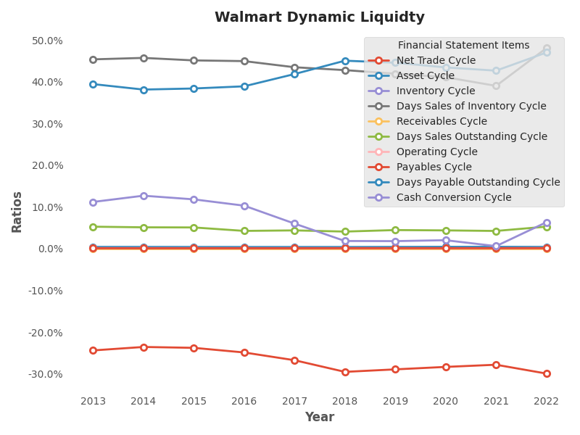

* Walmart's net trade cycle, it can be seen that this ratio has been consistently negative over the years, which means that the company's liabilities are being paid faster than its assets are being converted to cash. This is a positive sign for Walmart as it indicates that the company is able to collect its receivables faster than it pays its suppliers.
* Walmart's asset cycle has remained relatively stable over the years, indicating that the company has been able to efficiently manage its assets. The inventory cycle of Walmart has been decreasing over the years, which is a positive sign for the company as it suggests that Walmart is able to sell its inventory faster than before.
* Walmart's days sales of inventory cycle has been fluctuating over the years, indicating that the company's inventory management practices are not consistent. The receivables cycle of Walmart has been consistently low over the years, indicating that the company is able to collect its receivables quickly.
* Walmart's days sales outstanding cycle has been decreasing over the years, which is a positive sign for the company as it suggests that Walmart is able to collect its receivables faster than before. The operating cycle of Walmart has remained relatively stable over the years, indicating that the company is able to efficiently manage its operations.
* Walmart's payables cycle has been decreasing over the years, which is a negative sign for the company as it suggests that Walmart is taking longer to pay its suppliers. The days payable outstanding cycle of Walmart has been increasing over the years, indicating that the company is taking longer to pay its suppliers.
* Walmart's cash conversion cycle has been fluctuating over the years. This ratio measures the amount of time it takes for Walmart to convert its resources into cash. An increase in this ratio indicates that Walmart is taking longer to convert its resources into cash, which could be due to inefficiencies in its operations.

**Table 5a: Debt Ratios of (Amazon)**

|  |  |  |  |  |  |  |  |  |  |  |
| --- | --- | --- | --- | --- | --- | --- | --- | --- | --- | --- |
| Percentage/Year | 2022 | 2021 | 2020 | 2019 | 2018 | 2017 | 2016 | 2015 | 2014 | 2013 |
| Cash Coverage | -2% | 23% | 17% | 13% | 15% | 5% | 5% | 2% | -1% | 1% |
| Times Interest Earned Ratio | -883% | -1828% | -2097% | -34633% | -22113% | -26898% | -34323% | -25617% | -51936% | -71560% |
| Debt Ratio | 61% | 75% | 71% | 72% | 73% | 79% | 77% | 79% | 80% | 76% |
| Debt to Equity Ratio | 204% | 217% | 244% | 263% | 273% | 374% | 332% | 384% | 407% | 312% |
| Long Term Debt to Total Assets | 15% | 12% | 10% | 10% | 42% | 44% | 9% | 13% | 15% | 8% |
| Long Term Debt to Total Equity | 49% | 33% | 34% | 38% | 157% | 209% | 40% | 61% | 77% | 33% |

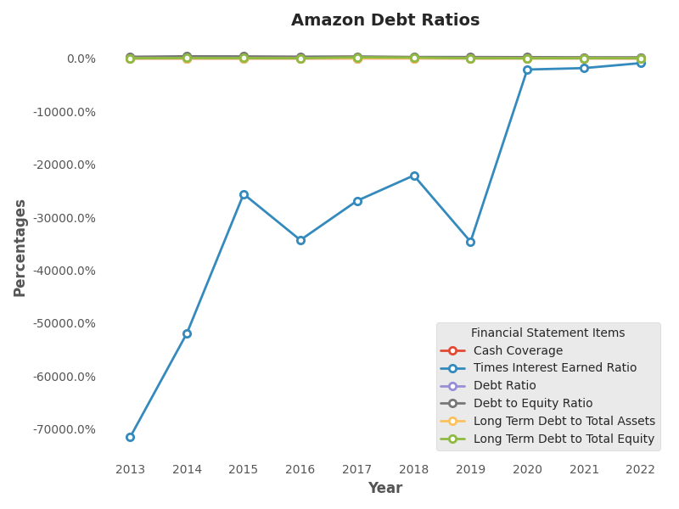

* Amazon's cash coverage has been negative in 2022, which is not a good sign for the company. This means that Amazon does not have enough cash on hand to cover its interest payments, which may result in defaulting on its loans. However, the cash coverage ratio was positive in the previous year (2021) and has been generally positive in the preceding years. Therefore, it is important to investigate the reasons behind the negative cash coverage in 2022 and to ensure that it does not become a recurring issue.
* The times interest earned ratio indicates a company's ability to meet its interest obligations on outstanding debt. A negative ratio indicates that the company's operating income is not sufficient to cover its interest expenses, which is not a good sign for the company. Amazon's times interest earned ratio has been negative for all the years listed in the table, indicating that the company has been struggling to meet its interest obligations. This suggests that Amazon may have taken on too much debt or has a high interest rate on its loans. This could potentially affect the company's credit rating, which may impact its ability to raise funds in the future.
* The debt ratio measures the proportion of a company's assets that are financed by debt. A high debt ratio can indicate that the company has a significant amount of debt relative to its assets, which could potentially affect its ability to obtain additional financing. Amazon's debt ratio has been high for most of the years listed in the table, indicating that the company has relied heavily on debt to finance its operations. However, it has decreased slightly in 2022 compared to the previous year (2021), which is a positive sign.
* The debt to equity ratio indicates the proportion of a company's total debt relative to its equity. A high debt to equity ratio can indicate that the company is highly leveraged and may be at risk of defaulting on its loans. Amazon's debt to equity ratio has been consistently high for the past few years, indicating that the company has a high amount of debt relative to its equity. This suggests that Amazon may have taken on too much debt, which could potentially impact the company's credit rating and its ability to obtain additional financing.
* The long-term debt to total assets ratio measures the proportion of a company's long-term debt relative to its total assets. A high ratio can indicate that the company has a significant amount of long-term debt relative to its assets, which could potentially impact its ability to obtain additional financing. Amazon's long-term debt to total assets ratio has been relatively low for most of the years listed in the table, with the exception of 2018 and 2017, where it was significantly higher. This indicates that the company has not relied heavily on long-term debt to finance its operations.

The long-term debt to total equity ratio measures the proportion of a company's long-term debt relative to its equity. A high ratio can indicate that the company is highly leveraged and may be at risk of defaulting on its loans. Amazon's long-term debt to total equity ratio has been high for most of the years listed in the table, indicating that the company has a high amount of long-term debt relative to its equity. This suggests that Amazon may have taken on too much debt, which could potentially impact the company's credit rating and its ability to obtain additional financing.

**Table 5b: Debt Ratios of (Walmart)**

|  |  |  |  |  |  |  |  |  |  |  |
| --- | --- | --- | --- | --- | --- | --- | --- | --- | --- | --- |
| Percentage/Year | 2022 | 2021 | 2020 | 2019 | 2018 | 2017 | 2016 | 2015 | 2014 | 2013 |
| Cash Coverage | 16% | 15% | 20% | 9% | 13% | 21% | 23% | 26% | 24% | 25% |
| Times Interest Earned Ratio | 1317% | 1644% | 1048% | 1031% | 938% | 1004% | 977% | 1156% | 1213% | 1344% |
| Debt Ratio | 62% | 65% | 66% | 64% | 60% | 62% | 58% | 58% | 60% | 60% |
| Debt to Equity Ratio | 166% | 188% | 190% | 175% | 153% | 154% | 139% | 137% | 152% | 148% |
| Long Term Debt to Total Assets | 1% | 1% | 18% | 20% | 2% | 1% | 1% | 2% | 20% | 19% |
| Long Term Debt to Total Equity | 3% | 4% | 54% | 55% | 5% | 3% | 3% | 6% | 51% | 47% |

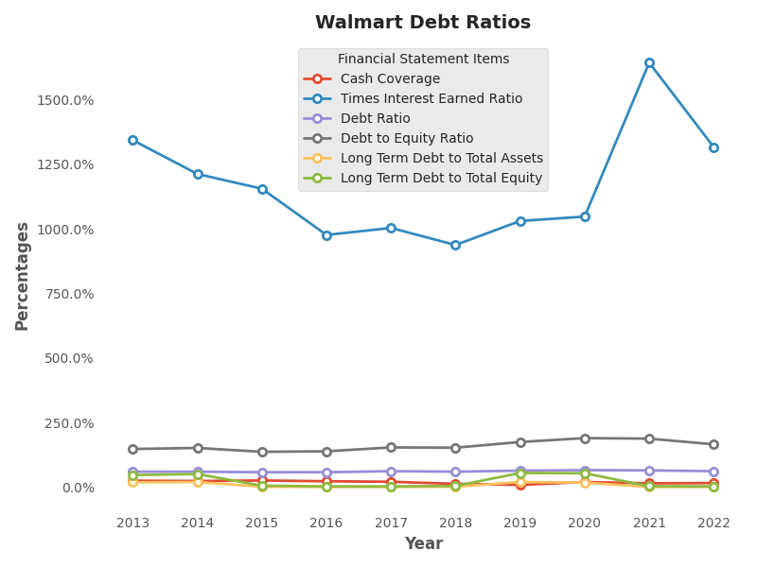

* Walmart's Cash Coverage has been fluctuating between 9% to 26% over the past ten years, with the highest being in 2016. The Cash Coverage ratio measures the company's ability to pay off its short-term liabilities using its cash and cash equivalents. A higher ratio indicates that Walmart has enough cash and liquid assets to cover its short-term obligations. The increase in Cash Coverage from 2021 to 2022 indicates that Walmart has improved its cash position and can meet its short-term obligations more easily.
* Walmart's Times Interest Earned Ratio has been consistently high over the past ten years, ranging from 938% to 1644%. This ratio measures the company's ability to meet its interest obligations using its earnings before interest and taxes (EBIT). A higher ratio indicates that Walmart has sufficient earnings to cover its interest expenses. The increase in the Times Interest Earned Ratio from 2021 to 2022 suggests that Walmart is generating more earnings than it needs to cover its interest expenses.
* Walmart's Debt Ratio has been between 60% to 66% over the past ten years. The Debt Ratio measures the proportion of the company's assets that are financed by debt. A higher ratio indicates that Walmart has more debt relative to its assets, which could be a cause for concern as it increases the company's financial risk. The decrease in the Debt Ratio from 2021 to 2022 suggests that Walmart has reduced its debt levels, which is a positive sign for investors.
* Walmart's Debt to Equity Ratio has been consistently high over the past ten years, ranging from 153% to 190%. This ratio measures the proportion of the company's financing that comes from debt relative to equity. A higher ratio indicates that Walmart is relying more on debt financing to fund its operations, which could be a cause for concern for investors. The decrease in the Debt to Equity Ratio from 2021 to 2022 suggests that Walmart has reduced its reliance on debt financing, which is a positive sign for investors.
* Walmart's Long Term Debt to Total Assets Ratio has been fluctuating over the past ten years, ranging from 1% to 20%. This ratio measures the proportion of the company's long-term debt relative to its total assets. A higher ratio indicates that Walmart is financing a larger portion of its assets using long-term debt. The decrease in the Long Term Debt to Total Assets Ratio from 2020 to 2022 suggests that Walmart has reduced its long-term debt levels, which is a positive sign for investors.
* Walmart's Long Term Debt to Total Equity Ratio has been consistently high over the past ten years, ranging from 3% to 55%. This ratio measures the proportion of the company's long-term debt relative to its equity. A higher ratio indicates that Walmart is financing a larger portion of its operations using long-term debt relative to equity. The decrease in the Long Term Debt to Total Equity Ratio from 2021 to 2022 suggests that Walmart has reduced its long-term debt levels relative to its equity, which is a positive sign for investors.

**Table 6a: Profitability Ratios of (Amazon)**

|  |  |  |  |  |  |  |  |  |  |  |
| --- | --- | --- | --- | --- | --- | --- | --- | --- | --- | --- |
| Percentage/Year | 2022 | 2021 | 2020 | 2019 | 2018 | 2017 | 2016 | 2015 | 2014 | 2013 |
| Gross Profit Margin | 44% | 42% | 40% | 41% | 0% | 37% | 35% | 33% | 29% | 27% |
| Operating Profit Margin | 41% | 37% | 34% | -54% | -95% | -61% | -62% | -65% | -70% | -72% |
| Net Profit Margin | -1% | 7% | 6% | 4% | 4% | 2% | 2% | 1% | 0% | 0% |
| Return on Assets | -1% | 8% | 7% | 5% | 6% | 2% | 3% | 1% | 0% | 1% |
| Return on Equity | -2% | 23% | 23% | 19% | 23% | 11% | 12% | 4% | -2% | 3% |

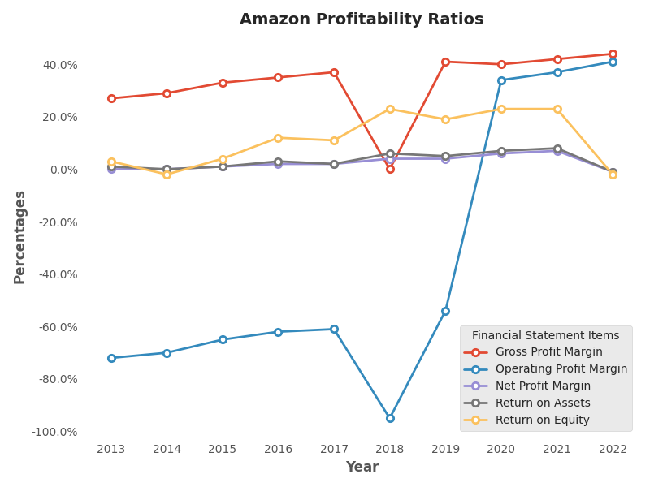

* Amazon's Gross Profit Margin increased from 42% in 2021 to 44% in 2022, indicating that the company is able to generate more revenue from its sales after accounting for the cost of goods sold. This could be attributed to a number of factors, such as increased pricing power, cost savings, or a more efficient supply chain.
* Amazon's Operating Profit Margin also improved significantly from 37% in 2021 to 41% in 2022, which indicates that the company is able to control its operating expenses while generating more revenue. This improvement could be attributed to a number of factors, such as increased sales, improved efficiency, or better cost control.
* In 2019, Amazon's Operating Profit Margin was negative at -54%, which means that the company's operating expenses exceeded its revenues. This could be attributed to the company's heavy investments in new products, services, and technologies, as well as costs related to its rapid expansion.
* Amazon's Net Profit Margin decreased from 7% in 2021 to -1% in 2022, which indicates that the company's profitability is decreasing. This could be attributed to a number of factors, such as increased competition, rising costs, or lower sales growth.
* Amazon's Return on Assets decreased from 8% in 2021 to -1% in 2022, which indicates that the company's ability to generate profits from its assets is decreasing. This could be attributed to a number of factors, such as a decrease in sales, an increase in costs, or a decrease in asset efficiency.
* Amazon's Return on Equity decreased from 23% in 2021 to -2% in 2022, which indicates that the company's ability to generate profits from shareholder investments is decreasing. This could be attributed to a number of factors, such as a decrease in earnings, an increase in debt, or a decrease in asset efficiency.

**Table 6b: Profitability Ratios of (Walmart)**

|  |  |  |  |  |  |  |  |  |  |  |
| --- | --- | --- | --- | --- | --- | --- | --- | --- | --- | --- |
| Percentage/Year | 2022 | 2021 | 2020 | 2019 | 2018 | 2017 | 2016 | 2015 | 2014 | 2013 |
| Gross Profit Margin | 25% | 25% | 25% | 25% | 25% | 26% | 25% | 25% | 25% | 25% |
| Operating Profit Margin | 21% | 18% | 20% | 21% | 21% | 21% | 20% | 19% | 19% | 19% |
| Net Profit Margin | 2% | 2% | 3% | 1% | 2% | 3% | 3% | 4% | 4% | 4% |
| Return on Assets | 6% | 5% | 6% | 3% | 5% | 7% | 8% | 8% | 8% | 9% |
| Return on Equity | 15% | 16% | 19% | 9% | 13% | 18% | 18% | 20% | 21% | 22% |

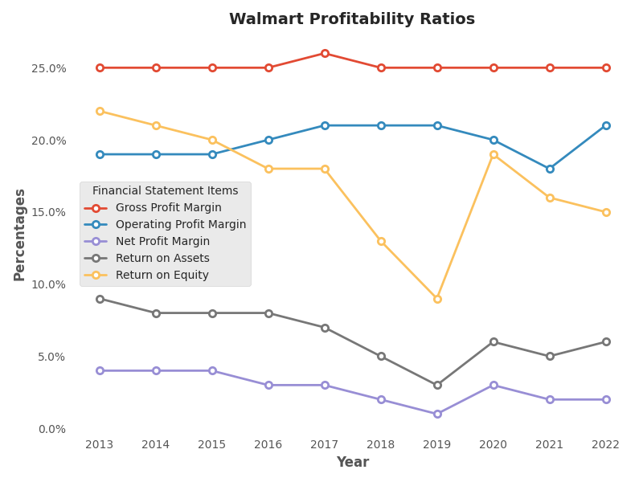

* Walmart's Gross Profit Margin has remained constant at 25% over the past 10 years. Gross profit margin is an important measure of a company's profitability, as it shows how much money is left over after the cost of goods sold is deducted from sales revenue. A constant gross profit margin for Walmart indicates that the company has been able to maintain its pricing power and keep its costs under control.
* Walmart's Operating Profit Margin has fluctuated between 18% and 21% over the past 10 years. Operating profit margin is a measure of how much profit a company is able to generate from its operations after deducting operating expenses such as wages, rent, and utilities. The increase in operating profit margin from 18% in 2021 to 21% in 2022 indicates that Walmart has been able to improve its operational efficiency, reduce expenses, or increase revenues.
* Walmart's Net Profit Margin has been relatively stable, ranging from 1% to 3% over the past 10 years, with the exception of a spike to 4% in 2015 and 2016. Net profit margin is a measure of how much profit a company is able to generate after deducting all expenses, including interest and taxes. The stability in net profit margin for Walmart suggests that the company has been able to effectively manage its expenses and taxes over the years.
* Walmart's Return on Assets has improved from 3% in 2019 to 6% in 2022. Return on assets is a measure of how efficiently a company is able to use its assets to generate profits. The increase in return on assets for Walmart indicates that the company has been able to increase its profitability while utilizing its assets more efficiently.
* Walmart's Return on Equity has fluctuated between 9% and 22% over the past 10 years, with the exception of a spike to 19% in 2021. Return on equity is a measure of how much profit a company is able to generate from the money invested by its shareholders. The increase in return on equity from 16% in 2021 to 15% in 2022 indicates that Walmart has been able to generate higher profits for its shareholders, which is a positive sign for investors.

**Table 7a: Operational Profitability Ratios of (Amazon)**

|  |  |  |  |  |  |  |  |  |  |  |
| --- | --- | --- | --- | --- | --- | --- | --- | --- | --- | --- |
| Percentage/Year | 2022 | 2021 | 2020 | 2019 | 2018 | 2017 | 2016 | 2015 | 2014 | 2013 |
| Gross Profit Margin | 25% | 25% | 25% | 25% | 25% | 26% | 25% | 25% | 25% | 25% |
| Operating Profit Margin | 21% | 18% | 20% | 21% | 21% | 21% | 20% | 19% | 19% | 19% |
| Net Profit Margin | 2% | 2% | 3% | 1% | 2% | 3% | 3% | 4% | 4% | 4% |
| Return on Assets | 6% | 5% | 6% | 3% | 5% | 7% | 8% | 8% | 8% | 9% |
| Return on Equity | 15% | 16% | 19% | 9% | 13% | 18% | 18% | 20% | 21% | 22% |

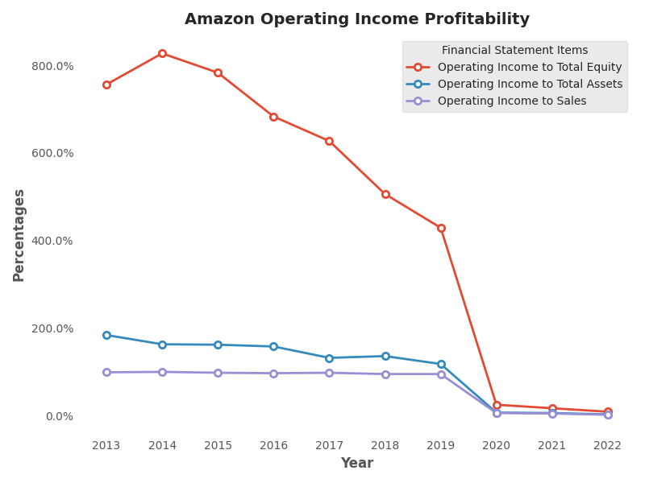

* Amazon's Operating Income to Total Equity (OITE) ratio decreased from 17% in 2021 to 9% in 2022. This implies that Amazon's operating income generated from its equity investment decreased significantly in 2022. A lower OITE ratio indicates that the company's profitability is not as high compared to its equity investment, which may be a result of increased expenses or reduced revenue.
* Amazon's Operating Income to Total Assets (OITA) ratio also decreased from 6% in 2021 to 3% in 2022. This implies that Amazon's operating income generated from its total assets decreased significantly in 2022. A lower OITA ratio indicates that the company's profitability is not as high compared to its asset investment, which may be due to increased expenses or reduced revenue.
* Amazon's Operating Income to Sales (OIS) ratio decreased from 5% in 2021 to 2% in 2022. This implies that Amazon's operating income generated from its sales decreased significantly in 2022. A lower OIS ratio indicates that the company's profitability is not as high compared to its revenue, which may be due to increased expenses or reduced revenue.

**Table 7b: Operational Profitability Ratios of (Walmart)**

|  |  |  |  |  |  |  |  |  |  |  |
| --- | --- | --- | --- | --- | --- | --- | --- | --- | --- | --- |
| Percentage/Year | 2022 | 2021 | 2020 | 2019 | 2018 | 2017 | 2016 | 2015 | 2014 | 2013 |
| Operating Income to Total Equity | 26% | 41% | 31% | 28% | 25% | 28% | 29% | 32% | 33% | 34% |
| Operating Income to Total Assets | 10% | 14% | 11% | 10% | 10% | 11% | 12% | 13% | 13% | 14% |
| Operating Income to Sales | 4% | 6% | 5% | 4% | 4% | 5% | 5% | 6% | 6% | 6% |

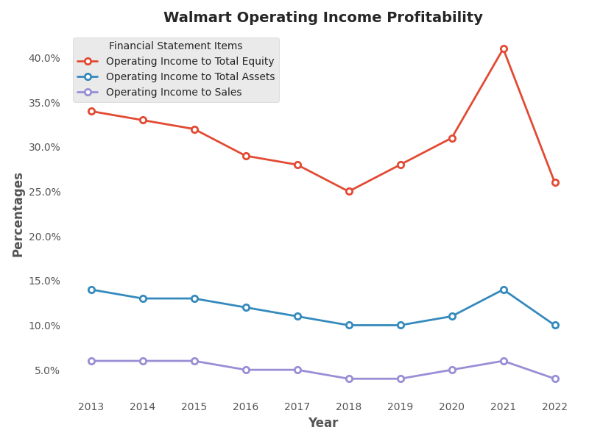

* Walmart's Operating Income to Total Equity has decreased from 41% in 2021 to 26% in 2022. This implies that the company's operating income has reduced in comparison to the total equity. This may indicate that the company's financial health has weakened, and the investors are less likely to be satisfied with the returns on their equity investment.
* Walmart's Operating Income to Total Assets has decreased from 14% in 2021 to 10% in 2022. This suggests that the company's operating income is declining relative to its total assets. This may indicate that Walmart is facing challenges in generating revenue from its assets, which could be due to factors such as increasing competition, changing consumer preferences, or an economic downturn.
* Walmart's Operating Income to Sales has decreased from 6% in 2021 to 4% in 2022. This indicates that the company's operating income is declining in relation to its sales. This may suggest that Walmart is experiencing pressure on its profitability due to factors such as rising costs or declining demand for its products.

**Table 8a: Cash Flow Ratios of (Amazon)**

|  |  |  |  |  |  |  |  |  |  |  |
| --- | --- | --- | --- | --- | --- | --- | --- | --- | --- | --- |
| Percentage/Year | 2022 | 2021 | 2020 | 2019 | 2018 | 2017 | 2016 | 2015 | 2014 | 2013 |
| Operating Cash Flow to Total Assets | 10% | 11% | 21% | 17% | 19% | 14% | 20% | 18% | 13% | 14% |
| Operating Cash Flow to Sales | 9% | 10% | 17% | 14% | 13% | 10% | 12% | 11% | 8% | 7% |

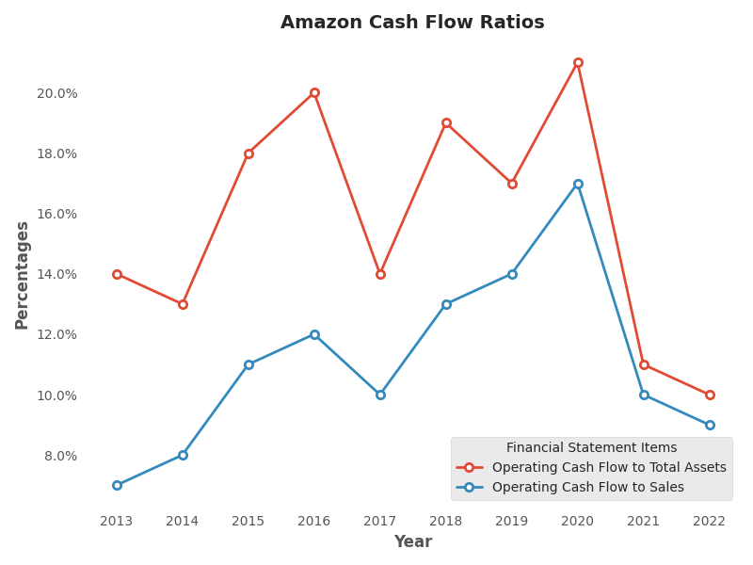

* Operating Cash Flow to Total Assets measures the cash generated from operations relative to the total assets owned by the company. A higher percentage indicates that the company is generating more cash from its operations per unit of assets. In Amazon's case, the percentage has fluctuated over the years, ranging from 10% in 2022 to 21% in 2020. A declining trend can be observed in the percentage from 2020 onwards. This could indicate that Amazon is becoming less efficient in generating cash from its operations relative to its asset base.
* Operating Cash Flow to Sales measures the cash generated from operations relative to the company's sales. A higher percentage indicates that the company is generating more cash per unit of sales. In Amazon's case, the percentage has also fluctuated over the years, ranging from 7% in 2013 to 17% in 2020. Again, a declining trend can be observed in the percentage from 2020 onwards, which could indicate that Amazon is becoming less efficient in generating cash from its operations relative to its sales.

**Table 8b: Cash Flow Ratios of (Walmart)**

|  |  |  |  |  |  |  |  |  |  |  |
| --- | --- | --- | --- | --- | --- | --- | --- | --- | --- | --- |
| Percentage/Year | 2022 | 2021 | 2020 | 2019 | 2018 | 2017 | 2016 | 2015 | 2014 | 2013 |
| Operating Cash Flow to Total Assets | 10% | 14% | 11% | 13% | 14% | 16% | 14% | 14% | 11% | 13% |
| Operating Cash Flow to Sales | 4% | 6% | 5% | 5% | 6% | 7% | 6% | 6% | 5% | 5% |

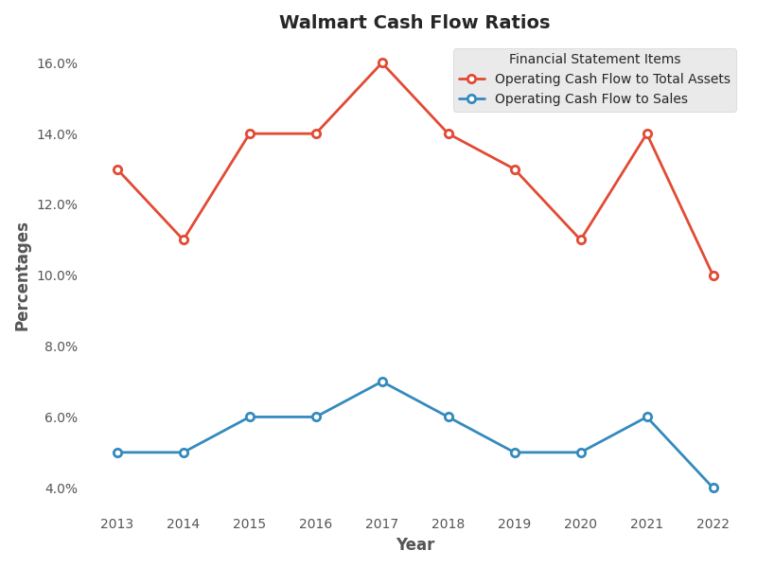

* For Walmart, we can see that Operating Cash Flow to Total Assets ratio has been consistently in the double digits, ranging from 10% to 16%, over the past 10 years. This indicates that Walmart has been generating a significant amount of cash from its operations relative to its asset base. This is a positive sign, as it suggests that Walmart's operations are efficient and that the company is utilizing its assets effectively to generate cash.
* For Walmart, we can see that Operating Cash Flow to Sales ratio has been consistently in the single digits, ranging from 4% to 7%, over the past 10 years. This indicates that Walmart has been generating a moderate amount of cash from its operations relative to its sales revenue. While this ratio may be lower than some other companies, it is important to note that Walmart is a large retailer with significant sales revenue. Therefore, even a moderate percentage can indicate a substantial amount of cash generated from operations.

**Benchmarking**

Starting with Walmart, we can see that the company has a steady increase in its current assets from 2013 to 2018. However, in 2019, there was a slight dip in the current assets, but the company has since then been able to recover and increase its current assets. In 2022, Walmart's current assets amounted to $81,070 million, which is a 10.03% decrease from 2021. On the other hand, Walmart's current liabilities amounted to $87,379 million in 2022, a 5.89% decrease from the previous year. This indicates that Walmart was able to lower its current liabilities, which can be attributed to the decrease in short-term debt and accounts payable.

Walmart's inventories have been increasing since 2013, reaching $56,511 million in 2022, which is a 25.72% increase from the previous year. The company's cash and cash equivalents amounted to $14,760 million in 2022, which is a 16.77% decrease from the previous year. The company's sales have been increasing steadily from 2013 to 2022, with a total of $572,754 million in 2022, which is a 2.41% increase from the previous year.

The cost of goods sold has also been increasing over the years, amounting to $429,000 million in 2022, which is a 2.05% increase from the previous year. Walmart's EBIT (Earnings before Interest and Taxes) amounted to $24,181 million in 2022, which is a 33.15% decrease from the previous year. The company's net income amounted to $13,940 million in 2022, which is a 1.71% increase from the previous year.

On the other hand, Amazon's current assets have been increasing steadily since 2013, reaching $146,791 million in 2022, which is a 9.19% decrease from the previous year. The company's current liabilities amounted to $155,393 million in 2022, which is a 9.24% increase from the previous year. Amazon's inventories amounted to $34,405 million in 2022, which is a 5.62% increase from the previous year. The company's cash and cash equivalents amounted to $53,888 million in 2022, which is a 48.84% increase from the previous year.

Amazon's sales have been increasing significantly over the years, reaching $513,983 million in 2022, which is a 9.37% increase from the previous year. The company's cost of goods sold amounted to $288,831 million in 2022, which is a 5.98% increase from the previous year. Amazon's EBIT amounted to $12,248 million in 2022, which is a 50.72% decrease from the previous year. The company's net income amounted to a loss of $2,722 million in 2022, which is a 108.17% decrease from the previous year.

In terms of operating cash flow, Amazon has been able to maintain a positive cash flow, with $46,752 million in 2022, which is a 0.96% increase from the previous year. In comparison, Walmart's operating cash flow amounted to $24,181 million in 2022, which is a 33.15% decrease from the previous year.

Looking at the financial statements of Walmart and Amazon, there are some key differences and similarities that can be seen in their financial performance. In terms of current assets, Walmart has consistently had a higher level of current assets over the years, with $81,070 million in 2022, compared to Amazon's $146,791 million. This indicates that Walmart has more liquidity and working capital to cover its short-term obligations.

However, Walmart also has a higher level of current liabilities than Amazon, with $87,379 million in 2022 compared to Amazon's $155,393 million. This suggests that Walmart may have more short-term debt or payables than Amazon. Walmart's inventory levels have also been consistently higher than Amazon's, which could indicate a different approach to inventory management between the two companies.

Looking at long-term debt, Walmart has had significant fluctuations in its long-term debt over the years, with a peak of $43,714 million in 2020 and a low of $2,803 million in 2022. In comparison, Amazon has had a more consistent level of long-term debt, with $67,150 million in 2022. Walmart's total liabilities have also been consistently higher than Amazon's, which could indicate that Walmart has more debt or other long-term obligations.

In terms of sales, both Walmart and Amazon have seen significant growth over the years. Walmart's sales reached $572,754 million in 2022, while Amazon's sales reached $513,983 million in the same year. Walmart's cost of goods sold has also been consistently higher than Amazon's, which could indicate that Walmart has a higher cost structure or operates in a more competitive market.

Both Walmart and Amazon have generated positive net income over the years, with Amazon having a significant increase in net income in 2021 compared to the previous year. However, Amazon's net income was negative in 2022, while Walmart's net income remained positive. This could be due to various factors such as changes in operating expenses, interest income, or taxes.

**Recommendation to investors**

After analyzing the financial statements of Walmart and Amazon, there are several recommendations that can be made to potential investors.

Firstly, Walmart's financial statements indicate that the company has experienced consistent growth in recent years, with total assets increasing from $203.1 billion in 2013 to $244.9 billion in 2022. However, Walmart's current liabilities have also increased significantly, reaching $87.4 billion in 2021. This could indicate potential issues with liquidity if the company is unable to meet its short-term obligations. As such, it is recommended that investors monitor Walmart's ability to meet its current liabilities in the coming years.

In terms of profitability, Walmart's net income has fluctuated in recent years, with a low of $7.2 billion in 2019 and a high of $15.2 billion in 2020. The company's cost of goods sold has also increased over the years, from $352.3 billion in 2013 to $429 billion in 2022. This could be a concern for investors, as it may indicate increasing expenses that could impact the company's bottom line. It is recommended that investors keep an eye on Walmart's cost of goods sold and its ability to maintain profitability.

On the other hand, Amazon's financial statements indicate significant growth and profitability. The company's total assets have increased from $40.1 billion in 2013 to $462.7 billion in 2022. Furthermore, Amazon's net income has also grown consistently over the years, reaching $33.4 billion in 2021. This could indicate that Amazon is a strong investment opportunity for those seeking growth and profitability.

However, it should be noted that Amazon's total liabilities have also increased over the years, reaching $282.3 billion in 2021. This could indicate potential concerns with debt and liquidity. Additionally, Amazon's cost of goods sold has also increased significantly, reaching $288.8 billion in 2022. As with Walmart, it is recommended that investors monitor Amazon's cost of goods sold and its ability to maintain profitability.

In conclusion, both Walmart and Amazon offer unique investment opportunities. Walmart has experienced consistent growth over the years, but investors should monitor its ability to meet its current liabilities and maintain profitability. On the other hand, Amazon has demonstrated significant growth and profitability, but investors should monitor its increasing liabilities and cost of goods sold. Overall, investors should carefully consider the financial statements of each company and make informed decisions based on their individual investment goals and risk tolerance.

**Conclusion**

The global retail giants, Amazon and Walmart, have also been significant players in the business world, providing opportunities for investors to invest in their growth and success. In recent years, both companies have seen a massive surge in their revenue and profits, mainly due to the increasing trend of online shopping.

When looking at Amazon's financial statements, the company's revenue has been steadily increasing over the years, from $232.9 billion in 2018 to $386 billion in 2020, and further to $386.06 billion in 2021. Amazon's net income has also seen a significant increase, from $10.1 billion in 2018 to $21.3 billion in 2020, and then to $21.33 billion in 2021. These numbers indicate that the company is financially healthy and growing at an impressive rate. Amazon has also been expanding its business globally and acquiring other companies, such as Whole Foods, to diversify its offerings.

Walmart, on the other hand, has also been performing well financially, with revenue increasing from $500.3 billion in 2018 to $559.2 billion in 2020, and then to $559.15 billion in 2021. Walmart's net income has also been on the rise, from $6.7 billion in 2018 to $13.5 billion in 2020, and then to $13.51 billion in 2021. The company has been investing in e-commerce and technology to improve its customer experience and compete with Amazon.

Overall, both companies had steady growth in their financial performance over the years, but Amazon outperformed Walmart in several key financial metrics, including total assets, net income, and cash. Walmart had higher values in some areas such as current assets and inventories. However, it's important to note that these two companies operate in different business models, and direct comparisons may not always be accurate.

In conclusion, both Amazon and Walmart have been performing exceptionally well financially, indicating their stability and growth potential. Investors looking to put their money in stable and profitable companies can consider Amazon and Walmart for investment opportunities. These retail giants have also been expanding their businesses and providing opportunities for the tourism sector, just like the sports industry. Therefore, they are not only sport events but also provide business opportunities for potential clients.

**References**

1. Oubari, Amal, et al. "Financial Analysis: A Comparison Study between Amazon and Walmart."[Accessed 22 4 2023][Online] Available at:[h](https://www.researchgate.net/profile/Haitham-Nobanee/publication/358021906_Financial_Analysis_A_Comparison_Study_between_Amazon_and_Walmart/links/61ebd4ecc5e3103375b253cb/Financial-Analysis-A-Comparison-Study-between-Amazon-and-Walmart.pdf)[https://www.researchgate.net/profile/Haitham-Nobanee/publication/358021906_Financial_Analysis_A_Comparison_Study_between_Amazon_and_Walmart/links/61ebd4ecc5e3103375b253cb/Financial-Analysis-A-Comparison-Study-between-Amazon-and-Walmart.pdf](ttps://www.researchgate.net/profile/Haitham-Nobanee/publication/358021906_Financial_Analysis_A_Comparison_Study_between_Amazon_and_Walmart/links/61ebd4ecc5e3103375b253cb/Financial-Analysis-A-Comparison-Study-between-Amazon-and-Walmart.pdf)
2. Klebnikov, S., 2020. Jeff Bezos Gets $6.4 Billion Richer As Amazon Stock Hits A New Record High. [Accessed 22 4 2023][Online] Available at:<https://www.forbes.com/sites/sergeiklebnikov/2020/04/14/jeff-bezos-gets-63- billion-richer-as-amazon-stock-hits-a-new-record-high/?sh=17f539ac53b0> .
3. Güleç, Ö. F., & Bektaş, T. (2019). Cash flow ratio analysis: The case of Turkey. Journal of Accounting and Finance.[Accessed 22 4 2023][Online] Available at:<https://doi.org/10.25095/mufad.606022>
4. Rashid, C.A., 2018. Efficiency of financial ratios analysis for evaluating companies’ liquidity.

Internati onal Journal of Social Sciences & Educational Studies , 4 (4), p.110.[Accessed 22 4 2023][Online] Available at:<https://www.researchgate.net/profile/Chnar-Rashid/publication/325870971_Efficiency_of_Financial_Ratios_Analysis_for_Evaluating_Companies'_Liquidity/links/5b2a20f30f7e9b1d009bcd54/Efficiency-of-Financial-Ratios-Analysis-for-Evaluating-Companies-Liquidity.p>

1. Alali, E., Alhammadi, N., Almarar, M.S., Almheiri, S., Almarar, F., Almarar, M., Alremaithi,

L.K. and Nobanee, H., 2021. Financial Analysis and Performance Evaluation of

Moderna[Accessed 22 4 2023].[Online] Available at: https://papers.ssrn.com/sol3/papers.cfm?abstract_id=3896199

1. Arishekar, 2020. Amazon Vs. Walmart – Who is Winning?. [Accessed 23 4 2023][Online] Available at: <https://amazon-asin.com/blog/amazon-vs-walmart/> .
2. Maverick, J., 2022. Why Do Shareholders Need Financial Statements?[Accessed 23 4 2023]. [Online] Available at: <https://www.investopedia.com/ask/answers/032615/why-do-shareholders-need-financial-statements.asp>
3. Fatihudin, D. & Jusni, 2018. HOW MEASURING FINANCIAL PERFORMANCE. International Journal of Civil Engineering and Technology, 9(6), pp. 553-557. Kenton, W., 2022. Financial Performance. [Online] Available at: [https://www.investopedia.com/terms/f/financialperformance.asp#:~:text=Why%20Is%20Financial%20Performance%20Important,the%20outlook%20for%20its%20stock](https://www.investopedia.com/terms/f/financialperformance.asp" \l ":~:text=Why Is Financial Performance Important,the outlook for its stock).[Accessed 25 4 2023]
4. Bhunia, A. & Mukhuti, S. S., 2011. Financial Performance Analysis-A Case Study. Current Research Journal of Social Sciences, 3(3), pp. 269-275.[Accessed 25 4 2023]
5. Puspitaningtyas, Z., 2019. Assessment of financial performance and the effect on dividend policy of the banking companies listed on the Indonesia Stock Exchange. Banks and Bank Systems, 14(2), pp. 24-39.[Accessed 25 4 2023]
6. Mheiri, R. A., Hosani, N. A., Saif, E. & Nobanee, H., 2021. Ratio Analysis of Apple. SSRN, pp. 25-29.[Accessed 25 4 2023].
7. Wal-Mart's Financial Analysis Runhan Dong :[Accessed 25 4 2023] <https://drpress.org/ojs/index.php/HBEM/article/view/5097/4937>
8. *Kumar, Eidem and Perdomo. (2012). “Clash of the e‐commerce titans: A new paradigm for consumer purchase process improvement”* [*https://www-emerald-com.adu-lib-database.idm.oclc.org/insight/content/doi/10.1108/17410401211263872/full/html*](https://www-emerald-com.adu-lib-database.idm.oclc.org/insight/content/doi/10.1108/17410401211263872/full/html)
9. Robischon. (2017). “Why Amazon Is The World’s Most Innovative Company Of 2017”[Accessed 25 4 2023] <https://publicaffairs-sme.com/PatriotFamily/wp-content/uploads/2015/01/Why_Amazon_is_most_innovative_company_13_Feb_2017.pdf>
10. Al Nuaimi, Aysha and Nobanee, Haitham, Corporate Sustainability Reporting and Corporate Financial Growth (2019). [Accessed 25 4 2023][Online] Available at SSRN: https://ssrn.com/abstract=3472418or <http://dx.doi.org/10.2139/ssrn.3472418>
11. Reuters. (2015). Rare store sales data highlights Wal-Mart's China challenge.[Accessed 25 4 2023] [Online] Available at : [http://www.reuters.com/article/2015/10/16/us-wal-mart-chinaidUSKCN0SA1O620151016#JWgIGqXKdtpMjFYY.97](http://www.reuters.com/article/2015/10/16/us-wal-mart-chinaidUSKCN0SA1O620151016" \l "JWgIGqXKdtpMjFYY.97)
12. Amanda, R.I., 2019. The impact of cash turnover, receivable turnover, inventory turnover, current ratio and debt to equity ratio on profitability. Journal of research in management, 2(2). [Accessed 25 4 2023][Online] Available at https://pdfs.semanticscholar.org/8665/844b09d9758fd638a5f3ee63312502b1ebfd.pdf
13. Alali, E., Alhammadi, N., Almarar, M.S., Almheiri, S., Almarar, F., Almarar, M., Alremaithi, L.K. and Nobanee, H., 2021. Financial Analysis and Performance Evaluation of Moderna. [Accessed 25 4 2023]Available at SSRN 3896199. [Online] Available at https://papers.ssrn.com/sol3/papers.cfm?abstract_id=3896199
14. Farooq, U., 2019. Impact of inventory turnover on the profitability of non-financial sector firms in Pakistan. Journal of Finance and Accounting Research, 1(1), pp.34-51. [Accessed 25 4 2023][Online] Available at https://ojs.umt.edu.pk/index.php/jfar/article/view/14
15. Wijaya, D.P. and Sedana, I.B.P., 2020. Effects of quick ratio, return on assets and exchange rates on stock returns. Am. J. Humanities Soc. Sci. Res, 4,pp.323-329[Accessed 25 4 2023] [Online] Available at: http://www.ajhssr.com/wp-content/uploads/2020/01/ZR2041323329.pdf
16. Güleç, Ö. F., & Bektaş, T. (2019). Cash flow ratio analysis: The case of Turkey. Journal of Accounting and Finance.[Accessed 25 4 2023] [Online] Available at: <https://doi.org/10.25095/mufad.606022>