📊 Stock Market Trend Analysis and Prediction using Machine Learning

📌 Executive Summary
This project analyzes stock price behavior of Apple Inc. The objective is to identify trends, evaluate market risk and build a prediction model to estimate future stock prices, using historical data and machine learning techniques.
This analysis supports data-driven investment decision by integrating statistical methods and machine learning. In result the model captures price movement, when prediction accuracy is influenced by market volatility.
📌 Problem Statement
Many factors in the financial market make the price prediction a complex task. So, from a business perspective this will support investment decision-making and risk assessment:
- Analyze historical trends
- Measure market volatility
- Build a predictive model for future price estimation
📌 Dataset Description
The dataset was imported from the library “yfinance” that includes daily trading data for Apple Inc from 2021 to 2025. Features are:
- Closing price
- Trading volume
- High and low prices
- Derived indicators (moving average, returns)
📌 Methodology
🔹 Data Preparation
- Missing values generated by rolling calculations were removed
- New features were built:
MA10(10-day moving average)
MA50(50-day moving average)
Returns which is volatility (rolling deviation of
returns)
- A target variable named “prediction” was created by shifting the closing price to represent the next day’s value
- With this preparation dataset transforms to a supervised learning problem
🔹 Feature Selection
These features are used for modeling:
- Closing price
- Short-term trend (MA10)
- Long-term trend (MA50)
- Market volatility(“returns”)
- These features identify trend and risk dynamics
🔹 Model Development
A Random Forest Regressor used because it is able to:
- Identify non-linear relationships
- Handle complex financial patterns
- Reduce overfitting
📈 Exploratory Analysis and Interpretation
🔹 Price Trend Analysis
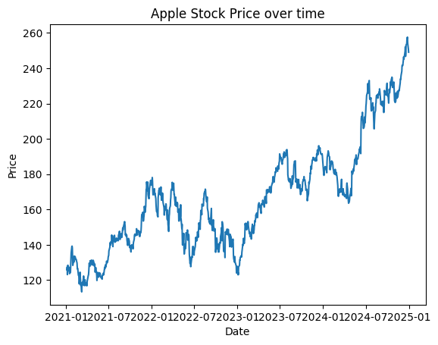
The stock here represent a long-term increase in trend with intermittent fluctuations.
👉 Insight :
This indicates growth potential but also short-term volatility.

🔹 Moving Averages
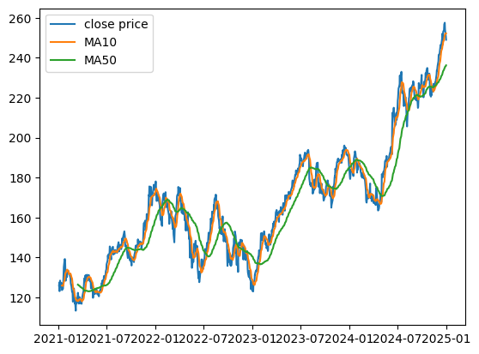
short-term and long-term moving averages are a smooth representation of price movement.
👉 Insight :
Crossovers between MA10 and MA50, which mean that there are potential trends shifts and are used in trading strategies.

🔹 Volatility Analysis
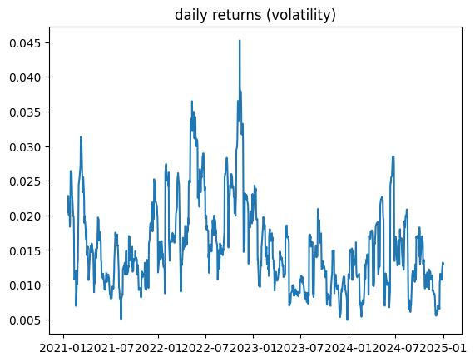
The daily returns plot shows the increase and decrease of fluctuations in returns.
👉 Insight :
Higher volatility proves the uncertainty and risk of market, which is important for decision making.
🤖 Model Evaluation
To evaluate the model we used multiple metrics:
- RMSE (Root Mean Squared Error)
- MAE (Mean Absolut Error)
- R² Score
👉 Interpretation:
- RMSE and MAE indicates the average prediction error
- R² reflect how good is the model to explains variability
The output of the coding shows that the model noticed general price patterns the accuracy of the model is limited by market randomness.
📊 Prediction Analysis
A multi-layered dashboard was developed to integrate:
- Price trends and Moving averages
- Market volatility (Risk Indicator)
- Model predictions vs actual values
👉 Strategic Value :
This dashboard provides a consolidated view of market behavior, enabling faster and more informed decision-making.
💡 Key Insights
- Stock prices exhibit identifiable trends despite short-term noise.
- Volatility is a major factor affecting prediction accuracy.
- Combining trend indicators with machine learning improves predictive performance.
- Predictions are more reliable for trend direction than exact values.

⚠️ Limitations
- Financial markets are influenced by external factors not included in the dataset.
- The model does not incorporate news, macroeconomic data, or sentiment.
- Prediction accuracy decreases during high volatility periods.
🔮 Recommendations
- Integrate additional features such as trading volume and technical indicators (RSI, MACD).
- Use advanced models like Gradient Boosting or LSTM.
- Incorporate external data sources for improved accuracy.
📌 Conclusion
This project demonstrates how data analytics and machine learning can be applied to financial markets to extract meaningful insights and support decision-making. While the model provides useful trend predictions, it also highlights the inherent uncertainty of financial markets.
The findings emphasize the importance of combining data-driven models with domain knowledge when making investment decisions.

