1) Download the following json file import it

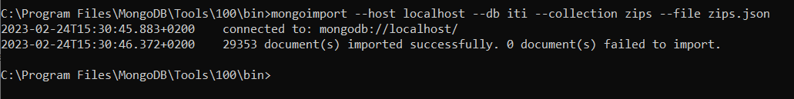

2) Find all document which contains data related to “NY”

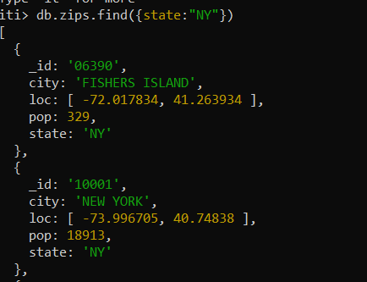

3) Find all zip codes whose population is greater than or equal 1000

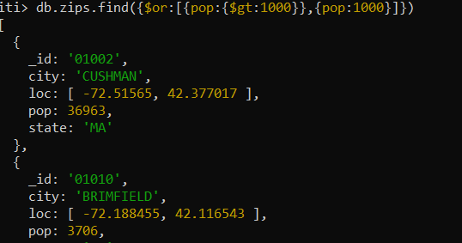

4) Add new Boolean field called “check”

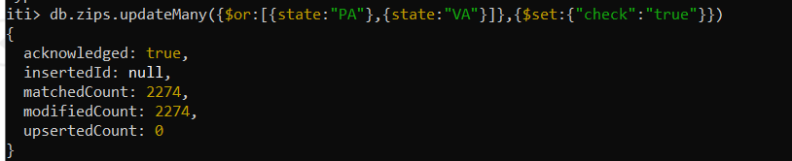

5) Find all cities whose latitude between 55 and 65

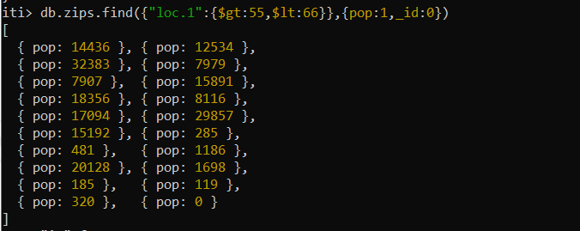

6) Create Index for states

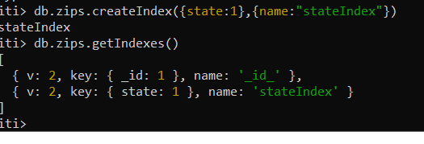

7) Increase the population by 0.2 for all cities

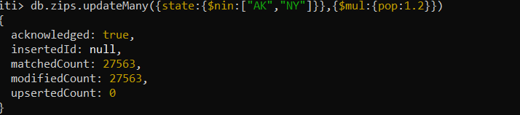

8) Update only one city whose longitude is lower than -71 and is not located in “MA”

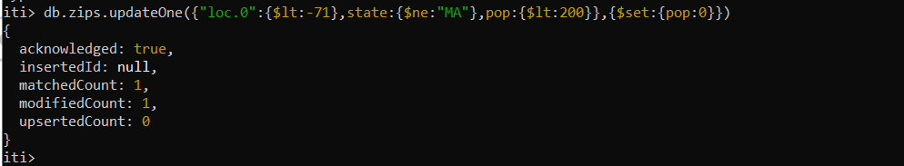

9) Update all documents whose city field is a string

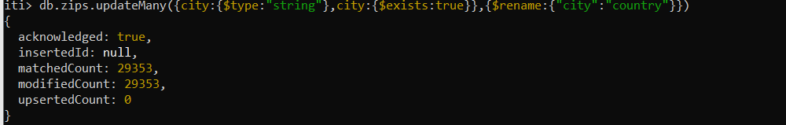

Part2