C++ for Robotics

Chapter 3: Functions
- Summary -
Estimated time to completion: 2 hours
In this unit you are going to learn some more advanced tools that are going to allow you to create more complex and interesting programs. Specifically, you are going to learn about functions.
- End of Summary -
Remember that in this course, we want to keep the focus on C++, not on ROS. You have been working with variables and datatypes, and you've learned what are the conditional statements and how to implement loops. Also, you have done some exercises using functions, or as we said, CALLING functions. It's time to really understand what that means!
In the most general sense, a function is a structuring element in programming languages, used to group a set of statements that you define once and can be utilized many times in a program. We just need to CALL them with one line of code. The only way to accomplish this without functions would be to reuse code by copying it and adapting it to a different context. Using functions usually enhances the comprehensibility and quality of the program. It also lowers the cost for development and maintenance of the software.
- Remember -
It is very important that you remember that C++ is a compiled language, so every time we make changes to our code we'll need to first compile it and then execute it, in order to see the changes in the simulation. Go back to section 1.1 if you have any doubt.
Additionally, if you want to test the scripts we will be presenting in this chapter remember to create a .cpp file in the /utilities folder and execute it by doing:
In [ ]:
cd ~/catkin_ws/src/cpp_course_repo/utilities/
In [ ]:
touch file.cpp
In [ ]:
g++ -std=c++11 file.cpp -o file_compiled
In [ ]:
./file_compiled

3.1 Definition of a function
A function in C++ is defined by a variable type, a name and parenthesis. The statements it applies come inside brackets. The easiest one has this structure:
In [ ]:
void myfunction() {
printf("Hello, ROS developer! \n");
}
Here we are defining a function that introduces three important concepts:
- void means that the function doesn't return any variable
- myfunction is the name we'll use to call it
- printf is the statement that this function reproduces every time we call it

3.2 Calling a function
In order to call a function, as we have done in previous chapters, you just have to specify the name of the function, followed by the open and close parenthesis. Check the example below where we first define the function, and then we call it:
In [ ]:
void myfunction() {
printf("The function myfunction() has been called \n");
}

myfunction();
If you compile and execute the above code in a .cpp script you will get the following output:
> The function myfunction() has been called

Note that if you define the function but never call it, you'll never see the print inside it.

3.3 Function parameters
Parameters are specified after the function name, inside the parenthesis. In the function's definition the parameters have to be passed with their data types. You can add as many parameters as you want, just separate them with a comma. Check out the example below:
In [ ]:
void myfunction(int a, int b) {
int sum = a+b;
cout << "Result: " << sum << endl;
}

myfunction(2,3);
myfunction(4,3);
This function performs the summation of two ints passed as parameters. We can call it as many times as we want, changing the input parameters if we want. If you execute it the expected output is:
> Result: 5

> Result: 7

As you can see, parameters in a function's definition are optional. However, if they are specified in the definition they become mandatory every time we call the function.
However we can also specify optional parameters (usually known as default parameters) which, if not passed by the user when calling the function, will have a default value. For example:
In [ ]:
void myfunction(int a=5, int b=1) {
int sum = a+b;
cout << "Result: " << sum << endl;
}

myfunction();
myfunction(2,3);
Here, in the first call the function will take the default parameters for a and b (a=5, b=1), so the sum will be sum=6. In the second call we specify the values for the parameters a and b (a=2,b=3), so the sum will be sum=5.
> Result: 6

> Result: 5

3.4 Return statement
In the previous chapters, whenever we performed calls to functions, sometimes they returned some kind of value, right? However, in the examples we've seen up until now, we are not returning anything from our functions, are we?
So, this clearly tells us that the return statement is not mandatory. As we said, in C++ a function was defined by a variable type, depending what type of variable they return. For example:
> void myfunction()
> int myfunction()
> string myfunction()
> list<int> myfunction()

The first one does not return anything, the second one an integer, the third one a string, the last one a list of integers. As you can see, there are as many possibilities as datatypes we have!
For example, everytime we've asked you to test a script, you've had to write your code inside a main function, expressed as int main(). This function is mandatory in a script we want to execute. Now you can understand that main is its name, int is the type we expect to return, and inside the brackets are the statements we want to execute. Finally, remember that we close the function by returning a 0, which is a type integer.
Let's modify the previous function to return the value of the sum of integers:
In [ ]:
int myfunction(int a=5, int b=1) {
int sum = a+b;
return sum;
}

int result = myfunction();
cout << "Result: " << result << endl;
Pay attention to two important things:
- The function is defined to return an integer (int myfunction), so inside the function the return statement must be followed by an integer value (return sum)
- Whenever we call the function, we must assign the result as an integer as well (int result)
Here, we modified the function to just perform the sum of the two integers. The value will only be printed after calling the function.
Let's also point out that in C++ functions can be overloaded, which means that multiple functions can have the same name with different parameters. For example, if we want the previous function to work with integers but also with doubles we can define it twice:
In [ ]:
int myfunction(int a=5, int b=1) {
return a+b;
}
double myfunction(double a=5.1, double b=4.4) {
return a+b;
}
int result1 = myfunction(2,3);
cout << "Int result: " << result1 << "\n";
double result2 = myfunction(2.1,3.3);
cout << "Double result: " << result2 << "\n";
where the function is called twice, once with integers and once with doubles. It should print:
> Int result: 5
> Double result: 5.4
Finally, a function can only return exactly one value, or we should say, one variable. A variable can be a numerical value, like an integer or a float, but it can also be a list or a dictionary. So, if we have to return for example three integer values, we can return a list with these three integer values, and specify it in the type function's definition:
In [ ]:
#include <list>

list<int> myfunction(int a=5, int b=1) {
int sum = a+b;
list<int> list_results({a,b,sum});
return list_results;
}

list<int> results = myfunction();
for (int number : results) {
cout << number << ", ";
}
cout << endl;
You should see how this script returns the three integers used in the function myfunction():
> 5, 1, 6,

3.5 Structure of a function
Finally, let's summarize the structure of a function we've seen so far:
> datatype my_function ( datatype1 parameter1, datatype2 parameter2 ) {
>
> block_statement;
>
> return variable;

> datatype variable = my_function ( parameter1, parameter2 );
- Exercise 3.1 -
Let's put all that to work!!
First, open the IDE again, and inside the folder /c_scripts/src/ open the file unit3_exercise.cpp. Take the unit2_exercise.cpp as an example for the structure of the code.
Create a function outside the main method that accepts as a parameter the object rosbot, of type RosbotClass, and an integer called n_secs. This function has to be called move_and_inform, and has to return a list with two floats: the new x and y coordinates of the robot.
To do this, put inside the function the actions of moving forward for n_secs seconds and then read the x,y position of the robot.
In this unit we are going to use the scenario of the Costa Coffee simulation. See here an example of a robot advancing for two seconds:
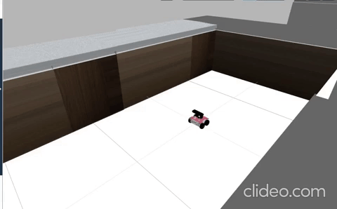
and printing the x and y coordinates in the shell:
Remember to run the program by doing:
In [ ]:
rosrun c_scripts unit3_exercise
- End of Exercise 3.1 -
- Solution of Exercise 3.1 -
Please try to do it by yourself unless you get stuck or need some inspiration. You will learn much more if you fight for each exercise.
unit3_exercise.cpp
In [ ]:
#include "rosbot_control/rosbot_class.h"
#include <ros/ros.h>
#include <list>
using namespace std;

list<float> move_and_inform( RosbotClass rosbot, int n_secs) {

rosbot.move_forward(n_secs);
float x = rosbot.get_position(1);
float y = rosbot.get_position(2);

list<float> list_coordinates({x,y});

return list_coordinates;
}

int main(int argc, char **argv) {
ros::init(argc, argv, "rosbot_node");

RosbotClass rosbot;

list<float> list_coordinates = move_and_inform(rosbot,5.0);
for (float coord : list_coordinates) {
cout << coord << ", ";
}

return 0;

}
- End of Solution of Exercise 3.1 -

3.6 Local and Global Variables in Functions
Variables are local to the functions in which they are defined. They cannot be used outside the function, and all their names inside that function must be unique. See the following example:
In [ ]:
void myfunction() {
string sentence = "Local Variable";
}

myfunction();
cout << sentence;
This example will bring an error, because sentence does not exist outside the function myfunction. Another particularity of local variables is that their lifetime lasts between when they are defined in the function, and when they are destroyed at the end of it.
If we want variables to be available for all the functions in the script we can use global variables, which are declared outside of functions. Generally, they are declared at the top of a file, below the includes.
See the following example:
In [ ]:
#include <iostream>
using namespace std;

string g_sentence; //global variable

void myfunction() {
g_sentence = "Global variable";
}

int main() {

myfunction();
cout << g_sentence << endl;

return 0;
}
The variable g_sentence is defined at the top of the code. Then the function myfunction uses it to assign it a string value, and the main function prints its value. As you can see, g_sentence can be used in all the functions of our script without needing to pass them as parameters when calling a function.
Just one more thing, many developers use a name for global variables preceeded by g_, that way if we see the variable in the code we'll know its a global variable.
Finally, be careful with the use of these global variables. They can be accessed from anywhere of the code, so when developing a really large code with lots of functions we may miss if they are being modified somewhere and never find it. It is good practice that, if we really need them, make them constant inside a script, by declaring them like this:
In [ ]:
const string g_sentence;

Let's play some more with the robot!
For the following exercise, we are going to introduce a new function:
- turn (clockwise, n_secs): This function allows you to turn the robot. You will need to pass two parameters to it.
  - clockwise: Specify here whether you want your robot to turn clockwise ("clockwise") or counter-clockwise ("counterclockwise").
  - n_secs: Specify here how long you want to robot to keep turning (in seconds).
This function will print a message after the movement is succesful.
- Exercise 3.2 -
See in the following picture where the rosbot starts in the Costa Coffee simulation:
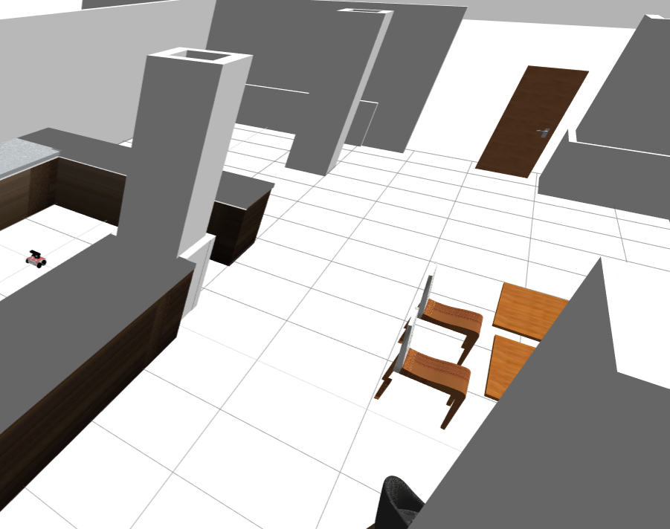
Then, open the IDE again, and inside the folder /c_scripts/src/ modify the file unit3_exercise.cpp.
Inside this new file create a function that will contain your desired trajectory. Remember that this function has to take as input parameter the rosbot object. Make the robot move around the world, using the functions move_forward(n_secs) and turn(clockwise,n_secs) to bring it from inside the kitchen (on the left) to the exit door (on the right).

Also, make the function return a string message of trajectory successful and print it.
- End of Exercise 3.2 -
- Solution of Exercise 3.2 -
Please try to do it by yourself unless you get stuck or need some inspiration. You will learn much more if you fight for each exercise.
unit3_exercise.cpp
In [ ]:
#include "rosbot_control/rosbot_class.h"
#include <list>
#include <ros/ros.h>
#include <string>
using namespace std;

string trajectory(RosbotClass rosbot) {
rosbot.turn("clockwise", 3);
cout << "Turn completed " << endl;
rosbot.move_forward(2.0);
cout << "Move completed" << endl;
rosbot.turn("counterclockwise", 3);
cout << "Turn completed" << endl;
rosbot.move_forward(10.0);
rosbot.turn("clockwise", 2);
rosbot.move_forward(3.0);

string message = "Trajectory was succesful!!";
return message;
}

int main(int argc, char **argv) {
ros::init(argc, argv, "rosbot_node");

RosbotClass rosbot;

string m = trajectory(rosbot);
cout << m << endl;

return 0;
}
- End of Solution of Exercise 3.2 -

3.7 Summary
In this chapter we've finally understood what we had been using in this course: Functions!
They are a basic unit of any programming language, as it is code that can be reused anytime we need to. Also they help mantain our scripts clean, and as you have seen, they can be reused from one script to another.
We will see later what defines a class, but for the moment we've learned how to use functions of the class RosbotClass, developed in another script in another ROS package.

