ROS Basics in 5 days (C++)

Unit 8 ROS Actions: Clients
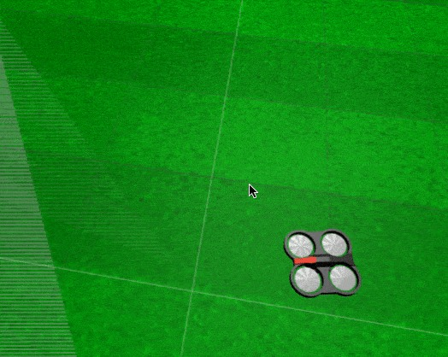
- Summary -
Estimated time to completion: 3 hours
What will you learn with this unit?
- What is a ROS action
- How to manage the actions of a robot
- How to call an action server
- End of Summary -
1) Did you understand the previous sections about topics and services?
2) Are they clear to you?
3) Did you have a good breakfast today?
If your answers to all of those questions were yes, then you are ready to learn about ROS actions. Otherwise, go back and do not come back until all of those answers are a big yes. You are going to need it...

Quadrotor simulation
Before starting with ROS actions learning, let's have some fun with the quadrotor simulation.\ Make the quadrotor take off and control it with the keyboard.\ How would you do that?\ \ By issuing the following commands:
First, you need to take off.
Execute in Shell #1
In [ ]:
rostopic pub /drone/takeoff std_msgs/Empty "{}"
Hit CTRL+C to stop it and to be able to type more commands. In this case, the commands to move the drone with the keyboard.
Execute in Shell #1
In [ ]:
rosrun teleop_twist_keyboard teleop_twist_keyboard.py
To land the drone, just publish into the /drone/land topic:
Execute in Shell #1
In [ ]:
rostopic pub /drone/land std_msgs/Empty "{}"
Code Explanation #1
rosrun: ROS command that allows you to run a ROS program without having to create a launch file to launch it (it is a different way from what we've been doing here).
teleop_twist_keyboard: Name of the package where the ROS program is. In this case, where the python executable is.
teleop_twist_keyboard.py: Python executable that will be run. In this case, it's an executable that allows you to input movement commands through the keyboard. When executed, it displays the instructions to move the robot.
End Code Explanation #1
- Exercise 8.1 -
Try to takeoff, move, and land the drone using the keyboard, as shown in the gif in Fig: 8.1
- End of Exercise 8.1 -
- Expected Result for Exercise 8.1 -

- End of Expected Result -

8.1 What are actions?

Actions are like asynchronous calls to services.
Actions are the same as services. When you call an action, you are calling a functionality that another node is providing. Just the same as with services. The difference is that when your node calls a service, it must wait until the service finishes. When your node calls an action, it doesn't necessarily have to wait for the action to complete.
Hence, an action is an asynchronous call to another node's functionality.
- The node that provides the functionality has to contain an action server. The action server allows other nodes to call that action functionality.
- The node that calls to the functionality has to contain an action client.
The action client allows a node to connect to the action server of another node.
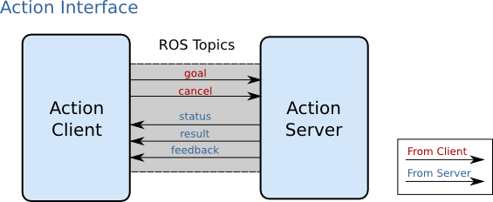
Now let's see an action in action (I'm so funny!)
- Exercise 8.2 -
Go to a shell and launch the ardrone action server with the following command:
Keep this program running for the rest of the tutorial, since it is the one that provides the action server you are going to use.
Execute in Shell #1, Leave It Running
In [ ]:
roslaunch ardrone_as action_server.launch
Questions:
- How do you know the whole list of topics available?
Execute in Shell #2
In [ ]:
rostopic list
- How do you know the whole list of services available?
Execute in Shell #2
In [ ]:
rosservice list
- How do you know the whole list of action servers available?
Execute in Shell #2
In [ ]:
rosaction list

WRONG GUESS!!!

In order to find which actions are available on a robot, you must do a rostopic list.
Execute in Shell #2
In [ ]:
rostopic list
Shell #2 Output
In [ ]:
user ~ $ rostopic list
...
...
/ardrone_action_server/cancel
/ardrone_action_server/feedback
/ardrone_action_server/goal
/ardrone_action_server/result
/ardrone_action_server/status
...
...
- End of Exercise 8.2 -
When a robot provides an action, you will see that in the topics list. There are 5 topics with the same base name, and with the subtopics cancel, feedback, goal, result, and status.
For example, in the previous rostopic list, the following topics were listed:
In [ ]:
/ardrone_action_server/cancel
/ardrone_action_server/feedback
/ardrone_action_server/goal
/ardrone_action_server/result
/ardrone_action_server/status
This is because you previously launched the ardrone_action_server with the command roslaunch ardrone_as action_server.launch Excercice 8.2
Every action server creates those 5 topics, so you can always tell that an action server is there because you identified those 5 topics.
Therefore, in the example above:
1. ardrone_action_server: Is the name of the Action Server.
2. cancel, feedback, goal, result and status: Are the messages used to comunicate with the Action Server.

8.2 Calling an action server
The ardrone_action_server action server is an action that you can call. If you call it, it will start taking pictures with the front camera, one picture every second, for the amount of seconds specified in the calling message (it is a parameter that you specify in the call).
Calling an action server means sending a message to it. In the same way as with topics and services, it all works by passing messages around.
- The message of a topic is composed of a single part: the information the topic provides.
- The message of a service has two parts: the goal and the response.
- The message of an action server is divided into three parts: the goal, the result, and the feedback.
All of the action messages used are defined in the action directory of their package.
You can go to the ardrone_as package and see that it contains a directory called action. Inside that action directory, there is a file called Ardrone.action. That is the file that specifies the type of the message that the action uses.
Type in a shell the following commands to see the message structure:
- Exercise 8.3 -
Type in a shell the following commands to see the message structure:
Execute in Shell #2
In [ ]:
roscd ardrone_as/action; cat Ardrone.action
Shell #2 Output
In [ ]:
user ~ $ roscd ardrone_as/action; cat Ardrone.action
#goal for the drone
int32 nseconds # the number of seconds the drone will be taking pictures
---
#result
sensor_msgs/CompressedImage[] allPictures # an array containing all the pictures taken along the nseconds
---
#feedback
sensor_msgs/CompressedImage lastImage # the last image taken
- End of Exercise 8.3 -
You can see in the previous step how the message is composed of three parts:
goal: Consists of a variable called nseconds of type Int32. This Int32 type is a standard ROS message, therefore, it can be found in the std_msgs package. Because it's a standard package of ROS, it's not needed to indicate the package where the Int32 can be found.
result: Consists of a variable called allPictures, an array of type CompressedImage[] found in the sensor_msgs package.
feedback: Consists of a variable called lastImage of type CompressedImage[] found in the sensor_msgs package.
You will learn in the second part of this chapter about how to create your own action messages. For now, you must only understand that every time you call an action, the message implied contains three parts, and that each part can contain more than one variable.

8.2.1 Actions provide feedback
Due to the fact that calling an action server does not interrupt your thread, action servers provide a message called the feedback. The feedback is a message that the action server generates every once in a while to indicate how the action is going (informing the caller of the status of the requested action). It is generated while the action is in progress.

8.2.2 How to call an action server
The way you call an action server is by implementing an action client.
The following is a self-explanatory example of how to implement an action client that calls the ardrone_action_server and makes it take pictures for 10 seconds.
- Exercise 8.4 -
- Create a new package named action_client_pkg. When creating the package, add as dependencies roscpp and actionlib.
- Inside the src folder of the package, create a new file named ardrone_action_client.cpp. Inside this file, copy the contents of ardrone_action_client.cpp (the next code block).
- Create a launch file for launching this code.
- Do the necessary modifications to your CMakeLists.txt file, and compile the package.
- Execute the launch file to run your executable.
Remember that you have to have the roslaunch ardrone_as action_server.launch running (probably in WebShell #1), otherwise this won't work because there will be NO action server to be connected to.
- End of Exercise 8.4 -
C++ Program 8.4a: ardrone_action_client.cpp
In [ ]:
#include <ros/ros.h>
#include <ardrone_as/ArdroneAction.h> // Note: "Action" is appended
#include <actionlib/client/simple_action_client.h>

int nImage = 0; //Initialization of a global variable

// Definition of the done calback. It is called once when the goal completes
void doneCb(const actionlib::SimpleClientGoalState& state,
const ardrone_as::ArdroneResultConstPtr& result)
{
ROS_INFO("The Action has been completed");
ros::shutdown();
}

// Definition of the active callback. It is called once when the goal becomes active
void activeCb()
{
ROS_INFO("Goal just went active");
}

// Definition of the feedback callback. This will be called when feedback is received from the action server. It just // prints a message indicating a new message has been received
void feedbackCb(const ardrone_as::ArdroneFeedbackConstPtr& feedback)
{
ROS_INFO("[Feedback] image n.%d received", nImage);
++nImage;
}

int main(int argc, char** argv)
{
ros::init(argc, argv, "drone_action_client"); // Initializes the action client node
// Create the connection to the action server
actionlib::SimpleActionClient<ardrone_as::ArdroneAction> client("ardrone_action_server", true);
client.waitForServer(); // Waits until the action server is up and running

ardrone_as::ArdroneGoal goal; // Creates a goal to send to the action server
goal.nseconds = 10; // Fills the goal. Indicates, take pictures along 10 seconds
client.sendGoal(goal, &doneCb, &activeCb, &feedbackCb); // sends the goal to the action server, specifying which // functions to call when the goal completes, when the // goal becames active, and when feedback is received

client.waitForResult();
return 0;
}
Code Explanation C++ Program: 8.4a
The code to call an action server is very simple:

1. First, you create a client connected to the action server you want:

actionlib::SimpleActionClient<ardrone_as::ArdroneAction> client("ardrone_action_server", true);
// actionlib::SimpleActionClient<the_action_server_action_message> client("the_action_server_name", true);
- The first parameter is the type of action message that it uses.
- The second parameter is the name of the action server you want to connect to.
The convention goes as follows:
- If your action message file was called Ardrone.action, then the type of action message you must specify is ArdroneAction. The same rule applies to any other type (R2Action, for an R2.action file or LukeAction for a Luke.action file). In our exercise it is:
actionlib::SimpleActionClient<ardrone_as::ArdroneAction> client("ardrone_action_server", true)

2. Then you create a goal:

ardrone_as::ArdroneGoal goal;
Again, the convention goes as follows:
- If your action message file was called Ardrone.action, then the type of goal message you must specify is ArdroneGoal. The same rule applies to any other type (R2Goal for an R2.action file or LukeGoal for a Luke.action file).
Because the goal message requires you to provide the number of seconds taking pictures, you must set that parameter in the goal class instance:
goal.nseconds = 10;

3. Next, you send the goal to the action server:

client.sendGoal(goal, &doneCb, &activeCb, &feedbackCb);
That sentence calls the action. In order to call it, you must specify 4 things:
- The goal parameters
- A done function to be called when the action finishes.
- An active function to be called when the action starts.
- A feedback function to be called from time to time to know the status of the action.
At this point, the action server has received the goal and started to execute it (taking pictures for 10 seconds). Also, feedback messages are being received. Every time a feedback message is received, the feedbackCb is executed.

4. Finally, you wait for the result:

client.waitForResult();
So, at the end, you should get something like this in the webshell where you run the action client:
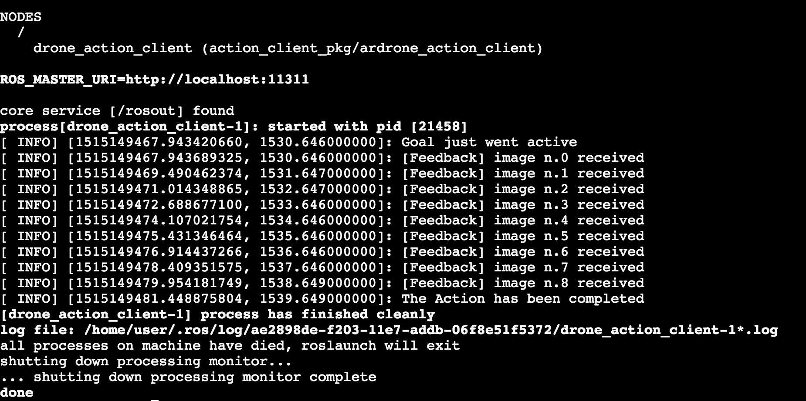
End Code Explanation

8.3 How to perform other tasks while the Action is in progress
You know how to call an action and wait for the result but... That's exactly what a service does! Then why are you learning actions?
Good point!
So the SimpleActionClient objects have two functions that can be used for knowing if the action that is being performed has finished, and how:
- wait_for_result(): This function is very simple. When called, it will wait until the action has finished and returns a true value. As you can see, it's useless if you want to perform other tasks in parallel because the program will stop there until the action is finished.
- get_state(): This function is much more interesting. When called, it returns an integer that indicates in which state is the action that the SimpleActionClient object is connected to:
0 ==> PENDING
1 ==> ACTIVE
2 ==> DONE
3 ==> WARN
4 ==> ERROR
This allows you to create a while loop that checks if the value returned by get_state() is 2 or higher. If it is not, it means that the action is still in progress, so you can keep doing other things.
- Exercise 8.5 -
- Inside the src folder of the package action_client_pkg, create 2 new files, named wait_for_result_test.cpp and no_wait_for_result_test.cpp. Inside this file, copy the contents of wait_for_result_test.cpp and no_wait_for_result_test.cpp (the following code blocks).
- Create 2 launch files for launching each one of the codes.
- Do the necessary modifications to your CMakeLists.txt file, and compile the package.
- Execute the launch files to run your executables and compare the results.
Remember that you have to have the roslaunch ardrone_as action_server.launch running (probably in WebShell #1), otherwise this won't work because there will be NO action server to be connected to.
- End of Exercise 8.5 -
C++ Program 8.5a: wait_for_result_test.cpp
In [ ]:
#include <ardrone_as/ArdroneAction.h> // Note: "Action" is appended
#include <actionlib/client/simple_action_client.h>

int nImage = 0;

void doneCb(const actionlib::SimpleClientGoalState& state,
const ardrone_as::ArdroneResultConstPtr& result)
{
ROS_INFO("The Action has been completed");
ros::shutdown();
}

// Called once when the goal becomes active
void activeCb()
{
ROS_INFO("Goal just went active");
}

void feedbackCb(const ardrone_as::ArdroneFeedbackConstPtr& feedback)
{
ROS_INFO("[Feedback] image n.%d received", nImage);
++nImage;
}

int main(int argc, char** argv)
{
ros::init(argc, argv, "wait_for_result");
actionlib::SimpleActionClient<ardrone_as::ArdroneAction> client("ardrone_action_server", true);
client.waitForServer();

ardrone_as::ArdroneGoal goal;
goal.nseconds = 10;

client.sendGoal(goal, &doneCb, &activeCb, &feedbackCb);
//client.waitForResult();

ros::Rate loop_rate(2);

while (client.waitForResult() != true)
{
ROS_INFO("Doing Stuff while waiting for the Server to give a result...");
loop_rate.sleep();
}

return 0;
}
C++ Program 8.5b: no_wait_for_result_test.cpp
In [ ]:
#include <ros/ros.h>
#include <ardrone_as/ArdroneAction.h> // Note: "Action" is appended
#include <actionlib/client/simple_action_client.h>

int nImage = 0;

void doneCb(const actionlib::SimpleClientGoalState& state,
const ardrone_as::ArdroneResultConstPtr& result)
{
ROS_INFO("[State Result]: %s", state.toString().c_str());
ROS_INFO("The Action has been completed");
ros::shutdown();
}

// Called once when the goal becomes active
void activeCb()
{
ROS_INFO("Goal just went active");
}

void feedbackCb(const ardrone_as::ArdroneFeedbackConstPtr& feedback)
{
ROS_INFO("[Feedback] image n.%d received", nImage);
++nImage;
}

int main(int argc, char** argv)
{
ros::init(argc, argv, "drone_action_client");
actionlib::SimpleActionClient<ardrone_as::ArdroneAction> client("ardrone_action_server", true);
client.waitForServer();

ardrone_as::ArdroneGoal goal;
goal.nseconds = 10;

client.sendGoal(goal, &doneCb, &activeCb, &feedbackCb);
//client.waitForResult();

ros::Rate loop_rate(2);
actionlib::SimpleClientGoalState state_result = client.getState();
ROS_INFO("[State Result]: %s", state_result.toString().c_str());

while ( state_result == actionlib::SimpleClientGoalState::ACTIVE || state_result == actionlib::SimpleClientGoalState::PENDING )
{
ROS_INFO("Doing Stuff while waiting for the Server to give a result...");
loop_rate.sleep();
state_result = client.getState();
ROS_INFO("[State Result]: %s", state_result.toString().c_str());
}

return 0;
}
Code Explanation C++ Programs: 8.5a and 8.5b
Essentially, the difference is that in the first program (8.5a), the log message ("Doing Stuff while waiting for the Server to give a result....") will never be printed, while in the 8.5b it will.
This is because in 8.5a, the program starts the while loop to check if the value returned by client.waitForResult() is True or False, but it will wait for a value that will only be returned when the Action has Finished. Therefore, it will never get inside the while loop because it will always return the value True.
On the other hand, in the 8.5b program, it checks if state_result == PENDING || state_result == ACTIVE. And because the function get_state() will return the current state of the action immediately, it allows other tasks to perform in parallel. In this case, printing the log message WHILE printing also the feedback printed by the Action.
At the end, you should get something like this:
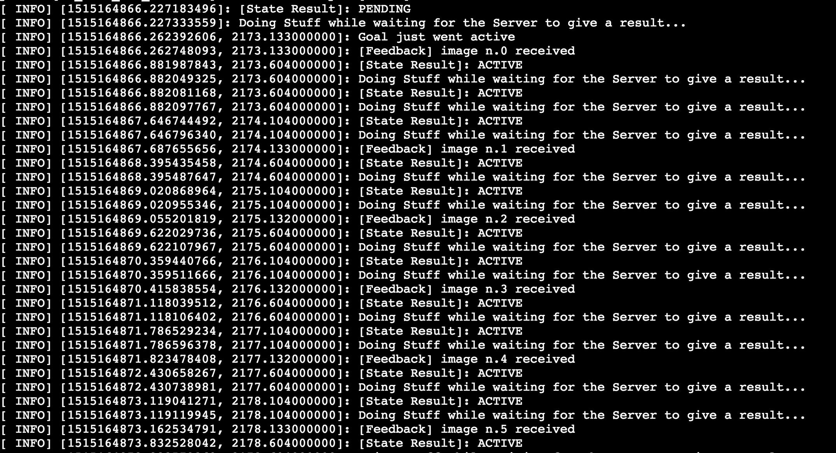
End Code Explanation C++ Programs: 8.5a and 8.5b
You can get more information about ROS action clients in C++ in this client API
- Exercise 8.6 -
- Create a package that contains and launches the action client from Excercice {8.4a}: ardrone_action_client.cpp, from a launch file.
- Add some code that makes the quadcopter move around while the action server has been called (in order to take pictures while the robot is moving).
- Stop the movement of the quadcopter when the last picture has been taken (action server has finished).
Remember that you have to have the roslaunch ardrone_as action_server.launch running (probably in WebShell #1), otherwise this won't work because there will be NO action server to be connected to.
- End of Exercise 8.6 -
- Notes for Exercise 8.6 -
1) You can send Twist commands to the quadcopter in order to move it. These commands have to be published in /cmd_vel topic . Remember the TopicsUnit.
2) You must send movement commands while waiting until the result is received, creating a loop that sends commands at the same time that check for completion. In order to be able to send commands while the action is in progress, you need to use the SimpleActionClient function getState() .
- End of Notes -

8.4 Preempting a goal
It happens that you can cancel a goal previously sent to an action server prior to its completion.
Cancelling a goal while it is being executed is called preempting a goal.
You may need to preempt a goal for many reasons, like, for example, the robot went mad about your goal and it is safer to stop it prior to the robot doing some harm.
In order to preempt a goal, you send the cancel_goal to the server through the client connection.
In [ ]:
client.cancelGoal()
- Exercise 8.7 -
1. Inside the src folder of the package action_client_pkg, create a new files named cancel_goal_test.cpp. Inside this file, copy the contents of cancel_goal_test.cpp.
2. Create a launch files for launching the code.
3. Do the necessary modifications to your CMakeLists.txt file, and compile the package.
4. Execute the launch file in order to run the executable.
Remember that you have to have the roslaunch ardrone_as action_server.launch running (probably in WebShell #1), otherwise this won't work because there will be NO action server to be connected to.
- End of Exercise 8.7 -
C++ Program 8.6a: cancel_goal_test.cpp
In [ ]:
#include <ros/ros.h>
#include <ardrone_as/ArdroneAction.h> // Note: "Action" is appended
#include <actionlib/client/simple_action_client.h>

//int PENDING = 0;
//int ACTIVE = 1;
//int DONE = 2;
//int WARN = 3;
//int ERROR = 4;

int nImage = 0;

void doneCb(const actionlib::SimpleClientGoalState& state,
const ardrone_as::ArdroneResultConstPtr& result)
{
ROS_INFO("[State Result]: %s", state.toString().c_str());
ROS_INFO("The Action has been completed");
ros::shutdown();
}

// Called once when the goal becomes active
void activeCb()
{
ROS_INFO("Goal just went active");
}

void feedbackCb(const ardrone_as::ArdroneFeedbackConstPtr& feedback)
{
ROS_INFO("[Feedback] image n.%d received", nImage);
++nImage;
}

int main(int argc, char** argv)
{
ros::init(argc, argv, "cancel_goal_test");
actionlib::SimpleActionClient<ardrone_as::ArdroneAction> client("ardrone_action_server", true);
client.waitForServer();

ardrone_as::ArdroneGoal goal;
goal.nseconds = 10;

client.sendGoal(goal, &doneCb, &activeCb, &feedbackCb);
//client.waitForResult();

ros::Rate loop_rate(2);
actionlib::SimpleClientGoalState state_result = client.getState();
ROS_INFO("[State Result]: %s", state_result.toString().c_str());
int counter = 0;

while ( state_result == actionlib::SimpleClientGoalState::ACTIVE || state_result == actionlib::SimpleClientGoalState::PENDING )
{
ROS_INFO("Doing Stuff while waiting for the Server to give a result...");
loop_rate.sleep();
state_result = client.getState();
ROS_INFO("[State Result]: %s", state_result.toString().c_str());
++counter;
if (counter == 2)
{
ROS_INFO("Canceling goal...");
client.cancelGoal();
ROS_INFO("Goal canceled...");
state_result = client.getState();
ROS_INFO("[State Result]: %s", state_result.toString().c_str());
ROS_INFO("counter = %d", counter);
}
}

return 0;
}
Code Explanation C++ Program: 8.6a
It's exactly the same code as the 8.5b, except for the use of the cancelGoal() function.
This program counts to 2, and then it cancels the goal. This triggers the server to finish the goal and, therefore, the function getState() returns the value PREEMPTED.
You should see something like this in the webshell output of the client:
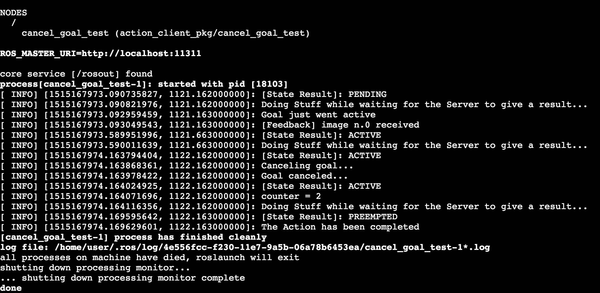
And this in the server webshell:
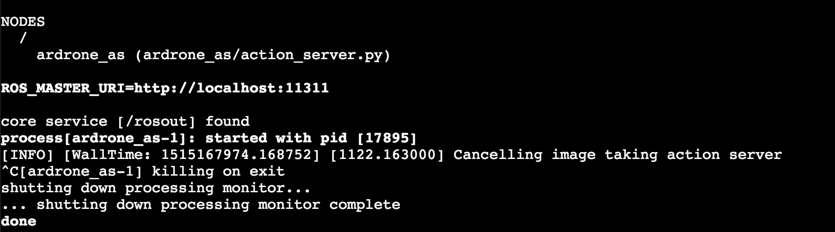
End Code Explanation C++ Program: 8.6a
There is a known ROS issue with Actions. It issues a warning when the connection is severed. It normally happens when you cancel a goal or you just terminate a program with a client object in it. The warning is given in the Server Side.
[WARN] Inbound TCP/IP connection failed: connection from sender terminated before handshake header received. 0 bytes were received. Please check sender for additional details.
Just don't panic, it has no effect on your program.

8.5 How does all that work?
You need to understand how the communication inside the actions works. It is not that you are going to use it for programming. As you have seen, programming an action client is very simple. However, it will happen that your code will have bugs and you will have to debug it. In order to do proper debugging, you need to understand how the communication between action servers and action clients works.
As you already know, an action message has three parts:
- the goal
- the result
- the feedback
Each one corresponds to a topic and to a type of message. For example, in the case of the ardrone_action_server, the topics involved are the following:
- the goal topic: /ardrone_action_server/goal
- the result topic: /ardrone_action_server/result
- the feedback topic: /ardrone_action_server/feedback
Look again at the ActionClient+ActionServer communication diagram.
So, whenever an action server is called, the sequence of steps are as follows:
1. When an action client calls an action server from a node, what actually happens is that the action client sends to the action server the goal requested through the /ardrone_action_server/goal topic.
2. When the action server starts to execute the goal, it sends to the action client the feedback through the /ardrone_action_server/feedback topic.
3. Finally, when the action server has finished the goal, it sends to the action client the result through the /ardrone_action_server/result topic.
Now, let's do the following exercise in order to see how all this ballet happens underneath your programs.
- Exercise 8.8 -
- Read the whole exercise prior to executing it, because you have to get properly set up prior to the start of executing anything.
- Deamonize the action server and echo the goal topic (press CTRL + C to kill the ardrone_as action_server.launch if you had it still running).
Execute in Shell #1
In [ ]:
roslaunch ardrone_as action_server.launch &
(to kill it when finished, use the command: rosnode kill /ardrone_as)
In [ ]:
rostopic echo /ardrone_action_server/goal
Echo the feedback topic:
Execute in Shell #2:
In [ ]:
rostopic echo /ardrone_action_server/feedback
Echo the result topic:
Execute in Shell #3:
In [ ]:
rostopic echo /ardrone_action_server/result
Execute in Shell #4: Launch the action server client
- Execute the launch you created in Exercice 8.6, so that the drone starts to take pictures and move around.
- Now do the following:
- Quickly visit the terminal that contained the goal echo (WebShell #1). A message should have appeared indicating the goal you sent (with 10 seconds of taking pictures).
- Quickly visit the feedback terminal containing the feedback echo (WebShell #2). A new message should be appearing every second. This is the feedback sent by the action server to the action client.
- Quickly visit the result terminal (WebShell #3). If 10 seconds have not yet passed since you launched the action client, then there should be no message. If you wait there until the 10 seconds pass, you will see the result message sent by the action server to the action client appear.
- End of Exercise 8.8 -
- Notes for Exercise 8.8 -
Each one of those three topics have their own type of message. The type of the message is built automatically by ROS from the .action file.
For example, in the case of the ardrone_action_server the action file is called Ardrone.action.
When you compile the package (with catkin_make), ROS will generate the following types of messages from the Ardrone.action file:
- ArdroneActionGoal
- ArdroneActionFeedback
- ArdroneActionResult
Each topic of the action server uses its associated type of message accordingly.
- End of Notes -
- Exercise 8.9 -
- Do a rostopic info of any of the action topics and check that the types really correspond with the ones indicated above.
- End of Exercise 8.9 -
- Exercise 8.10 -
Due to the way actions work, you can actually call the ardrone_action_server action server from the shell, publishing into the topics directly (emulating, in effect, what the C++ code action client is doing). It is important that you understand this because you will need this knowledge to debug your programs.
- Press CTRL + C to kill the ardrone_as action_server.launch if you had it still running. If you had it demonized, use the command: rosnode kill /ardrone_as.
Run the action server:
Execute in Shell #1:
In [ ]:
roslaunch ardrone_as action_server.launch
Let's activate the ardrone_action_server action server through topics with the following exercise.
Use the webshell to send a goal to the /ardrone_action_server action server, and to observe what happens in the result and feedback topics.
Send goal to the action server
Execute in Shell #2:
In [ ]:
rostopic pub /[name_of_action_server]/goal /[type_of_the_message_used_by_the_topic] [TAB][TAB]
- End of Exercise 8.10 -
- Expected Result for Exercise 8.10 -
You should see the same result as in exercice 8.8, with the difference that the goal has been sent by hand, publishing directly into the goal topic, instead of publishing through a C++ program.
- End of Expected Result -
- Notes for Exercise 8.10 -
- You don't have to type the message by hand. Remember to use TAB-TAB to make ROS autocomplete your commands (or give you options).
- Once you achieve that, and ROS autocompletes the message you must send, you will have to modify the parameter nseconds, because the default value is zero (remember that parameter indicates the number of seconds taking pictures). Move to the correct place of the message using the keyboard.
- End of Notes -

8.6 The axclient
Until now, you've learnt to send goals to an Action Server using these 2 methods:
- Publishing directly into the /goal topic of the Action Server
- Publishing the goal using C++ code
But, let me tell you that there's still one more method you can use in order to send goals to an Action Server, which is much easier and faster than the 2 methods you've learnt: using the axclient.
The axclient is, basically, a GUI tool provided by the actionlib package, that allows you to interact with an Action Server in a very easy and visual way. The command used to launch the axclient is the following:
In [ ]:
rosrun actionlib axclient.py /<name_of_action_server>
Want do you think? Do you want to try it? Let's go then!
- Exercise 8.11 -
Before starting with this exercise, make sure that you have your action server running. If it is not running, the axclient won't work.
- Press [CTRL]+[C] to kill the ardrone_as action_server.launch if you had it still running. If you had it demonized, use the command: rosnode kill /ardrone_as
Execute in Shell #1: Run the action server
In [ ]:
roslaunch ardrone_as action_server.launch
- Now, let's launch the axclient in order to send goals to the Action Server.
Execute in Shell #2: Launch axclient
In [ ]:
rosrun actionlib_tools axclient.py /ardrone_action_server
- Note -
You might get the following error when launching the program:
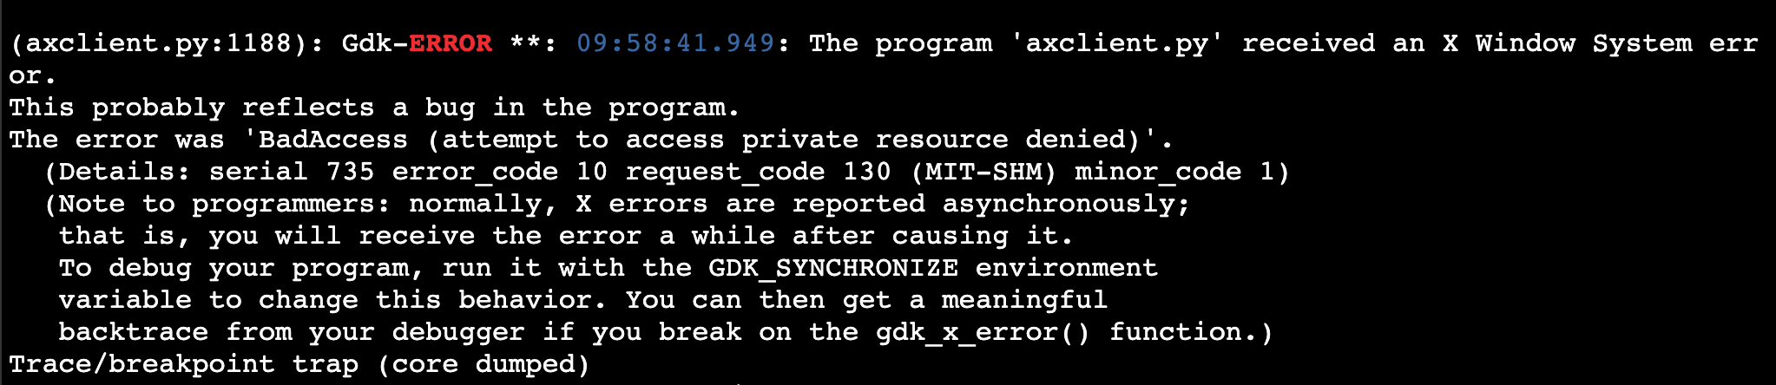
If you get this error, just relaunch the program again and it should work.
- End of Note -
- In order to be able to visualize axclient, you will need to open the graphical interface window. To open this graphical interface window, just hit the icon with a screen in the IDE and a new tab will open.
Now, you should see in your new tab something like this:

Now everything is settled, and you can start playing with axclient! For instance, you could send goals to the Action Server and visualize the different topics that take part in an Action, which you have learnt in this Chapter.
- End of Exercise 8.11 -
- Expected Result for Exercise 8.11 -
Action in process:

Action succeeded:

- End of Expected Result -
- Notes for Exercise 8.11 -
- Sometimes you may find that when you click the SEND GOAL button, or when you try to change the value of the goal you want to send, you can't interact with the axclient screen. If that's the case, just go to another tab and return again to the tab with axclient, and everything will work fine.
- End of Notes -
Maybe you're a little bit angry at us now, because we didn't show you this tool before? Don't be!!
The very simple reason why we didn't talk about this tool earlier is because we want you to learn how Actions really work inside. Once you have the knowledge, you are then ready to use the shortcuts.
- Solutions -
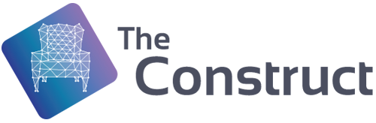
Please try to do it by yourself unless you get stuck or need some inspiration. You will learn much more if you fight for each exercise.
Follow this link to open the solutions for the Actions Part 1: Actions Part 1 Solutions
- End Solutions -

