Advanced C++ for Robotics

Unit 8: Exception Handling
- Summary -
In this unit, we will learn about exception handling. As the name suggests, we will be tackling unexpected or exceptional errors. This means that code that does not have any errors during compile-time can still have run-time errors when we execute the code. So to handle such types of runtime errors, we will study and implement exception handling. We will go through the following concepts to understand the topic:
- Throwing an exception from a function
- Handling Multiple Exceptions
- User-defined exception classes
- Class level exceptions
- std::exception class hierarchy
- End of Summary -
An exception, as expressed before, is a problem that arises during the execution of a program. A C++ exception is a response to an exceptional circumstance that arises while a program is running. Consider a case where you have written an array of size 4 but in the code, you are trying to access the 6th element of the code. Although the code is logically correct but accessing an element that does not exist will throw an error. So, whenever we write code and are doubtful that a particular section of code can cause an error, we use exception handling specific tools to write code.
You might be wondering why to use exception handling tools when we can use if-else loops to check for errors. Well, you are thinking in the right direction but as a programmer
- When an unknown piece of code comes up, the presence of exception handling tools expresses the presence of doubt that certain errors can come up in that section. Thus, making the code more readable and separating the error handling code from the main code.
- Using exception handling provides methods/functions with the choice to tackle or not tackle with an exception.
Now that you know what exception handling is, let’s understand how to use it.

8.1 Throwing an exception from a function
When we deal with exceptions in C++, we use these three keywords: try, throw and catch. Let’s understand what they are.
try: Use this block to write the part of code that you feel can throw an error. For example, 2 divided by 0. Which should return infinite or not defined but results in a runtime error when written and executed as a code. So the code section describing division will come inside the try block.
throw: A program throws an exception when a problem shows up. That is the code you wrote inside the try block that caused an error so the throw keyword came to the rescue. This is done using a throw keyword, the error is passed to the catch section for further processing.
catch: A program catches an exception with an exception handler at the place in a program where you want to handle the problem. The catch keyword indicates the catching of an exception. Here you describe what you want to do with the error.
Let’s put these keywords to use to understand the concept. We will be calling exception handling tools from a function. Observe, implement and understand.
Demo 8.1
To keep things clean create a new ROS package called exercises_unit_8 that depends on roscpp.
Inside of it create a new empty file in the src directory called demo_81.cpp.
Execute in Shell #1
In [ ]:
cd ~/catkin_ws/src
In [ ]:
catkin_create_pkg exercises_unit_8 roscpp
In [ ]:
touch ~/catkin_ws/src/exercises_unit_8/src/demo_81.cpp
Copy and paste the following code into demo_81.cpp
demo_81.cpp
In [ ]:
#include <iostream>
#include <stdexcept>

using namespace std;

int Zero(int a)
{
if (a ==0)
throw a;

return (a);
}

int main()
{
int num = 2;
int den = 0;
float result;
try
{
cout << Zero(den); //exception
result = num/den;
}

catch (int e)
{
cerr << "Enter non zero denominator. " << e<< " as denominator not accepted."<<endl;
return -1;
}

return 0;
}
Save the file and navigate to the demo_81.cpp file using the terminal before compiling.
Execute in Shell #1
In [ ]:
clang++ demo_81.cpp -o demo_81
Use ./ to run the file.
Execute in Shell #1
In [ ]:
./demo_81
Expected Output:
Enter non zero denominator. 0 as denominator not accepted.
End of Demo 3.1

8.2 Handling Multiple Exceptions
In cases where there is multiple run-time error possibility, we have to use multiple catch blocks to deal with the errors in the desired way. In cases, when we are unsure of the datatype of exception a so called generalized catch block is used, like so:
catch(...){
}
Demo 8.2
While still inside ~/catkin_ws/src/exercises_unit_8/src create a new file called demo_82.cpp that will contain the following code:
demo_82.cpp
In [ ]:
#include<iostream>
using namespace std;

void multiple(int x) {
try {
if (x > 0)
throw x;
else
throw 'x';
} catch (int x) {
cout << "Catch a integer and that integer is:" << x<<endl;
} catch (char x) {
cout << "Catch a character and that character is:" << x<<endl;
}catch (...){
cout<<"Just in case something unexpected comes up"<<endl;}
}

int main() {
cout << "Testing multiple catches:\n";
multiple(10);
multiple(0);
multiple('a');
return 0;
}
Save and compile:
Execute in Shell #1
In [ ]:
clang++ demo_82.cpp -o demo_82
Execute in Shell #1
In [ ]:
./demo_82
Expected Output:
Testing multiple catches:
Catch a integer and that integer is:10
Catch a character and that character is:x
Catch a integer and that integer is:97
End of Demo 8.2
- Exercise 8.1 -
In this exercise we will use the robot_commander library from previous units to steer the simulated robot based on user input. The main goal is to validate all user input against specific patterns so that only certain options are accepted as input values.
Notes:
- Inside ~/catkin_ws/src/exercises_unit_8/src create a new file validate_user_input.cpp and paste the starter code from below.
- As always, read through the provided starter code before starting to write any new code.
Tasks:
- Include exception handling using try, catch and throw.
- Ask the user to enter a turn velocity and store the value that they enter using this line:
std::cin >> turn_velocity;
- Validate the input value by checking:
  - If the value is between -1.0 and 0 trun the robot accordingly using my_robot.turn(turn_velocity, 5).
  - If the value is different, throw an exception message, then add a catch block that catches that exception and prints a message to the user.
  - Finally catch any uncaught errors/exceptions using a generalized catch block and also print a message to the user.
- Make the following modifications to the CMakeLists.txt file.
  - Add the robot_commander dependency to it.
  - Add the line to generate the executable file from its C++ source code file.
  - Make sure the executable gets linked to the catkin libraries.
Optional challenge:
- Check whether input value is of the correct type or not, in this case if it's a decimal number or not. To do so you can use std::cin.fail() which keeps a boolean that indicates whether the preceding input failed or not.
- Additionally it's better to clear error flags and buffer right after getting an error on incorrect input. This is done with the lines: std::cin.clear();
std::cin.ignore(256, '\n');
Run your code using rosrun:
Execute in Shell #1
In [ ]:
rosrun exercises_unit_8 validate_user_input
You should get an output which should be similar to this:
[ INFO] [1649273714.321960612]: Initializing node
Enter turn velocity: 5
Enter turn velocity between -1.0 and 0.0
Enter turn velocity: -6
Enter turn velocity between -1.0 and 0.0
Enter turn velocity: -0.5
[ INFO] [1649273726.440342368, 1043.355000000]: Turning clockwise
[ INFO] [1649273734.625924390, 1048.356000000]: Stopping the robot
Enter turn velocity: g
Please entry of a decimal number.
Starter code:
validate_user_input.cpp
In [ ]:
#include "robot_commander/robot_commander.h"
#include <ros/ros.h>
#include <iostream>
#include <exception>

int main(int argc, char **argv) {
ros::init(argc, argv, "exercise_8_1");

RobotCommander my_robot;

int n =0;

while(n<5){

float turn_velocity;
std::cout << "Enter turn velocity: ";

// INSERT YOUR CODE BELOW THIS LINE

// INSERT YOUR CODE ABOVE THIS LINE
n++;
}

return 0;
}
- End of Exercise 8.1 -
- Solution for Exercise 8.1 -
validate_user_input.cpp
In [ ]:
#include "robot_commander/robot_commander.h"
#include <iostream>
#include <ros/ros.h>

int main(int argc, char **argv) {
ros::init(argc, argv, "exercise_8_1");

RobotCommander my_robot;

int n = 0;

while (n < 5) {

float turn_velocity;
std::cout << "Enter turn velocity: ";

// INSERT YOUR CODE BELOW THIS LINE

try {
std::cin >> turn_velocity;
if (std::cin.fail())
throw 'x';
else if (turn_velocity >= -1.0 && turn_velocity <= 0.0)
my_robot.turn(turn_velocity, 5);
else if (turn_velocity > 0.0)
throw 1;
else if (turn_velocity < -1.0)
throw 1;
else
throw 'x';
} catch (int n) {
std::cout << "Enter turn velocity between -1.0 and 0.0" << std::endl;
} catch (...) {
std::cout << "Please enter a decimal number." << std::endl;
std::cin.clear();
std::cin.ignore(256, '\n');
}

// INSERT YOUR CODE ABOVE THIS LINE
n++;
}

return 0;
}
Edit the CMakeLists.txt and add the robot_commander dependency to it. Look for the find_package command near the middle of the file and replace it with:
find_package(catkin REQUIRED COMPONENTS
roscpp
robot_commander
)
Also specify to build validate_user_input.cpp:
add_executable(validate_user_input src/validate_user_input.cpp)
target_link_libraries(validate_user_input ${catkin_LIBRARIES})
- End of Solution for Exercise 8.1-

8.3 User defined exception class
We can define and use custom exceptions if we need to. To do so, we will have to inherit a custom made class from the exception class provided by C++. To use class exception we must include an exception header using the pre-processor directive.
Demo 8.3
demo_83.cpp
In [ ]:
#include <iostream>
#include <exception>

using namespace std;

class Divide_By_Zero_Exception : public exception {

public:
const char* what() const throw()
{
return "Divide By Zero Exception\n";
}
};

int main()

{
try
{
int a, b;
cout << "Enter two numbers : ";
cin >> a >> b;
// compute a / b
if (b == 0)
{
Divide_By_Zero_Exception d;
throw d;
}
else
{
cout << "a / b = " << a / b << endl;
}
}
catch (exception& e)
{
cout << e.what();
}
}

Code explained
In this derived class we must overide the base's class what() method. It is important the we use correct signature for the what() method:
In [ ]:
const char* what() const throw()
- const char*: is the method's return value, which is a mutable pointer to an immutable character or string literal.
- what(): this class that inherits from the exception class that me want to overide. It takes no arguments.
- const: this function does not modify the (non-mutable) members of the object on which it is called, and hence can be called on const instances of its class
- throw(): this is called an exception specification it tells the compiler that this methos does not throw any exceptions.
Expected Output :
Enter two numbers : 2
0
Divide By Zero Exception
End of Demo 8.3

8.4 Class level exception
Class level exceptions are those in which an object of a class is thrown when a run-time error pops up. Let's understand how to put classes and their objects to use.
Demo 8.4
Inside ~/catkin_ws/src/exercises_unit_8/src create a new file called demo_84.cpp. The code to be added to that file is as follows:
demo_84.cpp
In [ ]:
#include <iostream>
using namespace std;

class case_1 {
};

class case_2 {
};

int main()
{
for (int i = 1; i <= 2; i++) {
try {
if (i == 1)
throw case_1();

else if (i == 2)
throw case_2();
}

catch (case_1 c1) {
cout << "Caught case_1 class exception \n";
}

catch (case_2 c2) {
cout << "Caught case_2 class exception \n";
}
}
}
Save and compile:
Execute in Shell #1
In [ ]:
clang++ demo_84.cpp -o demo_84
Execute in Shell #1
In [ ]:
./demo_84
Expected Output:
Caught exception of demo1 class
Caught exception of demo2 class
End of Demo 8.4
- Exercise 8.2 -
Let us continue this exercise where we left off last time. Open ~/catkin_ws/src/exercises_unit_8/src /validate_user_input.cpp for editing.
Tasks:
- You must include the <exception> header.
- Create a class named WrongTurnException which inherits from the Exception base class.
- Inside of it override the what() method and return an error message string.
- The return type of this must be char* which stands for character string.
- Modify the try{}…catch() block so that an user-defined exception is thrown if the input value is not allowed.
- Remember to create an object of WrongTurnException class and use the throw keyword to explicitly throw an exception using this object.
Compile and then run as usual:
Execute in Shell #1
In [ ]:
rosrun exercises_unit_8 validate_user_input
You should get an output which should be similar to this:
[ INFO] [1649273714.321960612]: Initializing node
Enter turn velocity: 5
Allowed turn velocity only between -1.0 and 0.0
Enter turn velocity: -6
Allowed turn velocity only between -1.0 and 0.0
Enter turn velocity: -0.5
[ INFO] [1649273726.440342368, 1043.355000000]: Turning clockwise
[ INFO] [1649273734.625924390, 1048.356000000]: Stopping the robot
Enter turn velocity: g
Please entry of a decimal number.
- End Of Exercise 8.2 -
- Solution for Exercise 8.2 -
validate_user_input.cpp
In [ ]:
#include "robot_commander/robot_commander.h"
#include <exception>
#include <iostream>
#include <ros/ros.h>

using namespace std;

class WrongTurnException : public exception {
public:
const char *what() const throw() {
return "Allowed turn velocity only between -1.0 and 0.0\n";
}
};

int main(int argc, char **argv) {
ros::init(argc, argv, "exercise_8_1");

RobotCommander my_robot;

int n = 0;

while (n < 5) {

float turn_velocity;
std::cout << "Enter turn velocity: ";

try {
std::cin >> turn_velocity;
if (std::cin.fail())
throw 'x';
else if (turn_velocity >= -1.0 && turn_velocity <= 0.0)
my_robot.turn(turn_velocity, 5);
else if (turn_velocity > 0.0) {
throw WrongTurnException();
} else if (turn_velocity < -1.0) {
throw WrongTurnException();
} else
throw 'x';
} catch (WrongTurnException e) {
std::cout << e.what();
} catch (...) {
std::cout << "Please enter a decimal number." << std::endl;
std::cin.clear();
std::cin.ignore(256, '\n');
}

n++;
}

return 0;
}
- End of Solution for Exercise 8.2 -

8.5 std::exception class hierarchy
C++ provides a list of standard exceptions defined in the header file exception. We can import this header file and throw the desired standard exception. Exceptions are arranged in a parent-child class hierarchy. With std::exception as the base class. So, c++ provides a range of built-in exceptions. Refer to the image to observe the hierarchy followed by the class exception.
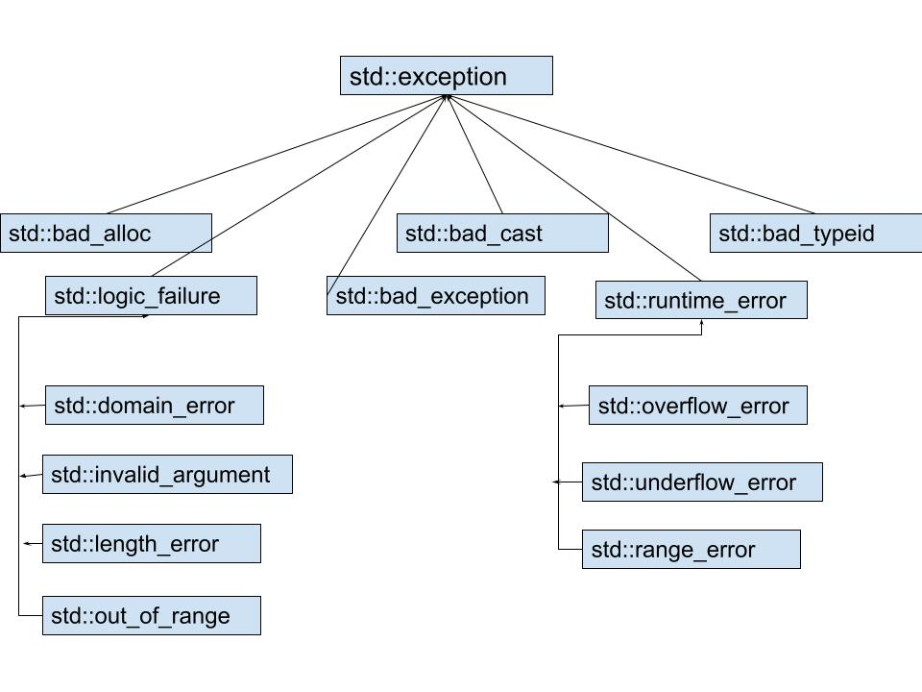
Let's understand each type of error in detail:
- Std::exception – It is an exception and parent class of all standard c++ exception
- std::bad_alloc - is the type of the object thrown as exceptions by the allocation functions to report failure to allocate storage.
- The std::bad_cast exception is thrown by the dynamic_cast operator as the result of a failed cast to a reference type.(Dynamic Cast: A cast is an operator that converts data from one type to another type)
- std::bad_typeid The bad_typeid exception is thrown by the typeid operator when the operand for typeid (The typeid operator allows the type of an object to be determined at run time)is a NULL pointer.
- Std::bad_exception -This is an exception thrown by unexpected handler. This exception is thrown to signal a failed attempt to copy an exception object.
- class std::invalid_argument indicates that an invalid argument was passed to a function. (Proper coding can, of course, prevent invalid arguments from reaching a function.)
- Class std::length_error indicates that a length larger than the maximum size allowed for the object being manipulated was used for that object.
- Class std::out_of_range indicates that a value, such as a subscript into an array, exceeded its allowed range of values.
- std::domain_error - Generally, the domain of a mathematical function is the subset of values that it is defined for. For example, the square root function is only defined for non-negative numbers. Thus, a negative number for such a function would qualify as a domain error.
- Class std::runtime_error, is the base class of several other standard exception classes that indicate execution-time errors
- class std::overflow_error describes an arithmetic overflow error (i.e., the result of an arithmetic operation is larger than the largest number that can be stored in the computer)
- class std::underflow_error describes an arithmetic underflow error (i.e., the result of an arithmetic operation is smaller than the smallest number that can be stored in the computer).
- std::range_error: It is a runtime error exception and It can be used to report range errors (that is, situations where a result of a computation cannot be represented by the destination type).
Demo 8.5
demo_85.cpp
In [ ]:
#include <iostream> // std::cout
#include <new> // std::bad_alloc

int main () {
try
{
int* Array= new int[100000000000000];//trying to allocate dynamic memory
std::cout << "Tried successfully\n";
}
catch (std::bad_alloc& e)
{
std::cerr << "bad_alloc caught: " << e.what() << '\n';
}
return 0;
}
Expected Output:
bad_alloc caught: std::bad_alloc
End of Demo 8.5
I hope you enjoyed and learned a lot from this course. Now that you understand various advanced C++ concepts, I suggest you try to understand how important ROS projects are written. You can explore the Navigation Stack, ros_control or robot_localization repositories and get insights on how the concepts that you have learned through this course are used as the building block on which most of ROS core packages stand. And remember you can always explore The Construct content to learn more about ROS and robots from the root level. I wish you good luck! Keep learning and keep growing :)

