Customer Segmentation Report
RFM Feature Engineering & Clustering — Online Retail Dataset (UCI)
Dec 2010 – Dec 2011 · UK-based online retailer

1. Executive Summary
This report segments the customer base of a UK-based online retailer using Recency, Frequency, and Monetary (RFM) behavior, derived from 541,909 raw transaction lines spanning December 2010 to December 2011. After cleaning, 396,470 valid transaction lines across 4,334 unique customers were used to build the segmentation.
Three clustering methods were compared — K-Means, Hierarchical (Ward linkage), and DBSCAN — and K-Means with k=4 was selected as the primary segmentation, validated with the silhouette score and confirmed structurally by the hierarchical dendrogram.
The result is four actionable segments: Champions/VIP, Loyal/Core, Recent/Promising, and At risk/Lapsed. The headline finding is a classic long-tail pattern: the top 15.8% of customers by cluster (Champions/VIP) generate 63.9% of total revenue, while the largest group by headcount (At risk/Lapsed, 37.7% of customers) contributes only 6.6% of revenue.

2. Data & Cleaning
The raw dataset is transaction-level (one row per product line per invoice), so the first step was aggregating it to the customer level. Cleaning removed:
- 135,080 rows with a missing CustomerID (can't be attributed to a customer)
- 8,905 cancellation rows (InvoiceNo starting with 'C')
- 40 rows with non-positive Quantity or UnitPrice (data errors)
- 1,414 rows of non-product stock codes (postage, bank charges, manual entries, etc.)
This left 396,470 clean transaction lines across 4,334 unique customers, matching the ~4,000-customer scale described in the dataset documentation.

3. RFM Feature Engineering & Preparation
For each customer we computed Recency (days since last purchase), Frequency (distinct orders), and Monetary (total spend), plus supporting behavioral features (average basket value, category diversity, total items purchased).
RFM values are heavily right-skewed — Frequency and Monetary skewness were 11.98 and 19.54 respectively before transformation. A log1p transform reduced these to 1.21 and 0.40, after which features were standardized (zero mean, unit variance) so no single metric dominates the distance calculations used by clustering.

4. Clustering Methods & Comparison

4.1 K-Means — Elbow & Silhouette
K-Means was run for k = 2 through 10. The elbow plot and silhouette scores below guided the choice of k.
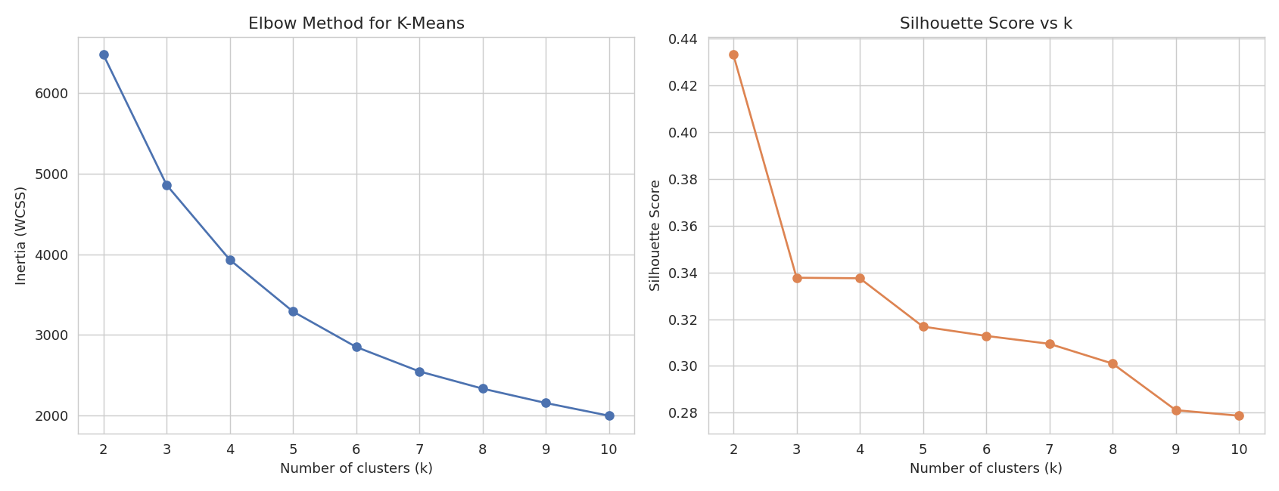
The silhouette score is mathematically maximized at k=2, but that split only separates 'active' from 'inactive' customers — too coarse for targeted marketing. We instead chose the smallest k ≥ 4 whose silhouette score stayed within 75% of the global maximum, which selected k=4. This is a deliberate trade-off: a small, quantified amount of statistical separation for a segmentation granular enough to act on, and it lines up with where the elbow curve visibly flattens.

4.2 Hierarchical Clustering (Ward Linkage)
A dendrogram on a 300-customer sample shows a clear nested grouping structure, consistent with 4 natural clusters.
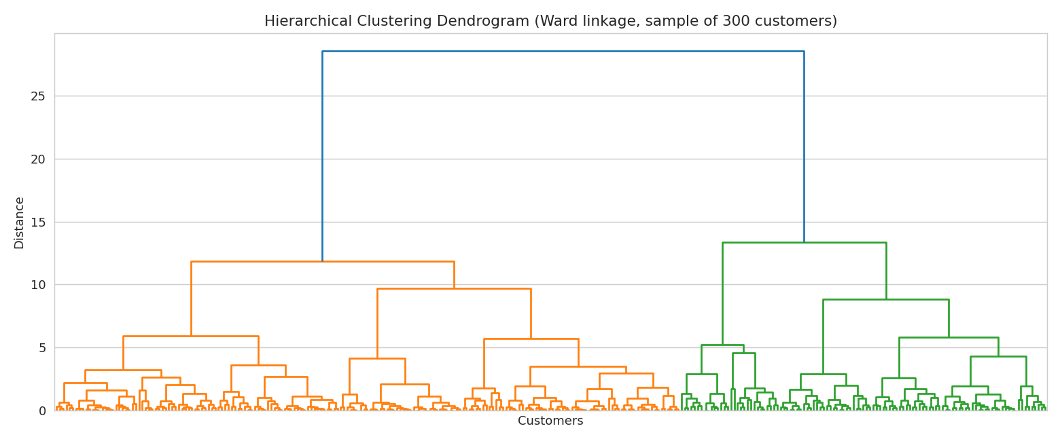

4.3 DBSCAN
A k-distance plot (k = min_samples = 5) was used to inform the eps parameter search.
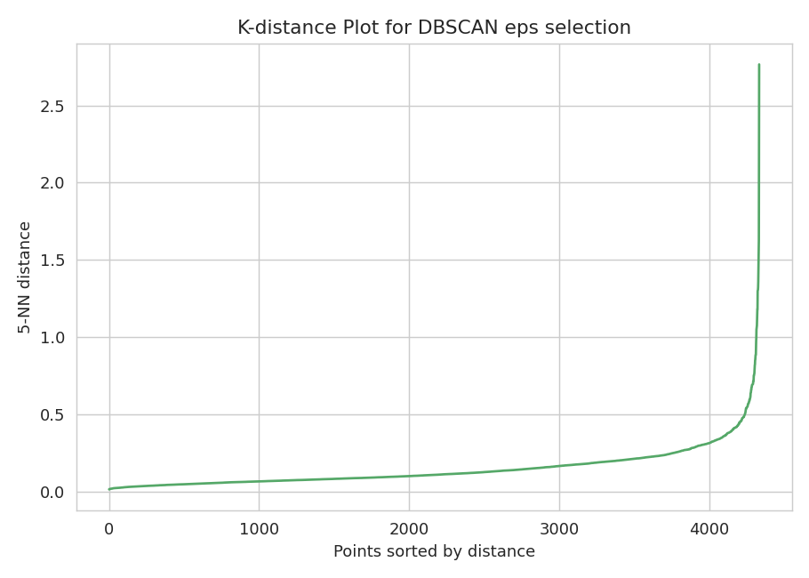
Scanning eps from 0.3 to 0.8, eps=0.4 produced 4 clusters with only 2.3% of customers flagged as noise — comparable in cluster count to K-Means/Hierarchical, at the cost of a lower silhouette score.

4.4 Method Comparison
Method | Clusters | Silhouette | Notes
K-Means (k=4) | 4 | 0.338 | Even, well-separated, easiest to explain to stakeholders
Hierarchical / Ward (k=4) | 4 | 0.267 | Confirms the same structure — not an artifact of K-Means
DBSCAN (eps=0.4) | 4 | 0.129 (non-noise) | 2.3% flagged as noise/outliers; more sensitive to eps

K-Means (k=4) was selected as the primary segmentation: it is the most stable and interpretable of the three, and the hierarchical clustering independently agrees on the same structure. DBSCAN's noise points are retained as a complementary signal for identifying atypical customers (Section 6).

5. Cluster Profiles & Business Interpretation
Segments were visualized in 2D via PCA (capturing 93.9% of variance across PC1 and PC2):
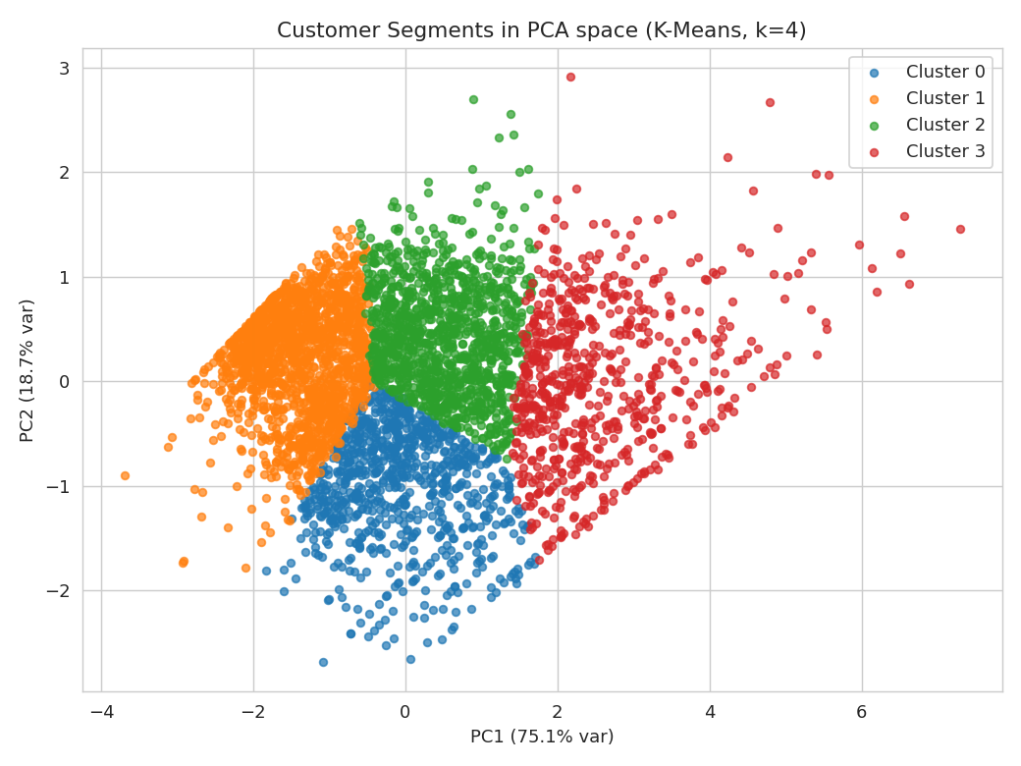
Cluster means, in original units:
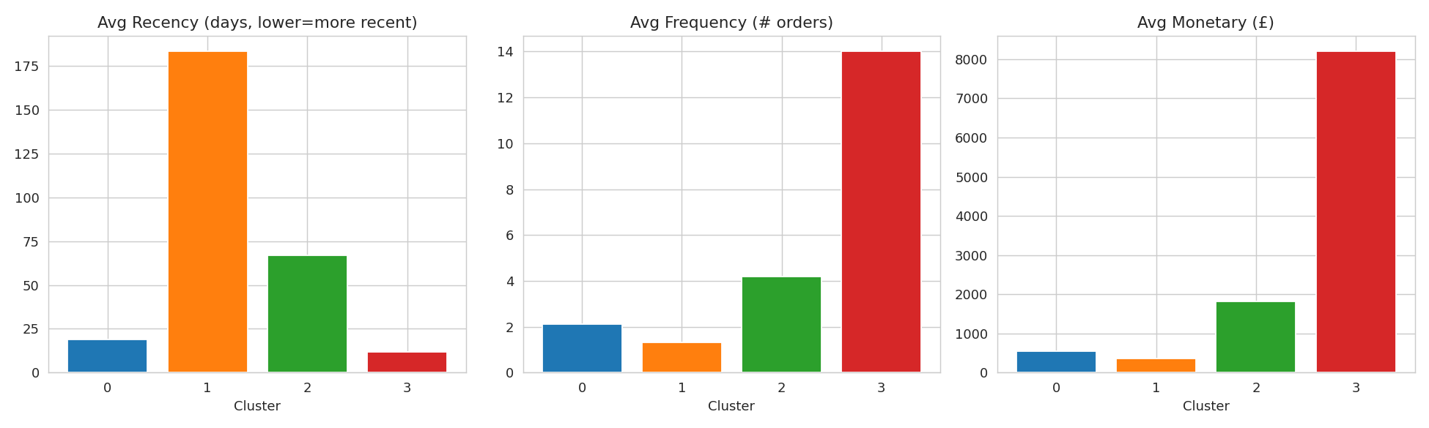
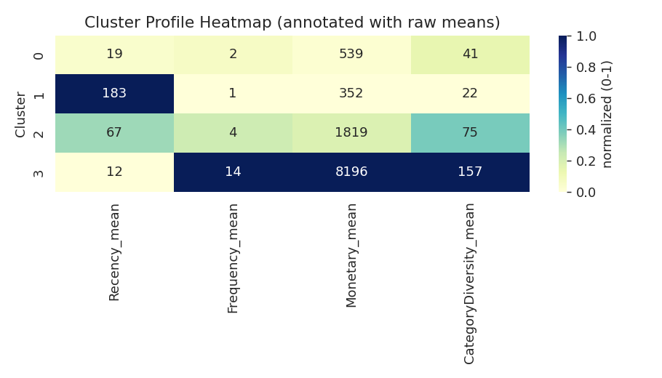
Cluster | Size (%) | Recency (days) | Frequency (orders) | Monetary (£, avg) | Revenue share | Segment
3 | 15.8% | 12 (best) | 14.0 (best) | 8,196 (best) | 63.9% | Champions / VIP
2 | 27.0% | 67 | 4.2 | 1,819 | 24.3% | Loyal / Core
0 | 19.5% | 19 | 2.1 | 539 | 5.2% | Recent / Promising
1 | 37.7% | 183 (worst) | 1.3 | 352 | 6.6% | At risk / Lapsed

Champions / VIP (15.8% of customers, 63.9% of revenue)
Most recent purchasers, highest order frequency (14 orders on average), and by far the highest spend (£8,196 average). This small group is disproportionately responsible for revenue.
- Action: white-glove retention — loyalty perks, early access to new stock, dedicated account outreach. Losing even a few of these customers has an outsized revenue impact.

Loyal / Core (27.0% of customers, 24.3% of revenue)
Solid repeat buyers with moderate recency (~67 days) and healthy spend (£1,819 average). The natural pool to graduate into Champions/VIP.
- Action: upsell and cross-sell campaigns, personalized offers, tiered loyalty program nudges toward VIP status.

Recent / Promising (19.5% of customers, 5.2% of revenue)
Recently active (19 days) but still low frequency (2.1 orders) and modest spend — likely newer or trial customers who haven't yet become habitual buyers.
- Action: onboarding nurture sequences, second-purchase incentives, category discovery emails to build purchase habits.

At risk / Lapsed (37.7% of customers, 6.6% of revenue)
The largest group by headcount but the least engaged — average recency of 183 days and the lowest frequency and spend. Despite being over a third of the customer base, this group contributes relatively little revenue.
- Action: win-back email campaigns, time-limited discounts, and re-engagement surveys to understand drop-off; consider suppressing low-value spend on this segment beyond a few win-back attempts.

6. Bonus Analysis

6.1 Outlier / Anomaly Detection
Two complementary methods flagged unusual customers: DBSCAN noise points (2.3%, 98 customers) and Isolation Forest trained on the scaled RFM features (3.0%, 130 customers), with 62 customers flagged by both — a meaningful overlap that increases confidence in those specific customers being genuinely atypical (e.g., extreme bulk buyers or wholesalers hiding in the consumer data).

6.2 t-SNE Visualization
t-SNE often separates clusters more cleanly than PCA for visual inspection. Outlier customers (Isolation Forest) are circled in black.
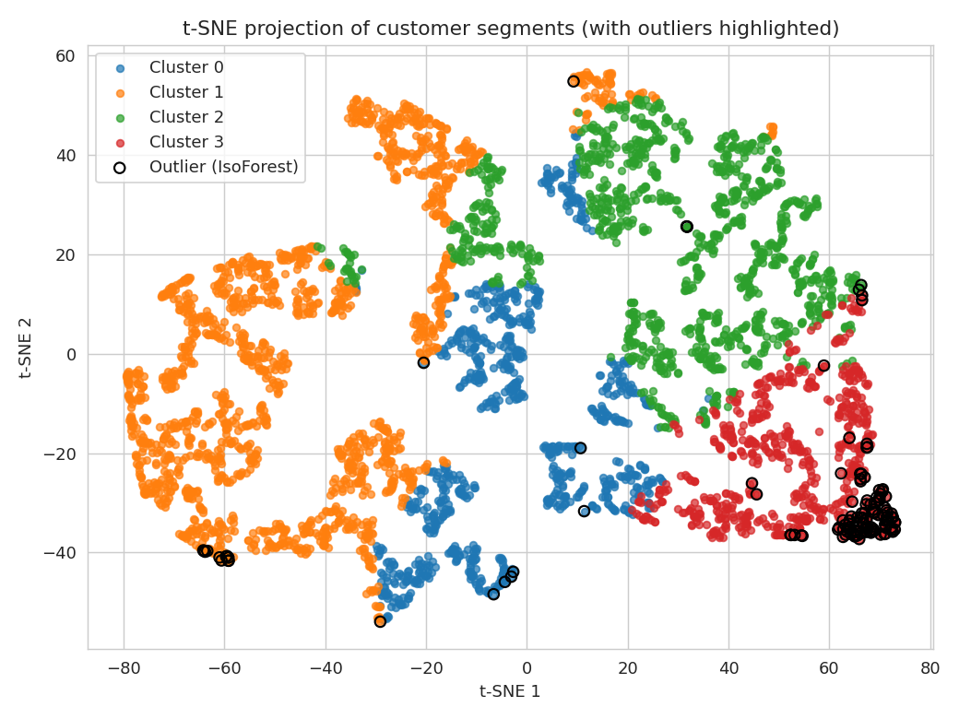

6.3 Extended Behavioral Features
Beyond core RFM, category diversity (distinct products purchased) was computed per customer and included in profiling. It correlates strongly with the segmentation: Champions/VIP customers buy from 157 distinct product categories on average, versus 22 for At risk/Lapsed customers — reinforcing that engagement breadth tracks with engagement depth.

7. Recommendations
- Prioritize retention spend on Champions/VIP (Cluster 3) — this 15.8% of customers is nearly two-thirds of revenue and the highest-leverage group to protect.
- Run a structured win-back campaign against At risk/Lapsed (Cluster 1) given its size (37.7% of the base); even modest reactivation lifts meaningful revenue at scale.
- Build nurture flows for Recent/Promising (Cluster 0) customers to convert trial behavior into repeat purchasing before they drift toward the At risk segment.
- Investigate the 62 customers flagged by both outlier methods individually — they may be wholesalers or data anomalies that should be excluded from consumer segmentation entirely.
- Re-run this segmentation quarterly, since RFM values (especially Recency) shift as customer behavior evolves.

