Md. Omar Kaushru: **solved 4 problems**

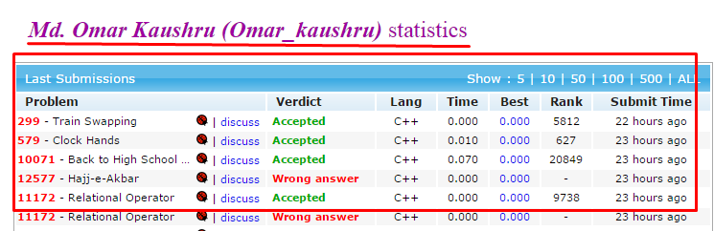

Mahmudul Maruf: **Solved 3 problems**

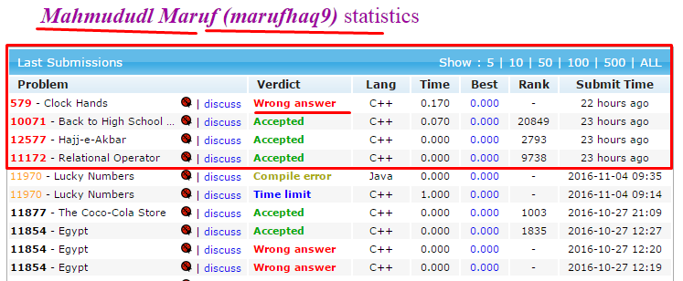

Jubaer Ahmed: **Solved 2 problems**.

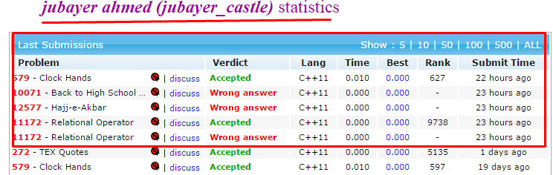

But announced as: 1st prize: Mahmudul Maruf

2nd prize: Md. Omar Kaushru

3rd prize: Jubaer Ahmed

I don’t know the reason behind this. Allah knows everything.