Client code:

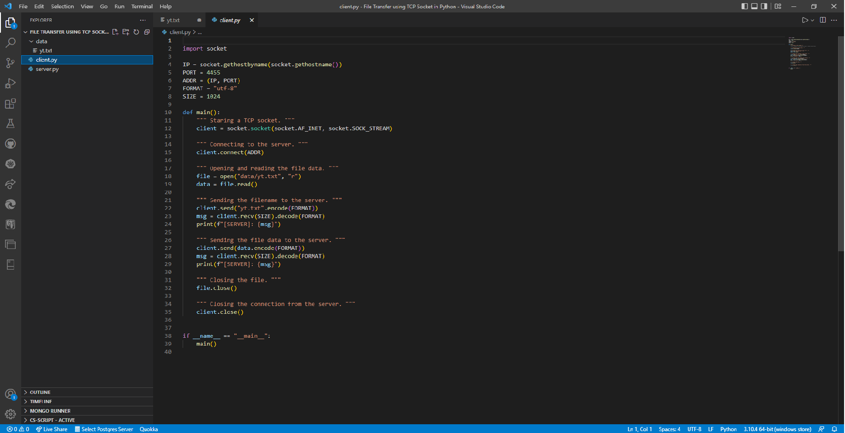

Server code:

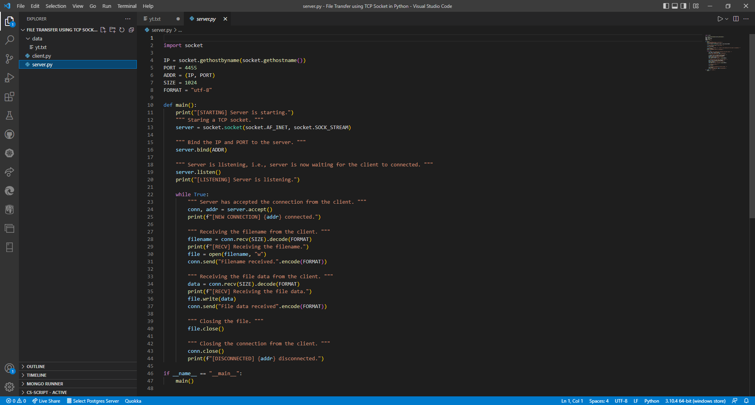

Runs and output:

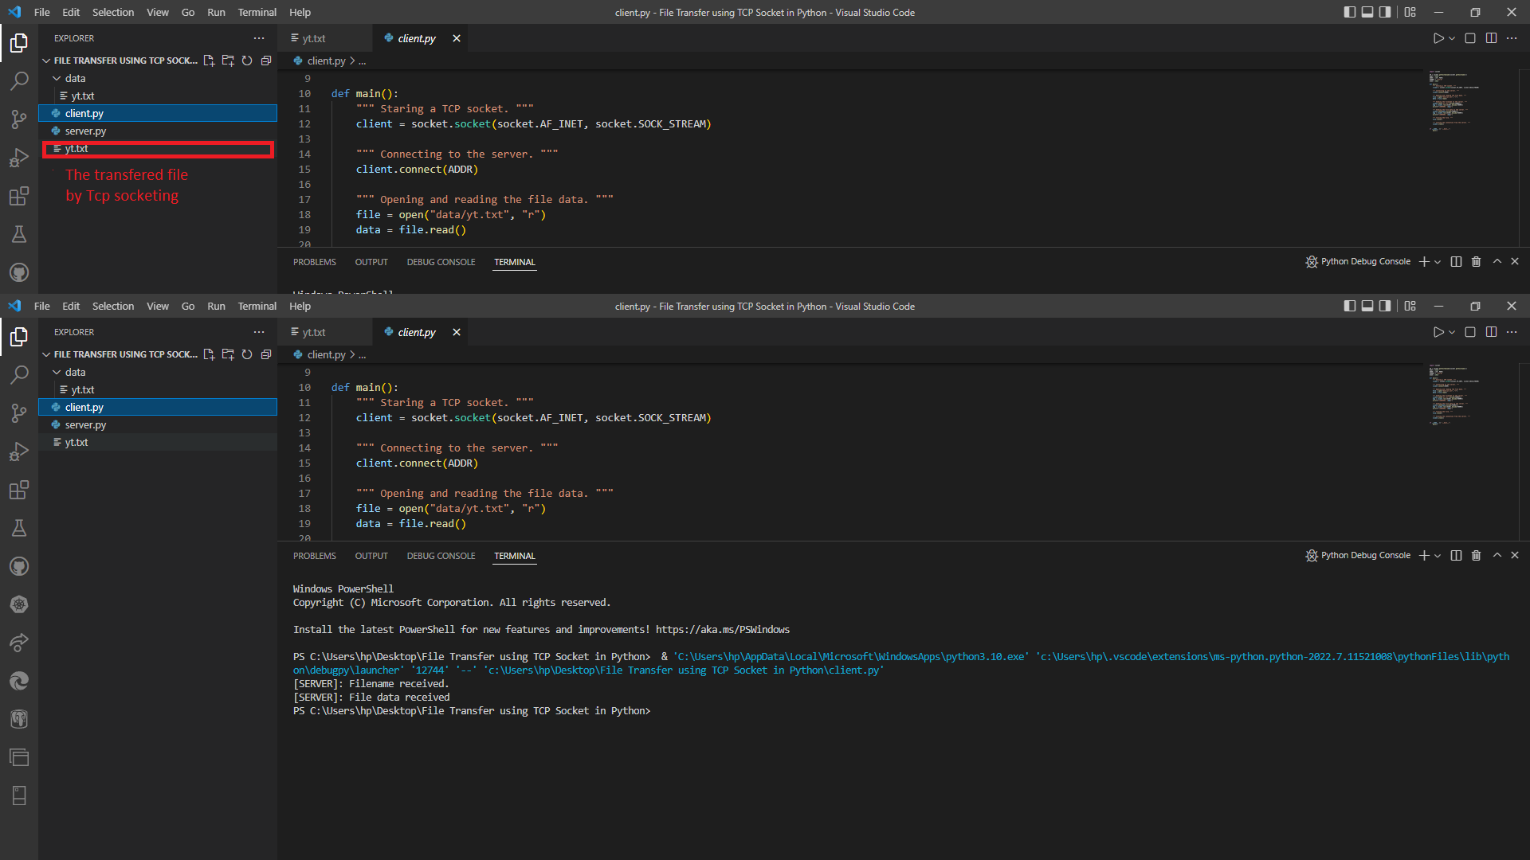

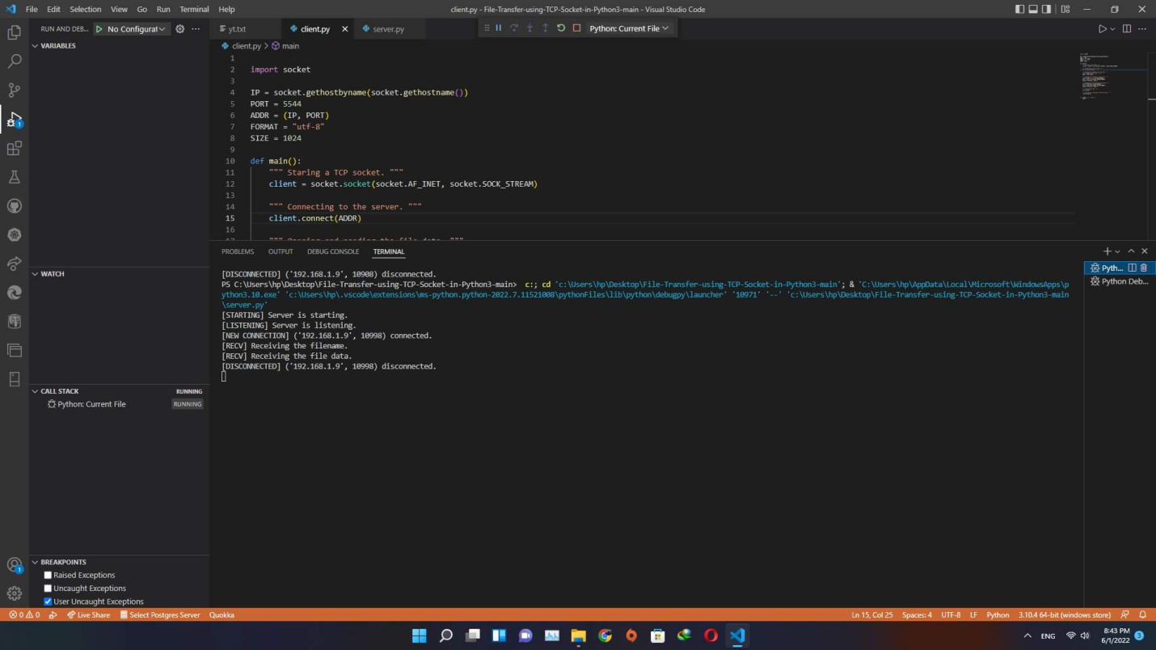

Link of my drive for the codes:

https://drive.google.com/drive/folders/1-JO7v1vKQALfHdf2WxIHvs_kWSGQ_rgo