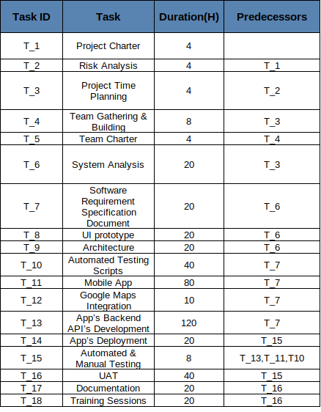

* Planned Start date: 1 Jan 2022
* Duration : 236 Hours , approximately 6 working weeks if we assume we work 40 Hour per week
* Planned delivery date: 12 Feb 2022
* Team size: 8 Members

2 testers-2 UI/UX designer -3 developer-1 front end developer-1 BA