1. Install Ubuntu OS using virtual machine.

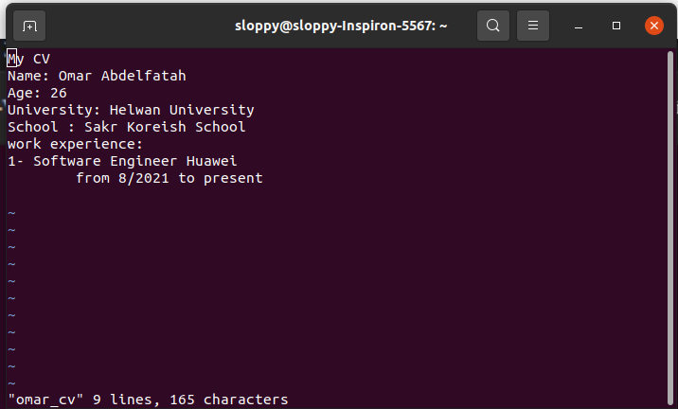

2. What is the difference between cat and more command?

- cat command  
 displays the contents of the file

- more command  
 displays the file and directory names. Halts once the screen page is full and prompts to press a key to continue

3. What is the difference between rm and rmdir using man?

- rm removes files & directories

- rmdir removes empty directories

4. Copy the /etc/passwd file to your home directory making its name is mypasswd.

cp /etc/passwd /home/mypasswd

5. Rename this new file to be oldpasswd.

mv /home/mypasswd /home/oldpasswd

6. You are in /usr/bin, list four ways to go to your home directory

* cd /home/sloppy
* cd ~
* cd $HOME
* cd ../../home/sloppy

7. List Linux commands in /usr/bin that start with letter w

ls /usr/bin|grep w

8. Display the first 4 lines of /etc/passwd

head –n4 /etc/passwd

9. Display the last 7 lines of /etc/passwd

tail –n7 /etc/passwd

10. Display the man pages of passwd the command and the file sequentially in one command.

man –a passwd

11. Display the man page of the passwd file.

man –l /etc/passwd

12. Display a list of all the commands that contain the keyword passwd in their man page.

man –k ‘passwd’