Fluorescent Dissolved Oxygen Probe
Instructions for use

1. Product Introduction
Dissolved oxygen sensor uses fluorescence method to measure dissolved oxygen in water. Based on the principle of fluorescence quenching, the time of excited red light is inversely proportional to the concentration of oxygen molecules, and then the oxygen concentration is calculated. The product can be used in aquaculture, environmental monitoring, industrial production process water quality monitoring and other fields.
  - Technical indicators
Specifications | Parameters
Measurement range | Dissolved oxygen:(0-20)mg/L or 0-200% saturation  Temperature: 0-50 ℃
Measurement accuracy | Dissolved oxygen: TypeB: ± 0.1-0.3mg/L;TypeC: ± 0.3mg/L  Temperature:<0.3 ℃
Resolution | 0.01mg/l
Response time | Section B: T90<120s; Section c: T90>120s
Power supply | 9V-24VDC, 12V power supply recommended
Output signal | Using RS485 serial communication, Modbus protocol
Working temperature | 0-40 ℃
Storage temperature | -5-60 ℃
Outer dimensions | Φ32mm*17mm
Sensor material | Shell: ABS; combustible titanium alloy, etc.
Use recommend | TypeB: suitable for water quality clean online, handheld monitoring needs. Fast and precise.  TypeC: aquaculture online dedicated, suitable for harsh water; fluorescent film with antibacterial, scratch resistance, anti-interference ability, etc.

  - Sensor size

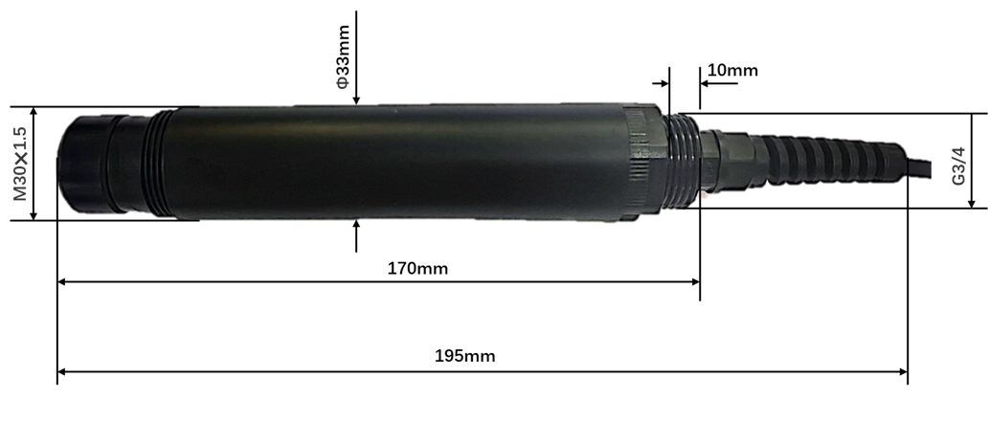
  - Wiring mode
Red: 9~24V; Black: GND; White: RS485-A; Yellow: RS485-B. If there is a cable label, the label shall prevail.
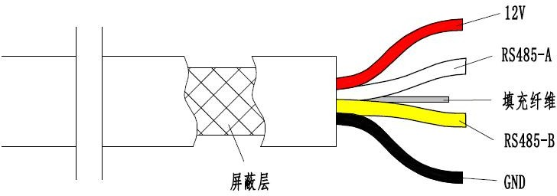
Shielding Layer
Filler Fibre
- Modbus Communication
Note: When the sensor is in an unknown address, you can use the broadcast address: 255 for device communication
Introduction to 2.1 Agreement
The sensor has Modbus RS485 communication function, and the basic configuration is as follows:
Modbus RTU
Baud rate | 9600
data bit | 8 Bits
parity check | None
Stop bit | 1 bit

MODBUS Definition of Data Transfer
 | Device Address | Function code | Data | Calibration
Bytes | 1 | 1 | n | CRCH | CRCL
2.2 instruction support:
0x 03 reads into the register, 0x 06 writes into the register, and 0x 10 writes into the register continuously.
2.3 information frame format:

0x03 | Read data | [HEX]
01 | 03 | ×××× | ×××× | ××××
Address | Function code | Data First Address | Data length | check code

0x06 | Write data | [HEX]
01 | 06 | ×××× | ×××× | ××××
Address | Function code | Data address | Data length | check code

0x10 | Write data continuously [HEX]
01 | 10 | ×××× | ×××× | ×× | ×××× | ××××
Address | Function code | Start Address | Number of registers | Bytes | Write Data | check code

2.4 register data format:
Property | Function code | Address | Parameters | Conversion Factor/Description
Read | 03 | 0x01 | dissolved oxygen concentration | 0.01/Signed
Read | 03 | 0x02 | Temperature | 0.01/Signed  Range 0-50 ℃
Read/Write | 03/06 | 0x03 | Air pressure | 1/Signed  Range 600-800mmHg
Read/Write | 03/06 | 0x04 | salinity setting value | 1/Signed  Range 0-40 ‰
Read | 03 | 0x06 | saturation | 0.1/Signed
Write | 06 | 0x07 | One point calibration | Write 1 for calibration
Write multiple | 10 | 0X08 ~ 0X0B | Parameter A | Double HGFEDCBA
Write multiple | 10 | 0X0C ~ 0X0F | Parameter B | Double HGFEDCBA
Write multiple | 10 | 0X10~0X13 | Parameter C | Double HGFEDCBA
Write multiple | 10 | 0X14-0X17 | Parameter D | Double HGFEDCBA
Write multiple | 10 | 0X18-0X1C | Parameter E | Double HGFEDCBA
Read | 03 | 0x24 | phase difference | 0.01/Signed
Read/Write | 03/06 | 0x29 | Address | 255 to Universal Address
Note: Actual result = register data * conversion factor
2.5 protocol instance:
2.5.1 Modify the device address
Function: Set the device address of the sensor, the address range is 1-255 (the broadcast address of the sensor is 255). Can be set by register address 0x29. For example, change the current device address 1 to 2
query/response frame
 | Address code | Function code | Start Address | Register Data | Check Low | Check High
Host Inquiry | 01 | 06 | 00 29 | 00 02 | D9 | C3
Answer from machine | 01 | 06 | 0029 | 00 02 | D9 | C3
The correct reply frame is returned, and the address will be modified successfully.
Data description: 00 02H = 2, equipment address changed to 2
Tx:01 06 00 29 00 02 D9 C3
Rx:01 06 00 29 00 02 D9 C3
2.5.2 Obtain temperature and dissolved oxygen value
Function: Obtain the temperature and dissolved oxygen value of the sensor, the temperature unit is ℃, and the dissolved oxygen value includes concentration and saturation, and the unit is mg/l and%. Six registers can be read in succession starting from register address 0x 01.
Host Inquiry Frame
Address code | Function code | Start Address | Number of registers | Check Low | CRC Check High Bit
01 | 03 | 00 01 | 00 06 | 94 | 08
slave answer frame
Address code | Function code | Bytes | Register 1  (Oxygen concentration) | Register 2  (Temperature) | Register 3  (atmospheric pressure) | Register 4  (salinity setting)
01 | 03 | 0C | 03EE | 08 16 | 02F8 | 00 00

Register 5  (meaningless) | Register 6  (Saturation value) | Check Low | Check High
00 00 | 04 63 | 29 | 2A
Data calculation description:
Dissolved oxygen concentration: 03 EEH = 1006*0.01mg/l = 10.06mg/l
Temperature: 08 16H = 2070*0.01 ℃ = 20.7 ℃.
Atmospheric pressure: 02F8H = 760mmHg.
Salinity setting: 00 00H = 0 ‰.
Saturation: 04 63H = 1123*0.1=112.3%.
Tx:01 03 00 01 00 06 94 08
Rx:01 03 0C 03 EE 08 16 02 F8 00 00 00 00 04 63 29 2A
2.5.3 One-point user calibration
Function: Calibrate the measured value, which is set by register address 0x07. Write 1 to this address to complete automatic calibration. After successful calibration, the saturation return data is 100.
query/response frame
 | Address code | Function code | Start Address | Register Data | Check Low | Check High
Host Inquiry | 01 | 06 | 00 07 | 00 01 | F9 | CB
Answer from machine | 01 | 06 | 00 07 | 00 01 | F9 | CB
Protocol example:
Tx:01 06 00 07 00 01 F9 CB
Rx:01 06 00 07 00 01 F9 CB
2.5.4 Setting salinity
Function: Set salinity compensation parameters for probe measurement in seawater. This can be set via a register with address 0x04. The default salinity is 0, which sets the power-down protection.
The following takes the device address 0x 01 as an example to illustrate the request frame and the response frame of the salinity setting instruction.
query/response frame
 | Address code | Function code | Start Address | Register Data | Check Low | Check High
Host Inquiry | 01 | 06 | 00 04 | 00 1E | 48 | 03
Answer from machine | 01 | 06 | 00 04 | 00 04 | 48 | 03
Note: The salinity setting value is 30, in ‰.
Data parsing description:
Salinity setting: 00 1EH = 30 ‰
Tx:01 06 00 04 00 1E 48 03
Rx:01 06 00 04 00 1E 48 03
2.5.5 Setting Atmospheric Pressure
Function: Set the probe atmospheric pressure for oxygen concentration measurement compensation, the default is standard atmospheric pressure, the unit is mmHg. It can be set by register address 0x 03, which sets power-down protection.
The following takes the device address 0x 01 as an example to illustrate the request frame and the response frame of the salinity setting instruction.
query/response frame
 | Address code | Function code | Start Address | Register Data | Check Low | Check High
Host Inquiry | 01 | 06 | 00 03 | 02F8 | 79 | 28
Answer from machine | 01 | 06 | 00 03 | 02F8 | 79 | 28
Note: The atmospheric pressure setting value is 760, and the unit is mmHg.
Data parsing description:
Air pressure setting value: 02F8H = 760mmHg.
Tx:01 06 00 03 02 F8 79 28
Rx:01 06 00 03 02 F8 79 28
2.5.6 Setting Fluorescent Cap Parameters
Function: Use when replacing the fluorescent cap. Fluorescent cap parameters can be set for 20 consecutive registers starting at start address 0x 08. Note: Fluorescent cap parameter is double type, double HGFEDCBA.
Host Inquiry Frame
Address code | Function code | Start Address | Number of registers | Check Low | Check High
01 | 10 | 00 08 | 00 14 | 41 | C4
slave answer frame
Address code | Function code | Start Address | Quantity | Bytes | Register 8-11 Data | Register 12-15 Data
01 | 10 | 00 08 | 00 14 | 28 | 04BD C1 E5 A2 F2 D7 3E | 5A 04 CE 6B 4F 3D 50 BF

Register 16-19 Data | Register 20-23 Data | Register 24-27 Data | Check Low | Check High
85 44 DA C6 9F A8 B0 3F | FC 8C 0B 07 42 32 FF BF | C3 64 AA 60 54 12 37 40 | E4 | 4E
Data parsing description:
Fluorescent cap parameter A (register 8-11 data):04 BD C1 E5 A2 F2 D7 3EH = 5.7096e-006.
Fluorescent cap parameter B (register 12-15 data):5A 04 CE 6B 4F 3D 50 BFH =-0.00099118.
Fluorescent cap parameter C (register 16-19 data):85 44 DA C6 9F A8 B0 3FH = 0.065073.
Fluorescent cap parameter D (register 20-23 data):FC 8C 0B 07 42 32 FF BFH =-1.94977.
Fluorescent cap parameter E (registers 24-27 data):C3 64 AA 60 54 12 37 40H = 23.0716.
Tx:01 10 00 08 00 14 41 C4
Rx:01 10 00 08 00 14 28 04 BD C1 E5 A2 F2 D7 3E 5A 04 CE 6B 4F 3D 50 BF 85 44 DA C6 9F A8 B0 3F FC 8C 0B 07 42 32 FF BF C3 64 AA 60 54 12 37 40 E4 4E
3. Sensor parameter setting and calibration
3.1 parameter setting
3.1.1 Sensor connection
Connect the digital dissolved oxygen sensor to the computer through Modbus RS 485, open Modbus debugging software: Modbus Poll, set addresses 1,9600,N,8,1, after the sensor is successfully connected, select "Setup-Read/Write Definition", set the Address to 0001 ,Quantity to 6, and click OK, as shown in Figure 3.1.1(1), to start reading the sensor value.
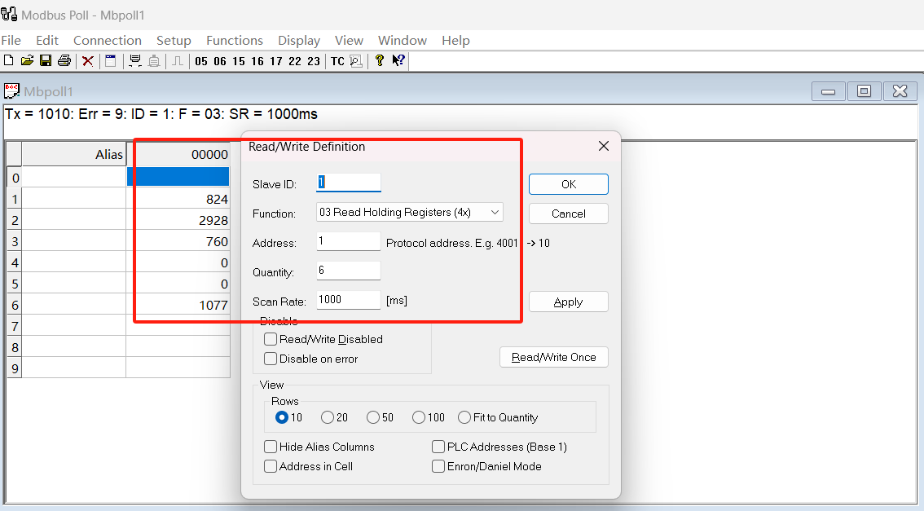
3.1.1(1)
3.1.2 Sensor reading
Complete the above 3.1.1 operation steps and start the reading value of the sensor, where the data type is single-precision shaping, as shown in the following figure, where:
The dissolved oxygen concentration address is 1, and the value is 8.21mg/L.
The temperature address is 2 and the temperature is 29.47 ℃
Barometric address 3, value 760mmHg
Saturation address is 6 and the value is 107.7%
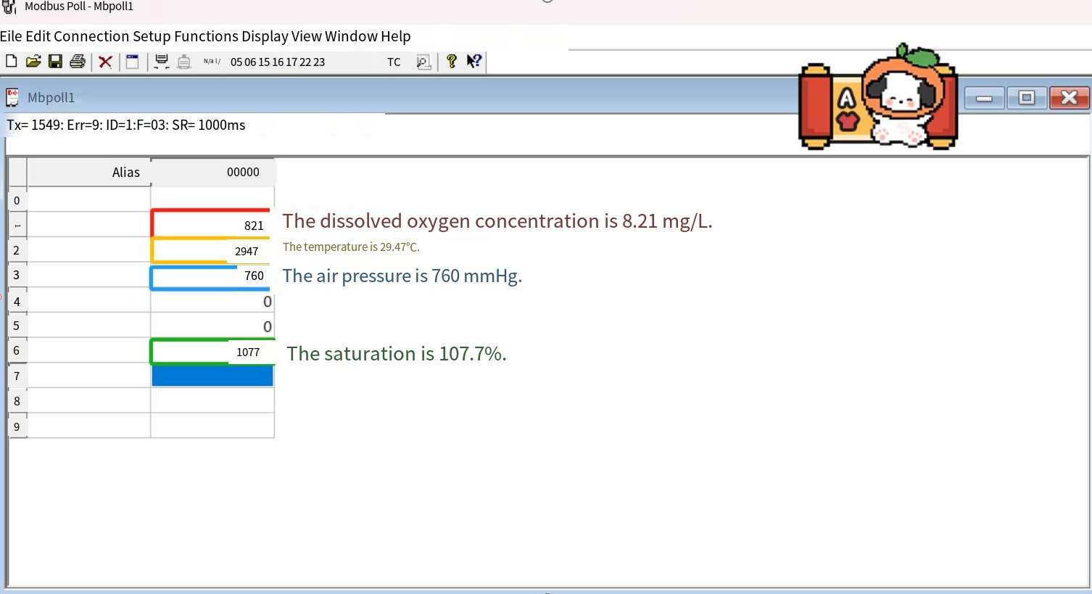

3.1.3 One-point sensor calibration
After connecting the sensor to the computer, prepare the saturated water body. By default, the water body that is aerated for more than 30min is saturated water. After the sensor is put in, double-click the calibration address on the computer to pop up a dialog box, enter 1, and the sensor starts automatic calibration after confirmation. The corresponding calibration result is the data of the corresponding saturation address bit. After the saturation is stable and does not change, the calibration is completed.
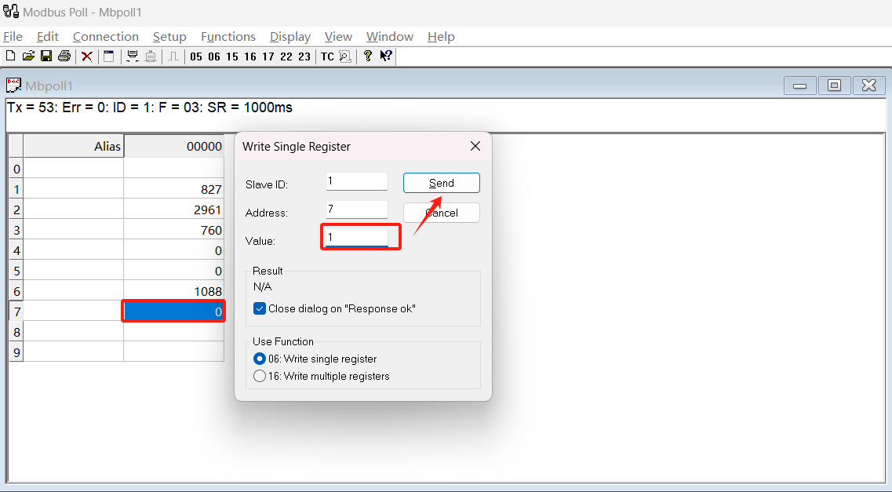

3.1.4 Sensor salinity settings
After connecting the sensor with the computer, prepare the standard solution with known concentration, stir evenly, put it into the sensor, double-click the calibration address on the computer to pop up a dialog box, enter the corresponding concentration value (the default salinity setting range is 0~40), after confirmation, the sensor starts automatic salinity setting, and the corresponding result is the data of the corresponding salinity setting address bit. When the data in the corresponding register changes to the corresponding concentration value, it, it indicates that the salinity setting is complete
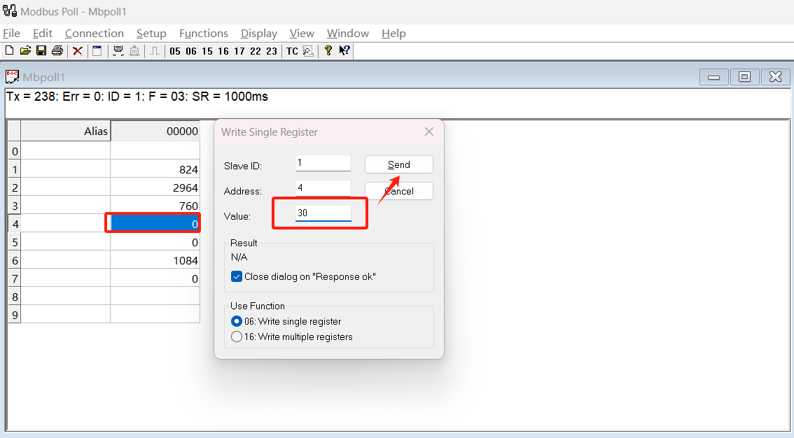
3.1.5 Sensor Atmospheric Pressure Setting
After connecting the sensor to the computer, prepare the air pressure device. After placing the sensor, double-click the calibration address on the computer to pop up a dialog box, enter the corresponding air pressure value. After confirmation, the sensor starts to automatically set the air pressure. The corresponding result is the data of the corresponding air pressure address bit. When the data in the corresponding register changes to the corresponding air pressure value, the air pressure setting is completed.
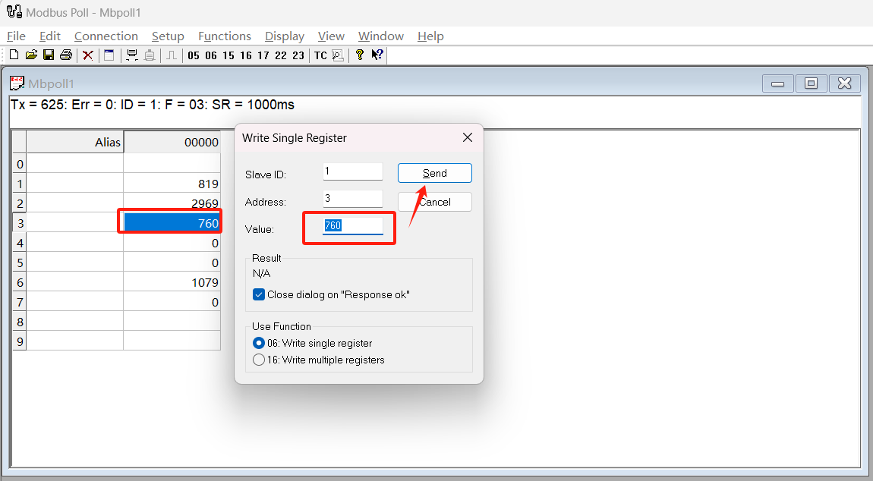

3.1.6 Sensor Address Modification
The default communication address of the sensor is 1. The user can modify the communication address of the sensor according to requirements. After connecting the sensor, select "Setup-Read/Write Definition", set the Address to 41,Quantity to 1, and click OK.
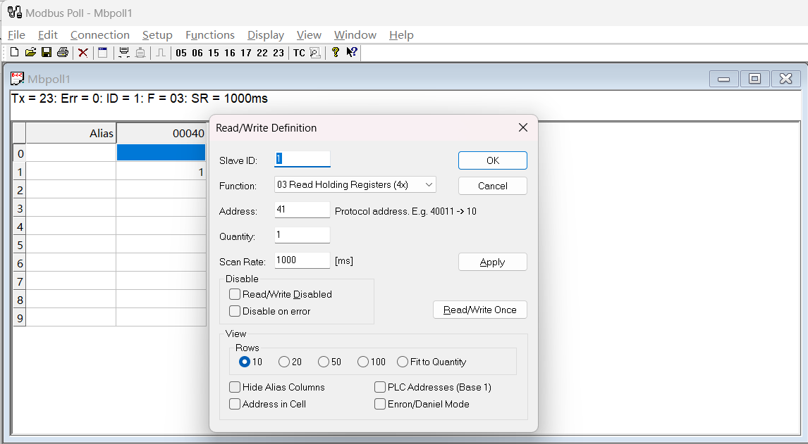
Assuming that the sensor communication address needs to be modified to 10, select 41 address bits, double-click 41 address bits, and enter "10" in the pop-up window. After clicking Send, the sensor will be disconnected and communication can be restored by reusing the correct communication address.
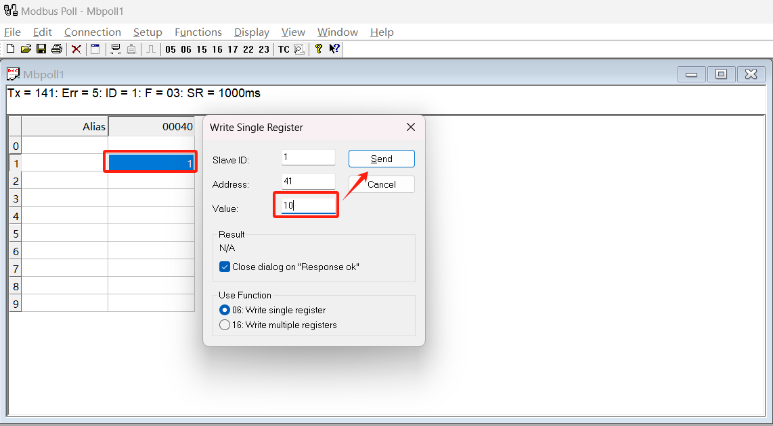
Note: The fluorescent cap setting is only used when replacing a new fluorescent cap. Contact the manufacturer. In other cases, it is forbidden to modify the coefficient, otherwise it will cause abnormal measurement and reading! ! !
3.2 calibration
3.2.1 One-point calibration:
Preparation of saturated oxygen environment: use the oxygen pump to expose air to the water, and take out the oxygen pump after 15 minutes. At this time, the water environment is saturated oxygen environment. * If conditions do not permit, you can find 1 bottles of pure water, pour out 1/3 and shake violently for 1 minute to create a saturated water environment.
One-point calibration: place the dissolved oxygen probe in saturated water. After the data is stable (A/B membrane is generally placed for more than 3 minutes and C membrane is generally placed for more than 10 minutes), calibrate according to "2.5.3 User One-point Calibration". After calibration, the saturation data can be read. If the saturation data is about 100, the calibration is successful.
4. Replacement of fluorescent cap
In order to ensure the accuracy of the test, it is recommended to replace the fluorescent cap once a year. If the fluorescent cap is found to be seriously damaged, it should be replaced in time. Refer to the following for the replacement steps:
1) Unscrew the old fluorescent cap counterclockwise, as shown in the figure below.
2) Check whether the original sealing ring is damaged. If it is damaged, remove the original sealing ring, replace it with a new sealing ring, and coat it with silicone grease to facilitate the installation of a new fluorescent cap.
3) Check whether the optical window is clean. If there are stains, wipe them clean with lens paper.
4) Install the new fluorescent cap clockwise and ensure to tighten it.
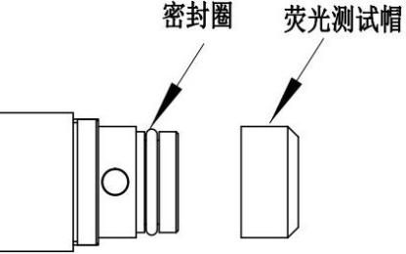
5) After installing the new fluorescent cap, re-calibrate the dissolved oxygen probe according to "Parameter Setting and Calibration.

5. Maintenance and maintenance
Fluorescence Testing Cap
Sealing Ring
In order to ensure the accuracy of the measurement, the sensor needs to be regularly maintained and maintained. Including the cleaning of the sensor, whether the appearance of the sensor is damaged, whether the sensing film is complete, etc.
- Sensor cleaning and inspection
Because there are many impurities in the water environment, the probe may be contaminated by algae after a period of use and needs to be cleaned regularly. In the cleaning process, there is no need to disassemble the sensor, use a soft and moist cloth or a sponge to gently wipe the front fluorescent film, and for some stubborn dirt, you can add some household detergent to the water for cleaning. Note: The frequency of maintenance is recommended to arrange the cleaning cycle according to the condition of the water body. Check whether the appearance of the sensor is damaged. If the shell or cable is damaged, stop using it and contact the after-sales service for replacement.
- Preservation of sensors
When not in use, please put the front end of the sensor in a rubber cap with a wet sponge to keep the sensor in a wet state for a long time, so that the probe can still be in good condition when it is used next time.
If the sensor is in a dry state for a long time, the measurement result will drift, resulting in inaccurate measurement data. If it is in a dry state, it needs to be soaked in water for more than 24-48 hours before continuing to work.

6. Precautions
- Avoid the sensor is exposed to the sun, cool storage, avoid high temperature, high humidity or special dry environment.
- Avoid applying any mechanical stress (pressure, scratches, etc.) directly to the fluorescent film in use.
- It is forbidden to scrape with hard objects such as nails.
- It is forbidden to use alcohol, acetone and other organic solvents to clean the head of the fluorescent film.
- The sensor recommends replacing the fluorescent cap every 1 to 2 years.
- Use rings and ropes to fix the sensor. The cable should not be tight during normal operation, otherwise it is easy to break the cable and cause abnormal sensor.
- Periodically inspect the sensor housing for damage due to corrosion or other causes. The copper protective cover is oxidized and blackened during transportation and long-term use.

7. Frequently Asked Questions
Question | Possible causes | Solution
The probe does not display measurement data | The power supply is not connected or the communication cable is connected incorrectly. | Check whether the power supply is normal and whether the line sequence connection is normal.
Measured value continues to be abnormal | The outer surface of the fluorescent cap is attached or damaged | Clean or replace the sensing membrane
Low measurement data using a period of time | Fluorescent film surface with algae, foreign matter attached | Wipe the membrane gently with a cotton swab or finger pulp
Measurement data is too high | - Unscrew the fluorescent cap by mistake or enter water.  - The surface of the fluorescent film is damaged. | - Inspect the fluorescent cap for signs of unscrewing or cracking.  - Replace the fluorescent film if the surface of the fluorescent film falls off.

8. Quality assurance and after-sales service
The warranty period of the instrument is one year (subject to the date of purchase). During the warranty period, if there is any quality problem, the company will repair or replace the defective products free of charge. The company can repair the faults caused by human external factors, but it needs to charge a fee (accessories such as fluorescent film and other consumables are not covered by the warranty). Before repairing faulty instruments, you need to contact our company and get permission before mailing. When mailing, please pack properly to avoid damage during transportation.

