**Overview:**

This document aims to investigate the effect of changing boundary conditions on the APPVMD algorithm. Three boundary conditions are simulated; namely, pinned-pinned (default study), fixed-pinned, and fixed-fixed. These simulations are carried out for all four vehicle classes to gain an understanding of these effects of almost all vehicle classes. It is worth mentioning that the default boundary condition us rerun, where negligible differences are observed due to the variability of the surface roughness definition for each vehicle pass. The following tables are generated to investigate the effects of boundary conditions on the APPVMD accuracies.

**Results:**

Table 1: Pinned-pinned condition.

|  |  |  |  |  |  |
| --- | --- | --- | --- | --- | --- |
| Vehicle Class | Not Detected | Low CFR | Med CFR | High CFR | % detected |
| Hatchback | 9 | 20 | 8 | 2 | 76.9% |
| Sedan | 1 | 12 | 17 | 9 | 97.4% |
| SUV | 2 | 8 | 16 | 13 | 94.8% |
| Truck | 7 | 7 | 9 | 16 | 82.1% |

Table 2: Fixed-pinned condition.

|  |  |  |  |  |  |
| --- | --- | --- | --- | --- | --- |
| Vehicle Class | Not Detected | Low CFR | Med CFR | High CFR | % detected |
| Hatchback | 10 | 19 | 10 | 0 | 74.4% |
| Sedan | 1 | 26 | 11 | 1 | 97.4% |
| SUV | 4 | 22 | 11 | 2 | 89.7% |
| Truck | 15 | 18 | 6 | 0 | 61.5% |

Table 3: Fixed-fixed condition.

|  |  |  |  |  |  |
| --- | --- | --- | --- | --- | --- |
| Vehicle Class | Not Detected | Low CFR | Med CFR | High CFR | % detected |
| Hatchback | 14 | 14 | 10 | 1 | 64.1% |
| Sedan | 2 | 27 | 10 | 0 | 94.8% |
| SUV | 2 | 25 | 10 | 2 | 94.8% |
| Truck | 14 | 15 | 10 | 0 | 64.1% |

**Discussion:**

I also inspected the ratio of the bridge psd amplitude to the vehicle natural frequency and made a brief relational plot, as shown below. Each column represents a boundary condition type (bc_type) where pp, fp, and ff correspond to pinned-pinned, fixed-pinned, and fixed-fixed, respectively. The x and y axes are the ratio and bridge IDs, respectively, and the points are distinguished based on color and type. The color classifies based on whether the vehicle was able to capture the frequency and the type corresponds to the vehicle class.

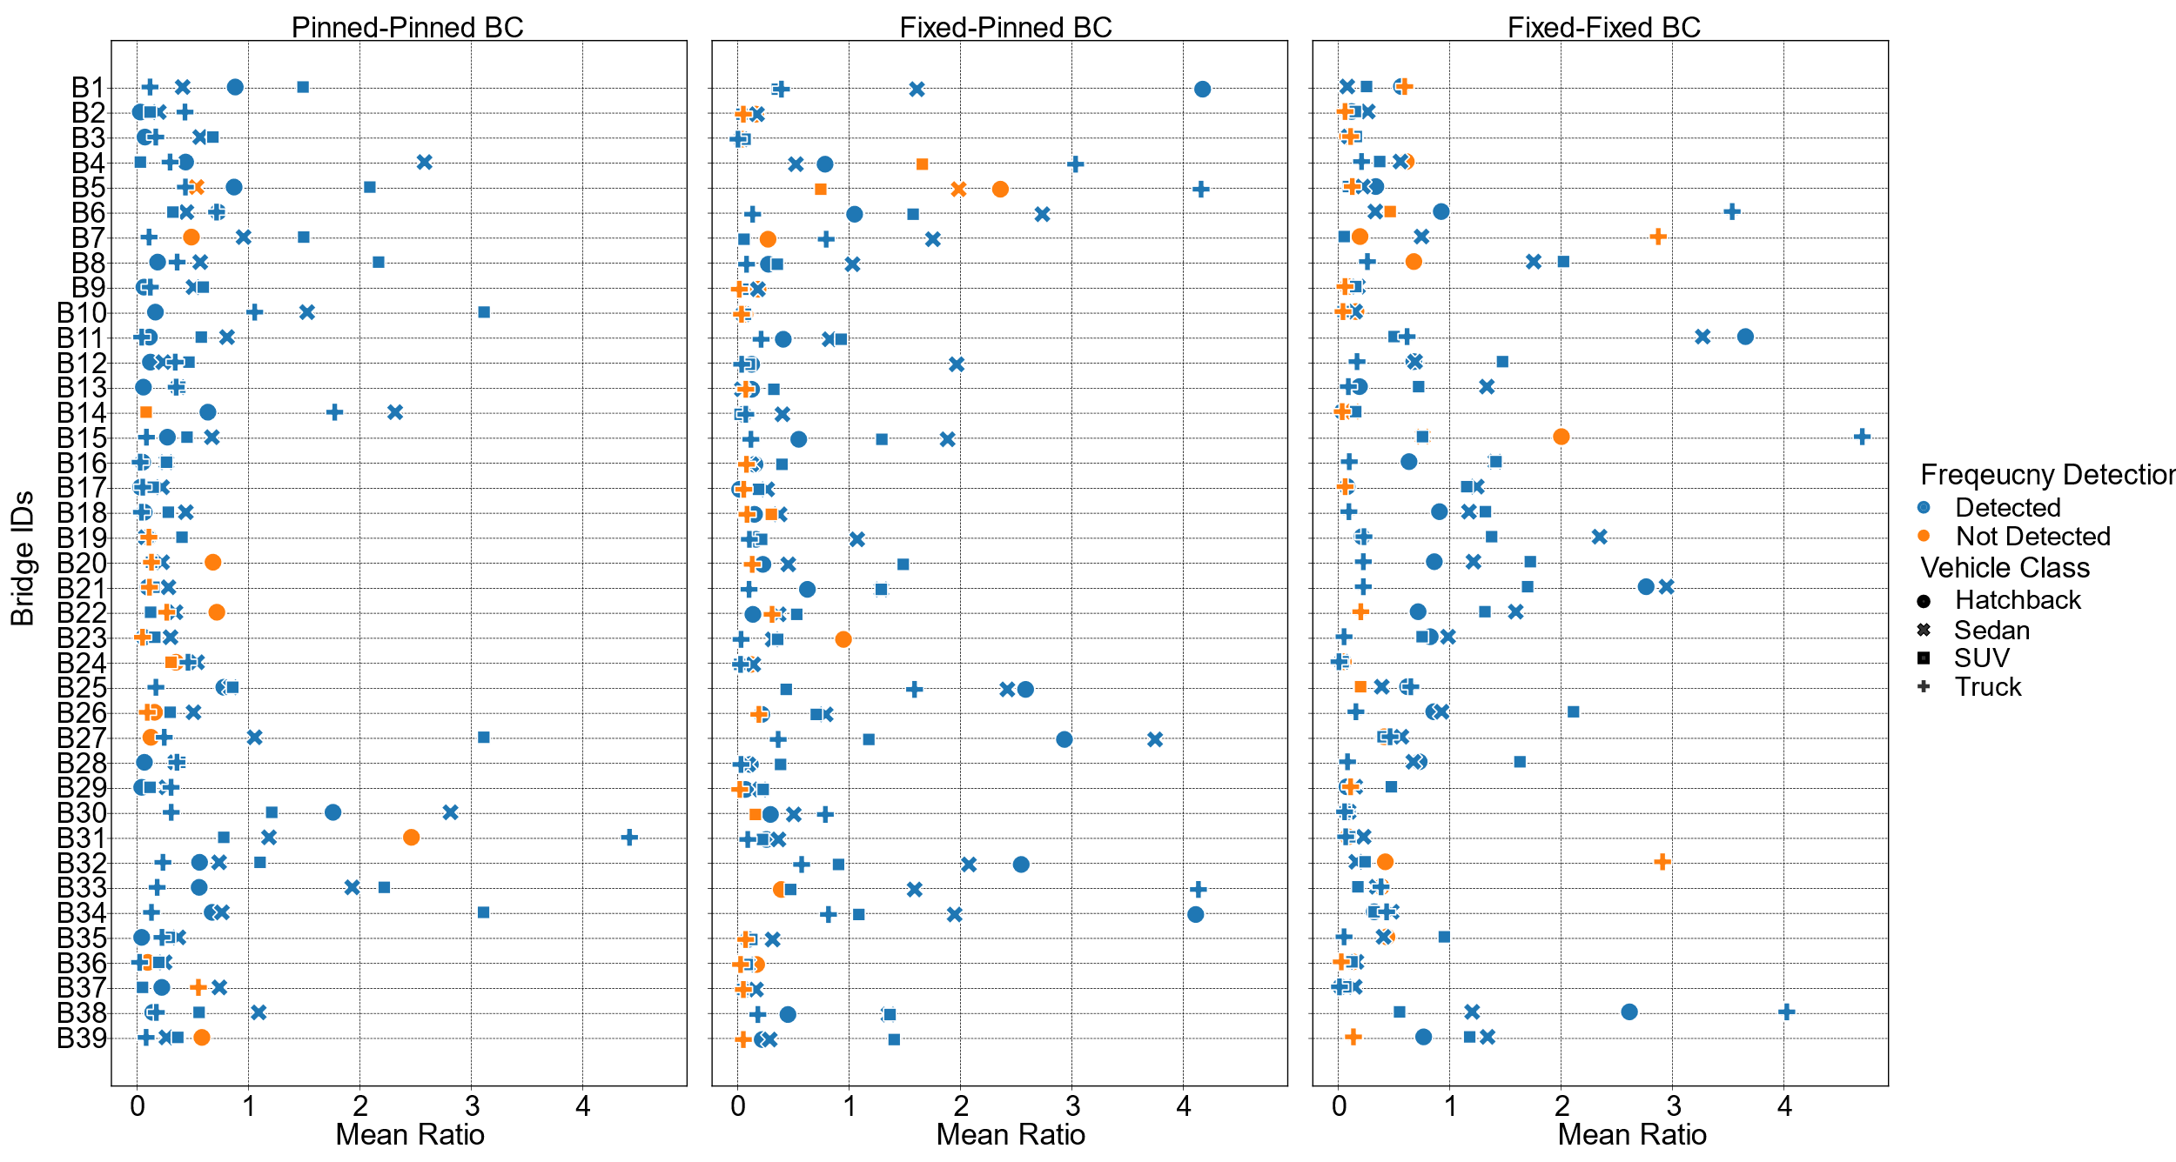

Afterwards, I arbitrarily decided to select the points that are above 0.10 ratio, since the specified height range to pick peaks is at 10% of the maximum amplitude. These points are then classified into tables based on the boundary condition type and vehicle class, as shown below.

Table 4: Number of successful detection that demonstrate a PSD ratio greater than 0.10.

|  |  |  |  |
| --- | --- | --- | --- |
| Vehicle Class | Count for PP | Count for FP | Count for FF |
| Hatchback | 18 | 25 | 20 |
| Sedan | 37 | 34 | 33 |
| SUV | 35 | 26 | 31 |
| Truck | 25 | 17 | 15 |