**Omar Abushbak**

**100368325**

**USE CASE DESCRIPTION**

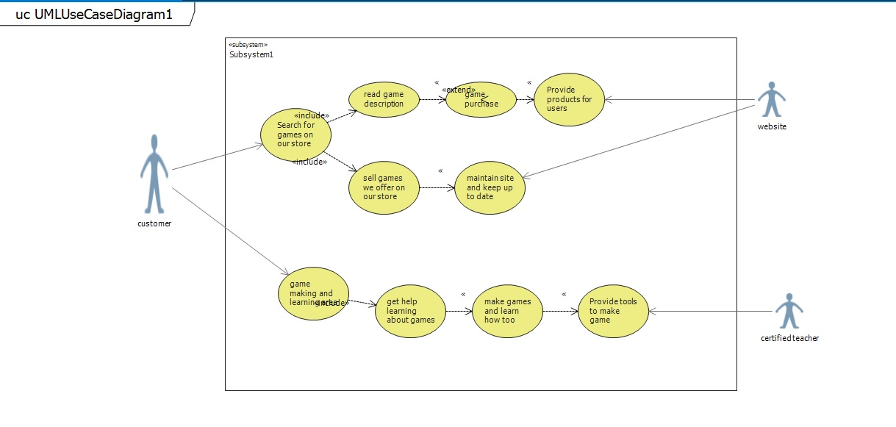

|  |  |
| --- | --- |
| USE CASE | Searching for games on our store |
| Primary Actor | Customer |
| Level | Ground level |
| Stakeholder | Customer and website owner |
| Precondition | Customer searching for game |
| Minimal Guarantee | Customer not finding the product they looking for |
| Success Guarantee | Customers wishes are fulfilled and receive what they are looking for |
| Trigger | Customer redirected to ground level |

|  |  |
| --- | --- |
| USE CASE | Game making and learning area |
| Primary Actor | Customer |
| Level | Ground level |
| Stakeholder | Customer website owner |
| Precondition | Customer clicking on the app making option |
| Minimal Guarantee | Not able to accuses the app making section |
| Success Guarantee | Customer has started learning |
| Trigger | Redirected to ground level |

|  |  |
| --- | --- |
| USE CASE | Getting help learning about the games |
| Primary Actor | Customer |
| Level | Ground level |
| Stakeholder | Customer, website owner |
| Precondition | Reaching the learning section |
| Minimal Guarantee | Unable to follow instructions |
| Success Guarantee | Customer well on their way into learning about app making |
| Trigger | redirected to ground level |

|  |  |
| --- | --- |
| USE CASE | Game purchasing |
| Primary Actor | Customer |
| Level | Purchasing level |
| Stakeholder | Customer and website owner |
| Precondition | Customer failed to purchase |
| Minimal Guarantee | Payment Declined. |
| Success Guarantee | Payment successful |
| Trigger | Redirected to purchasing level |