This project by:
1-Omar Ahmed Ismail----202508584
2- Amr Ashraf Ahmed Elsaied----202507976
SECTION:8 (with Enginer Ahmed Bilal)

WITH DOCTOR:
Assoc. Prof. Dr. Mohamed Maher Ata
In group:1

Introduction
The "Smart Islamic Research Assistant" is a desktop application developed using Python to help users search for Islamic information from multiple sources in one place.
The system collects data from:
-Islamic books
-Religious fatwas
-Educational YouTube videos
The project uses modern technologies such as:
-Web scraping
-Data analysis
-Data visualization
-Graph Analysis
The application provides an easy and organized way to search Islamic content instead of searching manually across many websites.

Project Idea
The main idea of the project is to create a unified Islamic search platform that can:
-Search for Islamic books
-Search for religious fatwas
-Search for YouTube lessons
-Save results into Excel files
-Analyze and visualize the collected data
The system also creates a Knowledge Graph to show the relationship between the search keyword and the extracted results.

Project Objectives
The project aims to: simplify Islamic research, collect information from multiple sources, improve user experience through a graphical interface, Apply data analysis techniques on collected data , visualize information using graphs and charts and Build a practical Python application using real-world technologies.

Technologies Used
Programming Language:Python, libraries and tools and selenium used for browser automation and web scraping.
-Pandas: Used for data cleaning and analysis.
-NetworkX: Used for building the Knowledge Graph.
-Matplotlib: Used for creating charts and visualizations.
-Tkinter & CustomTkinter: Used for building the graphical user interface (GUI).
-Openpyxl: Used for exporting data into Excel files.
-SerpAPI: Used for retrieving YouTube search results.
-Arabic Reshaper & bidi: Used for displaying Arabic text correctly in graphs and charts.
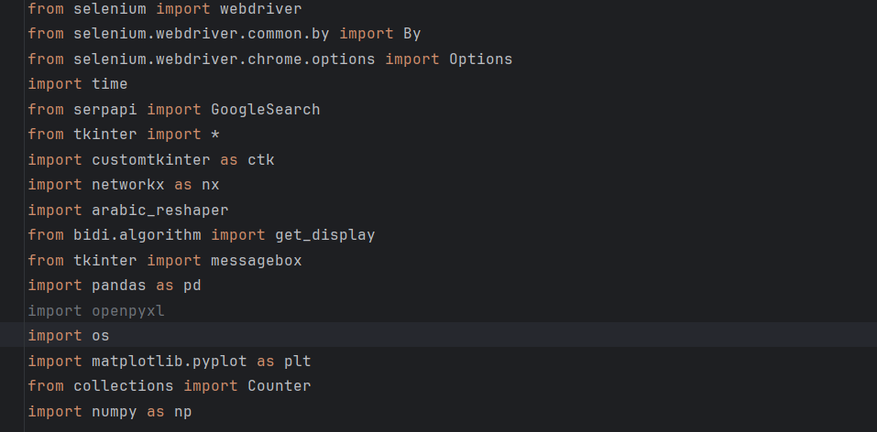
-This image explains the libraries and tools that used in this application.
System Workflow
1.Main Menu
When the application starts, the main screen appears with a clean and organized interface offering multiple options:
1-Full Search (Books + YouTube + Fatwas)
2-Books Only Search
3-YouTube Lectures Search
4-Fatwa Search
5-About the Application
6-Data Visualization Tools (Graph / Heatmap / 3D Point Cloud)
-The home page features a visually appealing design with icons, images, and interactive buttons for easy navigation.
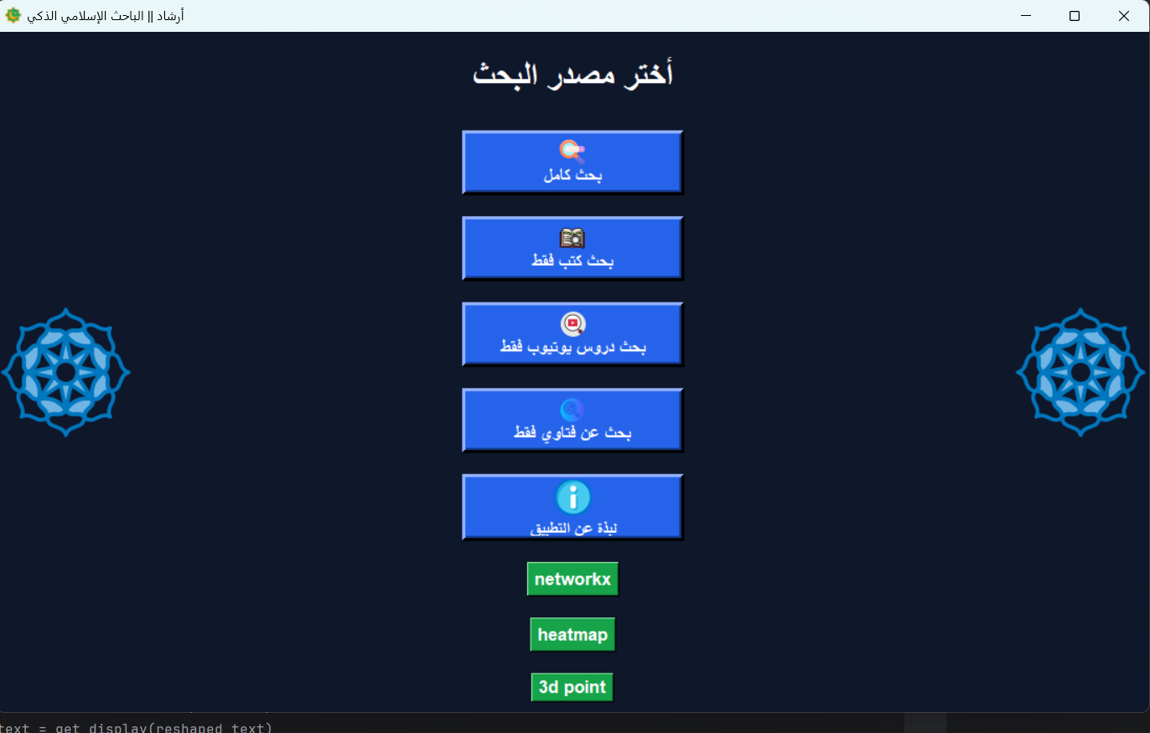
-This image explains the home page interface.

2.Search Pages
Each search option opens a dedicated page that includes:
-A text input field for the query (e.g….الصلاة,الحج)
- Input field for video count in full search and videos search only (e.g.10,20….)
-A search button
-A back button to return to the main menu
-A results display box
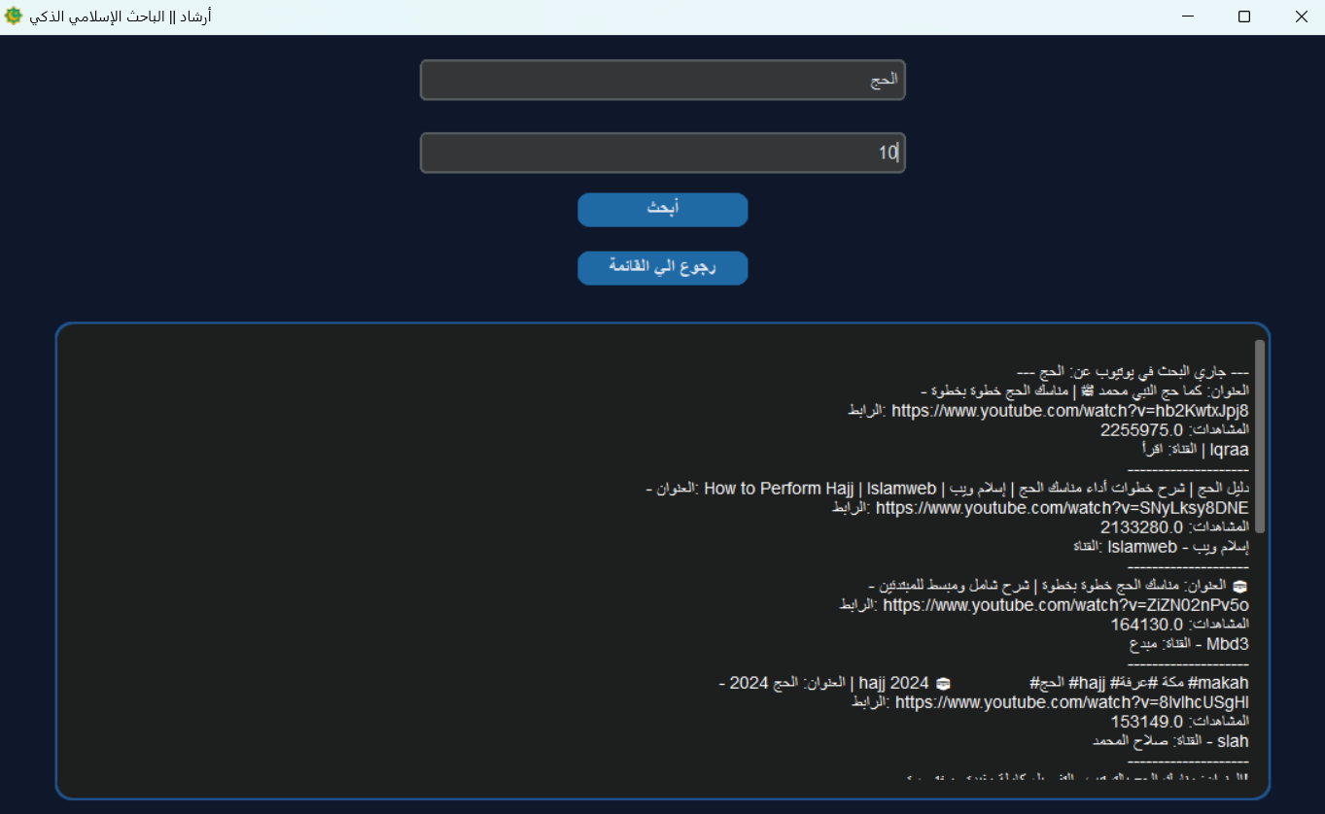
-this image explains search page.

3.Search Results
The application aggregates results from multiple sources:
-Islamic books
-YouTube lectures
-Islamic fatwas
All results are displayed in a unified and structured output area.

Data Visualization Tools
The application includes advanced data visualization tools built using NetworkX and Matplotlib to transform search data into meaningful graphical representations.
1. Knowledge Graph:
This module visualizes relationships between different data sources such as:
-Islamic books (green nodes)
-YouTube videos (red nodes)
-Islamic fatwas (blue nodes)
Each node represents a data item, while edges represent relationships between them.
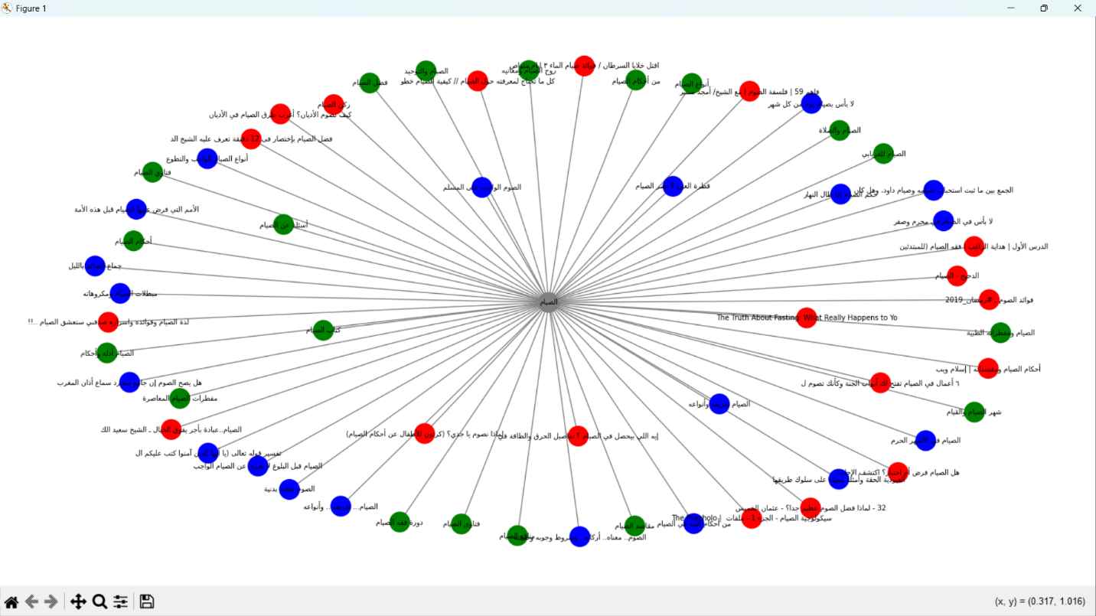
- This image explains visualization with NetworkX.

2. 3D Point Cloud Visualization:
This feature represents data distribution in a 3D space, where each axis corresponds to a data type:
-X-axis: YouTube videos
-Y-axis: Books
-Z-axis: Fatwas
Each point represents an individual item and is color-coded:
-Video( red color)
-Book(green color)
-Fatwa(blue color)
This visualization helps analyze the distribution and weight of information across different sources.
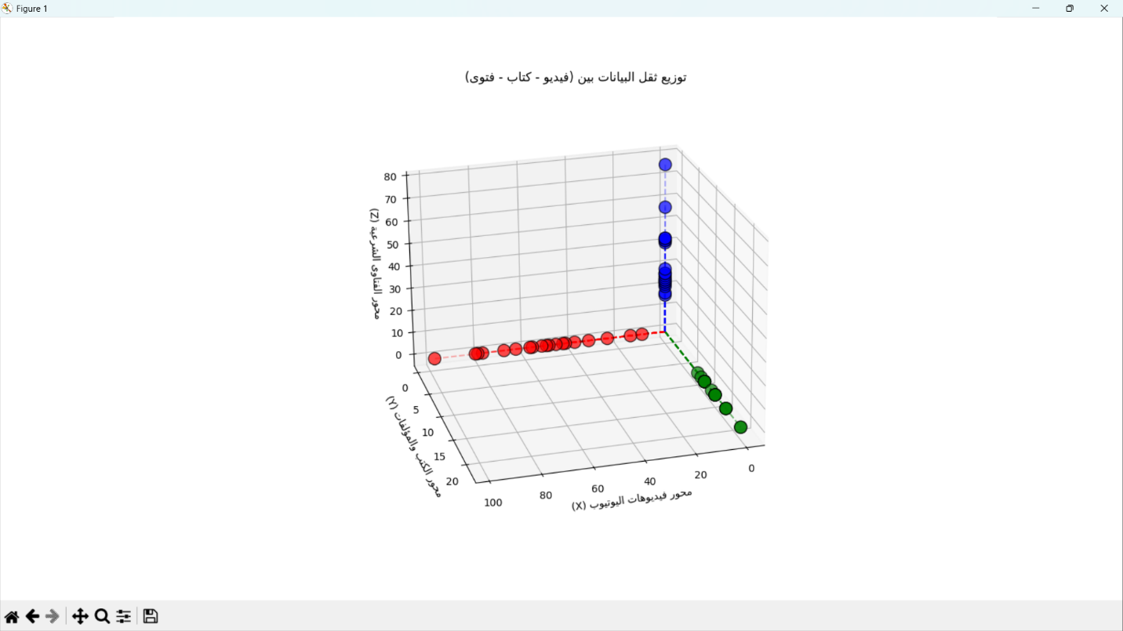
- This image explains visualization with 3D point cloud.

3. Heatmap Analysis
This tool analyzes extracted titles and identifies the most frequently occurring words.
It performs:
-Tokenization of titles
-Frequency counting
-Visualization using a heatmap
Where color intensity represents frequency ,each cell shows a keyword and its count
This helps in:
-Identifying user interests
-Extracting dominant keywords
-Understanding search trends
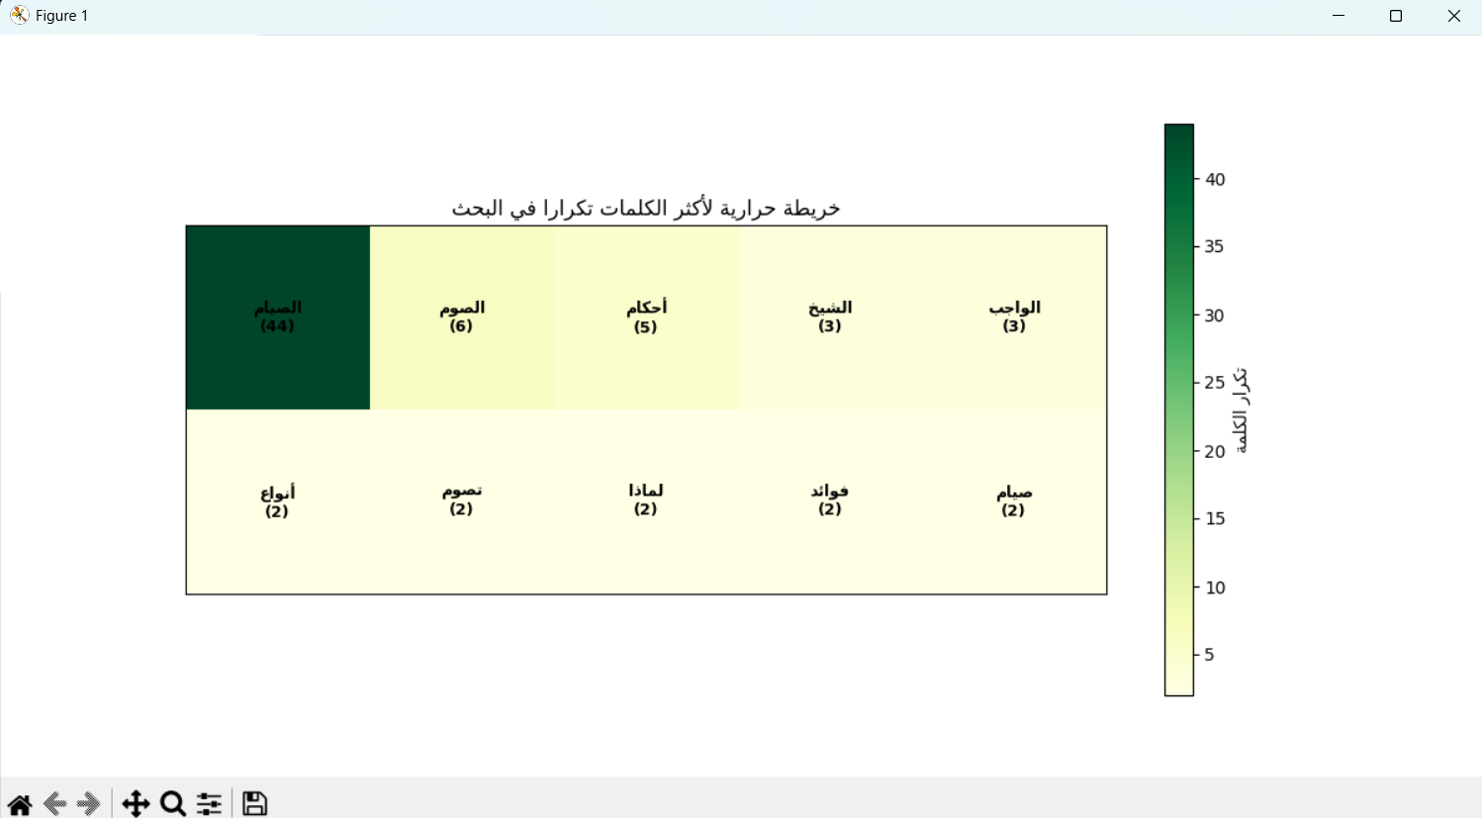
- This image explains visualization with heatmap.

conclusion
The Smart Islamic Research Assistant project successfully demonstrates how modern technologies can be integrated to build a practical and intelligent Islamic research platform. The system combines web scraping, data analysis, visualization, and graph analysis techniques to provide users with an efficient way to access Islamic knowledge from multiple sources in one application.
Through the use of Python libraries such as Selenium, Pandas, NetworkX, Matplotlib, and Tkinter, the project offers a complete workflow starting from data collection and ending with visualization and analysis. The application helps users save time and effort by organizing Islamic books, fatwas, and educational YouTube videos in a clear and interactive manner.
In addition, the project highlights the importance of data visualization through Heatmaps,3D Point Clouds, and Knowledge Graphs, which make the collected information easier to understand and analyze.
Overall,this project represents a strong example of applying Artificial Intelligence and Data Science concepts in real-world applications,while also serving an educational and beneficial purpose for Islamic research and learning.

Reference
https://youtu.be/taL3r_JpwBg?si=iTMeEB-_xExrSvFT
https://youtu.be/WQ2TEHsSwRk?si=yPInGOhFHFkpK5H3
https://www.crummy.com/software/BeautifulSoup/bs4/doc/
https://customtkinter.tomschimansky.com/documentation/

