Exercise #1 (1): Changing text

- Extend [this HTML page](exercise1.html) such that on moving the mouse over the yellow box the text changes to "**Can I help you**?". Then, when the mouse is moved outside the box the text changes back to "Hello world!".

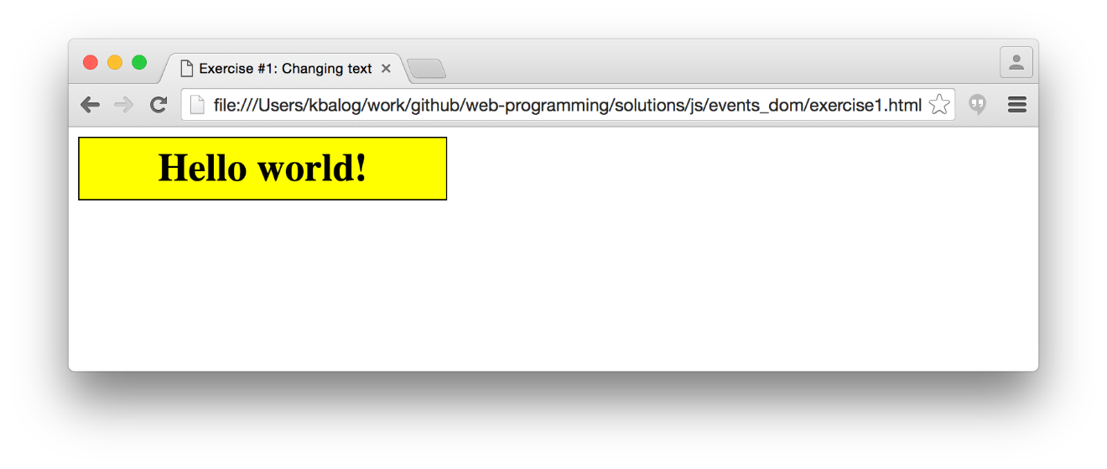

## Exercise #2 (2): Changing colors

- (exercise2.html) contains a 200x200px div. Write JS code that sets the initial color of the div is blue, then changes the color when the div is clicked to red,

- In this exercise, you are only allowed to make changes inside `<script>...</script>` and cannot change other parts of the HTML code.

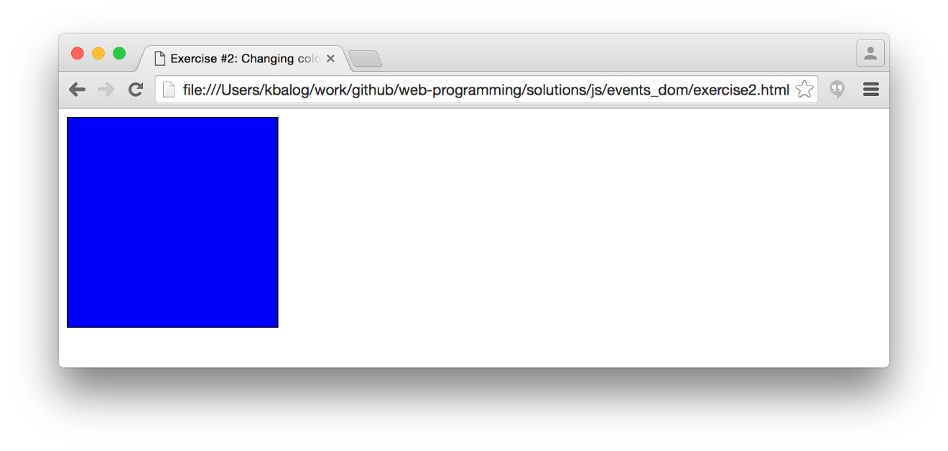

## Exercise #3 (3): Changing images

- The page shows a select list and a "no image" picture by default.

- Once the user changes the selection in the list, display the selected image.

* Set the src of the image to the option value and the alt of the image to the name of the option.

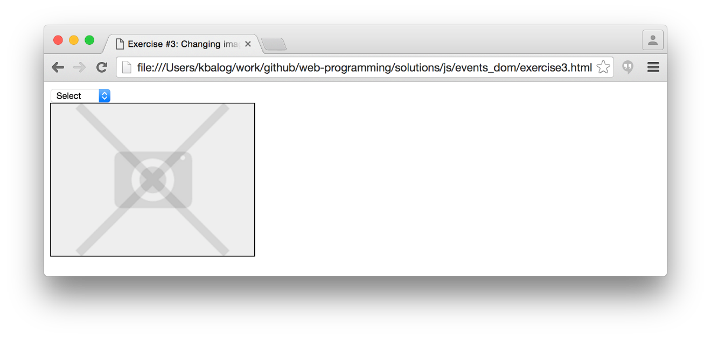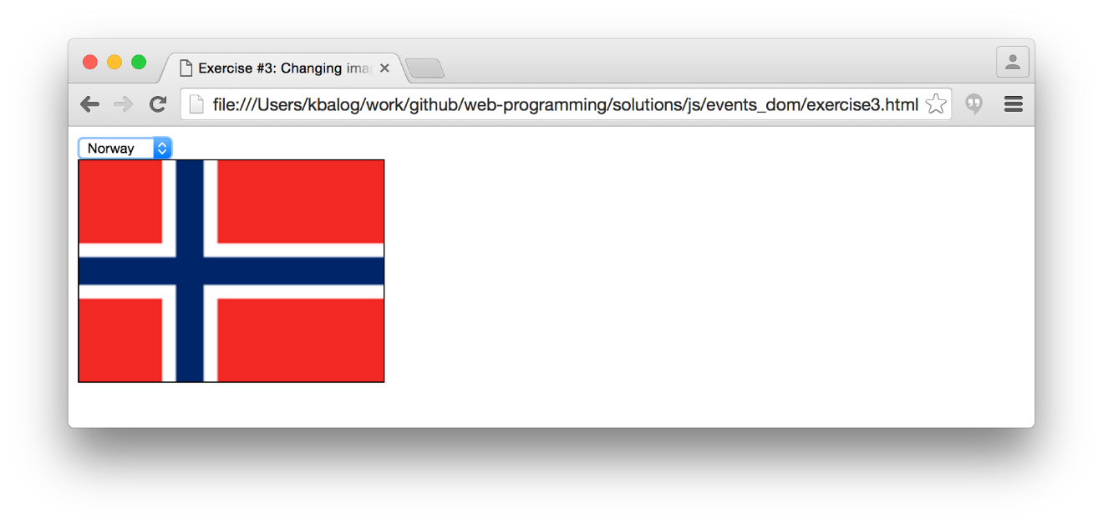

## Exercise #4 (4): Formatting text

- Create a simple what-you-see-what-you-get text editor.

- Change the text inside the "text" div according to the form selections.

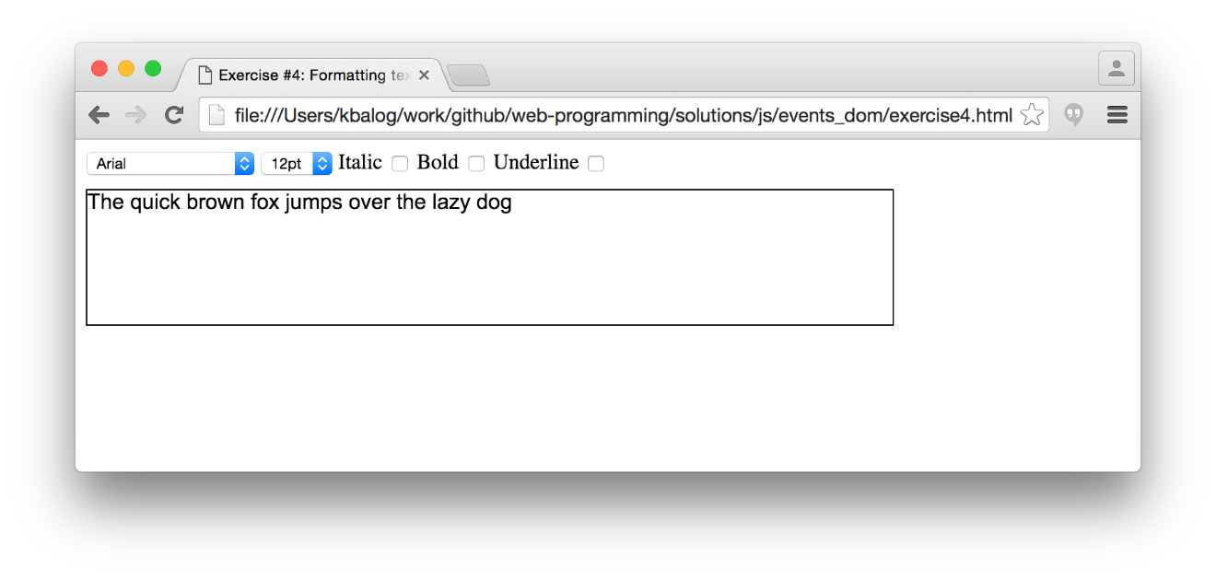

## Exercise #5 (5): Input check

- Perform input check and display an error message next the the corresponding field if there is an error.

* Passwords must be at least 6 characters long.

* The two passwords must match.

- By default the submit button should be hidden. Display the button only when there are no errors.

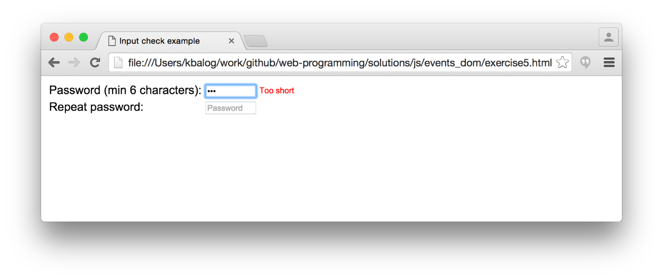

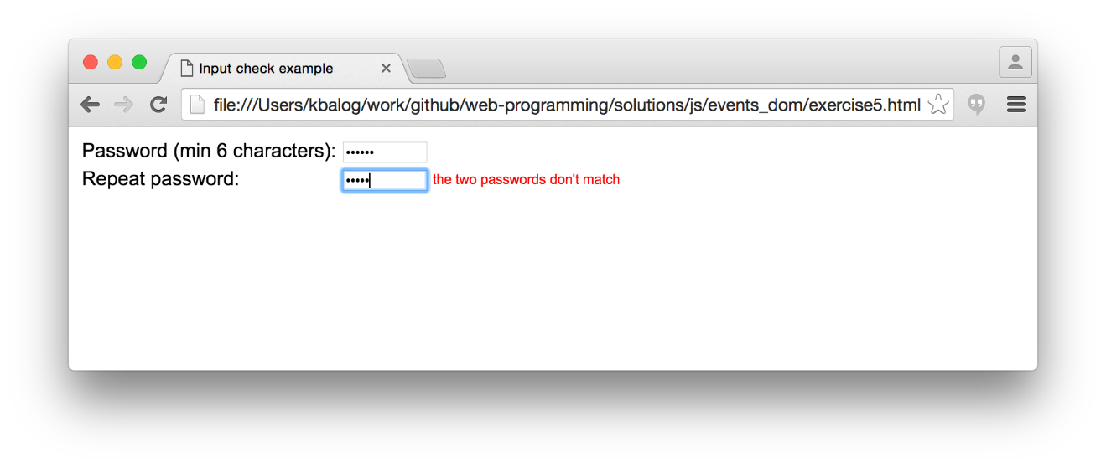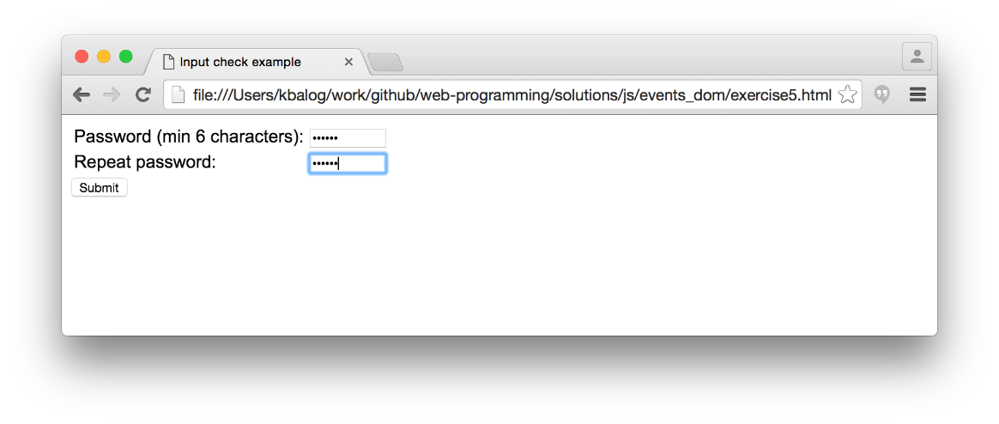

## Exercise #6: **Optional Task**

Create a simple playlist application where users can add songs to a list.

