ENSF-381: Full Stack Web Development Laboratory
Lab04

GitHub Link: https://github.com/omaralmhf/ENSF381Lab4

Group Information:

Omar Al-Mahfoodh (UCID#30257072)
Javier Dal Monte Casoni (UCID#30254262)

Exercise 1:

Screenshot of the Output:



Exercise 2:

Screenshot from Step 9:
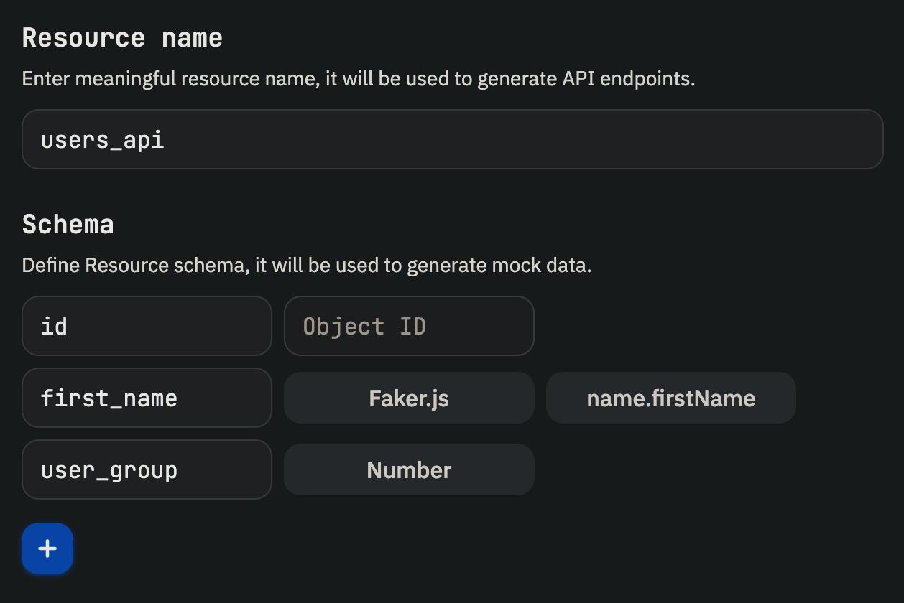
Screenshot from Step 12: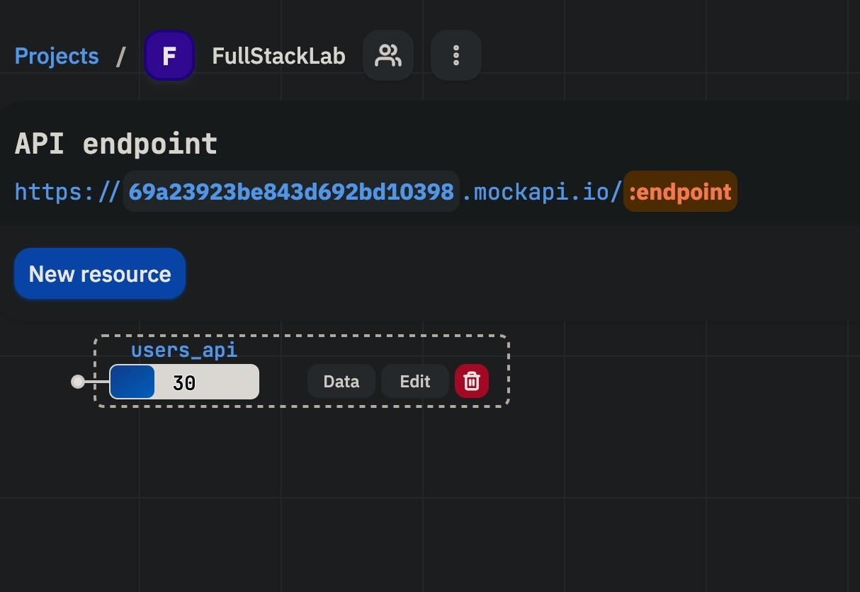

Screenshot from Step 14: 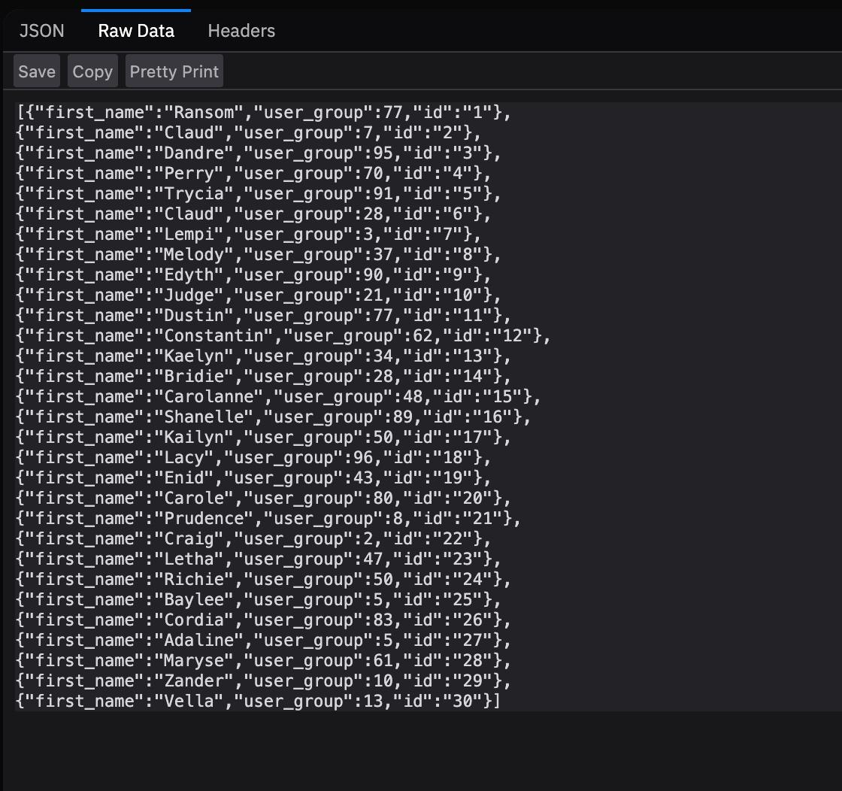

Exercise 3:
Screenshot A: 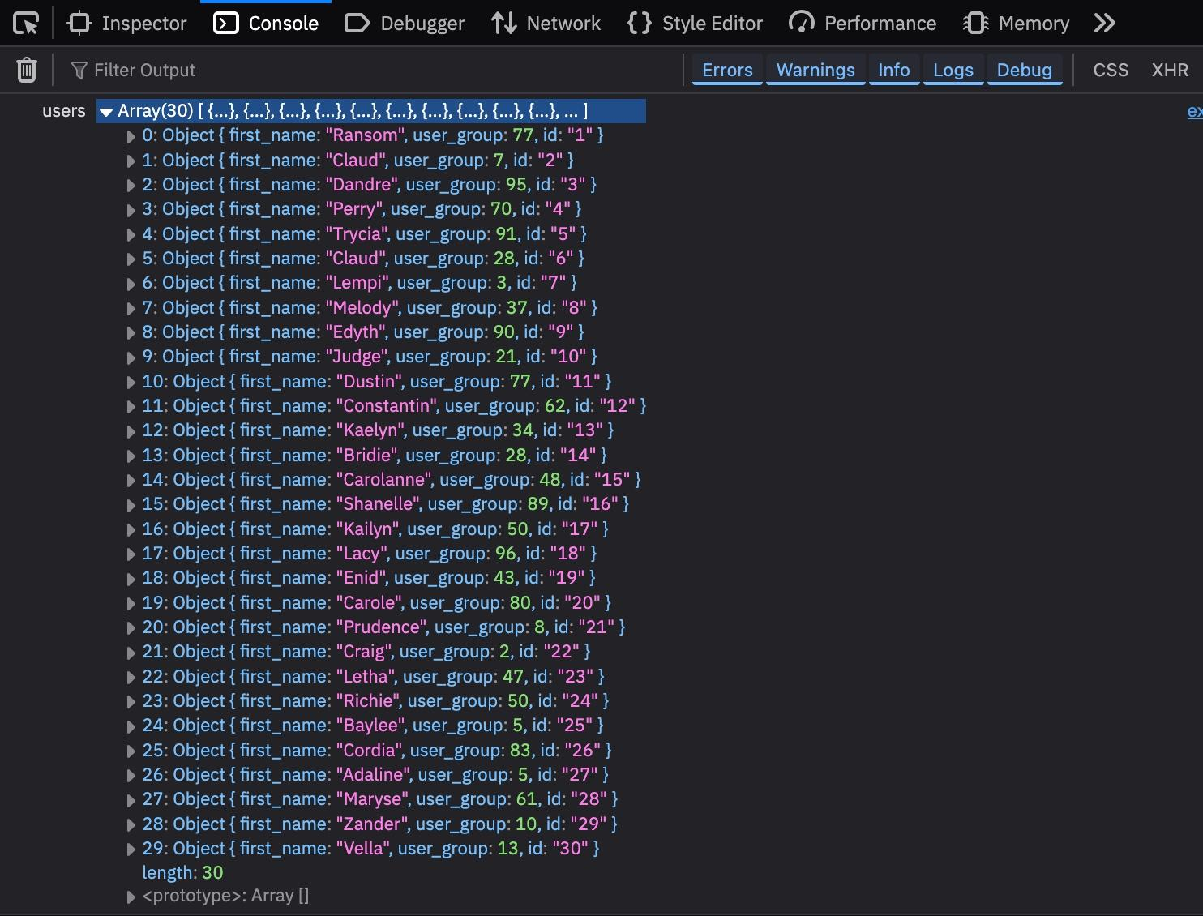

Screenshot B: