
Module Code | : | Switching and Routing Essentials(112025-JOM)
Intake Code | : | APD2F2511CS(CYB)
Lecturer Name | : | Joshua Samual
Hand out Date | : | December 2025, 5:43 PM
Hand in Date |  | Friday, 27 February 2026, 11:59 PM
Group No. | : | JOM-01
Group Leader | : | OMAR ABDULMUNEM MOHAMED MARYUL

 | Student ID |  |  |  | Student Name
 | ALAJMANI SALAH SHAMSAN WADEEA
 | Mohamed Jamal Mohamed Erhuma
 | Wasiul Alam Talukder
 | OMAR ABDULMUNEM MOHAMED MARYUL
A.GroupCompont
 |  | ASSIGNMENT COMPONENT | MARKS | CONTRIBUTION PERCENTAGE |  | CONTRIBUTION PERCENTAGE | CONTRIBUTION PERCENTAGE | CONTRIBUTION PERCENTAGE |  | CONTRIBUTION PERCENTAGE | CONTRIBUTION PERCENTAGE | TOTAL %
kl and connect |  | OMAR ABDULMUNEM MOHAMED MARYUL | 30
Penang connect |  | ALAJMANI SALAH SHAMSAN WADEEA | 25
Johor Site connect |  | Mohamed Jamal Mohamed Erhuma | 25
Malaka |  | Wasiul Alam Talukder | 20

Table of Contents
KL (HQ) Network Design and Configuration Report 4
Executive Summary 4
Key highlights: 4
Network Objectives: 4
Scope of Work: 4
Network Topology Design 5
Key Components: 5
Penang Site 6
1. Executive Overview 6
2. Physical Topology Description 7
3. VLAN and Network Segmentation 8
3.1 VLAN 40 – Finance Department 8
3.2 VLAN 50 – R&D Department 8
3.3 VLAN 60 – Delivery Department 9
3.4 Management VLAN 9
4. IP Addressing Plan 10
5. Inter-VLAN Routing 10
7. Wireless Architecture 11
8. Port Configuration Model 12
9. Security and Isolation 12
10. Network Validation Checklist 13
11. Design Evaluation 13
12. Conclusion 14
Johor Site 15
1. Executive Overview 15
2. Core Infrastructure 16
2.1 Multilayer Switch (Core) 16
3. VLAN and Subnet Architecture 17
3.1 VLAN 20 – JB IT User Network 17
3.2 VLAN 30 – Management Network 17
4. Routed Infrastructure 17
4.1 Router (Edge / WAN Router) 17
5. Server Farm Architecture 18
6. Static Routing Implementation 19
6.1 On Multilayer Switch 19
6.2 On Router 19
7. Wireless Infrastructure 19
8. Port Configuration Model 20
8.1 Access Ports (User Devices) 20
8.2 Uplink to Router (Routed Port) 20
8.3 VLAN Interface Example 20
9. IP Addressing Summary 21
10. Traffic Flow Analysis 21
10.1 Internal Communication (Same VLAN) 21
10.2 Inter-VLAN Communication 21
10.3 Accessing Server Farm 21
11. Security Considerations 21
12. Verification Checklist 22
13. Design Evaluation 22
14. Conclusion 23

KL (HQ) Network Design and Configuration Report

Executive Summary
This report gives the design and configuration of the KL (HQ) network, which provides efficient network communication, redundancy, and defense. The network topology will consist of the design of VLANs, Inter-VLAN routing, EtherChannel, HSRP to provide redundancy between gateways, and security features to prevent Layer 2 attacks.

Key highlights:
- VLANs were set up under Management (10), HR (20), and Design (30).
- EtherChannel used to connect switches to provide more bandwidth and redundancy.
- HSRP installed as a means to provide a high availability of the default gateway.
- It has also included port security and other security measures to avoid unauthorized access.

Introduction
The KL (HQ) network will be developed to facilitate the organizational structure in such a way that different departments of the organization (Management, HR, Design) can be able to communicate. The design is also aimed at ensuring high availability, security and future growth.

Network Objectives:
Support the smooth communication among VLANs. Increase availability through Etherchannel and HSRP. Secure the network against typical Layer 2 attacks with security capabilities.

Scope of Work:
Set up of VLANs, routing, HSRP, and Etherchannel of the KL network. Execution of security measures like port security. Embarkation of backup systems in the event of uninterrupted services.

Network Topology Design
The network topology for KL (HQ) consists of Core Switches, Edge Switches, and routers that connect to other remote sites. Below is the designed topology diagram that includes the VLANs for Management, HR, and Design departments.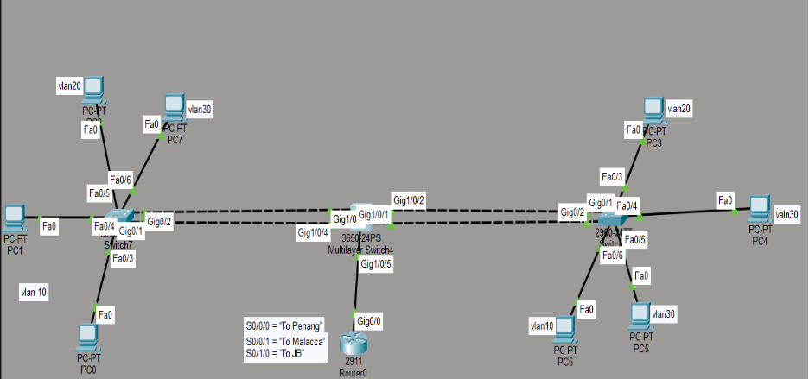
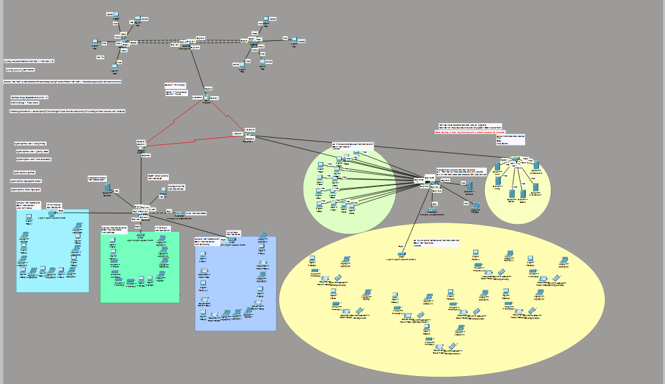
Key Components:
- Core Switches: Core switches are in charge of routing between VLANs.
- Edge Switches: Processing local access to the devices.
- EtherChannel: It is applied between switches in order to offer redundancy as well as increased throughput.
- HSRP: Gateway redundancy set.
IP Addressing Plan
Site | VLAN | Department | Network Address | Subnet Mask | Default Gateway
Kuala Lumpur (HQ) | 10 | Management | 192.168.10.0/24 | 255.255.255.0 | 192.168.10.1
 | 20 | HR | 192.168.20.0/24 | 255.255.255.0 | 192.168.20.1
 | 30 | Design | 192.168.30.0/24 | 255.255.255.0 | 192.168.30.1

Link Details | Network Address | Subnet Mask | KL (HQ) Interface IP | Branch Interface IP
KL ↔ Penang | 100.0.0.0/30 | 255.255.255.252 | 100.0.0.1 | 100.0.0.2
KL ↔ Malacca | 100.0.0.4/30 | 255.255.255.252 | 100.0.0.5 | 100.0.0.6
KL ↔ JB | 100.0.0.8/30 | 255.255.255.252 | 100.0.0.9 | 100.0.0.10

LAN and WAN Configuration:

LAN Configuration
SVIs for each VLAN:
- VLAN 10: 192.168.10.1
- VLAN 20: 192.168.20.1
- VLAN 30: 192.168.30.1
interface Vlan10
ip address 192.168.10.1 255.255.255.0
no shutdown

Routing Configuration:
- OSPF for routing between VLANs:
router ospf 1
network 192.168.10.0 0.0.0.255 area 0
network 192.168.20.0 0.0.0.255 area 0

EtherChannel Configuration:
- Configuring two GigabitEthernet ports for EtherChannel:
interface range Gi1/0/1 - 2
channel-group 1 mode active
switchport mode trunk
switchport trunk allowed vlan 10,20,30
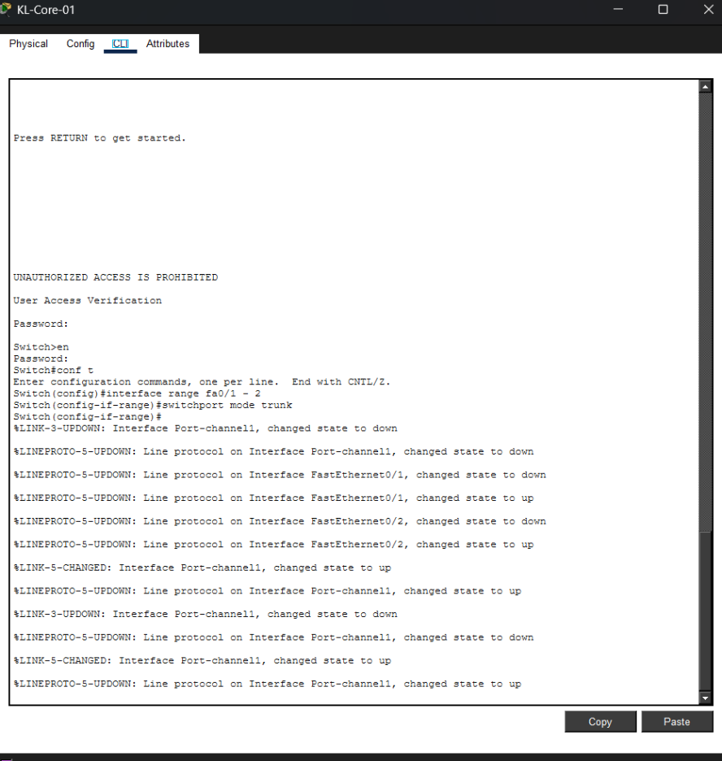
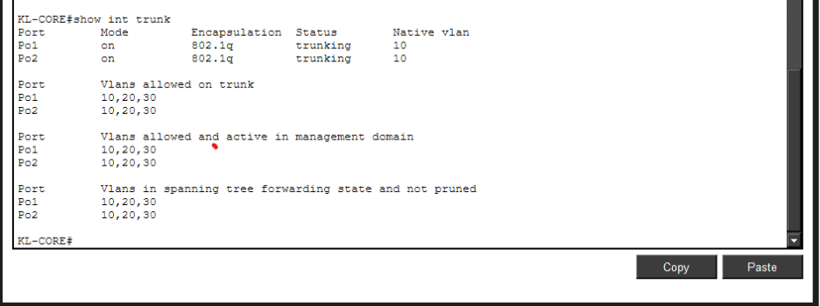

WAN Configuration
- Assigning public IPs for the WAN links using the /30 subnets.
- OSPF Configuration for WAN routers to ensure dynamic routing.
router ospf 10
network 192.168.10.0 0.0.0.255 area 0
network 192.168.20.0 0.0.0.255 area 0
network 192.168.30.0 0.0.0.255 area 0
network 100.0.0.0 0.0.0.3 area 0
network 100.0.0.4 0.0.0.3 area 0
network 100.0.0.8 0.0.0.3 area 0
end
write memory

EtherChannel and HSRP Configuration
EtherChannel:
EtherChannel is configured for link aggregation between the switches. The LACP protocol is used for negotiation.
HSRP:
HSRP provides gateway redundancy for the devices in each VLAN.
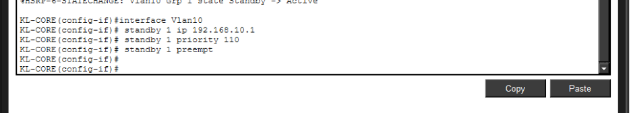
Security Measures

Port Security:
Port security is configured to restrict unauthorized devices from connecting to the network.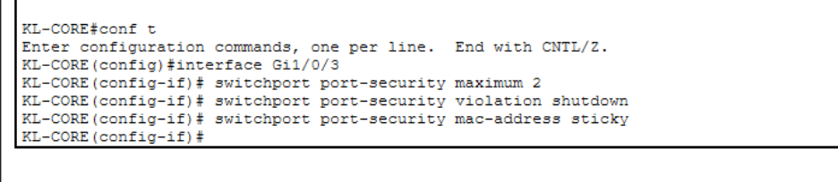

Layer 2 Security Attacks and Mitigation

Attacks:
- MAC Address Flooding – Use port security to prevent excessive MAC addresses.
- VLAN Hopping – Proper trunking configuration prevents VLAN hopping.
- Spanning Tree Manipulation – Enable BPDU guard and root guard.
- ARP Spoofing – Use dynamic ARP inspection and IP source guard.

Testing and Validation

Ping Tests:
Ping between devices in different VLANs:
PC1 (VLAN10) to Gateway 192.168.10.1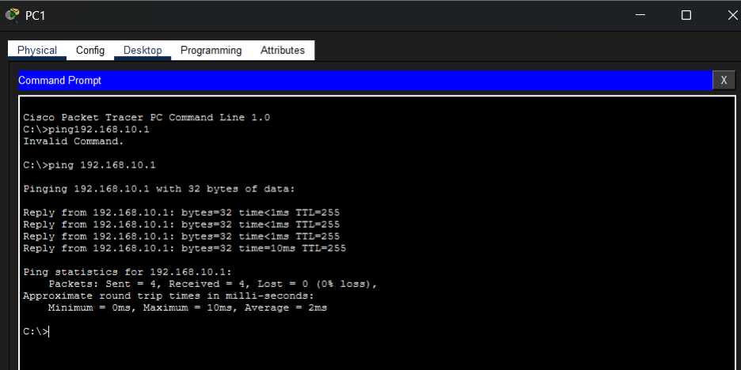
PC2 (VLAN20) to Gateway 192.168.20.1
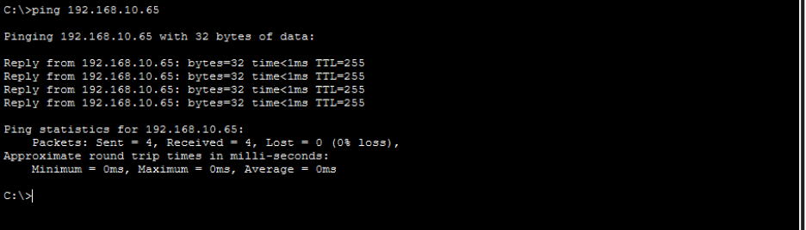

EtherChannel Test:
- Verify EtherChannel
configurationwith show etherchannel summary command.
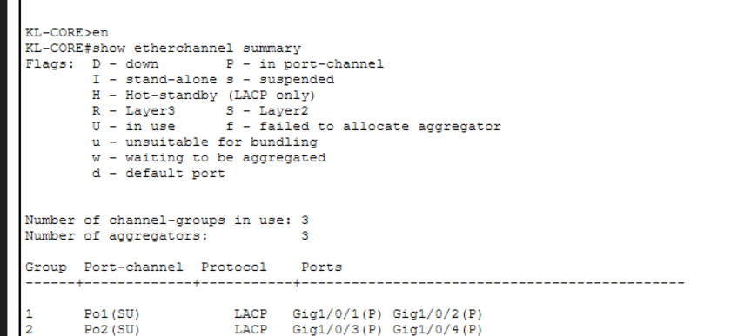

HSRP Test:
- Verify HSRP failover by shutting down the primary router.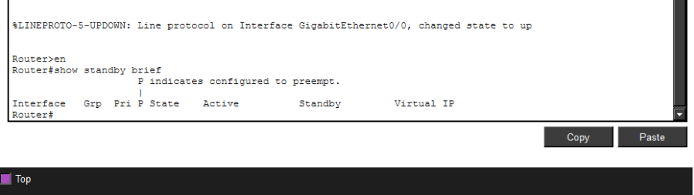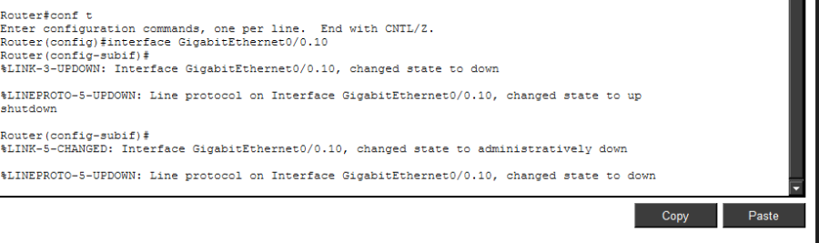
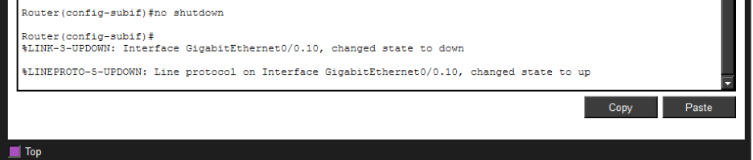

Conclusion
KL (HQ) network is properly designed and configured with VLANs, inter VLAN routing, EtherChannel to provide redundancy and HSRP to provide high availability. Port security and other security measures have been put in place to secure the network against Layer 2 attacks.

Penang Site
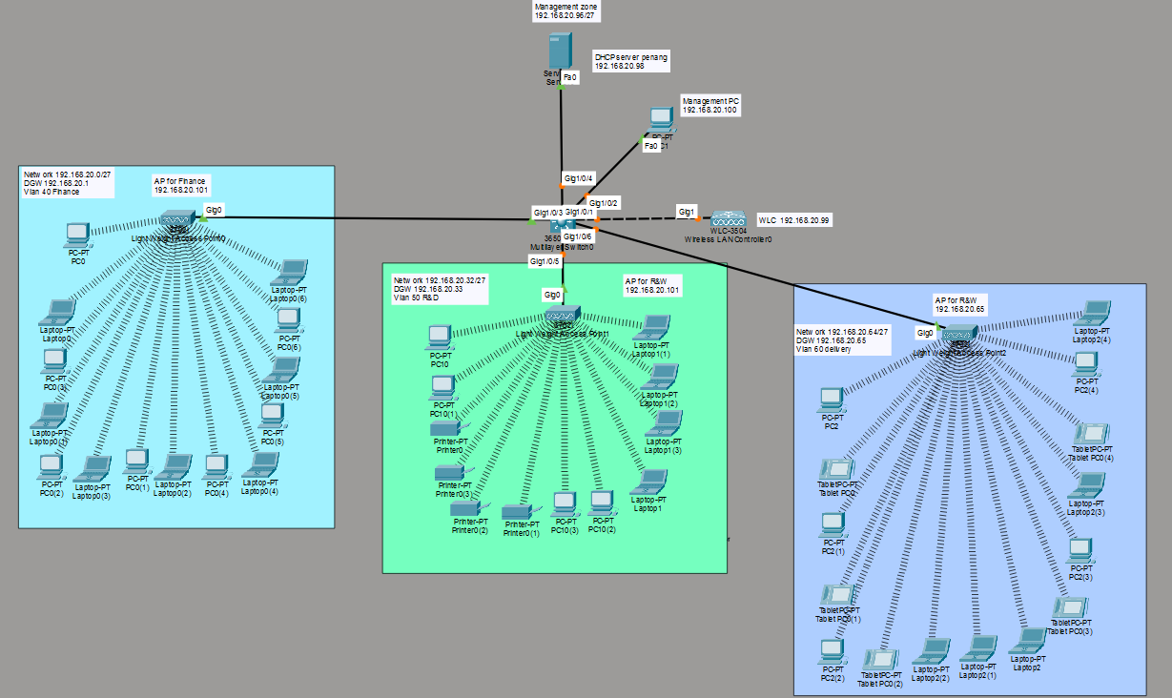

1. Executive Overview
This document describes the logical and physical design of a segmented enterprise network deployed in a branch environment (Penang). The network is structured using VLAN-based segmentation with centralized Layer 3 switching, centralized DHCP services, and controller-based wireless architecture.
The topology consists of:
- 1 × Multilayer Switch (Core/Distribution)
- 1 × Wireless LAN Controller (WLC-3504)
- 3 × Lightweight Access Points (LWAP 3702i)
- 1 × DHCP Server
- 1 × Management PC
- Multiple end-user devices (PCs, Laptops, Tablets, Printers)
- 3 Business VLANs + 1 Management VLAN
Inter-VLAN routing is handled at the multilayer switch via Switch Virtual Interfaces (SVIs).

2. Physical Topology Description
Core Infrastructure
Device: Cisco 3560 Multilayer Switch
Role:
- VLAN segmentation
- Inter-VLAN routing
- Trunk aggregation
- DHCP relay (if configured)
Connected Interfaces:
- Gi1/0/1 → WLC-3504
- Gi1/0/2 → Management PC
- Gi1/0/4 → DHCP Server
- Gi1/0/3 → AP Finance
- Gi1/0/5 → AP R&W
- Additional trunk → AP Delivery

Wireless Infrastructure
Controller: Cisco WLC-3504
IP Address: 192.168.20.99
Function:
- Centralized management of LWAPs
- SSID to VLAN mapping
- Wireless client authentication and traffic forwarding
Access Points (Lightweight 3702i):
AP Name | Department | IP Address | VLAN
AP Finance | Finance | 192.168.20.101 | VLAN 40
AP R&W | R&D | 192.168.20.101 | VLAN 50
AP Delivery | Delivery | 192.168.20.65 | VLAN 60
APs operate in Lightweight mode and register to the WLC.

3. VLAN and Network Segmentation
The network is divided into four logical zones:

3.1 VLAN 40 – Finance Department
Network: 192.168.20.0/27
Subnet Mask: 255.255.255.224
Default Gateway (SVI): 192.168.20.1
Usable Range: 192.168.20.2 – 192.168.20.30
Broadcast: 192.168.20.31
Devices:
- PCs
- Laptops
- Wireless clients via Finance AP
Purpose:
- Isolate Finance users from other departments.

3.2 VLAN 50 – R&D Department
Network: 192.168.20.32/27
Subnet Mask: 255.255.255.224
Default Gateway (SVI): 192.168.20.33
Usable Range: 192.168.20.34 – 192.168.20.62
Broadcast: 192.168.20.63
Devices:
- PCs
- Laptops
- Printers
- Wireless clients via R&W AP
Purpose:
- Support development resources and internal testing.

3.3 VLAN 60 – Delivery Department
Network: 192.168.20.64/27
Subnet Mask: 255.255.255.224
Default Gateway (SVI): 192.168.20.65
Usable Range: 192.168.20.66 – 192.168.20.94
Broadcast: 192.168.20.95
Devices:
- PCs
- Tablets
- Laptops
- Wireless clients via Delivery AP
Purpose:
- Operational and logistics access.

3.4 Management VLAN
Network: 192.168.20.96/27
Subnet Mask: 255.255.255.224
Management Zone: 192.168.20.96/27
Key Devices:
Device | IP Address
DHCP Server | 192.168.20.98
WLC | 192.168.20.99
Management PC | 192.168.20.100
Purpose:
- Infrastructure management
- Centralized services
- Administrative access

4. IP Addressing Plan
The entire 192.168.20.0/24 network is subnetted into four /27 subnets.
Each department receives:
- 30 usable host addresses
- Separate broadcast domain
- Dedicated default gateway
This ensures:
- Controlled broadcast domains
- Department isolation
- Simplified troubleshooting

5. Inter-VLAN Routing
Inter-VLAN routing is implemented using SVIs on the Cisco 3560 multilayer switch.
Example logical configuration structure:
interface vlan 40
ip address 192.168.20.1 255.255.255.224
no shutdown
interface vlan 50
ip address 192.168.20.33 255.255.255.224
no shutdown
interface vlan 60
ip address 192.168.20.65 255.255.255.224
no shutdown
Routing is enabled using:
ip routing
Function:
- Enables communication between departments when required.
- Provides gateway functionality.

6. DHCP Services
DHCP Server IP: 192.168.20.98
Location: Management VLAN
Expected DHCP Pools:
VLAN | Network | Default Gateway
40 | 192.168.20.0/27 | 192.168.20.1
50 | 192.168.20.32/27 | 192.168.20.33
60 | 192.168.20.64/27 | 192.168.20.65
DHCP assigns:
- IP address
- Subnet mask
- Default gateway
- DNS (if configured)

7. Wireless Architecture
Architecture Type: Controller-Based Wireless
Process Flow:
- LWAP boots.
- Obtains IP via DHCP.
- Discovers WLC.
- Establishes CAPWAP tunnel.
- SSID broadcast.
- Client associates.
- Traffic tunneled to WLC.
- WLC forwards to appropriate VLAN.
SSID-to-VLAN mapping ensures:
- Finance SSID → VLAN 40
- R&D SSID → VLAN 50
- Delivery SSID → VLAN 60

8. Port Configuration Model
AP-facing switch ports must be trunk ports:
interface Gi1/0/x
switchport mode trunk
switchport trunk allowed vlan 40,50,60
Server/PC ports must be access ports:
interface Gi1/0/y
switchport mode access
switchport access vlan 99
Incorrect trunk configuration will cause:
- AP disconnection
- DHCP failure
- VLAN mismatch
- WLC packet drops

9. Security and Isolation
Current segmentation provides:
- Department-level isolation
- Broadcast containment
- Logical separation
Recommended enhancements:
- ACLs between VLANs
- Management VLAN access restriction
- Port security on access ports
- Disable unused interfaces
- Enable SSH for device management

10. Network Validation Checklist
To verify operational status:
- Ping default gateway from each VLAN client.
- Verify DHCP assignment:
ipconfig /all
- Check trunk status:
show interfaces trunk
- Verify VLAN membership:
show vlan brief
- Confirm AP registration on WLC.
- Verify inter-VLAN communication.
- Confirm server reachability.

11. Design Evaluation
Strengths:
- Proper subnetting strategy
- Clean VLAN separation
- Centralized wireless control
- Structured IP planning
- Expandable design
Limitations:
- Single core switch (single point of failure)
- No redundancy
- No firewall segmentation shown
Scalability:
- Additional VLANs can be added.
- Additional APs can register to WLC.
- Subnetting allows expansion within /24 block.

12. Wireless LAN Controller
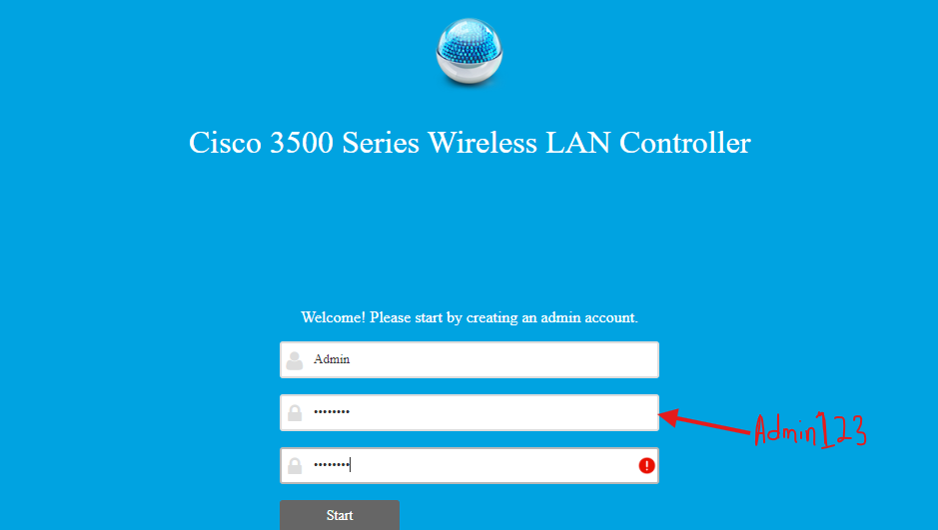
Password for the account of the management configuration
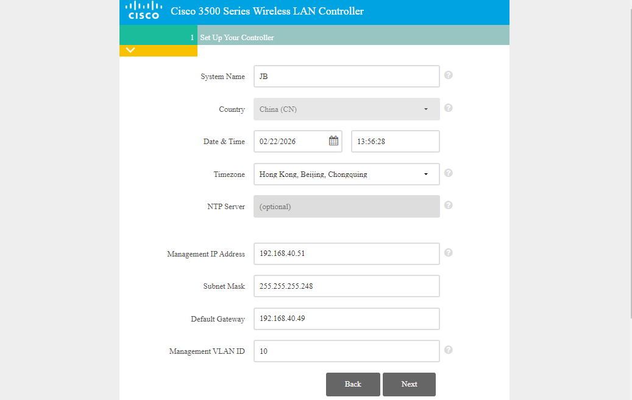
Modified the system name to JB to match the requirement of the branch, and added the management IP address which is the IP of the WLC (Wireless Lan Conroller) in addition to its subnet, and lastly the DGW default gateway and management vlan where the management takes place
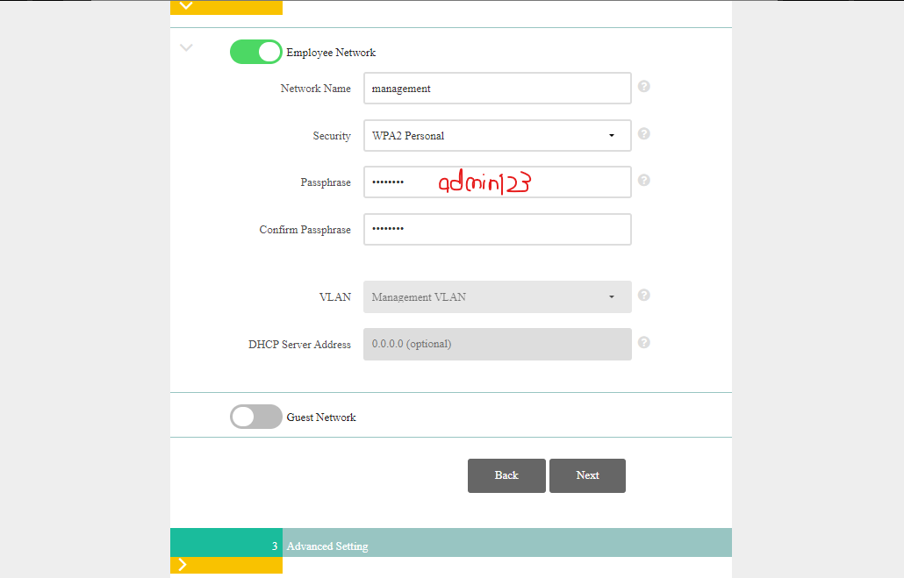
Configured management network name as “management” and applied the WPA2 to implement the password that will be securing the network by “admin123”, confirming the password aging by rentering it , and keeping the rest as it is
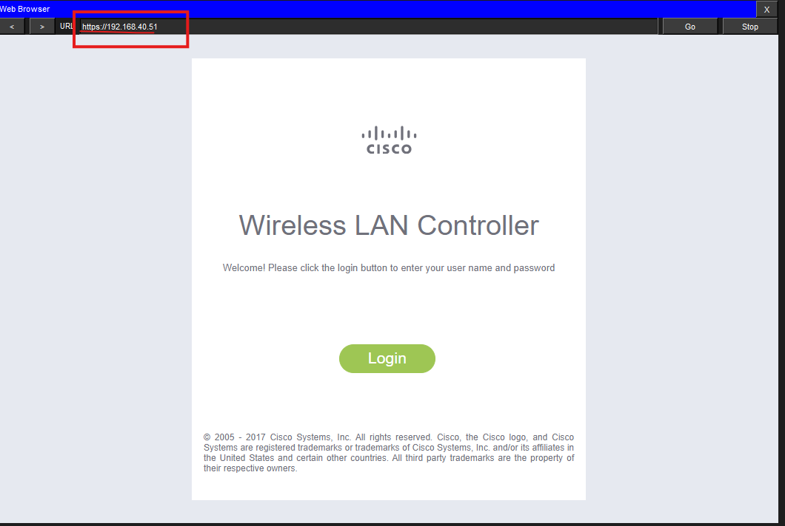
When done from configuring the basic configurations, the website will open by visiting the secure version for more advanced configurations
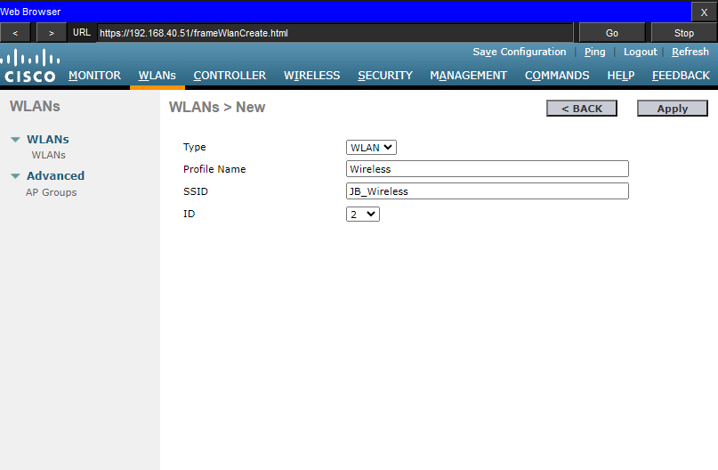
The diagram above shows the creationg of the network “JB_wireless” for the wireless devices in that branch giving it the vlan ID of 2 and then click on apply
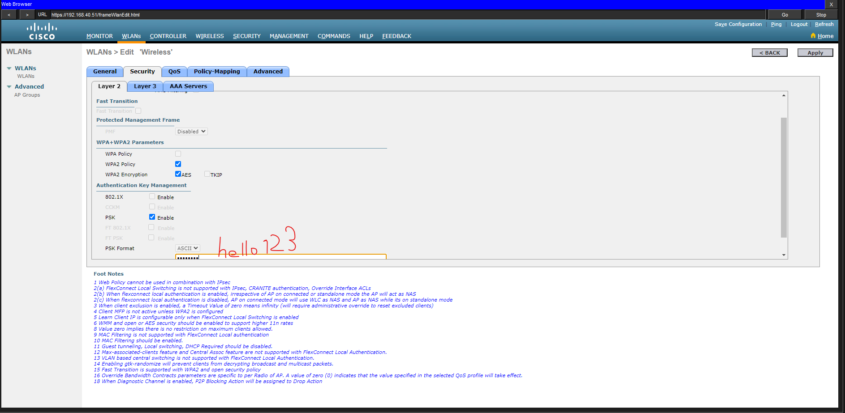
In the security tab to configure a password securing the network check the box “WPA2 Policy” and choosing the “PSK” Pre shared Key and giving the password as hello123
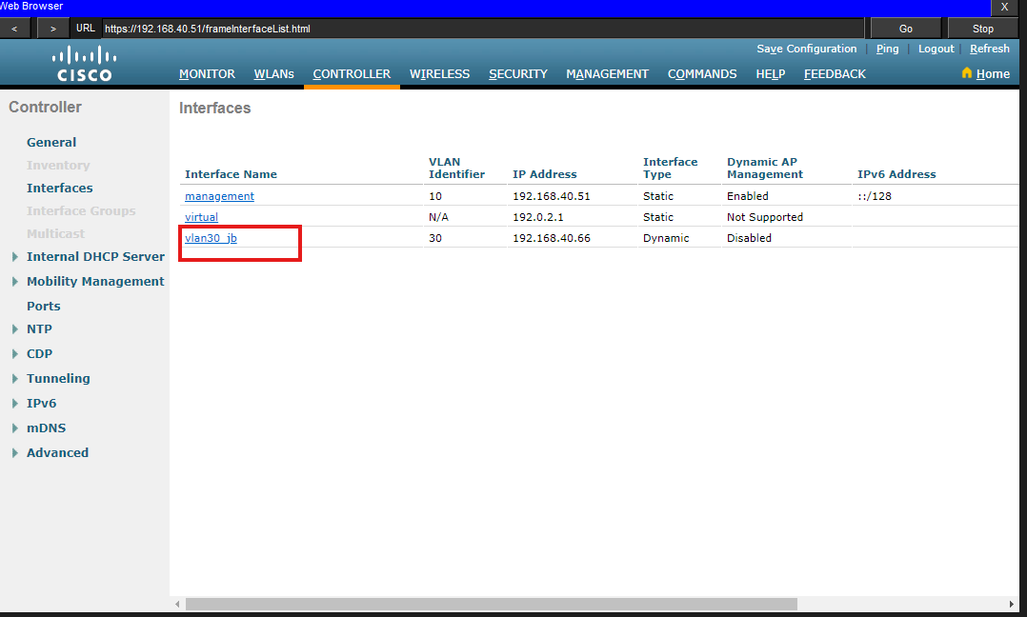
The interface vlan30_jb is created successfully after applying the configurations

13. Conclusion
The Penang branch network is designed using structured VLAN segmentation with centralized Layer 3 switching and controller-based wireless architecture. The addressing scheme is logically divided using /27 subnets, enabling departmental isolation and efficient broadcast management.
The architecture supports scalability, controlled routing, and centralized wireless management while maintaining clear separation between operational zones.

Johor Site
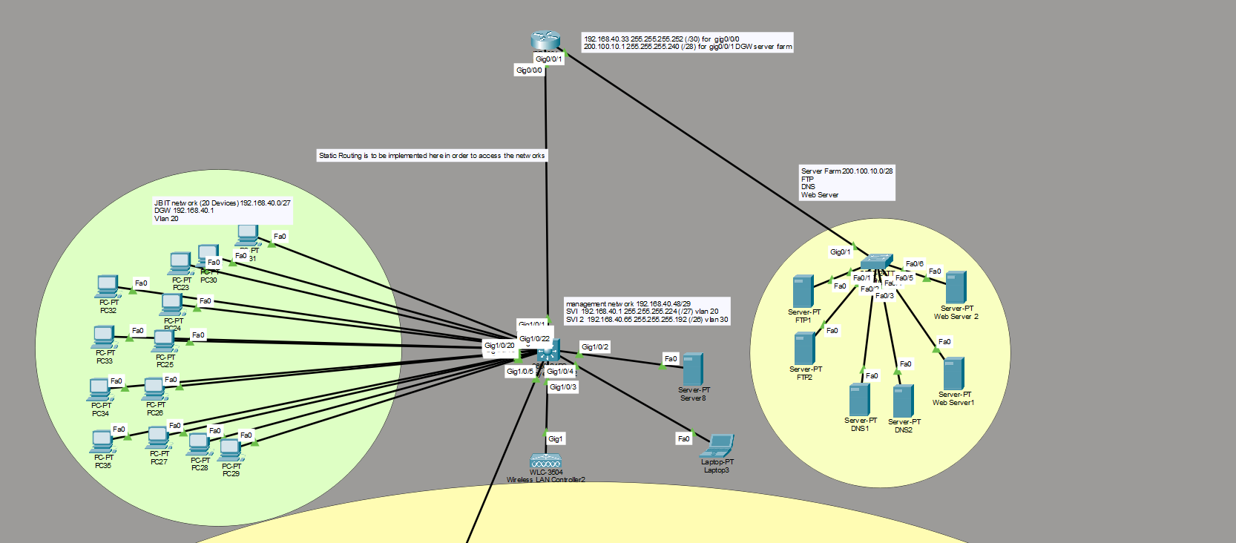
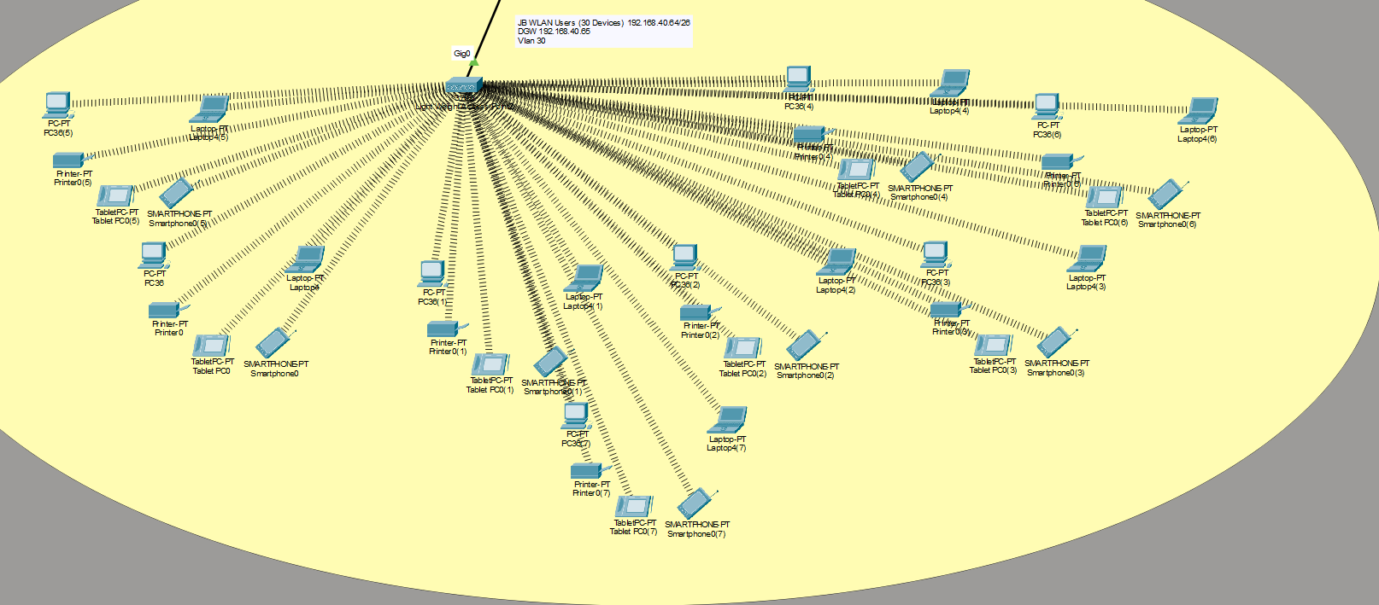

1. Executive Overview
This topology represents a segmented enterprise LAN (JB IT Network) connected to an external Server Farm network via routed interfaces. The design implements:
- VLAN-based internal segmentation
- Centralized Layer 3 switching
- Static routing toward external networks
- Dedicated management subnet
- Server farm accessible through a routed gateway
The architecture separates:
- User LAN (VLAN 20)
- Management VLANs (VLAN 20 / VLAN 30)
- Server Farm Network (200.100.10.0/28)
- Routed WAN/Point-to-Point Link (192.168.40.32/30)

2. Core Infrastructure

2.1 Multilayer Switch (Core)
Device Role:
- Default gateway for internal VLANs
- Inter-VLAN routing
- Aggregation switch
- Uplink to external router
Key Interfaces:
Interface | Function
Gi1/0/20 | User access aggregation
Gi1/0/22 | Uplink to router
Gi1/0/2 | Server connection
Gi1/0/3–6 | Access layer connections
Gig1 | WLC connection
Routing is enabled using:
ip routing

3. VLAN and Subnet Architecture

3.1 VLAN 20 – JB IT User Network
Network: 192.168.40.0/27
Subnet Mask: 255.255.255.224
Default Gateway: 192.168.40.1
Maximum Hosts: 30
Purpose:
- Supports approximately 20 end-user devices.
- Isolated broadcast domain.
Devices:
- PCs PC23–PC35
- Wired endpoints connected via access ports

3.2 VLAN 30 – Management Network
SVI Address: 192.168.40.65
Subnet Mask: 255.255.255.192 (/26)
Management Subnet Reference:
192.168.40.48/29 is noted for dedicated management allocation.
Purpose:
- Infrastructure management
- Server management
- WLC and administrative access

4. Routed Infrastructure

4.1 Router (Edge / WAN Router)
Interfaces:
Gig0/0/0
IP: 192.168.40.33
Mask: 255.255.255.252 (/30)
Function:
- Point-to-point connection to multilayer switch
- Transit network for static routing
Network Range:
192.168.40.32 – 192.168.40.35

Gig0/0/1
IP: 200.100.10.1
Mask: 255.255.255.240 (/28)
Function:
- Default gateway for Server Farm
Server Farm Network:
200.100.10.0/28
Usable Range: 200.100.10.1 – 200.100.10.14

5. Server Farm Architecture
Network: 200.100.10.0/28
Gateway: 200.100.10.1
Servers Deployed:
Server | Function
FTP1 | File Transfer
FTP2 | File Transfer
DNS1 | Name Resolution
DNS2 | Name Resolution
Web Server1 | HTTP Service
Web Server2 | HTTP Service
All servers connect to an access switch that uplinks to the router on Gi0/0/1.
Purpose:
- Provide centralized services to internal users.
- Separated from internal VLAN for security and routing control.

6. Static Routing Implementation
Static routing is required to allow:
- Internal VLAN access to Server Farm
- Return traffic from Server Farm to internal networks

6.1 On Multilayer Switch
Route to Server Farm:
ip route 200.100.10.0 255.255.255.240 192.168.40.33

6.2 On Router
Route to Internal VLAN 20:
ip route 192.168.40.0 255.255.255.224 192.168.40.34
If VLAN 30 exists separately:
ip route 192.168.40.64 255.255.255.192 192.168.40.34
Explanation:
- 192.168.40.34 is the multilayer switch IP in the /30 network.
- Static routes ensure bidirectional communication.
Without these routes:
- Traffic will be dropped at router.
- No access to external services.

7. Wireless Infrastructure
Device: WLC-3504
Connected to multilayer switch via trunk or access (management VLAN).
Function:
- Manage lightweight APs.
- Provide wireless services for VLAN 20 or VLAN 30.
- Tunnel wireless traffic via CAPWAP.
Traffic Flow:
Client → AP → WLC → Core Switch → Router → Server Farm

8. Port Configuration Model

8.1 Access Ports (User Devices)
interface Gi1/0/x
switchport mode access
switchport access vlan 20

8.2 Uplink to Router (Routed Port)
If configured as Layer 3 port:
interface Gi1/0/22
no switchport
ip address 192.168.40.34 255.255.255.252
no shutdown

8.3 VLAN Interface Example
interface vlan 20
ip address 192.168.40.1 255.255.255.224
no shutdown

9. IP Addressing Summary
Network | Purpose
192.168.40.0/27 | User VLAN 20
192.168.40.32/30 | Router–Core Transit
192.168.40.48/29 | Management Subnet
192.168.40.64/26 | VLAN 30
200.100.10.0/28 | Server Farm
The addressing scheme is hierarchical and segmented.

10. Traffic Flow Analysis

10.1 Internal Communication (Same VLAN)
PC → Switch → SVI → Local Routing → Destination

10.2 Inter-VLAN Communication
PC VLAN 20 → SVI VLAN 20 → Layer 3 Routing → VLAN 30

10.3 Accessing Server Farm
PC → SVI VLAN 20 → Static Route → Router → Server Farm
Return path:
Server → Router → Static Route → Core → Client

11. Security Considerations
Current Design:
- Logical segmentation using VLANs.
- External services separated in routed subnet.
Recommended Improvements:
- ACLs on router to restrict server access.
- Disable unused ports.
- Enable SSH for management.
- Implement firewall between LAN and server farm.
- Separate DMZ zone if servers are public-facing.

12. Verification Checklist
On Multilayer Switch:
show ip route
show vlan brief
show interfaces status
On Router:
show ip route
show ip interface brief
Client Validation:
- Ping 192.168.40.1
- Ping 200.100.10.1
- Access web server via browser
- Test FTP connection
- Verify DNS resolution

13. Design Evaluation
Strengths:
- Clear VLAN segmentation
- Proper /30 transit network
- Structured static routing
- Isolated server farm
- Scalable addressing
Limitations:
- Static routing not scalable
- No redundancy
- No dynamic routing protocol
- No firewall enforcement shown

14. Conclusion
This topology implements a structured enterprise network with:
- VLAN-based internal segmentation
- Centralized Layer 3 routing
- Routed WAN connectivity
- Dedicated server farm network
- Static routing for controlled inter-network communication
The design supports predictable routing behavior and clear network boundaries while maintaining scalability for moderate growth.

Malacca Site

Introduction

The following report will outline the network implementation at the Malacca Site in the process of expanding the organizational network. The design is aimed at high availability, scalability, and security using industry-standard protocols, including Virtual Local Area Networks (VLANs), Etherchannel, Hot Standby Router Protocol (HSRP) and strong Layer 2 security. The given WAN connectivity to KL site are also implemented in this document.

Malacca Site Topology

The Malacca Site is planned to have hierarchical structure that is made of core and access layers. The topology is fitted with redundant links on switches in order to maintain continuity in connectivity and provision of a dedicated WAN link to the Kuala Lumpur (KL) site.

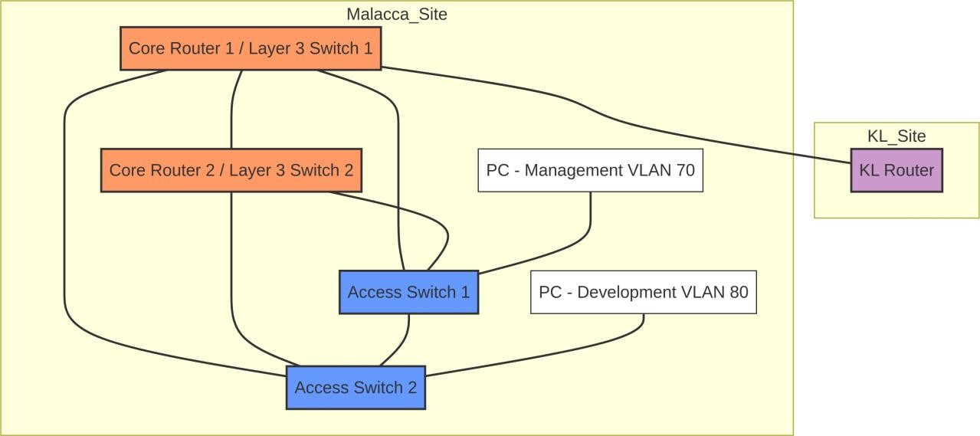

VLAN Segmentation
In order to enhance the network performance and his security, the site will be broken into two major VLANs:

VLAN ID | Name | Purpose
70 | Management | Network management, device management.
80 | Development | Software development and testing environments.

WAN Connectivity
A dedicated point to point link is connected to the Malacca site and Kuala Lumpur (KL) site. This inter-site connection has IP addressing as shown below:

Link | Network Address | Usable IPs
KL‒Malacca | 100.0.0.4⁄30 | 100.0.0.5, 100.0.0.6

VLAN Structure and Inter-VLAN Routing

VLAN Configuration
The access switches have VLANs 70 (Management) and 80 (Development). The logical segmentation is done by allocation of end devices to each of the VLANs.
Switch1#

show

vlan

brief

VLAN

Name

Status

Ports

Verification

Command:

1

default

active

Fa0/4,

Gi0/1,

Gi0/2

70

Management

active

Fa0/3

80

Development

active

show

vlan

brief

Inter-VLAN Routing
The Layer 3 core switches deal with inter-VLAN routing and they possess Switch Virtual Interfaces (SVIs) that are assigned to each VLAN and they serve as the default gateway to them.
Core
-
SW1# show ip interface brief | include Vlan
Vlan70

192.168.70.2

YES

manual

up

Vlan80

192.168.80.2

YES

manual

up

up

up

Verification

Command:

show

ip

interface

brief

|

include

Vlan

EtherChannel Implementation

Etherchannel is also done so as to connect together several physical Ethernet links into one logical link, which gives more bandwidth and fault tolerance between the access switches and the core layer.

Configuration Summary
The negotiation to form the EtherChannel on a dynamic manner was negotiated using the Link Aggregation Control Protocol (LACP).
Protocol: LACP (802.3ad)
Interfaces: FastEthernet 0/1, 0/2
Channel Group: 1

Verification
The subsequent output proves how the ports were successfully aggregated into the logical Port-Channel 1. Verification Command: show etherchannel summary

Switch1#

show

etherchannel

summary

Flags:

D
-

down

P
-

in port
-
channel
I
-

stand
-
alone s
-

suspended

H
-

Hot
-
standby (LACP only)
Group Port
-
channel Protocol

Ports

+

+

+

1

Po1(SU)

LACP

Fa0/1(P)

Fa0/2(P)

HSRP Implementation

The Hot Standby Router Protocol (HSRP) is set at the core level to offer a second default gateway to the hosts connected to VLAN 70 and 80. This makes sure that in case one of the core routers does not work, the other assumes the gateway roles without any interruption.

Redundancy Details
Virtu6l IP (VLAN 70): 192.168.70.1
Virtu6l IP (VLAN 80): 192.168.80.1
Prim6ry Router (VLAN 70): Core-SW1 (Priority 110)
Prim6ry Router (VLAN 80): Core-SW2 (Priority 110)

Verification
The status of the HSRP is confirmed to endorse the active and standby position of the routers..

Core
-
SW1#

show

standby

brief

P

indicates

configured

to

preempt.

|

Interface

Grp

Prio

P

State

Active

Vl70

70

110

P

Active

local

Standby

192.168.70.3

Virtual

IP

192.168.70.1

Vl80

80

90

P

Standby

192.168.80.3

local

192.168.80.1

Verific
a
tion

Comm
a
nd:

show

standby

brief

Layer 2 Security: DHCP Spoofing Attack and Mitigation

The Attack: DHCP Spoofing
The meaning of DHCP Spoofing attack is that an intruder (rogue) DHCP server is placed into the network. Depending on the nature of the attacks executed by a rogue server, the client can be offered false network settings resulting in Man-in-the-Middle or denial of service.

Mitigation Technique: DHCP Snooping
DHCP Snooping is a Layer 2 security that is used as a firewall between suspicious hosts and trusted DHCP servers. It filters DHCP messages and builds a binding table of legitimate IP-to-MAC address mappings.

Implementation Steps:
- Enable DHCP Snooping globally: ip dhcp snooping
- Enable for specific VLANs: ip dhcp snooping vlan 70,80
- Configure Trusted Interfaces: Interfaces connected to legitimate DHCP servers or other switches are configured as “trusted”.

Switch(config
-
if)
#

ip

dhcp

snooping

trust

Layer 2 Security: MAC Flooding Attack and Mitigation

The Attack: MAC Flooding
A MAC flooding attack enters a switch Content Addressable Memory (CAM) table with entries of numerous counterfeit MAC addresses. Once the CAM table has been full, the switch switches to a fail-open state where it acts as a hub and sends all the traffic to every port. This allows an attacker to capture traffic not intended for them.

Port Security Mitigation Technique
Port Security is a Layer 2 security option that enables an administrator to only allow the input into an interface by limiting and identifying the MAC addresses of the workstations which are permitted to gain access to the port. This stops MAC flooding attacks as it manages the MAC addresses that may be learned at a port.

Implementation Steps:

- Enable Port Security on the interface: switchport port-security
- Set maximum MAC addresses: switchport port-security maximum 2 (Allows a specified number of MAC addresses)
- Set violation mode: switchport port-security violation shutdown (Shuts down the port if a violation occurs)
- Configure sticky MAC addresses: switchport port-security mac-address sticky (Dynamically learns MAC addresses and adds them to the running configuration)

Switch1# show port
-
security interface FastEthernet0/3
Port Security

:
Enabled

Port

Status

:

Secure
-
up

Violation

Mode

:

Shutdown

Aging

Time

:

0

mins

Aging Type

:

Absolute
SecureStatic Address Aging :

Disabled
Maximum MAC Addresses

2
:
Current MAC Addresses

:

1

Sticky MAC Addresses

1
:

Last Source Address

000C.292D.3132
:
Security Violation Count

:

0

Verific
a
tion

Comm
a
nd:

show

port
-
security

interface

FastEthernet0/3

Spanning Tree Protocol Verification

STP is a protocol that is essential in eliminating loops in a switched network. It ensures a loop-free logical topology by blocking redundant paths.
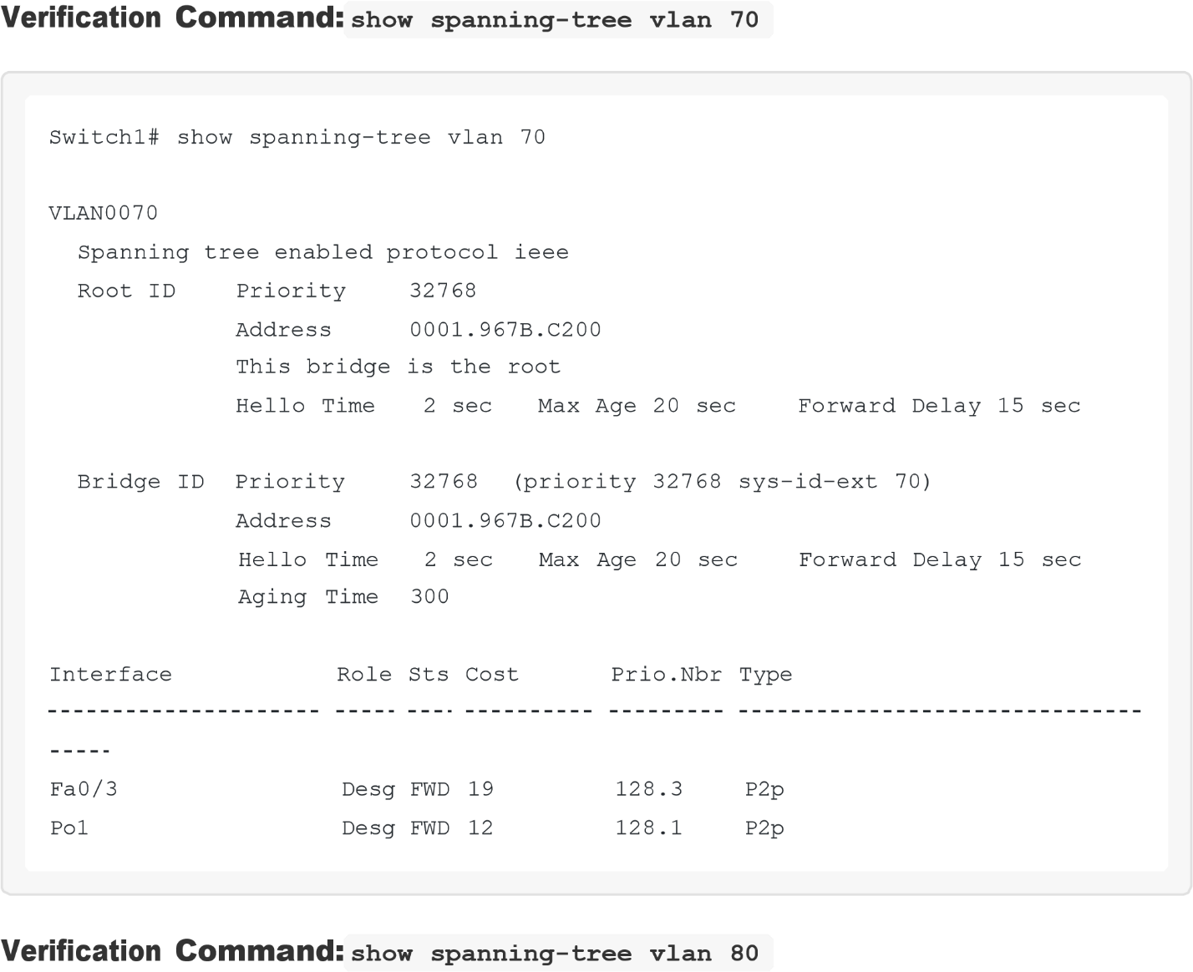
Switch2#

show

spanning
-
tree

vlan

80

VLAN0080

Spanning tree enabled protocol ieee
Root ID

Priority

32768

Address

0001.967B.C200

This

bridge

is

the

root

Hello

Time

2

sec

Max

Age

20

sec

Forward

Delay

15

sec

Bridge

ID

Priority

Address

32768

(
priority

32768

sys
-
id
-
ext

80)

0001.967B.C200

Interface

Role

Sts

Cost

Prio.Nbr

Type

Hello

Time

2

sec

Max

Age

20

sec

Forward

Delay

15

sec

Aging

Time

300

Fa0/3

Desg

FWD

19

128.3

P2p

Po1

Desg

FWD

12

128.1

P2p

DHCP Server Configuration

DHCP (Dynamic Host Configuration Protocol) is also set on a core switch, which assigns IP addresses to devices in VLAN 70 and VLAN 80 automatically and thereby eases the network management..

ip

dhcp

pool

VLAN70_POOL

network

192.168.70.0

255.255.255.0

default
-
router

192.168.70.1

dns
-
server

8.8.8.8

!

ip

dhcp

pool

VLAN80_POOL

network

192.168.80.0

255.255.255.0

default
-
router

192.168.80.1

dns
-
server

8.8.8.8

Verific
a
tion

Comm
a
nd:

show

ip

dhcp

binding

Core
-
SW1#

show

ip

dhcp

binding

Bindings

from

all

pools

not

associated

with

a

VRF:

IP address

Hardware address

Lease expiration
192.168.70.10

0001.0001.0001

Infinite

192.168.80.10

0002.0002.0002

Infinite

Type
Automatic

Automatic

OSPF Routing Configuration

OSPF (Open Shortest Path First) is an interior gateway protocol used to exchange routing information within an autonomous system. It is configured to ensure proper routing between the Malacca site and the KL site.

Core
-
SW1#

show

ip

ospf

neighbor

GigabitEthernet0/1

router

ospf

1

router
-
id

1.1.1.3

network

192.168.70.0

0.0.0.255

area

0

network

192.168.80.0

0.0.0.255

area

0

network

100.0.0.4

0.0.0.3

area

0

Verific
a
tion

Comm
a
nd:

ID

Interface

Pri

State

Dead

Time

Address

2.2.2.2

1

FULL/DR

00:00:32

100.0.0.6

show

ip

ospf

neighbor

Connectivity Verific6tion

Basic connectivity tests are carried out to guarantee that the devices can be able to communicate both within their VLANs, between VLANs and with the remote KL site.
PC in VLAN 70 > ping 192.168.70.1 (gateway)

PC>

ping

192.168.70.1

Pinging

192.168.70.1

with

32

bytes

of

data:

Reply from
192.168.70.1:
bytes=32 time<1ms TTL=255
Reply from 192.168.70.1: bytes=32 time<1ms TTL=255
Reply from 192.168.70.1: bytes=32 time<1ms TTL=255
Reply from 192.168.70.1: bytes=32 time<1ms TTL=255

Ping

statistics

for

192.168.70.1:

Packets: Sent = 4, Received = 4, Lost = 0 (0% loss),
Approximate round trip times in milli
-
seconds:

Minimum

=

0
ms,

Maximum

=

0
ms,

Average

=

0
ms

PC in VLAN 80 > ping 192.168.80.1 (gateway)

PC>

ping

192.168.80.1

Pinging

192.168.80.1

with

32

bytes

of

data:

Reply from 192.168.80.1: bytes=32 time<1ms TTL=255
Reply from 192.168.80.1: bytes=32
time<1ms TTL=255
Reply from 192.168.80.1: bytes=32 time<1ms TTL=255
Reply from 192.168.80.1: bytes=32 time<1ms TTL=255

Ping

statistics

for

192.168.80.1:

Packets: Sent = 4, Received = 4, Lost = 0 (0% loss),
Approximate round trip times in milli
-
seconds:

Minimum

=

0
ms,

Maximum

=

0
ms,

Average

=

0
ms

Ping to KL site: Core-SW1# ping 100.0.0.6

Core
-
SW1#

ping

100.0.0.6

Type

escape

sequence

to

abort.

Sending

5
,

100
-
byte

ICMP

Echos

to

100.0.0.6
,

timeout

is

2

seconds:

!!!!!

Success

rate

is

100

percent

(5
/5),

round
-
trip

min/avg/max

=

1
/1/
1

ms

Conclusion

The implementation of the Malacca Site offers a reliable and strong network infrastructure, and the said network is now connected in totality with the entire organization through the designated WAN link. Etherchannel and HSRP have been used thereby ensuring high delivery and performance. Moreover, DHCP Snooping and Port Security is important in crusading the core protection against the typical Layer 2 attacks, after which the Development and Management workers would have a safe space. Member 3 has been fully satisfied with respect to IP addressing and security requirements.

