Course Project Report
Introduction
This project implements a client-server based Ordering System using Java socket programming. The system allows users to create accounts, log in as either Admin or Customer, and perform different operations based on their roles.
Administrators can add, modify, and remove items from the system, while customers can create orders, view previous orders, reorder items, and add reviews. The application supports multiple clients simultaneously using multithreading, where each client connection is handled by a separate thread.To ensure data persistence, serialization is used to save and load users, items, and orders from files. In addition, synchronization techniques are applied to protect shared resources and guarantee correct behavior when multiple clients access the system concurrently.The UML class diagram presented in this report illustrates the design of the system classes and the relationships between them.
Classes Description
User
Abstract class that stores username and password.
Admin
Extends User and manages items.
Customer
Extends User and creates orders.
Item
Stores item information and reviews.
Order
Stores ordered items and calculates total value.
Server
Handles client connections and data persistence.
multiClients
Handles each client in a separate thread.
UML Class Diagram :
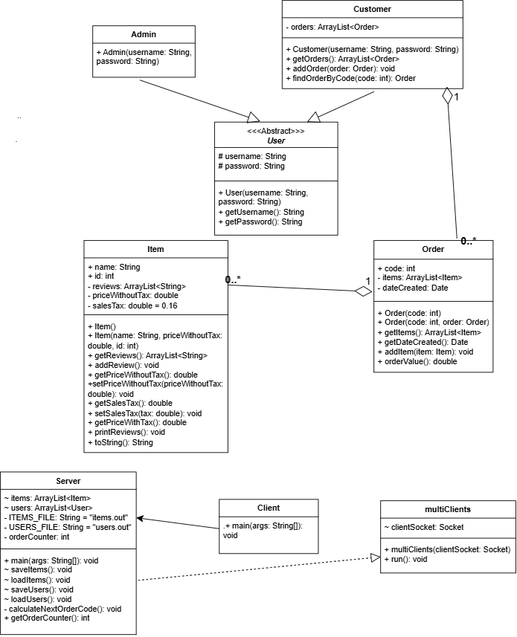

Conclusion
The developed ordering system successfully demonstrates the use of Java networking, multithreading, inheritance, abstraction, serialization, and synchronization concepts. The system allows multiple clients to interact with the server while maintaining data consistency and persistence.

