**EGRE 364 – Microcomputer System**

**Laboratory Number 4**

**Up-Down Counter in Assembly**

**Lab Section: Tuesday 1PM**

***Lab conducted on: September 24, 2019***

***Report Submitted on: October 11, 2018***

**Papa Beye & Omar Amr**

**Major: CPE & CPE**

**Introduction**

The purpose of this lab was to build on the concepts of the use of multiple GPIO input and output configurations and perform digital I/O input and output programming using Assembly in the Keil µVision software development environment. These configurations include registers input/output, push pull, open drain, pull up/down, ODR, IDR. The objective of this lab was using the new 7 segment display to create an up-down counter that interfaced with microcontroller to controlled as a counter with the joystick on the board and completing this objective by using Assembly program.

We used functions and concepts created from the previous lab to allow us to setup this lab. We were given the truth table of the 7-segment display for numbers 0-9 and A-E. We were able to light up the specific pin for each segment to display each number by using PE10 – PE15 and PH0 with a common cathode. We used the PA3 and PA5 input pins to input the up and down. We need to initialize the two input pins as pull down and we had to debounce the button input with software. We needed to debounce the mechanical input so that we make sure that the number displayed only changes only one per button press. We used software debouncing by implementing a timer interrupts to makes sure that the input is constant for a given amount of time and set the input to that value, thus allowing a time delay until the input is constant and debouncing the input. In this lab, we used the practice and methods that we used in lab 2.

**Functionality and Correctness**

The STM32L4 discovery board has a joystick on board with 5 input buttons. In this lab, we used the up and down push buttons, PA3 and PA5. Since both inputs’ buttons don’t have an internal pull-down circuit, Since the joystick is mechanical system, we must use software debouncing to stop the mechanical bouncing when the button is pressed. We used a simple function that counts for certain time while the input is constant and afterwards set the input. The pseudo code below shows how we can implement the software debouncing using wait time inside loops. The seven segment display is made up of ten pins and we need to use pins PE10-PE15 and PH0 on the board to activate a certain segment; Using the given truth table of the 7-segment display, we were able to create a function that would activate and set the appropriate ODR bit(s) so that the display showed the requested number. In order to “roll over” when incrementing past 9 or decrementing past 0, we had to use “if” statements that made sure that if the incrementing “count” variable was greater than 9, we reset it to zero. Likewise, the “count” variable was less than 0, we reset it to nine.

    LDR r0, =GPIOA_BASE

    LDR r1, [r0, #GPIO_IDR]

    LDR r2, =0x28

    AND r1, r1, r2

    CMP r1,#0x8

    LDR r0,[sp,#0x08]

    BEQ A3bd

    BNE ct5

ct5 LDR r0, =GPIOA_BASE

    LDR r1, [r0, #GPIO_IDR]

    LDR r2, =0x28

    AND r1, r1, r2

    CMP r1,#0x20

    LDR r0,[sp,#0x08]

    BEQ A5bd

    BNE st

A5bd  CMP r0, #0x0

      BEQ A5check

      BNE A5dbc

A5dbc SUB r0, r0, #0x1

      B A5bd

A5check LDR r0, =GPIOA_BASE

        LDR r1, [r0, #GPIO_IDR]

        LDR r2, =0x28

        AND r1, r1, r2

        CMP r1,#0x20

        BEQ A5check

        BNE dec

A3bd  CMP r0, #0x0

      BEQ A3check

      BNE A3dbc

A3dbc SUB r0, r0, #0x1

      B A3bd

A3check LDR r0, =GPIOA_BASE

        LDR r1, [r0, #GPIO_IDR]

        LDR r2, =0x28

        AND r1, r1, r2

        CMP r1,#0x8

        BEQ A3check

        BNE inc

inc LDR r0,[sp,#0x04]

    ADD r0, r0 ,#0x1

    STR r0, [sp,#0x04]

    B disp

dec LDR r0,[sp,#0x04]

    SUB r0, r0 ,#0x1

    STR r0, [sp,#0x04]

    B disp

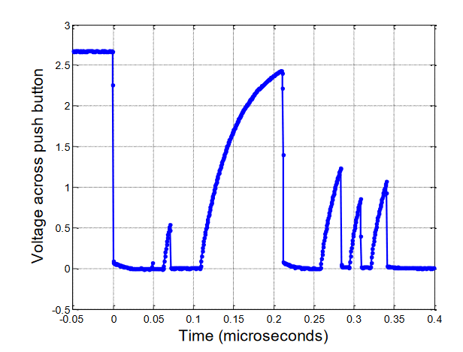

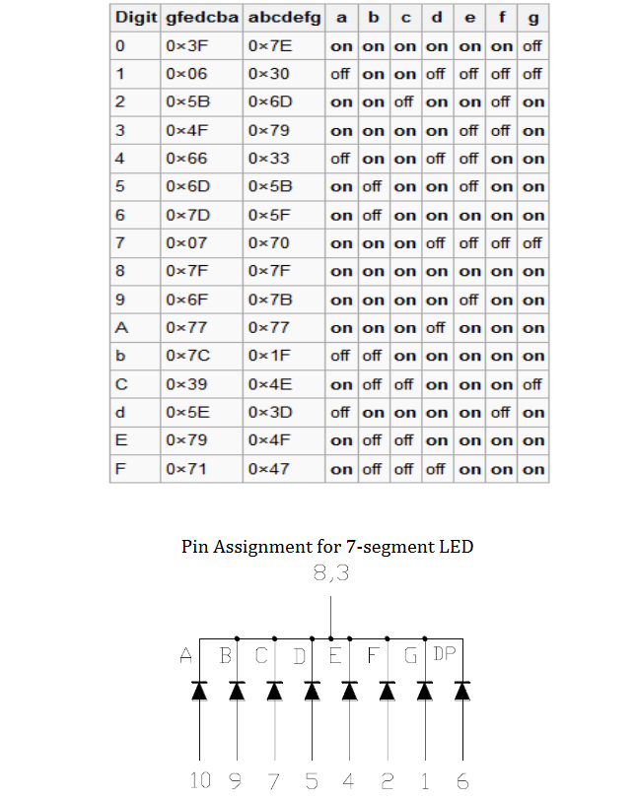

**Pre-Lab & Post Lab located in zip file**

**Conclusion**

In this lab, we became more comfortable with interfacing with a seven segment LED, implementing inputs, and correctly debouncing inputs with software. We learned about checking the IDR value of a pin and proper debouncing the input inside a function. We were able to achieve the objective of the up-down counter using the joystick and 7-segment display with proper software debouncing. We learned a lot about how to use functions to simplify the process of register calling and reading inputs with debouncing. We didn’t face any issues but there was a learning curve that allowed us to learn how to create and use functions to properly access and manipulate bit values of interest without altering other bits and reading inputs through the IDR.