EGRE 364 – Microcomputer System

Laboratory Number 5

Stepper Motor in Assembly
Lab Section: Tuesday 1PM

Lab conducted on: October 15 , 2019
Report Submitted on: October 25, 2018

Papa Beye & Omar Amr
Major: CPE & CPE

Introduction
The purpose of this lab was to build on the concepts of the use of multiple GPIO input and output configurations and perform digital I/O input and output programming using Assembly in the Keil µVision software development environment. These configurations include registers input/output, push pull, open drain, pull up/down, ODR, IDR. The objective was to drive a stepping in a repeating routine with half-stepping and full-stepping implementation using 2 buttons and another 2 buttons to control the speed of the motor. We used branches and mnemonics such as LDR, STR and BIC. We were able to initialize each GPIO port and manipulate the appropriate ODR values to turn the motor using the knowledge of the sequences of wave step, full step, and half step. We were given the sequence table of the wave step, full step and half step; we implemented the sequence table in our program allow the motor turn. We were able to rotate the motor with each step by causing a delay in between each step of the sequence table for half and full stepping. Using full step mode, the motor rotates by one step angle for each input pulse, allowing for a 90 degree turn with each step, thus 4 steps. Likewise, using half step mode, the motor rotates by half of a step angle for each input pulse, allowing for a 45 degree turn with each step, thus 8 steps for each rotation and to return to the start position. In order to using the outputs on the STM32L4 microcontroller, we used the H-Bridge for the motor as a “motor controller” between the microcontroller and the motor itself. We used the PA3 and PA5 input pins to input the up and down to increase or decrease the speed of the motor. We initialized the PA3 and PA5 pins as pull down. We implemented a delay function by utilizing a loop counts down from a given number and we can manipulate the delay value to increase or decrease the speed of the motor. this lab, we used the practice and methods that we learned in class about the stepper motor and overall Assembly processes from lab 4.
Functionality and Correctness
The STM32L4 discovery board has a joystick on board with 5 input buttons. In this lab, we used the up and down push buttons, PA3 and PA5 and the left and right push buttons, PA1 and PA2. Since the inputs’ buttons don’t have an internal pull-down resistor, we must initialize the pins as pull down. The assembly code below shows how we were able to delay and return to back to previous line of instruction using BX LR. The left and right buttons, PA3 and PA5, were implemented in our Assembly program by checking if they were pressed and if they were, they would either increase the delay value, thus slow down the motor speed, or decrease the delay value, thus speed up the motor. We set upper and lower bounds for the delay value because if the delay is too low or too high, the motor will not turn at all. Using the sequence table, we created two subroutines that looped that set the appropriate ODR bit(s) of GPIO port E. We checked if any button was pressed, and if they were pressed, it would branch to correct subroutine, otherwise it would continue to loop. We controlled the stepper motor via the H-Bridge because we cannot directly a motor by using the GPIO pins due to the low current. In our code, we had to initialize the clock and each GPIO port. We needed to implement a two algorithms of full stepping and half stepping while also polling/checking for input from the joystick (Up, Down, Left, Right).
Sequences for Half stepping and Full stepping using in Assembly code
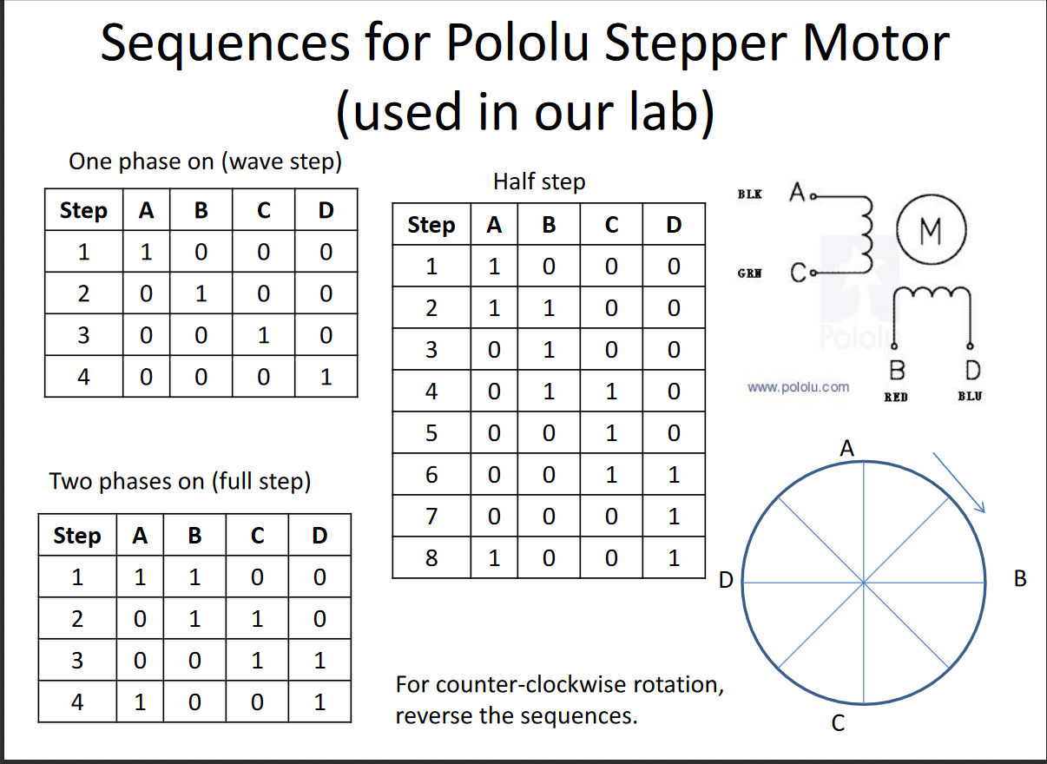
Delay Code used in Assembly program
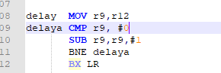

Pre-Lab included below
Post-Lab
- In order to make the motor to complete one rotation and reverse the rotation, we added a subroutine of the reverse of half step and full step and programmed it to go back and forth between the reverse and the non-reverse stepping. New complete Assembly code is attached in the ZIP folder, a file named “postlab.s” .

Conclusion
In this lab, we became more comfortable with interfacing a motor, implementing multiple inputs, and creating an algorithm to complete our lab objective. We learned about checking the IDR value of a pin and debouncing the input using branches. We were able to achieve the objective of the up-down counter using the joystick and 7-segment display with proper software debouncing. We used branches and CMP statements to be able to test and run routines to receive inputs from the up and down buttons and alter the LED value. We learned a lot about how to use branches and Assembly mnemonics and labels to initialize ports, access registers and reading inputs with debouncing. We didn’t face any issues but there was a learning curve that allowed us to learn how to create and use Assembly branches to properly access and manipulate bit values of interest without altering other bits and reading inputs through the IDR.

