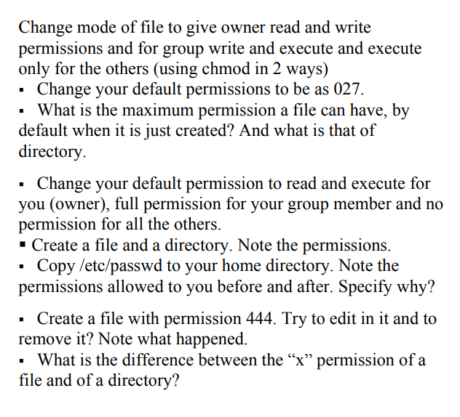

1)



2)

3)

- for file the max permissions -> 644

- for directory the max permissions -> 755

Because be default umask = 022

4)



5)

6)   
-I can’t edit in the file or delete it because it’s read only for the owner

7)

X permission

* In the file: allowed you to execute the file eg: if it’s a script
* In the directory : allowed you go inside the directory using cd