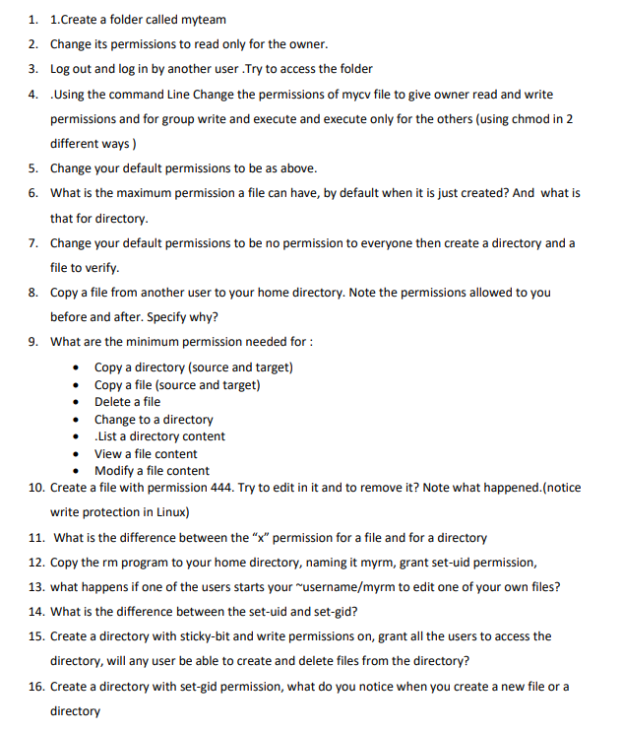







I can access the folder from the other usertou





5)





6)

For file -> 666

For directory -> 777

7)

8)



The file comes with its permissions

9)

**Directories**

* **Copy a directory (source)** → r + x
  + Need **read (r)** to see the directory contents.
  + Need **execute (x)** to access files inside.
* **Copy to a target directory** → w + x
  + Need **write (w)** to create the copy.
  + Need **execute (x)** to access the directory.
* **Delete a file inside a directory** → w + x **on the directory (not the file)**
  + Because deletion affects the directory entry, not the file itself.
* **Change to a directory (cd)** → x only
* **List directory content (ls)** → r
  + r to read the list of names.

**Files**

* **Copy a file (source)** → r
  + Need read to copy its content.
* **Copy a file (target location)** → w + x on the target directory
  + w to create a new file, x to access the directory.
* **View a file content (cat, less)** → r
* **Modify a file content (edit)** → w

10)

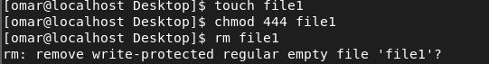

11)

X permission

* In the file: allowed you to execute the file eg: if it’s a script
* In the directory : allowed you go inside the directory using cd

12)



13)

User can run the file using the owner privilege

14)

Suid: other users can run the file using the owner privilege

Sgid: other users can run the file using the group privilege

15)

Users can create files but users can delete only their files but not others

16)

New files and directores will **inherit the group ownership** , instead of the user’s primary group.