Cairo University  
Faculty of Computers and Artificial Intelligent

**CS251**

**Software Engineering I**

Project Name

Software Design

Team Names

Month & Year

Contents

Instructions [To be removed] 3

Team 3

Document Purpose and Audience 3

System Models 3

I. Class diagrams 3

Important Algorithm 4

II. Sequence diagrams 5

Class - Sequence Usage Table 6

Ownership Report 6

Policy Regarding Plagiarism: 7

# Team

|  |  |  |  |
| --- | --- | --- | --- |
| **ID** | **Name** | **Email** | **Mobile** |
| 20200060 | Ahmed Waleed Shawky | Theassassin9213@gmail.com | 01000724734 |
| 20200343 | Omar Saied Salem | omarayman1290257@gmail.com | 01118355776 |
| 20210616 | Hadeer Muhammad Rashed | ahadeer857@gmail.com | 01153432552 |
| 20200620 | Huda Muhammad Rashed | 11410120200620@stud.cu.edu.eg | 01033301490 |

# 

# Document Purpose and Audience

# This document includes Design Specifications for Parking Garage application. who will read it project manager and garage owner.

**In order to understand the design of the software before it’s implemented**.

# 

# System Models

## I. Class diagram

**Class table**

| **Class ID** | **Class Name** | **Description & Responsibility** |
| --- | --- | --- |
| 1 | Garage owner actions | Shows all actions that the owner can do. |
| 2 | Garage operations | Responsible for the handling calculations and checking the actions that the owner wants to do. |
| 3 | vehicle | Storing each vehicle information. |

## ­

## II. Sequence diagrams

**Sequence diagram id:1**

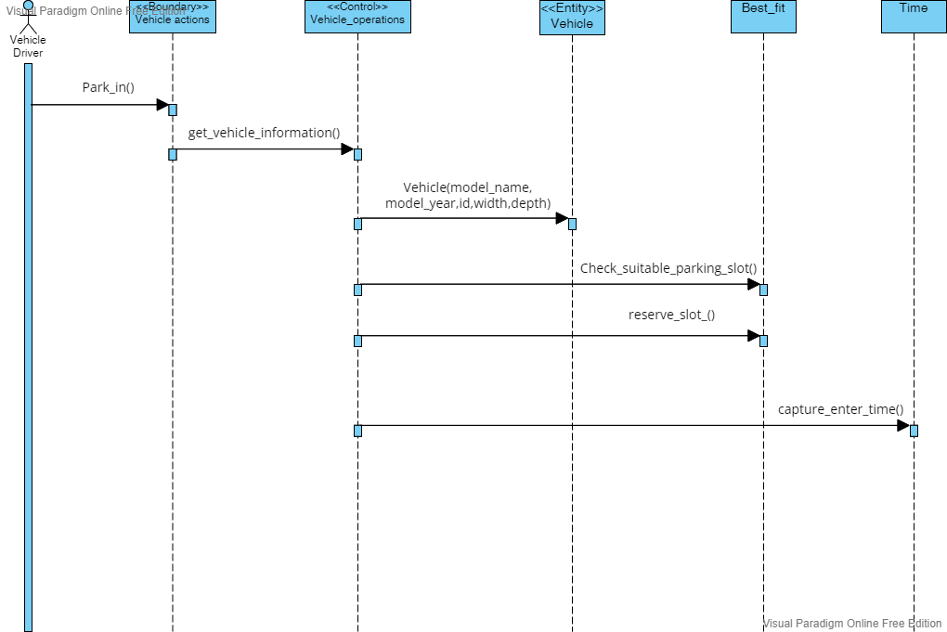

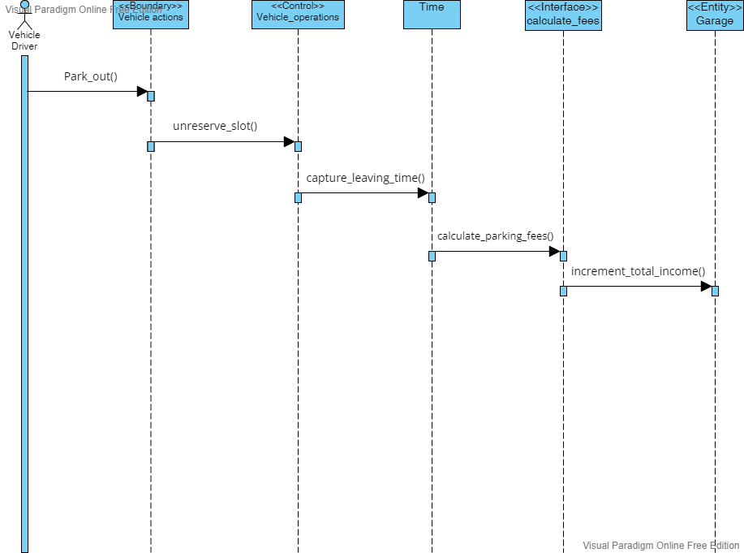**Sequence diagram id:2**

**Sequence diagram id:3**

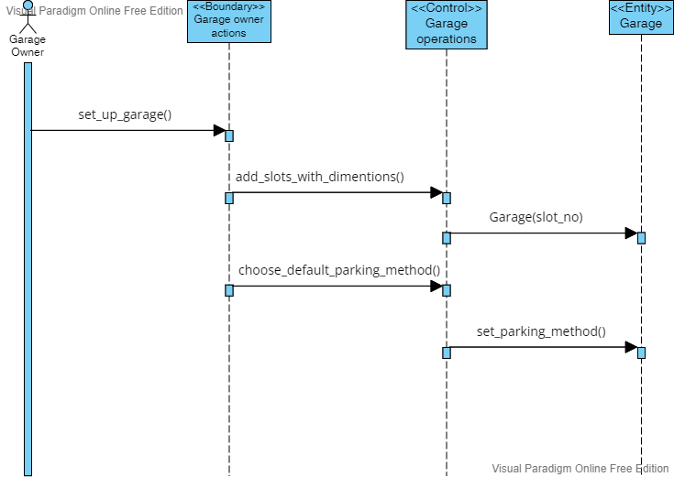

**Sequence diagram id:4**

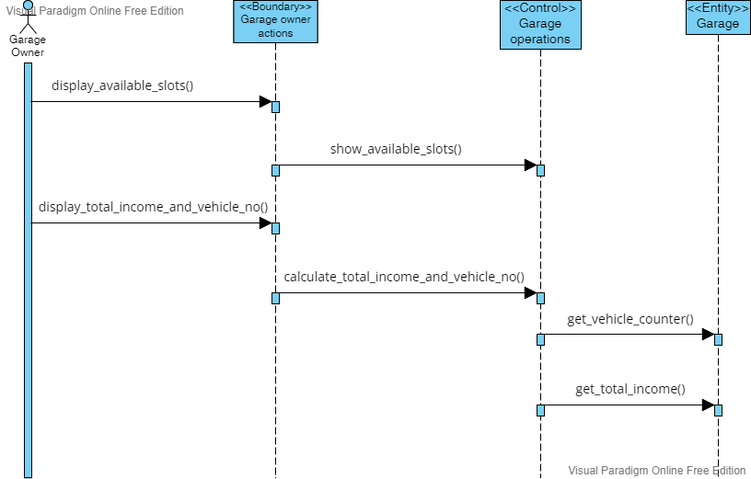

### Class - Sequence Usage Table

| **Class Name** | **Sequence Diagrams** | **Overall used methods** |
| --- | --- | --- |
| Garage | 2, 3, 4 | increment_total_income ()  set_parking_method ()  get_vehicle_counter ()  get_total_income ()  set_slot_no () |
| Garage operations | 3 ,4 | add_Slots_with_dimentions ()  choose_default_parking_method ()  show_available_slots ()  calculate_total_income_and_vehicle_no () |
| Garage owner actions | 3 ,4 | Set_up_garage ()  display_available_slots ()  display_total_income_and_vehicle_no () |
| Vehicle | 1 | set_vehcile_id ()  set_model_name ()  set_model_year ()  set_vehcile_width ()  set_vehicle_depth () |
| Vehicle actions | 1, 2 | Park_in ()  Park_out () |
| Vehicle operations | 1, 2 | get_vehicle_information ()  unreserve_slot () |
| Time | 1, 2 | Capture_entering_time ()  Capture_leaving_time () |
| Best_fit | 1 | Check_suitable_parking_slot ()  Reserve_slot () |
| Calculate_fees | 2 | Calculate_parking_fees () |

# Ownership Report

|  |  |
| --- | --- |
| **Item** | **Owners** |
| Class diagram | *Ahmed, Omar, Hoda, Hadeer* |
| Sequence diagram | *Ahmed, Omar, Hoda, Hadeer* |