**VISVESVARAYA TECHNOLOGICAL UNIVERSITY**

**Jnana Sangama, Machhe, Belagavi-590018**

An Internship Report

On

### “Hospital Management”

Submitted in partial fulfilment required for award of the Graduation Degree

**Bachelor of Engineering**

#### In

**Computer Science and Engineering**

Submitted by

#### KM AYSHA 1HK18CS070

Under the guidance of Under the guidance of

#### K. Sangeeta Supriya Mr. Sunil Kumar

Assistant Professor Project lead/HR

Dept. of CSE Take It Smart (OPC) Pvt.Ltd HKBKCE, Bengaluru

**2021 - 2022**

**Department of Computer Science & Engineering**

**HKBK COLLEGE *of* ENGINEERING**

#### (Approved by AICTE & Affiliated to VTU)

**22/1, Nagawara, Arabic College Post, Bangalore-45, Karnataka**

**Email:** [**info@hkbk.edu.in**](mailto:info@hkbk.edu.in) **URL:** [**www.hkbk.edu.in**](http://www.hkbk.edu.in/)

**HKBK COLLEGE *of* ENGINEERING**

N a g a w a r a , B a n g a l o r e – 560045 Approved by AICTE & Affiliated to VTU

**Department of Computer Science and Engineering**

**Certificate**

Certified that the Internship entitled **“Hospital Management”,** carried out by **Km Aysha (1HK18CS070)** is a bonafide student of **HKBK COLLEGE *of* ENGINEERING**, in partial fulfilment for the award of **Bachelor of Engineering** in **Computer Science and Engineering** of the **Visvesvaraya Technological University**, Belagavi, during the year 2021–22. It is certified that all corrections/suggestions indicated for Internal Assessment have been incorporated in the report deposited in the departmental library. The internship reporthas been approved as it satisfies the academic requirements in respect of **18CS185– Internship** prescribed for the said Degree.

K. Sangeeta Supriya

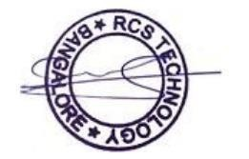

Guide

Mr. Sunil Kumar External Guide

Dr. Loganathan R

HOD

Dr. Tabassum Ara Principal

## ORGANIZATION CERTIFICATE

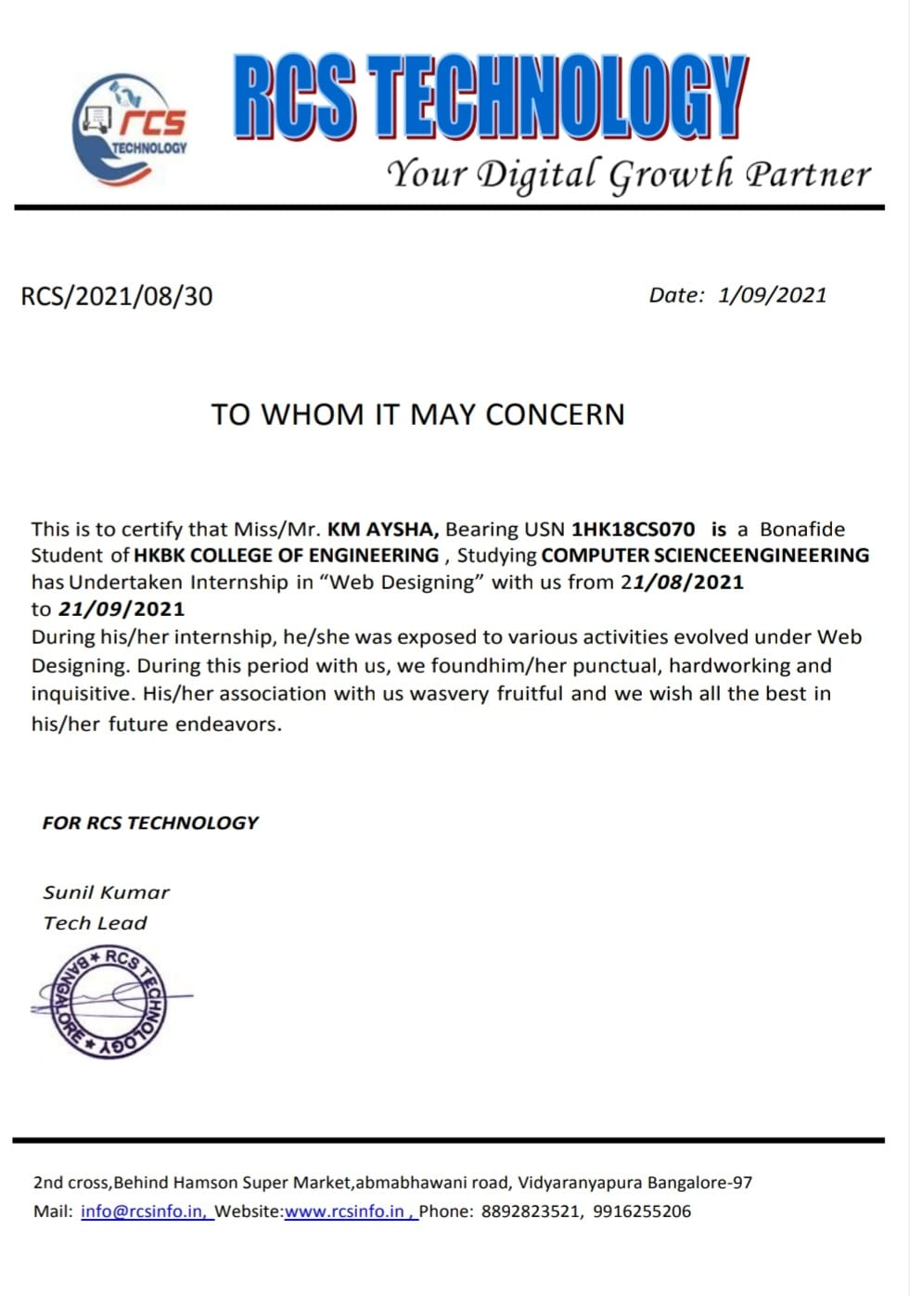

**ACKNOWLEDGEMENT**

I would like to express my regards and acknowledgement to all who helped me in completing this Internship successfully.

First of all I would take this opportunity to express my heartfelt gratitude to the personalities of HKBK College of Engineering, **Mr. C M Ibrahim**, Chairman, HKBKGI and **Mr. Faiz Mohammed**, Director, HKBKGI for providing facilities throughout the course.

I express my sincere gratitude to **Dr. Tabassum Ara** , Principal, HKBCE for her support and which inspired us towards the attainment of knowledge.

I consider it as great privilege to convey my sincere regards to **Dr. Loganathan. R.**, Professor and HOD, Department of CSE, HKBKCE for his constant encouragement throughout the course of the internship.

I would specially like to thank my guide, **K.Sangeeta Supriya**, Assistant Professor, Department of CSE for her vigilant supervision and her constant encouragement. She spent her precious time in reviewing the Internship work and provided many insightful comments and constructive criticism.

I would also like to thank my external guide **Mr. Sunil Kumar** from Take It Smart(OPC) Pvt. Ltd for giving me an opportunity to work as an Intern in the field of full-stack web development.

Finally, I thank Almighty, all the staff members of CSE Department, our family members and friends for their constant support and encouragement in carrying out the Internship work.

**1HK18CS070 Km Aysha**

## ABSTRACT

Technology means the skill to convey an idea to reach a goal. But nowadays, the term technology mainly signifies the knowledge of tools, machines, techniques, crafts, systems, and organization methods to solve a problem. Today, technological advancement has provided the human race with the ability to control and adapt to their natural environment. We live in a world where Alexaplays the music in the living room and Siri sets the alarm on the phone. These are done possiblyby innumerable programming languages; one such language is Python – a high-level programming language. Python is a versatile all-purpose high-level language that is used for handling scientific data and other structured as well as unstructured data. Full Stack Python is an open-source book that explains technical concepts in plain language. A full-stack Python developer has expertise in using the Python suite of languages for all applications.

During this internship, the brief ideas of Python, its modules and applications have been explained. I did my internship in “Python Web Designing” RCS Technology. This company assured me quality internship on Python Web Designing. In this internship, the main objectives were Introduction to python, its program flow, functions and modules, conditional blocks, exception handling, file operations, and so on. The idea behind this internship was to offer a stronghold on the basics of Python and its functions. This report of internship takes through all the knowledge and experience that I acquired from the concepts and work done during the internship period.

## TABLE OF CONTENTS

|  |  |
| --- | --- |
| **ACKNOWLEDGEMENT ABSTRACT**  **TABLE OF CONTENTS**  **LIST OF FIGURES** | **IV V VI**  **VII** |
| **CHAPTER 1** | **1** |
| **COMPANY PROFILE** | **2** |
| **CHAPTER 2** | **3** |
| **ABOUT THE PROJECT** | **4** |
| **CHAPTER-3** | **6** |
| **TECHNICAL DESCRIPTIONS** | **7** |
| **CHAPTER-4** | **9** |
| **DESIGN MODEL** | **10** |
| **CHAPTER 5** | **11** |
| **SPECIFIC OUTCOMES** | **12** |
| **CHAPTER – 6** | **13** |
| **SCREENSHOTS** | **14** |
| **CHAPTER – 7** | **16** |
| **SUMMARY** | **17** |
| **REFERENCES** | **18** |

VI

## LIST OF FIGURES

#### FIGURE 1 : Fundamental aspects of Full Stack Development 4

#### FIGURE 2 : Flowchart 10

#### FIGURE 3: Screenshot of login for staff 14

#### FIGURE 4: patient list 14

#### FIGURE 5: Update Dashboard 14

#### FIGURE 6: Adding details of a new patient 15

#### FIGURE 7:Adding details of a new patient 15

VII



# CHAPTER -1 COMPANY PROFILE

## Chapter 1

**COMPANY PROFILE**

### 1.1 About the Company

Founded in the year 2011, RCS Technology is a privately held E-learning company which has its headquarters in Bangalore. RCS Technology is a platform for engineering students that hold students’ hand from entering college to internship and job offer RCS Technology began with the vision toenable people with the skills to excel in their domain of specialization, both technical and non-technical.It aims to make people self-reliant in every sphere of life by imparting to them the technical and tacticalknow-how of the concepts of self-education ranging from technical domains like Cyber Security, Artificial Intelligence, and Machine Learning to everyday deeds like Personality Development. Providing rigorous training in the tenets of the domain and backing it with the provision of projects, RCS Technology helps trainees to build an overall practical experience that empowers them to a higher levelof understanding of the concept. Their internships help students in building their competency & get ready for industry. RCS Technology aims at specialization in Industrial Training, Live interactive sessions, Invaluable Certification, Top-notch Industry Experts for Training. They bring the students, educators, and employers on a common platform to fill the gap between academia & industry.

## Domains Offered

* + - Artificial Intelligence
    - Ethical Hacking
    - Data Science
    - ReactJS
    - Internet of Things
    - Machine Learning
    - AWS Training
    - Web Designing



Dept. of CSE, HKBKCE 2 2021-22



# CHAPTER -2

**ABOUT THE PROJECT**

## Chapter 2

**ABOUT THE PROJECT**

### Introduction

#### PROJECT AIMS AND OBJECTIVES

Full Stack Web Development refers to the development of both the front end and back end of a web application. The development process comprises three layers, i.e., the business logic layer (back end of the application), the presentation layer (front end of the application) and the databaselayer.

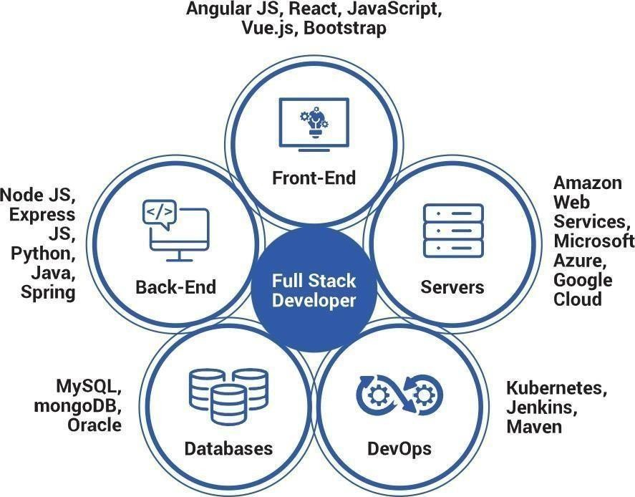The Python programming language is an open-source, widely-used tool for creating software applications. Python is often used to build and deploy web applications and web APIs. Python can also analyze and visualize data and test software, even if the software being tested is not written in Python.

### FIGURE 1: Fundamental aspects of Full Stack Development

While writing, code to design a website, a full stack web developer uses popular programming languages such as HTML5, CSS, JavaScript, and HTML. And, when the developer writes code toreceive information input from users and to save it in several databases, he/she uses several languages such as PHP, Python, etc. to create algorithms and business logic for manipulating the data gathered from the users.

Dept. of CSE, HKBKCE 4 2021-22

Hospital Management About the Project

### Proposed System

* + - Clean aesthetic User Interface, which change dynamically as per the patient status
    - Bed availability is properly indicated, only Beds that are available are shown
    - Can add patient details for storing it in the database. Patient's relative contact details are alsotaken to check if the relative has contracted COVID. Can also update patient details.
    - Information filled here, will make changes in the dashboard dynamically
    - Since there are relatively more COVID patients than any other diseases, a checklist for onlyCOVID symptoms is present
    - Hospital capacity, including Staffing levels (any shortages are indicated) information on ICUcapacity and available ventilators are displayed
    - How many patients are coming into the hospital with confirmed or suspected COVID- 19 cases
    - Many other relevant details that public health officials need to properly coordinate COVID response



Dept. of CSE, HKBKCE 5 2021-22



# CHAPTER -3 TECHNICAL DESCRIPTION

## Chapter-3

**TECHNICAL DESCRIPTIONS**

## Software Requirements

* Operating System : Windows 10
* IDE Used : Microsoft Visual Studio Code
* Language : Python – Django
* SQLite or any database

Any of the following recommended Web Browsers:

* + Google Chrome (v100.0.4896.127 or higher)
  + Mozilla Firefox (v99.0.1or higher)
  + Brave (v1.38.109 or higher)

## Hardware Requirements

* + Main Memory : Minimum – 2GB, Recommended – 4GB
  + Hard Disk : 120GB
  + Hard Disk speed in RPM : 5400rpm
  + Keyboard : Standard 140 keys (QWERTY)
  + Mouse : Standard optical mouse pointer
  + Monitor : 15” Digital Color Monitor

## Technical Specifications

Frontend:

* HTML5
* CSS3
* jQuery Backend:
* Django Framework
* SQLite

## Architecture of a web application

It is important to understand how to structure the code, how to keep files organized, how to structure the data in databases, where to host the media files, and where to perform computational tasks in case of complex and large web applications. The following can be suggested:

Dept. of CSE, HKBKCE 7 2021-22

Hospital Management Technical Descriptions

## Languages Used

**Front End Development**: The part of a website that the user interacts with directly is termed the front end. It is also referred to as the ‘client side’ of the application. It includes everything that users experience directly: text colors and styles, images, graphs and tables, buttons, colors, and a navigation menu. HTML, CSS, and JavaScript are the languages used for Front End development. The structure, design, behavior, and content of everything seen on browser screens when websites, web applications, or mobile apps are opened up, is front end.

### HTML5

HTML5 is a hypertext markup language used for structuring and presenting content on the World Wide Web. It is the fifth major HTML version that is a World Wide Web Consortium recommendation. HTML5 includes detailed processing models; it extends, improves, and rationalizes the markup available for documents and introduces markup and application programming interfaces (APIs) for complex web applications. HTML5 introduces a number of new elements and attributes that can help in building modern websites.

### CSS3

Cascading Style Sheets (CSS) is a style sheet language used for describing the look and formatting of a document written in a markup language. Some of the features of CSS3 are

 Selectors, Backgrounds

 Image Values and Replaced Content

 Text Effects

 2D and 3DTransformations, Animations

### jQuery

jQuery is a lightweight JavaScript library which is blazing fast and concise. jQuery has been designed to simplify HTML DOM tree traversal, as well as event handling, CSS animation.

### JavaScirpt

JavaScript is a scripting language that is browser based to add interactivity and enhance behavior of web pages. Some of the dynamic behavior that can be generated by JavaScript is validating forms, performing specific actions e.g. after a mouse click, adding timestamps etc. It also shares many of the features and structures of the Java programming language, though developed independently.



Dept. of CSE, HKBKCE 8 2021-22



# CHAPTER -4 DESIGN MODEL

## Chapter-4

**DESIGN MODEL**

### System Architecture

The major components in this system are as follows:

* + 1. **Forms:** New users can fill the Credential of the form according to the label mentioned and select the destination language and Pronunciation speaker.
    2. **Text-Speech Conversion:** This section Users to listen to Pronunciation of the Translated Text in the respective pronunciation selected in the form.

### Flow Chart

The flowchart displayed below represents the flow diagram of the application for both patiaent and doctor.

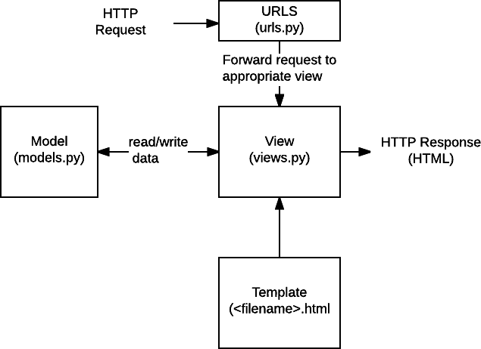

**FIGURE 2: Flowchart**



Dept. of CSE, HKBKCE 10 2021-22



# CHAPTER - 5 SPECIFIC OUTCOMES

## Chapter 5

**SPECIFIC OUTCOMES**

### Project Outcomes

.

* Know and get a basic overview of what Full stack development is.
* Get familiar with the basic Full stack development terminologies like front-end, back- end, databases and servers.
* To create and develop your own full stack application.

## Non-Technical Outcomes

* Communication skills
* Gaining work experience
* Attaining confidence
* Problem Solving skills
* Exploration of a desired career path
* Effective e-mail writing
* Telephone etiquettes



Dept. of CSE, HKBKCE 12 2021-22



# CHAPTER - 6

**SCREENSHOTS**

## Chapter 6

**SCREENSHOTS**

### Fig.3 Screenshot of login for staff fig.4 Patient List

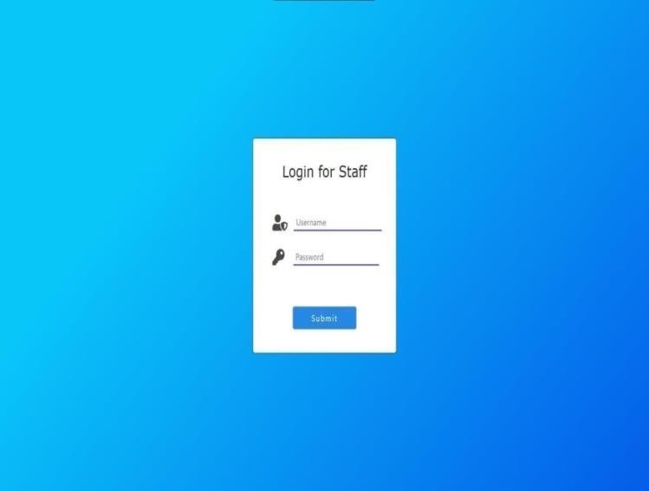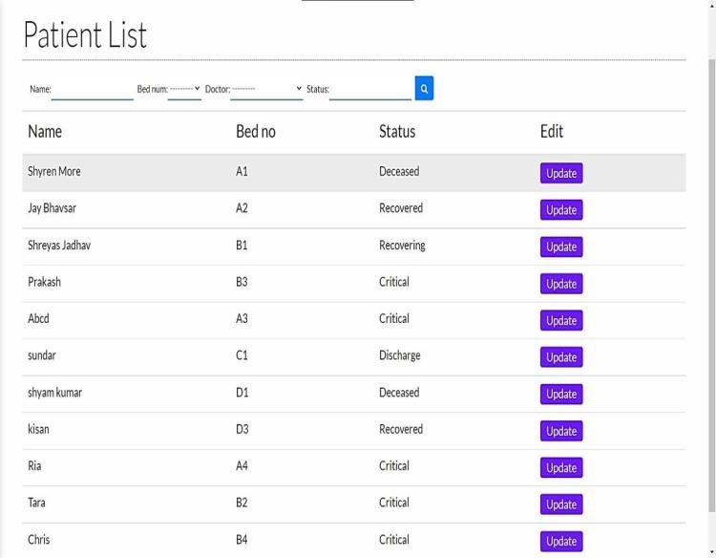

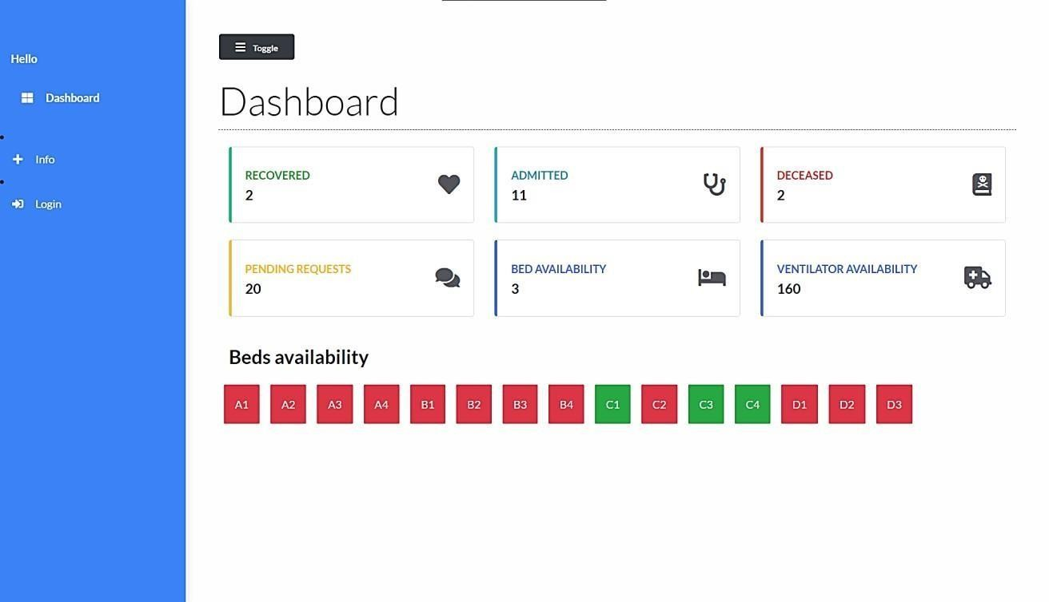

**Fig.5 Update dasboard**

Dept. of CSE, HKBKCE 14 2021-22

E – Library Management System Screenshots

#### Fig.6 Adding details of a new patient fig.7 Adding details of a new patient

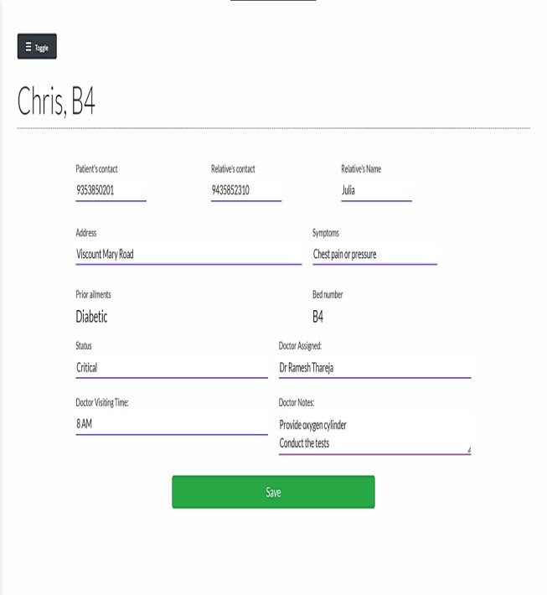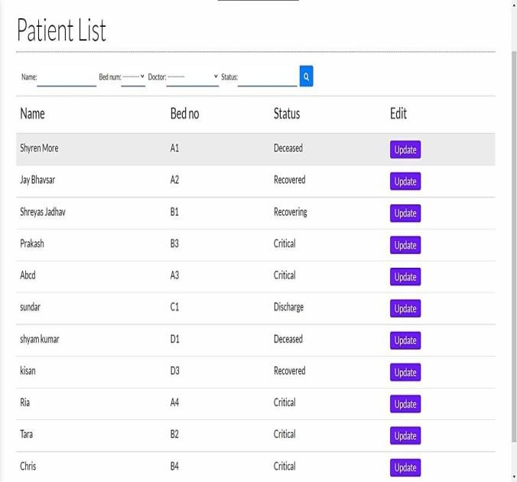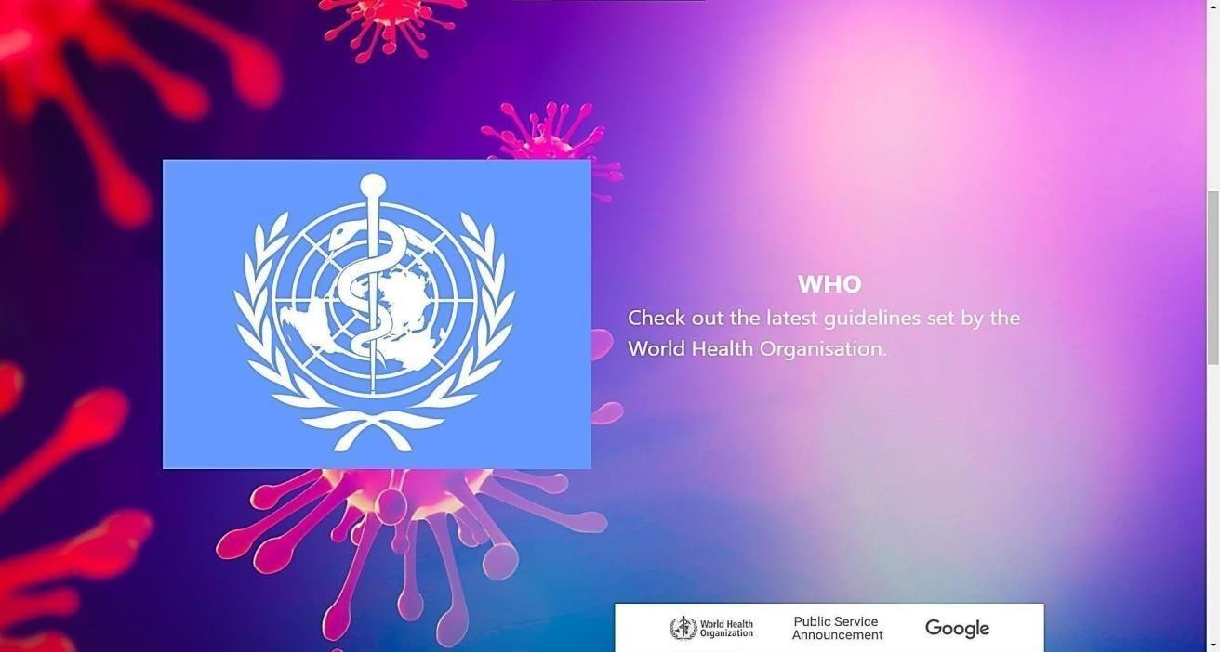



Dept. of CSE, HKBKCE 15 2021-22



# CHAPTER - 7 SUMMARY

## CHAPTER – 7

**SUMMARY**

All put together, I would describe my internship as an instructive and skillful experience during my internship at Brainovision Solutions India Pvt. Ltd., I gained knowledge in the field of Full stack development. I attended all the training sessions that were held on a daily basis during the training period. The projects assigned to me were successfully completed with all the dedication and potentiality. This internship helped me in deciding my career path making me more confidentand assured in exploring the in-depth concepts of Python and its frameworks and also about full stack development. At the end of this internship period, I successfully submitted the projects assigned and updated it to my guide. Considering my future professional career, this internship will bring an impactful experience and assess me in my future tasks. Apart from this, I learned a few other non- technical aspects like communication skills, company etiquettes and other related soft skills which will play an essential role in developing confidence and social skills at the workplace and also help in developing my overall personality.



Dept. of CSE, HKBKCE 17 2021-22

## REFERENCES

* <https://www.fullstackpython.com/>
* The Full Stack Developer: Your Essential Guide to the Everyday SkillsExpected of a Modern Full Stack Web Developer – Chris Northwood
* <https://developer.mozilla.org/en-US/docs/Learn/Server-side/Django/Introduction>
* <https://brainovision.org/courses/python-bootcamp-internship/>



Dept. of CSE, HKBKCE 18 2021-22