# VISVESVARAYA TECHNOLOGICAL UNIVERSITY

###### Jnana Sangama, Belagavi- 590 018



A

Mini Project Report

on

Regional Transport Office Management System

Submitted in partial fulfillment for the award of the Bachelor of Engineering degree In

Computer Science and Engineering V semester

15CSL58 — DBMS Laboratory with Mini Project For the Academic year 2020 - 2021

Submitted by

**MIRZA OMAR BAIG 1HK18CS082**

**Mohammed Ameen. A 1HK18CS087**

Under the guidance of

Prof. Vikram Sindhu

Assistant Professor, Department of Computer Science & Engineering

JAN 2021



###### Department of Computer Science &Engineerinq

HKBK COLLEGE *of* ENGINEERING

(Approved by AICTE & Affiliated to VTU)

22/1, Nagawara, Arabic College Post, Bangalore-45, Karnataka

Email: [info@hkbk.edu.in.](mailto:info@hkbk.edu.in) URL: [www.hkbk.edu.in](http://www.hkbk.edu.in/)

2020 - 2021

Dept. Of CSE, HKBKCE 2020-2021

HKBK COLLEGE *of* ENGINEERING

Nagawara,Bangalore—560045 Approved by AICTE & Affiliated toVTU

**Department of Computer Science and Engineering**

Certificate

Certified that the Project Work entitled “**RTO Management System**”, carried by

**MIRZA OMAR BAIG** **(1HK18CS082) and Mohammed Ameen.** **A** **(1HK18CS087)** bonafide students of HKBK COLLEGE of ENGINEERING, in partial fulfillment for the award of Bachelor of Engineering in **Computer Science** **and** **Engineering** of the Visvesvaraya Technological University, Belgavi, during the year 2020-2021. It is certified that all corrections/suggestions indicated for Internal Assessment have been incorporated in the report deposited in the departmental library. The project report has been approved as it satisfies the academic requirements in respect of **15CSL58—DBMS Laboratory with Mini Project** prescribed for the said Degree.

Prof. Vikram Sindhu

Guide

Dr. Loganathan R

HOD

Name of the Examiners

External Viva

Signature with Date

1.

2.

Dept. Of CSE, HKBKCE 2020-2021

**ACKNOWLEDGEMENT**

We would like to express our regards and acknowledgement to all who helped us in completing this project successfully.

First of all, we would take this opportunity to express our heartfelt gratitude to the personalities. The Chairman Mr. C M **Ibrahim,** HKBKGI and the Director Mr. C M **Faiz Mohammed,** HKBKGI for providing facilities and encouragement, throughout the course.

We express our sincere gratitude to **Dr. Muzzamil** Ahamed S, Principal, HKBKCE, for his support towards the attainment of knowledge.

We consider it as great privilege to convey our sincere regards to Professor and Head **Dr. Loganathan. R.,** Department of CSE, HKBKCE, Bangalore for his constant encouragement throughout the course of the project.

We would specially like to thank our guide, **Prof. Vikram** **Sindhu,** Assistant professor, Department of CSE, HKBKCE for her vigilant supervision and her constant encouragement. She spent her precious time in reviewing the project work and provided many insightful comments and constructive criticism.

Finally, We thank Almighty, all the staff members of CSE Department, our family members and friends for their constant support and encouragement in carrying out the project work.

Dept. Of CSE, HKBKCE 2020-2021

Mirza Omar Baig 1HK18CS082

Mohameed Ameen. A l HK18CS087

**ABSTRACT**

The RTO office management system project is prepared for RTO office to maintain all records like 2 wheeler registration, 3 wheeler registrations , LMV , HMV , learning license and driving license , changing of address , renewal form and much more. These are the main activities of RTO office. The administrator is a power user, he has the power to verify the data and provide appropriate solutions. By introducing the new system we have been organized some striking facilities . Registration of vehicle through online. Fancy number selection of vehicles through online. Issues of information about the license, which includes application forms and license test and other information. In the existing system of RTO office perform functions such as registration, license and fitness. Regional transport office is the organization of the Indian government responsible for maintaining a database of vehicles for various states of India. The RTO issues driving licenses organizes a collection of vehicle excise duty and sells personalized registrations. These are the main activities of RTO office, we developed this software application with a fully computerized method to manage all the data. At present all records are maintained manually.

Table of Contents

|  |  |  |
| --- | --- | --- |
| Acknowledgement |  | 111 |
| Abstract |  | 1V |
| Table of Contents |  | V |
| List of Figures |  | vii |
| Chapter 1 Introduction |  |  |
| 1.1 Introduction |  |  |
| 1.2 Problem Statement |  |  |
| 1.3 Proposed Statement |  |  |
| 1.4 Objectives |  |  |
| 1.5 Course Outcomes |  |  |
| Chapter 2 Requirements Analysis |  |  |
| 2.1 Initial Investigation |  |  |
| 2.2 Information Gathering |  |  |
| 2.3 Feasibility Study |  |  |
| 2.4 Existing System |  |  |
| 2.5 Proposed System |  |  |
| 2.6Advantages of Proposed System |  |  |
| Chapter 3 System Requirements Specification |  |  |
| 3.1 Functional Requirements |  |  |
| 3.2Non-functional Requirements |  |  |
| Chapter 4 System Design |  |  |
| 4.1 System Architecture |  |  |
| 4.2 E-R Diagram |  |  |
| 4.3 Schema Diagram |  |  |
| Chapter 5 System Implementation |  |  |
| 5.1 Tools and Languages used |  |  |
|  |  |  |
|  | V |  |

Chapter 6: Snapshots

Chapter 7: Conclusion and Future Work

Dept. Of CSE, HKBKCE 2020-2021

Chapter 8: Refrences

List of Figures

* 1. System Architecture
  2. E-R Diagram
  3. Schema diagram

6 Snapshots

Dept. Of CSE, HKBKCE 2020-2021

VI I

Dept. Of CSE, HKBKCE 2020-2021

# CHAPTER 1 INTRODUCTION



###### CHAPTER 1

* 1. INTRODUCTION:

**INTRODUCTION**

Regional Transport Office (RTO) is an Indian government bureau which is responsible for the registration of vehicles and issue of Driver’s License in India. RTO management will be having a lot of work regarding registration of vehicles and issue of driver’s license. Similarly, the vehicle owner sometimes forgets to carry the license and forgets the insurance at the time of inquiry. This paper proposed an approach to solving such problems that are by storing all the information related to vehicle and driver at database by RTO administrator.

RTO is an advanced “RTO management System “which is design keeping in a view to make the existing registration and issues of information about licence easier and faster. It includes the entire registration and insurance procedure starting from the initial phase of entering till the result. It is a more reliable, accurate, timesaving and free from any misuse. The system provides information regarding the RTO Application.

* 1. **PROBLEM STATEMENT:**

Existing RTO Office work is very complex, waste of time & much more Real-life problem for example if a person wants to make driving license then he or she first goes to RTO office and then they give work to the agent and then agent complete their work by taking a lot of money. In this way when passing his or her vehicle number, insurance of that vehicle, etc. are taking a lot of time. And nowadays each and every person is in hurry so by analyzing and considering these problems we are developing one web application which overcomes this problem and get a solution in an efficient way.

* 1. **PROPOSED SOLUTION:**

Here, we are developing a web application for RTO so here we give a brief description of our project overview. First, we provide familiar environment means the needy user can access this site for their work purpose related to RTO. First user needs to fill the registration form so that we provide authentication to him and then user can choose option he wants means if he select to making a driving license then we provide driving license requirement details and give available date to him so that he/she come on that date direct give the test so that he/she can save his time as well as money.

Dept. Of CSE, HKBKCE 2020-2021



* 1. OBJECTIVES:

The project is an attempt to reduce the delay in the services provided by the RTO offices and it consists of the following users:

1. Citizens, who wants license or want to register their vehicles
2. RTO Inspector
3. RTO Administrator
   1. OUTCOMES OF THE PROJECT:
      * This RTO management system provide services for the people registration of vehicles and issue of Driver’s License in India hence saving their time and money.

With this system there will no loss of data or records which generally happens when a non-computerized system is used.

All the modules are able to help the admin to manage the RTO database with more convenience and in a more efficient way as compared to offline database system that are not computeriz.

Dept. Of CSE, HKBKCE 2020-2021

Dept. Of CSE, HKBKCE 2020-2021

# CHAPTER 2 REQUIREMENT ANALYSIS

Chapter 2:

REQUIREMENT ANALYSIS

* 1. INITIAL INVESTIGATION:

The first step in reducing the risk of data loss the strategy for making sure that end users do not send sensitive or critical information outside the corporate network.

Inspector recommends that all the registration be screened for evidence of genuinity prior to the issue of all the license and the for vehicle or manufacturing use.

Screening of all documents submitted should be mandatory.

Offline exams be conducted thus leading to slot booking for LL and D1 tests,which should be feasible for the applicant.

For data integrity the data of all the users are prestored and kept under their aadhar number Thus saving their time of entering details.

* 1. INFORMATION GATHERING:

The information for the project is taken from google. Some information is taken by watching certain useful vedios on the related topic. Most of the things is been learnt with the help of our mentors. Some parts of the project is done through analyzing certain other existing projects.

* 1. FEASIBILITY STUDY:

Preliminary investigation examine project feasibility, the likelihood the system will be useful to the organization. The main objective of the feasibility study is to test the Technical, Operational and economical feasibility for adding new modules and debugging old running system. All system is feasible if they are unlimited resources and infinite time. There are aspects in the feasibility study portion of the preliminary investigation:

•Technica1 Feasibility

•Operation Feasibility

Dept. Of CSE, HKBKCE 2020-2021

•Economical Feasibility

* 1. EXISTING SYSTEM:

In the existing system things are done manually but in the proposed system we have to computerize the data using this application:

* + - Lack of security of data.
    - More man power.
    - Time consuming.
    - Needs manual calculations.
    - Fewer user friendly.
    - No proper co-ordination between different applications and users.
  1. PROPOSED SYSTEM:

The aim of proposed system is to develop a system of improved facilities. The

proposed system can overcome all the limitations of the existing system. This system provides proper security and reduces manual work:

* + - Security of data.
    - Ensure data accuracy.
    - Minimize manual data entry.
    - Minimum time required.
    - Greater efficiency.
    - Better service and user friendly.
  1. ADVANTAGES OF PROPOSED SYSTEM:
     + The system makes the overall project management much easier and flexible.
     + It provides higher level of security with level of authentication.
     + It provides a user-friendly application.
     + It provides higher efficiency and is easily accessible

Dept. Of CSE, HKBKCE 2020-2021

Dept. Of CSE, HKBKCE 2020-2021

# CHAPTER 3 SYSTEM REQUIREMENT

Chapter 3: System Requirements RTO Management System

Chapter 3:

SYSTEM REQUIREMENTS

3.1 Functional Requirements

The Functional Requirements Specification documents the operations and activities that a system is able to perform. It is designed to be read by a general audience. Readers should understand the system, but no particular technical knowledge should be required to understand the document.

The RTO Management system provides following functionality for effective usage and maintenance of time.

As the project is an attempt to make the existing RTO system fast and efficient, the built online RTO website provides numerous functionalities makes the job of the RTO officials easier and helps the citizens of the state in the most efficient way. From this, citizens get their job done as soon as possible in a systematic way with no difficulties, whether it may be acquiring license or registering their vehicles or submitting queries. The major functionalities provided by the online RTO website includes:

1. Apply for Learner’s License
2. Apply for Driving License
3. Vehicle Registration
4. Application Status check
5. Complaints/query submission
6. Information section
7. Gallery section.

The data to be stored include the details of citizens applying for learner’s license, driving license, vehicle registration and citizens who submit complaints/queries. The database also stores the information of RTO Inspectors who verify and update the status of learner’s license, driving license and vehicle registration.

Dept. Of CSE, HKBKCE 2020-2021

Chapter 3: System Requirements RTO Management System

**APPLY FOR LEARNER’S LICENSE:**

Citizen who craves for a Driving License (DL), starts by applying for a learner’s license registration (LLR) through their Aadhaar number and a password which will be used for authentication of the citizen in the future. The system is expected to allow only those citizens who are 18 years old or above for registration. All the minor applicants will be denied of further processing.

Once age is verified, the citizen is asked for the category of vehicle (COV) for which he/she wants to apply. After selecting COV, the system will generate an appropriate date, exam ID, exam password and venue for the LLR test. The venue for the test is decided based on the citizen’s address and accordingly, the nearest RTO office is assigned as the test venue.

APPLY FOR DRIVING LICENSE:

To apply for DL, one citizen must wait until his/her LLR is approved by the RTO Inspector. If the citizen fails to pass the LLR test, the LLR of that citizen will be rejected by the RTO Inspector. In that case, the citizen must re-apply for LLR if he/she wants DL. Once the citizen has received his LLR, he/she can apply for driving license, again through their Aadhaar number and a password as in the case of LLR. The system will check whether the LLR issued period is more one month and less than six months or not. If the LLR issued period is less than one month, the citizen will be asked to wait till one month completes.

If the LLR issued period is more than six months, the system will ask the citizen to re-apply for LLR. On a legitimate time of the LLR, the citizen will be asked for the COV to match whether LLR has been issued for the same COV for which the citizen is applying driving license for. On a correct match, the system will generate the test date, test ID and test venue. In this case also, the venue for the test is decided based on the citizen’s address and accordingly, the nearest RTO office is assigned as the test venue.

**VEHICLE REGISTRATION:**

This section is for the citizens to register their newly bought vehicles. The citizen will be asked to apply through their Aadhaar number and a password to be used for authentication. The citizen will be asked to submit the details of the vehicle such as the category of vehicle, vehicle company and the vehicle model. After the details are entered, the system will generate an appropriate date for the documents verification at the nearest RTO office.

**APPLICATION STATUS CHECK:**

Using this functionality, citizens can monitor the status of their LLR, DL and vehicle registration application whether it is approved or rejected. To check the status, citizen must enter the Aadhaar number and password entered while applying. In case of LLR, citizen can also download the approved learner’s license.

## COMPLAINT SUBMISSION:

The complaint submission form allows citizens to submit any complaint regarding the transportation system in the state through Aadhaar number.

Dept. Of CSE, HKBKCE 2020-2021

Chapter 3: System Requirements RTO Management System

#### INFORMATION SECTION:

The website contains an information section where latest news and upcoming events are published.

##### GALLERY SECTION:

The home page also contains a gallery section where photos of events conducted by the RTO are published.

**RTO INSPECTOR:**

The duty of RTO inspectors is to update the status of LLR, DL and vehicle registration applications. Correspondingly, the system has three RTO inspectors, one each for updating the status of LLR, DL and vehicle registration. An LLR Inspector can view the table of applicants who have applied for LLR and update the status of LLR. To update the status of LLR, the LLR inspector will be asked to enter the applicant’s Aadhaar number, LLR ID and update status (1for approval and -1for rejection). While viewing the LLR table, the inspector can also mail the applicant by clicking on the email link in the table.

Similarly, in the case of DL status update, the DL inspector must enter the Aadhaar number, DLID to update the DL status which also applies to updating the vehicle registration status. Both DL inspector and vehicle registration inspector can view respective DL and vehicle registration table with an option to mail the applicant.

#### RTO ADMINISTRATOR:

The administrator will also login using a login page just like RTO Inspector. The list of privileges available to the administrator.

That means, an administrator can view the LLR, DL and vehicle registration entry table. The admin can access the database of driving license holders and the registered vehicles. Prior to one month of the expiry of driving license and RCs book of the vehicle, the administrator will send an alert email to the respective individual. He/she can add new inspectors into the database or remove some of the existing one from the same. When any aspirant has got the driving license successfully, then the administrator will remove his record from the database of LLR or DL to maintain a fresh copy of both database. The update database option will delete the entries of applicants in LLR and DL table who have got the DL. It will also empty the complaints entry in the database. Whenever the administrator views any table, he/she will have an option to mail the applicants in the table. The administrator can also view complaints.

Dept. Of CSE, HKBKCE 2020-2021

Chapter 3: System Requirements RTO Management System

* + 1. Security Requirements

Speed

Size Reliability

Transaction/seconds User or event response

Number of help frames Mean time to failure Probability of unavailability

Rate of failure occurrence

Robustness Availability

Mean time to failure Probability of unavailability

Rate of failure

Probability Availability Number of target

Percentage of target development statements.

* 1. Hardware Requirements
     1. Keyboard.
     2. Mouse Or any Input Method that can interact with the browser (touch capacitive screen).
     3. Screen or monitor with screen resolution at least 1024x768. This is required for viewing the screen proper
  2. Software Requirements
     1. Any windows based operating system (Microsoft windows XP or higher).
     2. Browser (Chrome/Firefox) and xampp with apache server

Dept. Of CSE, HKBKCE 2020-2021

* + 1. Notepad.

# CHAPTER 4 SYSTEM DESIGN

Dept. Of CSE, HKBKCE 2020-2021

DATABASE DESIGN

### TABLES CREATED

* + - 1. citizen

|  |  |  |  |
| --- | --- | --- | --- |
| SNO | NAME | TYPE | DESCRIPTION |
| 1 | first_name | VARCHAR (30) |  |
| 2 | middle name | VARCHAR (30) |  |
| 3 | last name | VARCHAR (30) |  |
| 4 | aadhar | CHAR (12) | Primary Key |
| 5 | gender | CHAR (1) |  |
| 6 | dob | DATE |  |
| 7 | phone_no | CHAR (10) |  |
| 8 | mail id | VARCHAR (50) |  |

* + - 1. address

|  |  |  |  |
| --- | --- | --- | --- |
| SNO | NAME | TYPE | DESCRIPTION |
| 1 | aadhar | CHAR (12) | Primary key, Foreign key |
| 2 | street | VARCHAR (100) |  |
| 3 | city | VARCHAR (30) |  |
| 4 | state | VARCHAR (20) |  |

* + - 1. offices

|  |  |  |  |
| --- | --- | --- | --- |
| SNO | NAME | TYPE | DESCRIPTION |
| 1 | district | VARCHAR (30) | Primary key |
| 2 | rto address | VARCHAR (200) |  |

* + - 1. inspector

|  |  |  |  |
| --- | --- | --- | --- |
| SNO | NAME | TYPE | DESCRIPTION |
| 1 | d | INT | Primary Key |
| 2 | username | VARCHAR (50) |  |
| 3 | password | VARCHAR (100) |  |
| 4 | privilege | VARCHAR (5) |  |

Dept. Of CSE, HKBKCE 2020-2021

* + - 1. Ilr

|  |  |  |  |
| --- | --- | --- | --- |
| SNO | NAME | TYPE | DESCRIPTION |
| 1 | aadhar | CHAR (20) | Foreign Key |
| 2 | name | VARCHAR (50) |  |
| 3 | cov | VARCHAR (20) |  |
| 4 | edate | DATE |  |
| 5 | eid | VARCHAR (10) |  |
| 6 | Ilr id | INT | Primary Key |
| 7 | epwd | CHAR (10) |  |
| 8 | passwd | VARCHAR (50) |  |
| 9 | mail id | VARCHAR (50) |  |
| 10 | Ilr status | INT |  |
| 11 | Ilr issue date | DATE |  |

* + - 1. reg

|  |  |  |  |
| --- | --- | --- | --- |
| SNO | NAME | TYPE | DESCRIPTION |
| 1 | aadhar | CHAR (12) | Foreign key |
| 2 | name | VARCHAR (50) |  |
| 3 | cov | VARCHAR (30) |  |
| 4 | model | VARCHAR (20) |  |
| 5 | company | VARCHAR (20) |  |
| 6 | rdate | DATE |  |
| 7 | r id | INT | Primary key |
| 8 | passwd | VARCHAR (30) |  |
| 9 | mail id | VARCHAR (50) |  |
| 10 | reg status | INT |  |
| 11 | reg_issue_date | DATE |  |
| 12 | vno | VARCHAR (20) |  |
| 13 | reg_expiry_date | DATE |  |

* + - 1. dl

|  |  |  |  |
| --- | --- | --- | --- |
| SNO | NAME | TYPE | DESCRIPTION |
| 1 | aadhar | CHAR (12) | Foreign Key |
| 2 | name | VARCHAR (50) |  |
| 3 | cov | VARCHAR (20) |  |
| 4 | edate | DATE |  |
| 5 | eid | VARCHAR (10) |  |
| 6 | dl id | INT | Primary key |
| 7 | passwd | VARCHAR (50) |  |
| 8 | mail id | VARCHAR (50) |  |
| 9 | dl status | INT |  |
| 10 | dl issue date | DATE |  |

* + - 1. license

|  |  |  |  |
| --- | --- | --- | --- |
| SNO | NAME | TYPE | DESCRIPTION |
| 1 | d | INT | Primary Key |
| 2 | aadhar | CHAR (12) | Primary Key, Foreign key |
| 3 | name | VARCHAR (50) |  |
| 4 | license no | VARCHAR (20) |  |
| 5 | cov | VARCHAR (20) |  |
| 6 | license issue date | DATE |  |
| 7 | license expiry date | DATE |  |
| 8 | mail id | VARCHAR (50) |  |

* + - 1. complaint

|  |  |  |  |
| --- | --- | --- | --- |
| SNO | NAME | TYPE | DESCRIPTION |
| 1 | aadhar | CHAR (12) | Foreign Key |
| 2 | cdate | DATE |  |
| 3 | cdesc | TEXT |  |
| 4 | cid | INT | Primary key |

Dept. Of CSE, HKBKCE 2020-2021

ER DIAGRAM (Rotate to see the diagram) (Tool used: ERDPIus)

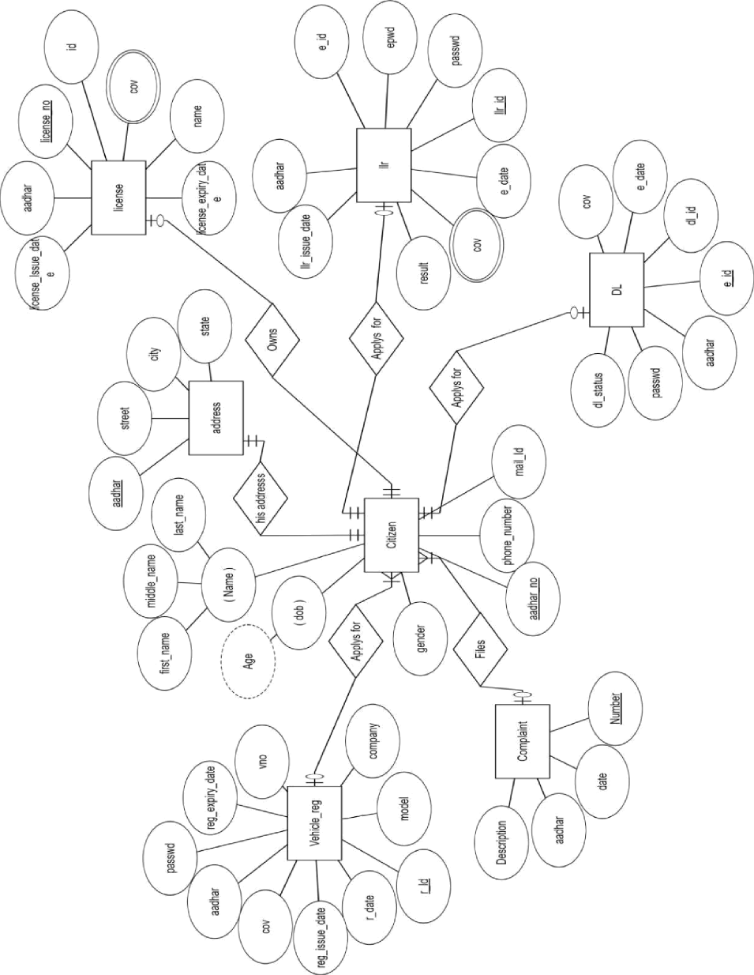

Dept. Of CSE, HKBKCE 2020-2021

Chapter 4: System design

RTO Management System

**4.3 Schema Diagram**

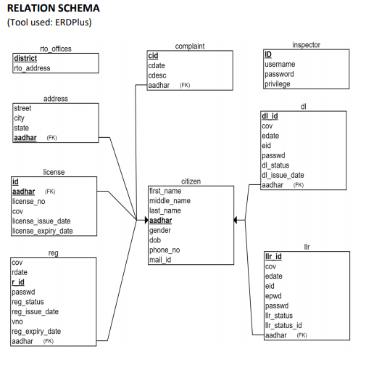

Dept. Of CSE, HKBKCE 2020-2021

**CHAPTER 5**

**SYSTEM IMPLEMENTATION**

Dept. Of CSE, HKBKCE 2020-2021

**RTO Management System**

**Chapter5: System Implementation**

**Chapter 5:**

**SYSTEM IMPLEMENTATION**

**5.1 Tools and languages used:**

**5.1.1 Tools used:**

1. Notepad/Notepad++

2. Apache

3. XAMPP

4. PHPMyAdmin (Database)

**5.1.2 Languages used:**

1. PHP (Hypertext Preprocessor)

2. SQL (Standardized Query Language)

3. HTML (Hypertext Markup Language)

* **Google Fonts :**

Used to make the web more beautiful, fast, and open through great typography.

Link-to-use : <https://fonts.google.com/>

* **Sublime Text 3 :**

Used as text editor for code, markup and prose.

Link-to-use : <https://www.sublimetext.com/3>

* **Bootstrap :**

Used to design and customize responsive front-end with extensive prebuilt components, and powerful JavaScript plugins.

Link-to-use : <https://getbootstrap.com/>

* **Pixabay :**

Used to get high quality images for website.

Link-to-use : <https://pixabay.com/>

* **w3schools.com :**

Used for learning, testing, and training.

Dept. Of CSE, HKBKCE 2020-2021

Link-to-use : https://www.w3schools.com/

**SOURCE CODE-TABLE CREATION**

--

-- Table structure for table `address`

--

CREATE TABLE `address` (

`aadhar` char(12) NOT NULL,

`street` varchar(100) NOT NULL,

`city` varchar(30) NOT NULL,

`state` varchar(30) NOT NULL

) ENGINE=InnoDB DEFAULT CHARSET=utf8mb4;

--

-- Dumping data for table `address`

--

INSERT INTO `address` (`aadhar`, `street`, `city`, `state`) VALUES

('7799124567', 'Sundara Vana', 'banglore', 'karnataka'),

('8772194207', 'MG road', 'Mysore', 'karnataka'),

('8899223311', 'Bellary', 'Hampi', 'karnataka'),

('9448294207', 'Coffee Trails The Hidden Valley', 'banglore', 'karnataka'),

('9789112354', 'Gowri Nivas', 'Chikmagalur', 'karnataka'),

('9889224355', 'Ulsoor Lake', 'banglore', 'karnataka');

-- --------------------------------------------------------

--

-- Table structure for table `citizen`

--

CREATE TABLE `citizen` (

`first_name` varchar(30) NOT NULL,

`middle_name` varchar(30) NOT NULL,

`last_name` varchar(30) NOT NULL,

`aadhar` char(12) NOT NULL,

`gender` char(1) NOT NULL,

`dob` date NOT NULL,

`phone_no` char(10) NOT NULL,

`mail_id` varchar(50) NOT NULL,

`img` mediumblob NOT NULL

) ENGINE=InnoDB DEFAULT CHARSET=utf8mb4;

--

-- Table structure for table `complaint`

--

CREATE TABLE `complaint` (

`aadhar` char(12) NOT NULL,

`cdate` date NOT NULL,

`cdesc` text NOT NULL,

Dept. Of CSE, HKBKCE 2020-2021

`cid` int(11) NOT NULL

) ENGINE=InnoDB DEFAULT CHARSET=utf8mb4;

-- --------------------------------------------------------

CREATE TABLE `dl` (

`aadhar` char(12) NOT NULL,

`name` varchar(50) NOT NULL,

`cov` varchar(20) NOT NULL,

`edate` date NOT NULL,

`eid` varchar(10) NOT NULL,

`dl_id` int(11) NOT NULL,

`passwd` varchar(50) NOT NULL,

`mail_id` varchar(50) NOT NULL,

`dl_status` int(11) NOT NULL,

`dl_issue_date` date NOT NULL

) ENGINE=InnoDB DEFAULT CHARSET=utf8mb4;

-- --------------------------------------------------------

--

-- Table structure for table `inspector`

--

CREATE TABLE `inspector` (

`id` int(11) NOT NULL,

`username` varchar(50) NOT NULL,

`password` varchar(100) NOT NULL,

`privilege` varchar(5) NOT NULL,

`name` varchar(250) NOT NULL

) ENGINE=InnoDB DEFAULT CHARSET=utf8mb4;

--

-- Dumping data for table `inspector`

--

INSERT INTO `inspector` (`id`, `username`, `password`, `privilege`, `name`)VALUES

(1, 'admin', 'admin', 'llr', 'john wick');

-- --------------------------------------------------------

--

-- Table structure for table `license`

--

CREATE TABLE `license` (

`id` int(11) NOT NULL,

`aadhar` char(12) NOT NULL,

`name` varchar(50) NOT NULL,

`license_no` varchar(20) NOT NULL,

`cov` varchar(20) NOT NULL,

`license_issue_date` date NOT NULL,

`license_expiry_date` date NOT NULL,

`mail_id` varchar(50) NOT NULL

) ENGINE=InnoDB DEFAULT CHARSET=utf8mb4;

Dept. Of CSE, HKBKCE 2020-2021

--

-- Dumping data for table `license`

--

INSERT INTO `license` (`id`, `aadhar`, `name`, `license_no`, `cov`, `license_issue_date`, `license_expiry_date`, `mail_id`) VALUES

(0, '9889224355', 'Pavan Kalyan Krishna', 'KA1', 'LMV', '2020-12-21', '2022-12-21', 'kalyankrishna@gmail.com');

-- --------------------------------------------------------

--

-- Table structure for table `llr`

--

CREATE TABLE `llr` (

`aadhar` char(20) NOT NULL,

`name` varchar(50) NOT NULL,

`cov` varchar(20) NOT NULL,

`edate` date NOT NULL,

`eid` varchar(10) NOT NULL,

`llr_id` int(11) NOT NULL,

`epwd` char(10) NOT NULL,

`passwd` varchar(50) NOT NULL,

`mail_id` varchar(50) NOT NULL,

`llr_status` int(11) NOT NULL,

`llr_issue_date` date NOT NULL

) ENGINE=InnoDB DEFAULT CHARSET=utf8mb4;

--

-- Dumping data for table `llr`

--

INSERT INTO `llr` (`aadhar`, `name`, `cov`, `edate`, `eid`, `llr_id`, `epwd`, `passwd`, `mail_id`, `llr_status`, `llr_issue_date`) VALUES

('8772194207', 'Demetra Fellman Yadav', 'HGMV', '2020-12-29', 'e2', 9, '1GOf0XaI9I', 'pass', 'Fellman@gmail.com', 0, '0000-00-00');

-- --------------------------------------------------------

--

-- Table structure for table `offices`

--

CREATE TABLE `offices` (

`district` varchar(30) NOT NULL,

`rto_address` varchar(200) NOT NULL

) ENGINE=InnoDB DEFAULT CHARSET=utf8mb4;

--

-- Dumping data for table `offices`

--

INSERT INTO `offices` (`district`, `rto_address`) VALUES

Dept. Of CSE, HKBKCE 2020-2021

('banglore', 'Regional Transport Office Bengaluru East- KA 03'),

('Bellary', 'Koramangala KA01 Bellary KA34'),

('Chikmagalur', 'Electronic City (KA-51) RTO Office, Bangalore arakere'),

('Mysore', 'Madikeri KA12 Hunsur, Mysore District KA45');

--

-- Table structure for table `reg`

--

CREATE TABLE `reg` (

`aadhar` char(12) NOT NULL,

`name` varchar(50) NOT NULL,

`cov` varchar(30) NOT NULL,

`model` varchar(20) NOT NULL,

`company` varchar(20) NOT NULL,

`rdate` date NOT NULL,

`r_id` int(11) NOT NULL,

`passwd` varchar(30) NOT NULL,

`mail_id` varchar(50) NOT NULL,

`reg_status` int(11) NOT NULL,

`reg_issue_date` date NOT NULL,

`vno` varchar(20) NOT NULL,

`reg_expiry_date` date NOT NULL

) ENGINE=InnoDB DEFAULT CHARSET=utf8mb4;

--

-- Dumping data for table `reg`

--

INSERT INTO `reg` (`aadhar`, `name`, `cov`, `model`, `company`, `rdate`, `r_id`, `passwd`, `mail_id`, `reg_status`, `reg_issue_date`, `vno`, `reg_expiry_date`) VALUES

('9889224355', 'Pavan Kalyan Krishna', 'LMV', 'roadster', 'tesla', '2020-12-28', 4, 'pass', 'kalyankrishna@gmail.com', 1, '2020-12-21', '14241', '2022-12-21');

--

-- Indexes for dumped tables

--

--

-- Indexes for table `address`

--

ALTER TABLE `address`

ADD PRIMARY KEY (`aadhar`);

--

-- Indexes for table `citizen`

--

ALTER TABLE `citizen`

ADD PRIMARY KEY (`aadhar`);

--

-- Indexes for table `complaint`

--

ALTER TABLE `complaint`

ADD PRIMARY KEY (`cid`);

Dept. Of CSE, HKBKCE 2020-2021

ALTER TABLE `dl`

ADD PRIMARY KEY (`dl_id`);

--

-- Indexes for table `inspector`

--

ALTER TABLE `inspector`

ADD PRIMARY KEY (`id`);

--

-- Indexes for table `license`

--

ALTER TABLE `license`

ADD PRIMARY KEY (`aadhar`);

--

-- Indexes for table `llr`

--

ALTER TABLE `llr`

ADD PRIMARY KEY (`llr_id`);

--

-- Indexes for table `offices`

--

ALTER TABLE `offices`

ADD PRIMARY KEY (`district`);

--

-- Indexes for table `reg`

--

ALTER TABLE `reg`

ADD PRIMARY KEY (`r_id`);

--

-- AUTO_INCREMENT for table `complaint`

--

ALTER TABLE `complaint`

MODIFY `cid` int(11) NOT NULL AUTO_INCREMENT, AUTO_INCREMENT=7;

--

-- AUTO_INCREMENT for table `inspector`

--

ALTER TABLE `inspector`

MODIFY `id` int(11) NOT NULL AUTO_INCREMENT, AUTO_INCREMENT=2;

--

-- AUTO_INCREMENT for table `llr`

--

ALTER TABLE `llr`

MODIFY `llr_id` int(11) NOT NULL AUTO_INCREMENT, AUTO_INCREMENT=10;

Dept. Of CSE, HKBKCE 2020-2021

ALTER TABLE `reg`

MODIFY `r_id` int(11) NOT NULL AUTO_INCREMENT, AUTO_INCREMENT=5;

COMMIT;

**CHAPTER 6:**

**SNAPSHOTS**

Dept. Of CSE, HKBKCE 2020-2021

**Chapter6: Snapshots**

**RTO Management System**

**Snapshots**

1. MAIN-PAGE:

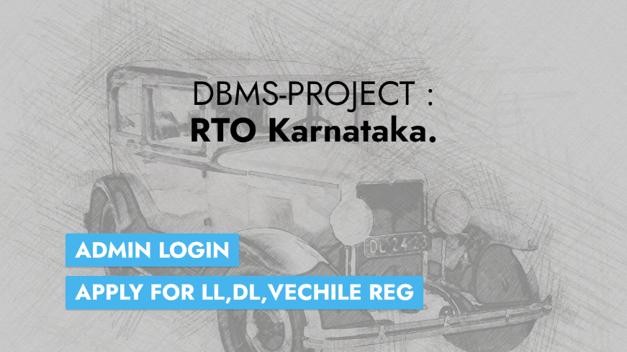

1. ADMIN-LOGIN:

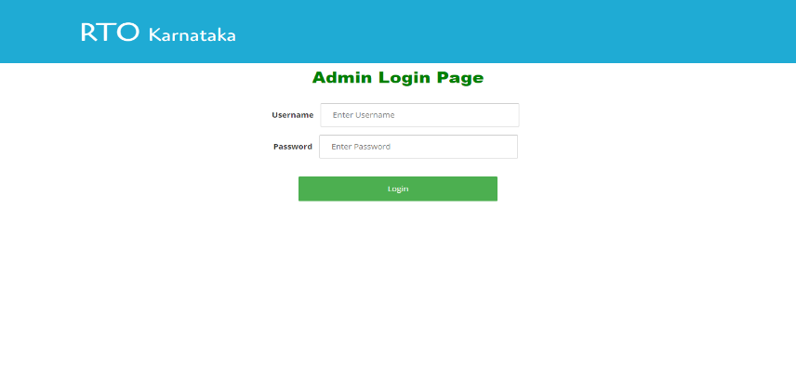

1. ADMIN-PAGE:

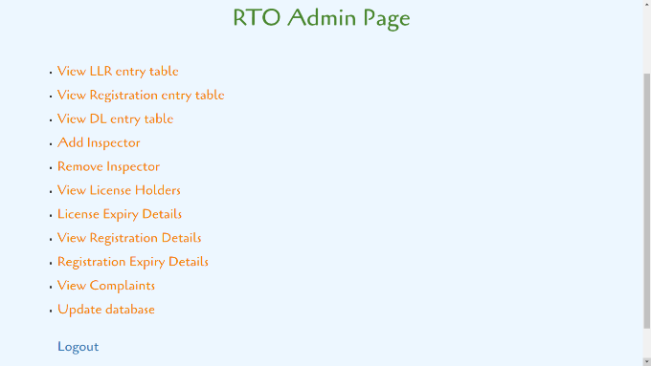

1. LLR’s REGISTRATION PAGE:

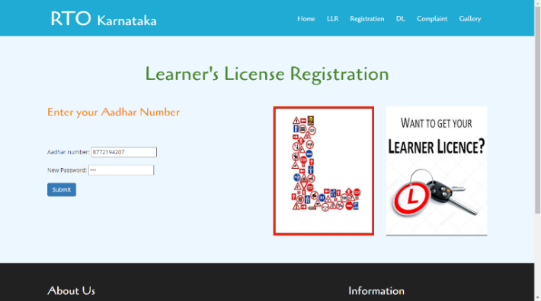

Dept. Of CSE, HKBKCE 2020-2021

5) COMPLAINT PAGE:

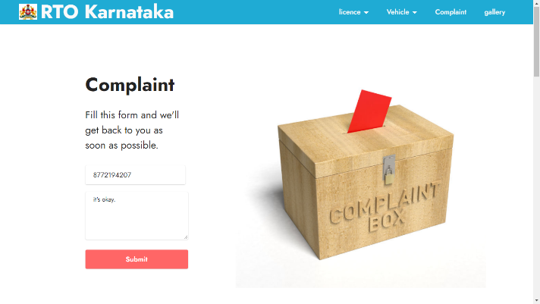

6) DLR’s REGISTRATION PAGE:

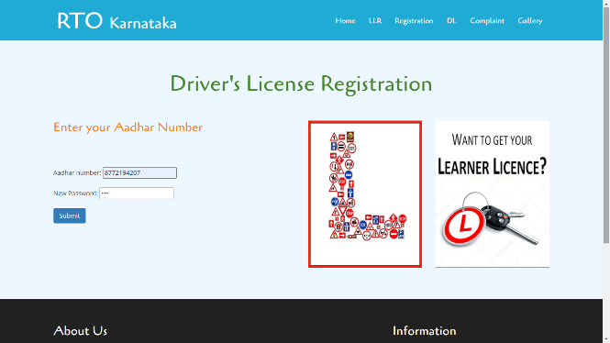

7) GALLERY PAGE:

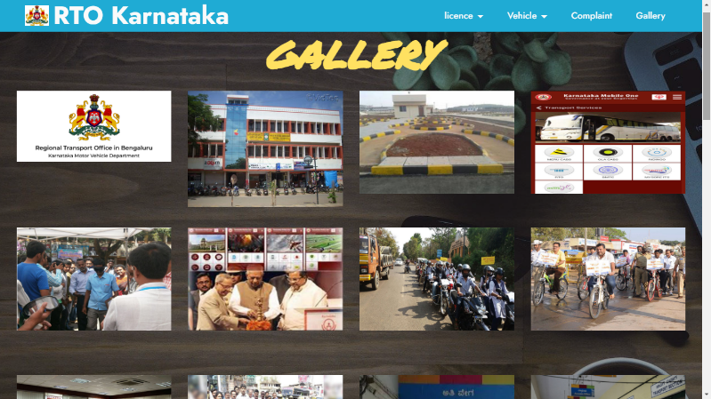

8) VEHICLE’s REGISTRATION PAGE:

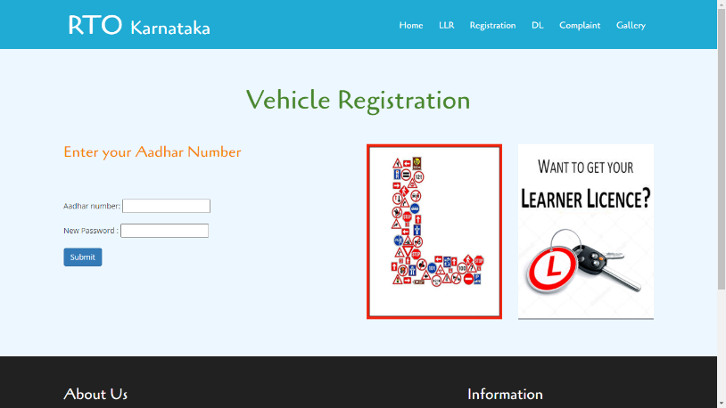

Dept. Of CSE, HKBKCE 2020-2021

9) STATUS PAGE OF LLR:

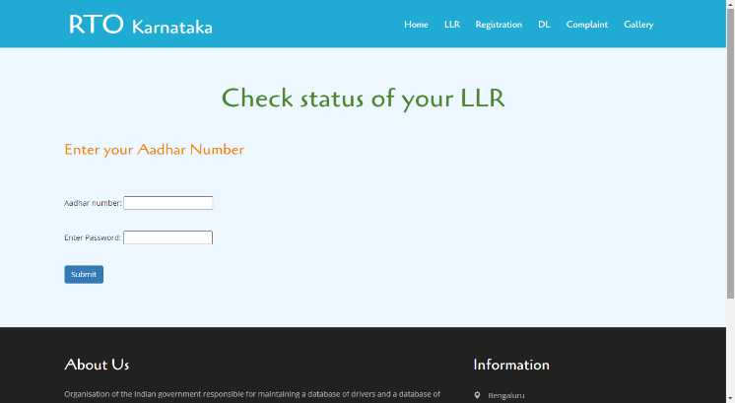

10) STATUS PAGE OF DLR:

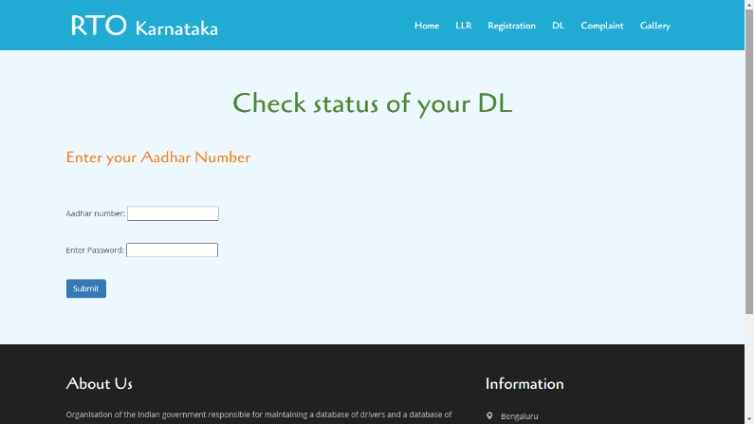

11) STATUS PAGE OF VECH REGISTRATION:

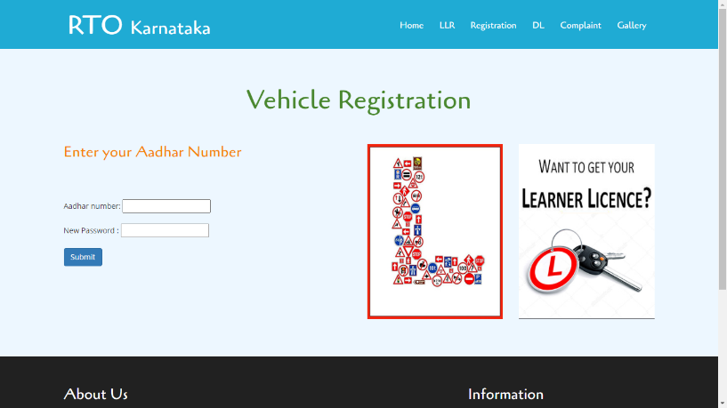

Dept. Of CSE, HKBKCE 2020-2021

**CHAPTER 7:**

**CONCLUSION AND FUTURE WORK**

Dept. Of CSE, HKBKCE 2020-2021

**Chapter7: Conclusion And Future Work**

**RTO Management System**

**CONCLUSION**

The implemented project RTO Management System brings out an improvement over the existing RTO system by reducing the processing delay and allowing RTO to provide quality of service to the citizen. It overall increases the efficiency of the RTO office and effectively reduces the burden on the RTO officials. People need not stand in long queues just to apply for LLR or DL at RTO offices. All this pre-registration task can be done online through the implemented system. Any doubts or queries can be submitted which will be responded by the officials. This project even eliminates the presence of middle man from the entire process and thereby decreasing the degree of corruption in the state. The other ways in which the system helps is by publishing the latest news and events. The project is mainly built using web scripting languages. So, in the future, updating the system or adding extra features to the system as per the requirements will not be difficult as simple web scripting languages will help us in accomplishing it

**Future Work:**

1.We can add more advance software for “RTO Management System”

including more facilities.

2.We can make it accessible worldwide.

3.Implementing the backup mechanism for taking backup of codebase and database on

regular basis on different servers.

Dept. Of CSE, HKBKCE 2020-2021

**REFERENCES**

**Google Fonts :** <https://fonts.google.com/>

**Sublime Text 3 :** <https://www.sublimetext.com/3>

**Bootstrap :** <https://getbootstrap.com/>

**Pixabay :** <https://pixabay.com/>

**w3schools.com :** <https://www.w3schools.com/>

**MYSQL :** <https://dev.mysql.com/>

**FreeCodeCamp :** [https://www.freecodecamp.org](https://www.freecodecamp.org/)  
  
  **Tutorialpoint :** [https://www.tutorialspoint.com](https://www.tutorialspoint.com/)

**BOOKS:**

**MySQL Crash Course, Ben Forta.**

**Software Engineering , Pressman.**

Dept. Of CSE, HKBKCE 2020-2021