Index
TerrainStratumPainter 1
What this asset do? 1
How to use? 2
V1.1 new feature 4
About Demo scene 5
Contact. 5

TerrainStratumPainter

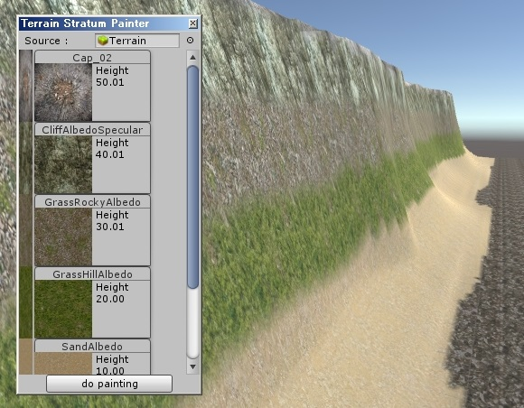
Thank you for downloading the TerrainStratumPainter.

What this asset do?
This asset automatically paint a terrain.
You just need to set each of height ranges and press the button.

How to use?
- Create a terrain.
- Make a mountain.
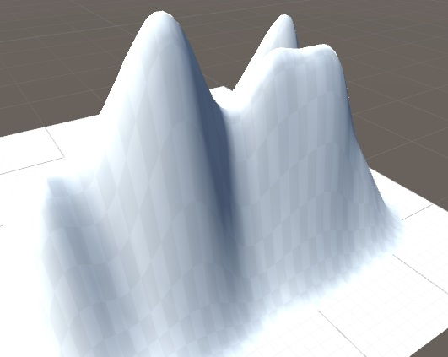

- Set terrain textures.
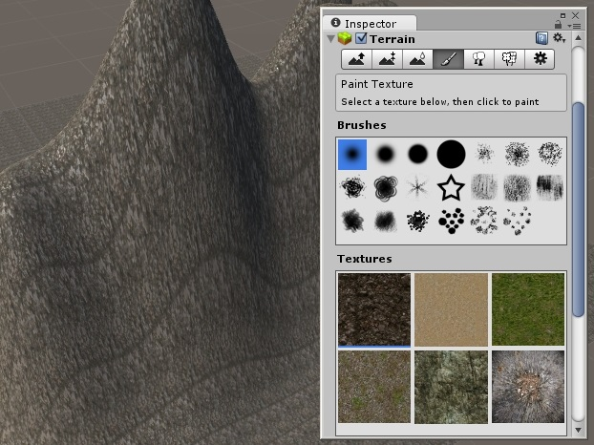

- Select a menu. [Tools => Terrain Stratum Painter]
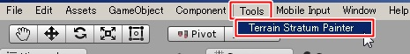

- Set height ranges.
- Press a button.
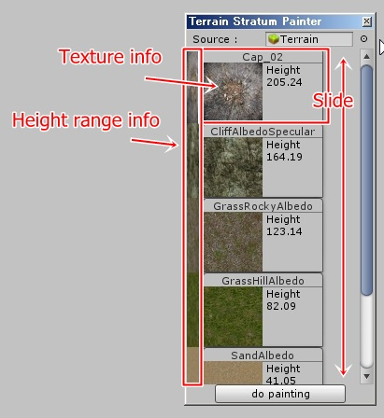
- Complete.
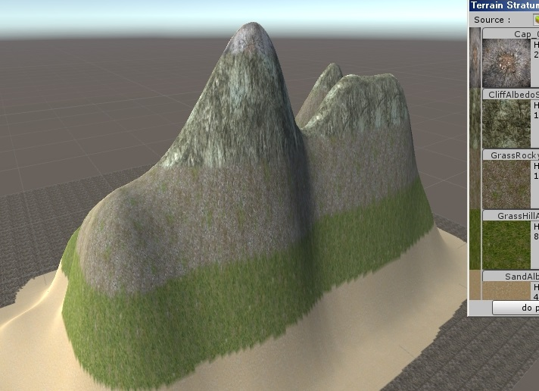

V1.1 new feature

There are 2 new features in version 1.1

- Undo button
This allow you to undo 1 previous paint.

- Target Area
You can paint a place where you want.

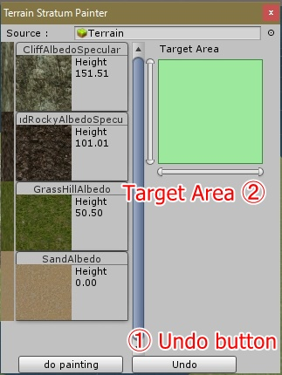

About Demo scene

This asset has one demo scene.
It shows you, how does this asset paint on a terrain.
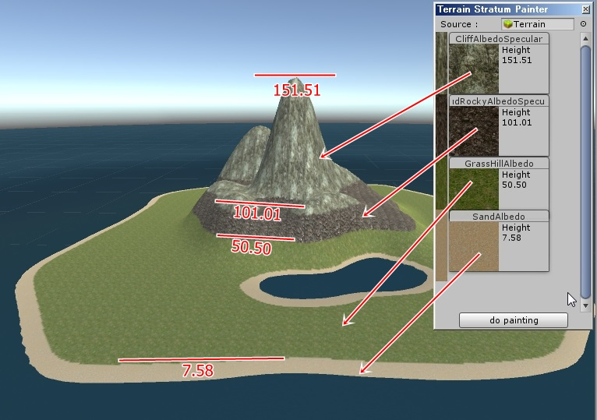

Contact.

If something happened, please contact me.

Website(jp) : http://magcat.php.xdomain.jp/brog/
E-Mail : syu-ya_ST@hotmail.co.jp

