Welcome to my test

Omar Díaz Díaz

Below you will find the instructions to use my little application.

# Getting ready

The zip file sent has 1 folder and 1 Doc file. The folder is the Backbase project to import in Eclipse or any Java IDE.

|  |  |
| --- | --- |
|  |  |

# Features

The application was developed using Java 8, Tomcat 7.0, Maven, Javadoc and Spring Security. I used a basic log4j trying to keep the application simple. The IDE was Eclipse Mars.

This is the Welcome Page and the only page with CSS code and an Image. Just for fun, the page has an effect when you moved the mouse over the image.

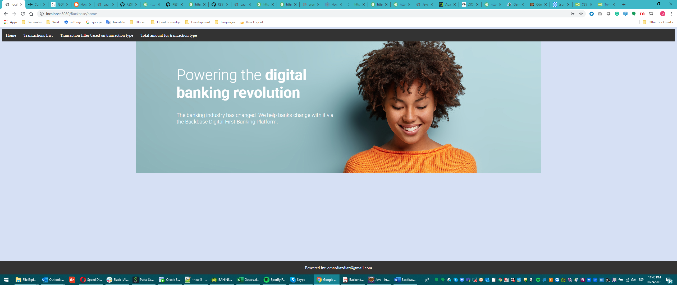

How to run the app

Please import the project to your Workspace. The project name is Backbase. Once you have the project imported, please run the application:

1.-Right button over the project – Run as – Run on Server

The IDE should be executing the Tomcat Server and deploying the application to the port 8080

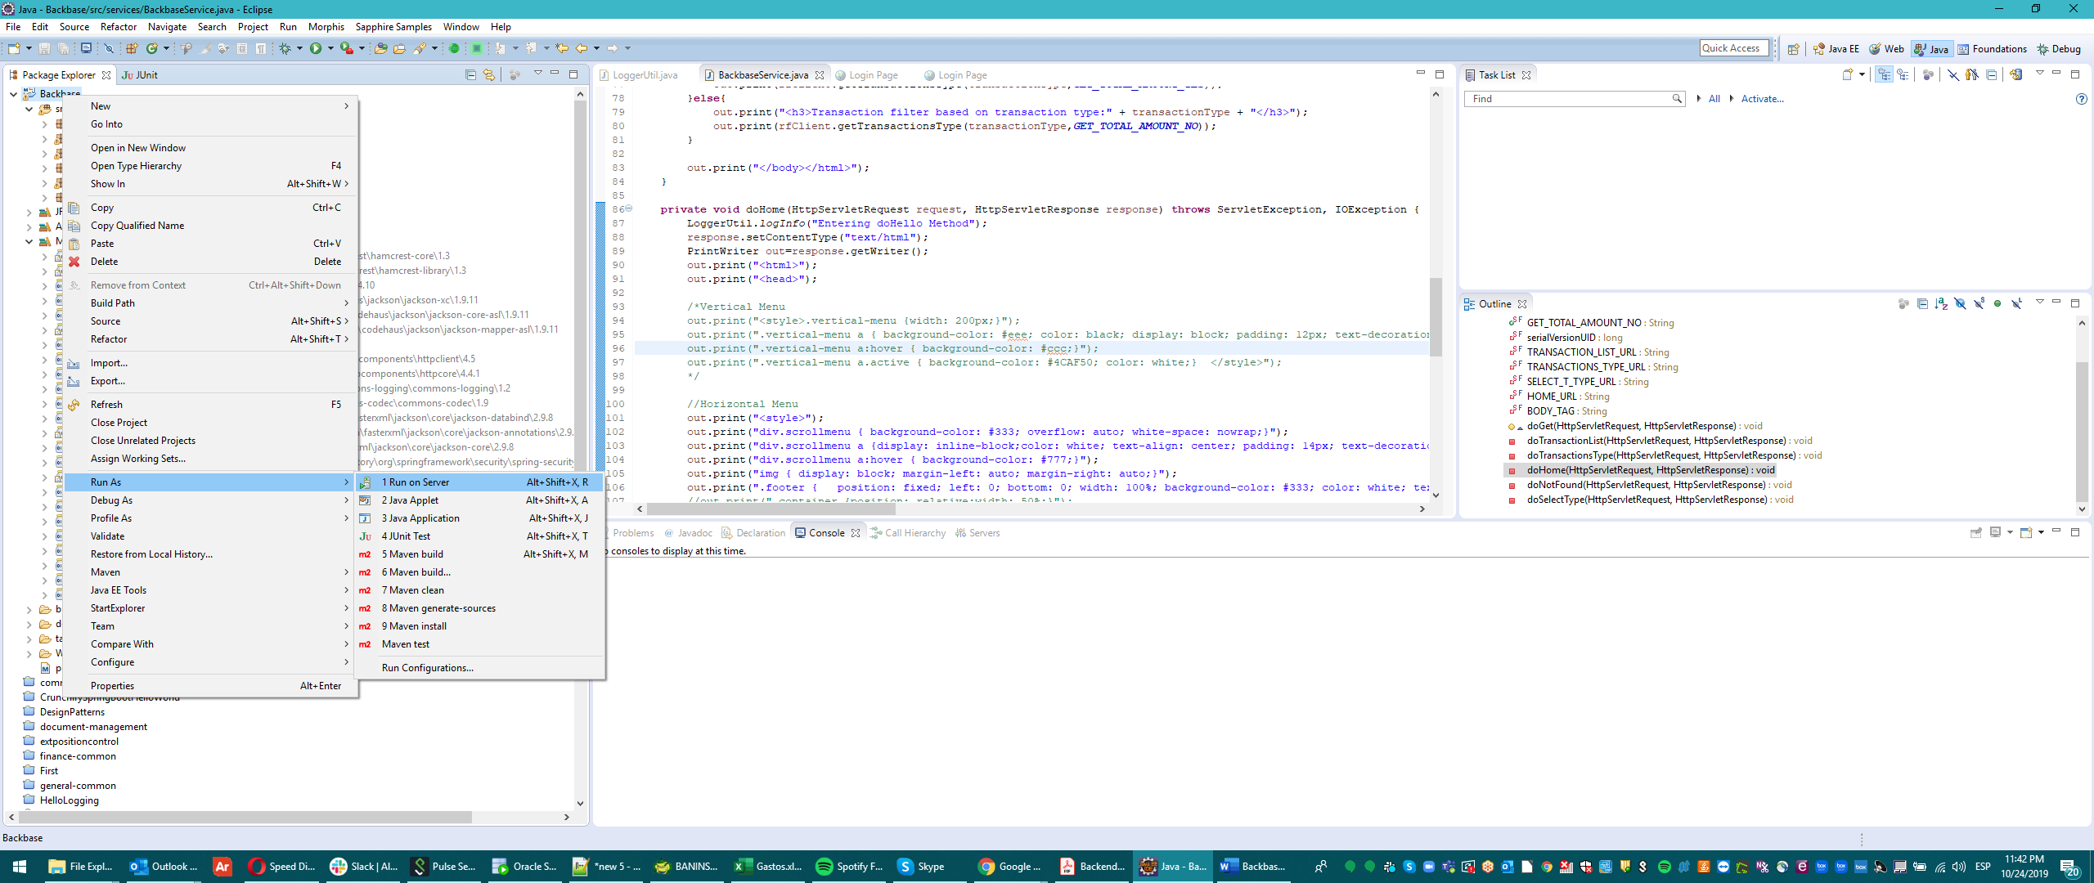

# Security login

Once the application is up and running, you will be able to hit this url:

<http://localhost:8080/Backbase/home>

The application will be requesting the user and password:

**User: omar**

**Pwd: 1234**

You can find this configuration in the springSecurity.xml file.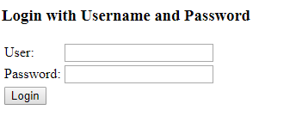

After the sucessful login, the application will be showing the Welcome page. Above in the left corner you can find a menu with 3 options:

1.-Transactions List

2.-Transaction filter based on transaction type and

3.-Total amount for Transaction type.

Transactions list

In this option you will be able to see all the transactions received from the OpenBank project. This is a part of that screen.

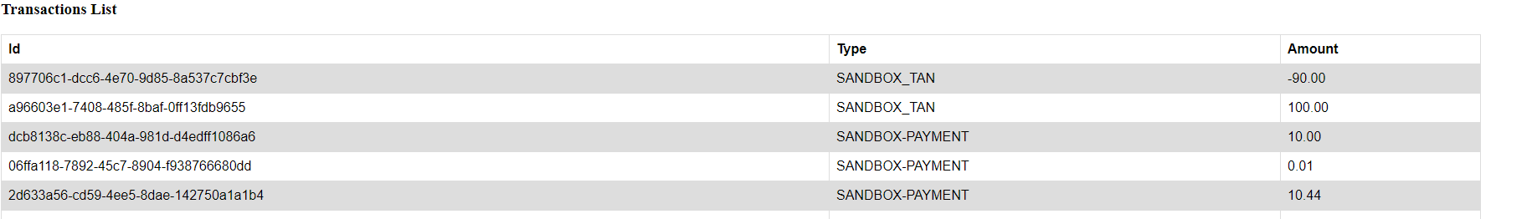

# Transaction filter based on transaction type

This screen will be displaying a drop down menu with 4 options:

1.-TAN

2.-PAYMENT

3.-EMPTY

4.-ALL

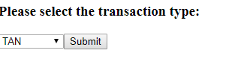

The application will be showing a list with the result of the OpenBank project.

# Total amount for transaction type

The behaviour is the same as the the previous application. You need to choose a transaction type in the drop down list then click on Submit button and expect the result. The amount will be showed in an html table.

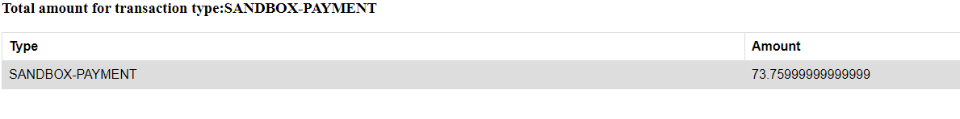

# Special test case

1.-Please open the Home Page. <http://localhost:8080/Backbase/home>

2.-Turn off your WIFI network

3.-Hit any Endpoint

4.- You should see “the service unavailable message”

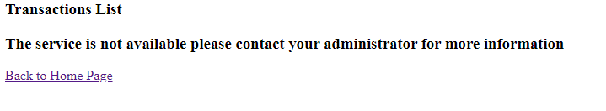

And in the console you should see the stacktrace with the error

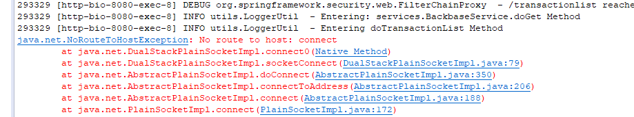

5.-Turn on your WIFI and hit any Endpoint

6.-You should see the required information.

This was a quick document of how to use the application.

Thank you

Regards