Siemens Staff Analysis Report

Report generated on 2025-05-27 14:33:52

# 1. Position Overview

Total number of unique positions: 84

# 2. Top 10 Positions

|  |  |
| --- | --- |
| Position | Count |
| Technical Office Engineer | 52 |
| Site Engineer | 49 |
| Driver G2 | 46 |
| Document Control | 30 |
| Health and Safety Supervisor | 29 |
| Senior Electrical Technical Office Engineer | 26 |
| Site TeamLeader Engineer | 25 |
| Foreman | 25 |
| Surveyor | 25 |
| Senior Site Engineer | 22 |

# 3. Monthly Analysis

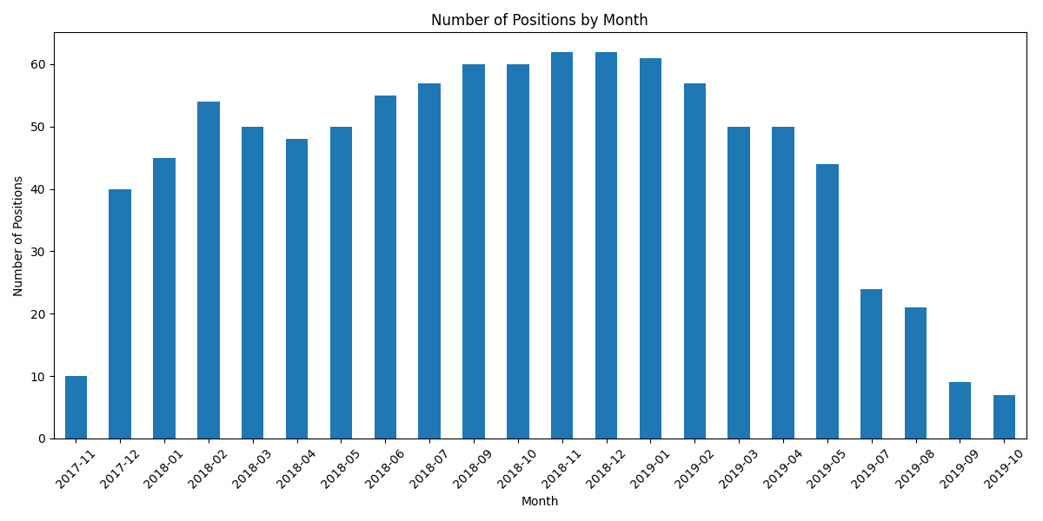

Peak month: 2018-11 with 62 positions

# 4. Location Analysis

SIEMENS: 976 positions