Siemens Wages Analysis Report

Report generated on 2025-05-27 14:48:56

# 1. Monthly Mandays Analysis

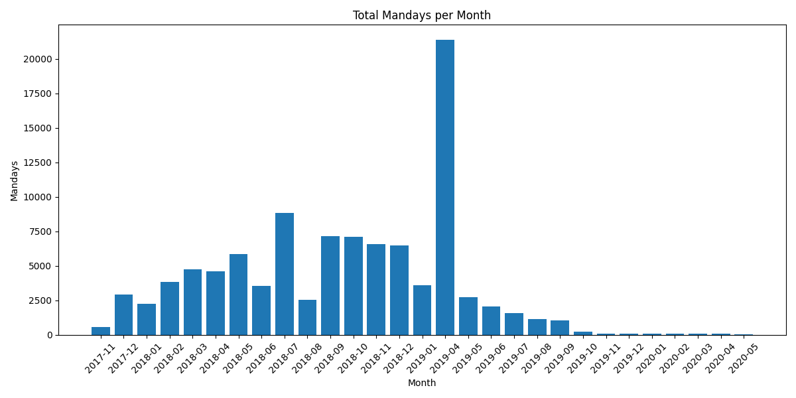

# 2. Monthly Amount Analysis

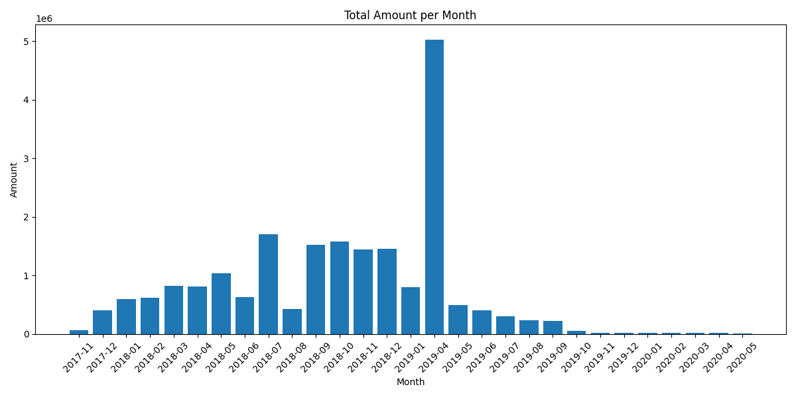

# 3. Top Occupations Analysis

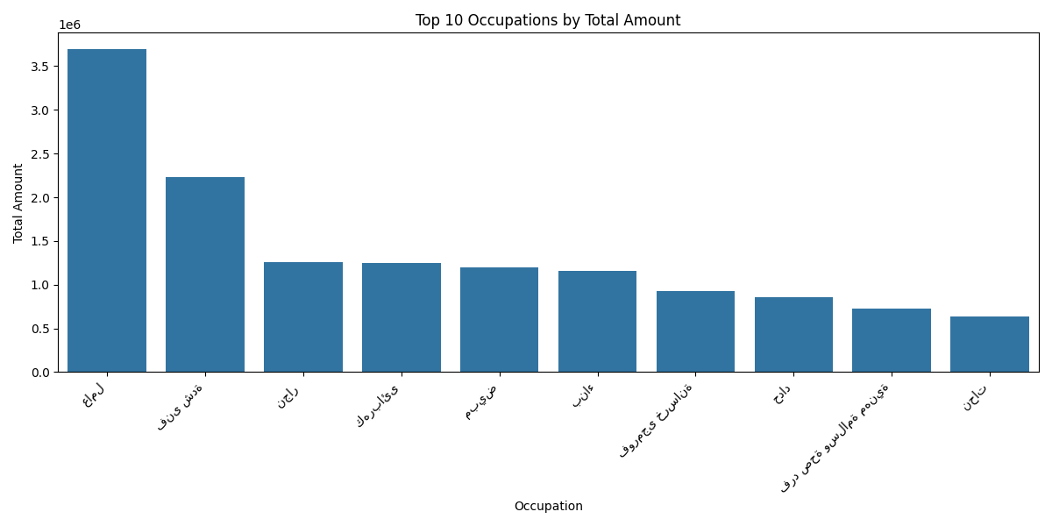

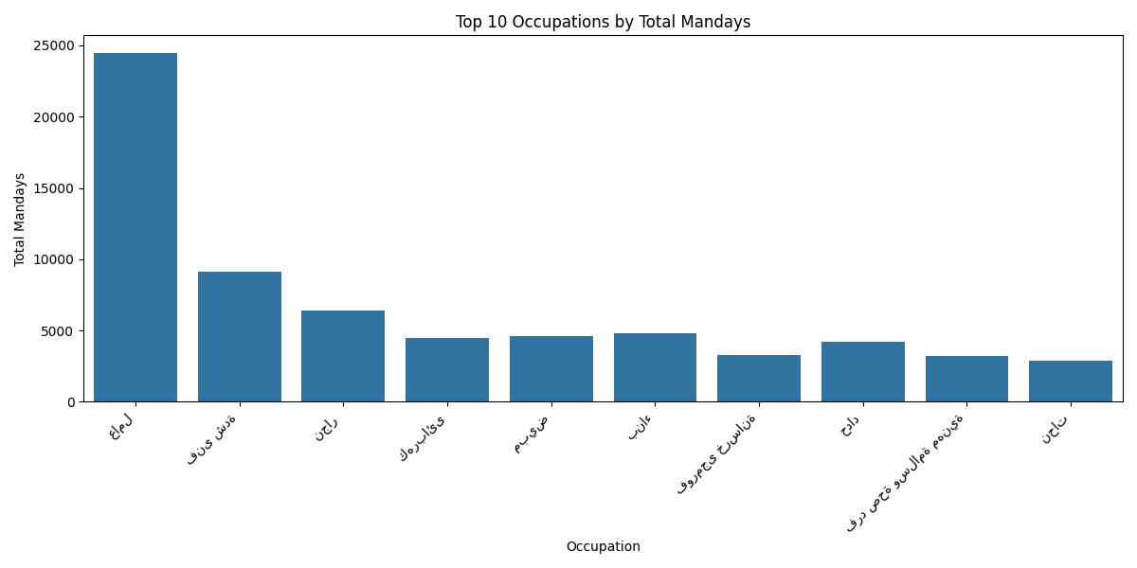

# 4. Statistical Summary

|  |  |
| --- | --- |
| Metric | Value |
| Total Amount Spent | 20,805,606.31 |
| Total Mandays | 101,561 |
| Average Daily Rate | 204.86 |
| Number of Unique Occupations | 85 |
| Peak Month (by Amount) | 2019-04 |

# 5. Mandays vs Amount Correlation

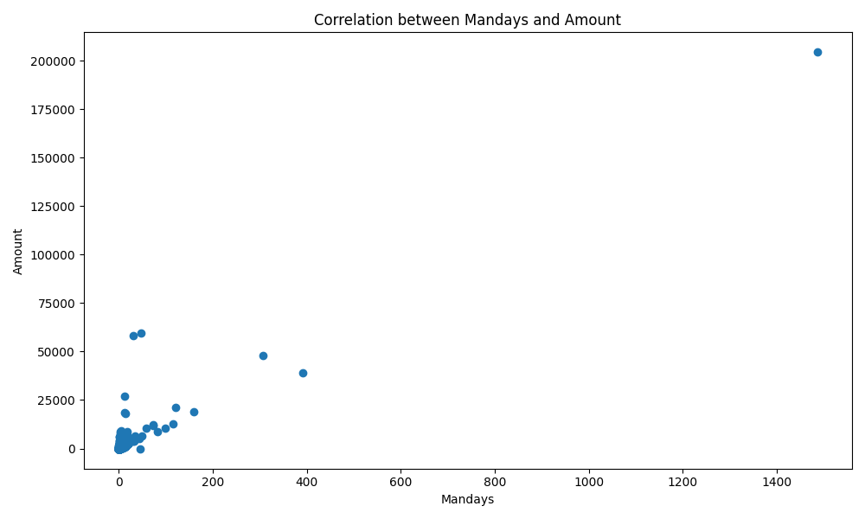

# 6. Rate Analysis

