Enhanced PDF Extraction Database Report

*Report generated on: 2025-05-19 17:27:19*

# Overall Statistics

Total PDFs Processed: 1773 documents

Total Projects: 29

Total Document Types: 4

# Document Type Analysis

Distribution of document types:

* • Contract: 965 documents
* • Unknown: 363 documents
* • Comparison: 262 documents
* • Purchase Order: 183 documents

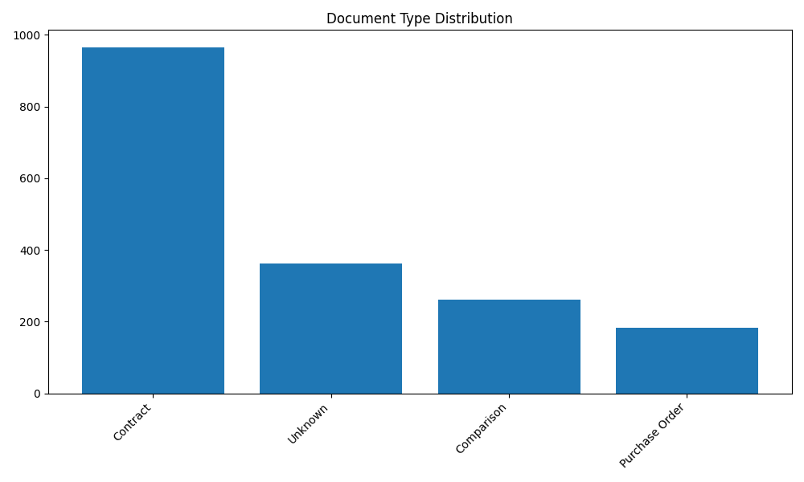

# Project Analysis

Top 10 projects by document count:

* • Bani suif power plant: 962 documents
* • Civic center: 121 documents
* • Carrefour Ismailia: 98 documents
* • Bani Suif Cement: 85 documents
* • Attaqa: 81 documents
* • CFC - Podium II: 77 documents
* • AL-ASEMA Tunnel 2: 55 documents
* • Al Jazzi Mall: 43 documents
* • Carrefour: 41 documents
* • Ain Sokhna Tunnel: 22 documents

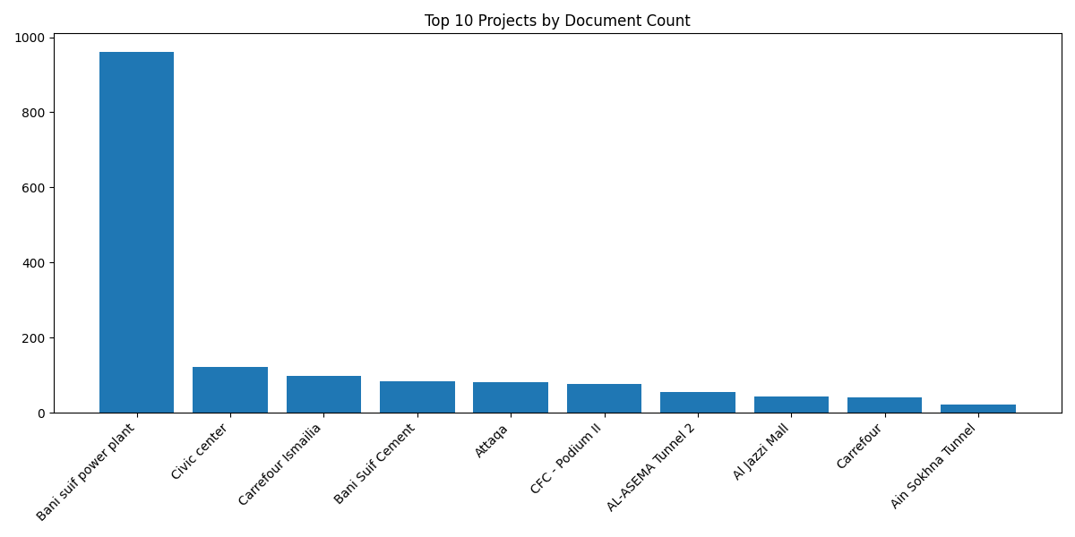

# Processing Timeline

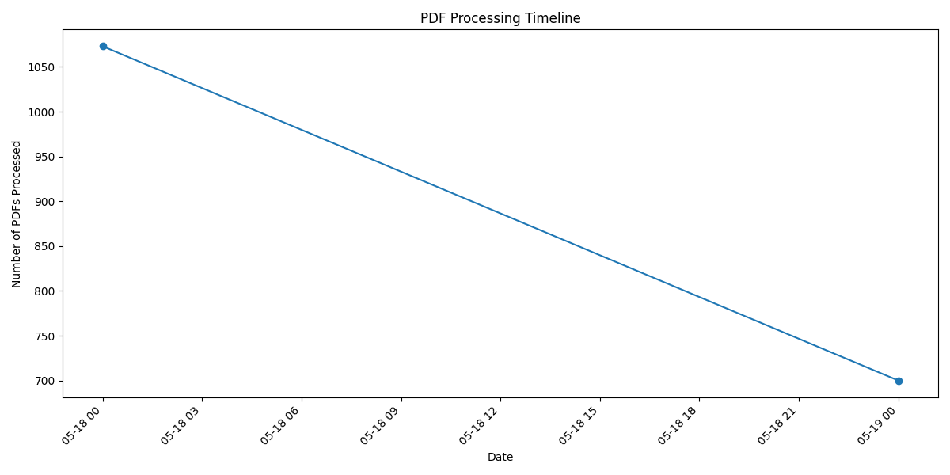

# Project-Document Type Matrix (Top 5 Projects)

#### Bani suif power plant:

* • Contract: 496 documents
* • Unknown: 313 documents
* • Comparison: 112 documents
* • Purchase Order: 41 documents

#### Civic center:

* • Contract: 107 documents
* • Comparison: 14 documents

#### Carrefour Ismailia:

* • Contract: 40 documents
* • Comparison: 33 documents
* • Purchase Order: 23 documents
* • Unknown: 2 documents

#### Bani Suif Cement:

* • Contract: 69 documents
* • Comparison: 14 documents
* • Purchase Order: 2 documents

#### Attaqa:

* • Contract: 66 documents
* • Comparison: 8 documents
* • Unknown: 4 documents
* • Purchase Order: 3 documents