PDF Extraction Report

Current Processing Directory:

* \\fileserver2\Head Office Server\Procurement (PR)\02 Projects Document

PDF Extraction Database Report

*Report generated on: 2025-05-20 16:27:02*

# Overall Statistics

Total Files in Directory: 16275 documents

Total PDFs Processed: 3580 documents

Processing Progress: 3580/16275 (22.0%)

Total Projects: 63

Total Document Types: 4

# Document Type Analysis

Distribution of document types:

* • Contract: 1874 documents
* • Comparison: 722 documents
* • Unknown: 448 documents
* • Purchase Order: 418 documents

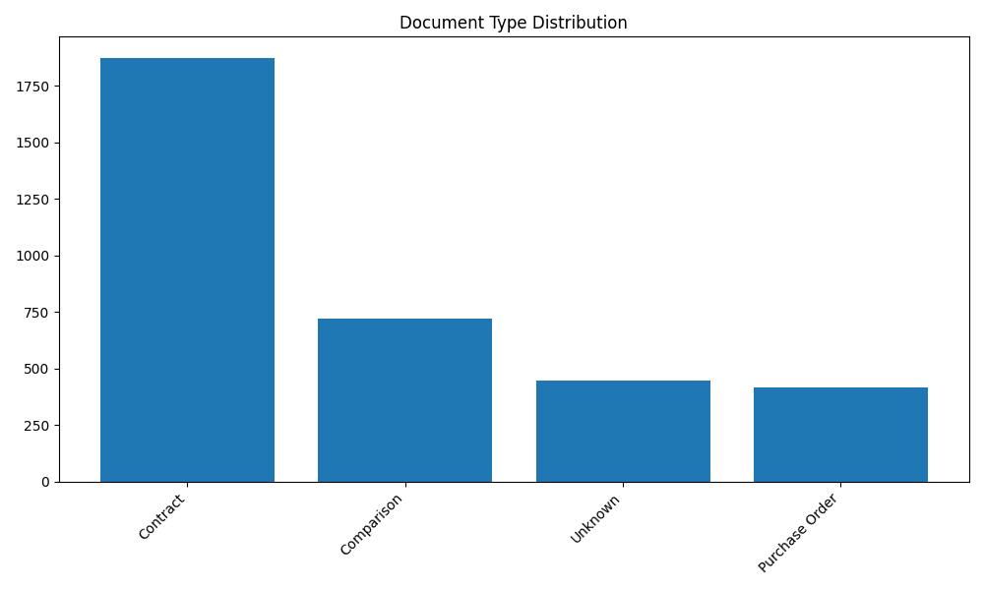

# Project Analysis

Top 10 projects by document count:

* • Bani suif power plant: 962 documents
* • Kayan 3: 203 documents
* • El Sweedy University: 142 documents
* • Civic center: 138 documents
* • El Sweedy Head Quarter CFC: 121 documents
* • El Sweedy University ( phase 2 ): 121 documents
* • El mostasmeren Substaion: 101 documents
* • Carrefour Ismailia: 98 documents
* • IKEA Mall Of Arabia: 98 documents
* • El Sweedy Stores Project on 10th of Ramadan: 88 documents

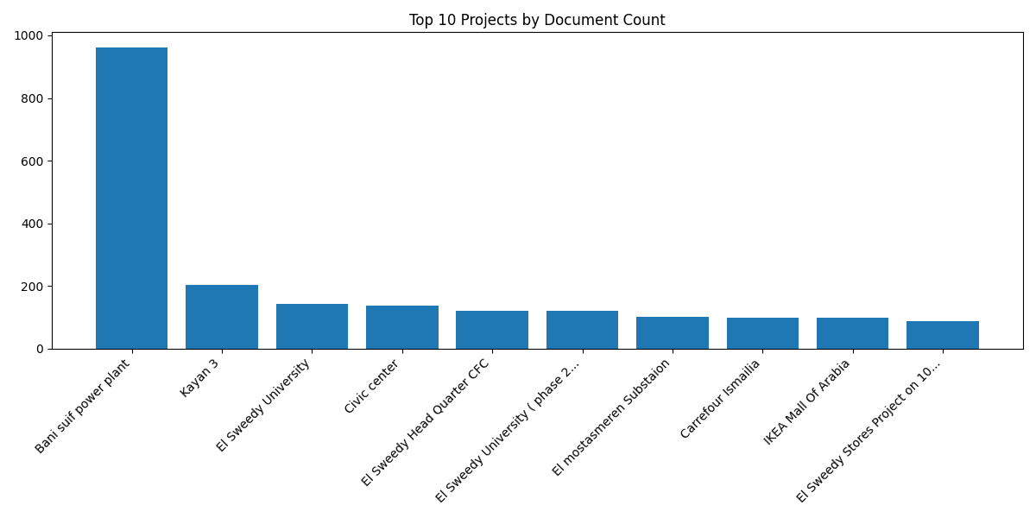

# Processing Timeline

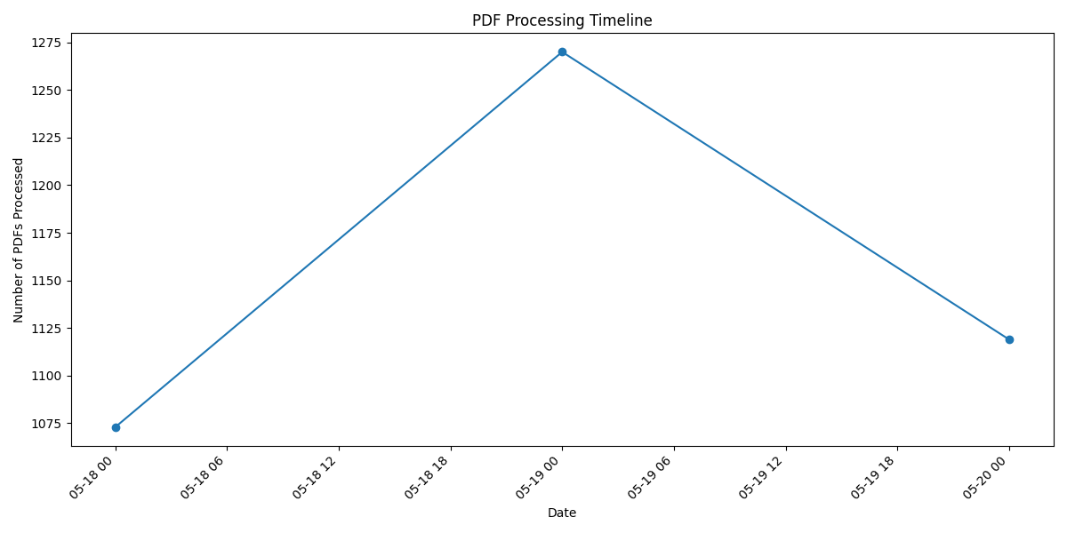

# Project-Document Type Matrix (Top 5 Projects)

#### Bani suif power plant:

* • Contract: 496 documents
* • Unknown: 313 documents
* • Comparison: 112 documents
* • Purchase Order: 41 documents

#### Kayan 3:

* • Contract: 133 documents
* • Comparison: 70 documents

#### El Sweedy University:

* • Contract: 65 documents
* • Comparison: 53 documents
* • Purchase Order: 24 documents

#### Civic center:

* • Contract: 115 documents
* • Comparison: 14 documents
* • Unknown: 6 documents
* • Purchase Order: 3 documents

#### El Sweedy University ( phase 2 ):

* • Contract: 69 documents
* • Purchase Order: 28 documents
* • Comparison: 24 documents