PDF Extraction Report

Current Processing Directory:

* \\fileserver2\Head Office Server\Procurement (PR)\02 Projects Document

PDF Extraction Database Report

*Report generated on: 2025-05-25 12:04:21*

# Overall Statistics

Total Files in Directory: 16275 documents

Total PDFs Processed: 10845 documents

Processing Progress: 10845/16275 (66.6%)

Total Projects: 148

Total Document Types: 4

# Document Type Analysis

Distribution of document types:

* • Contract: 5516 documents
* • Unknown: 2136 documents
* • Comparison: 1904 documents
* • Purchase Order: 1289 documents

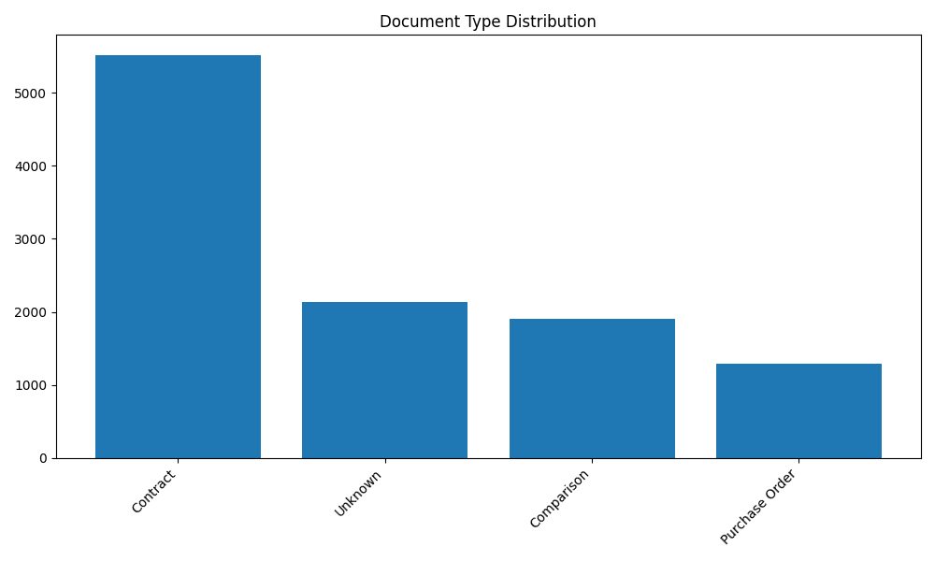

# Project Analysis

Top 10 projects by document count:

* • Unknown: 1536 documents
* • Bani suif power plant: 962 documents
* • Ministerial Building: 749 documents
* • Kayan 3: 525 documents
* • Olymbic Sports Hall: 353 documents
* • Sodic East: 321 documents
* • New Giza Hospital: 289 documents
* • Waldorf Astoria Mock Up Room Hotel: 271 documents
* • PKG 53&54: 208 documents
* • Royal City: 198 documents

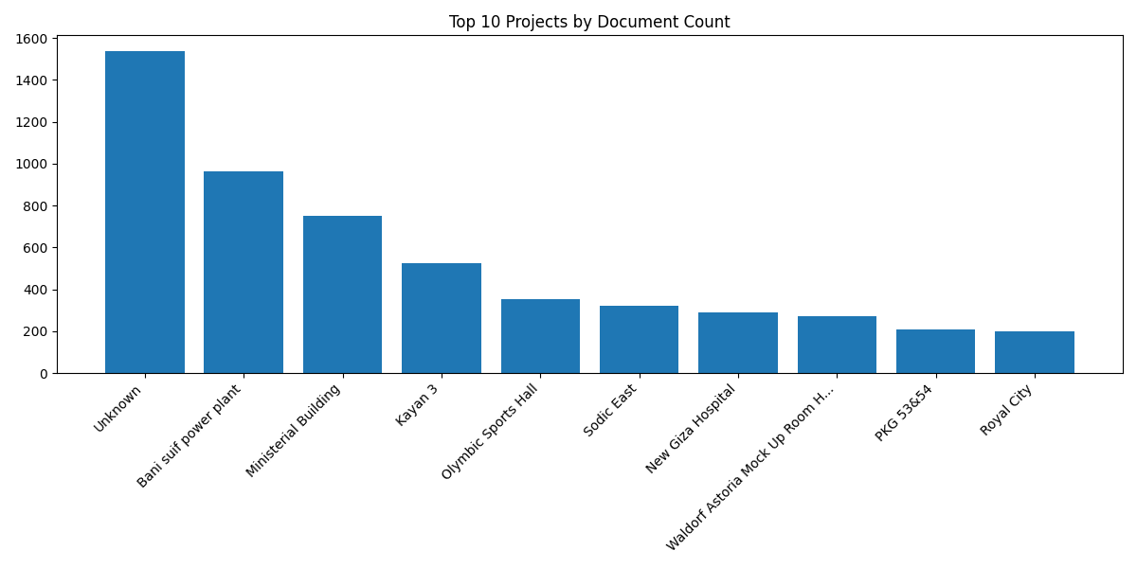

# Processing Timeline

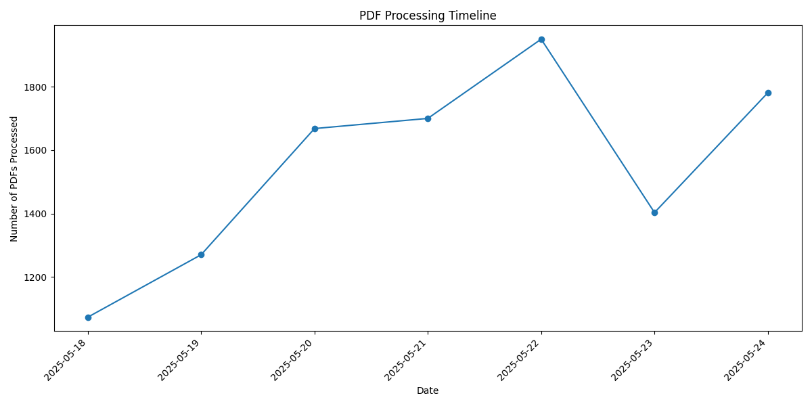

# Project-Document Type Matrix (Top 5 Projects)

#### Unknown:

* • Unknown: 1536 documents

#### Bani suif power plant:

* • Contract: 496 documents
* • Unknown: 313 documents
* • Comparison: 112 documents
* • Purchase Order: 41 documents

#### Ministerial Building:

* • Contract: 501 documents
* • Comparison: 157 documents
* • Purchase Order: 90 documents
* • Unknown: 1 documents

#### Kayan 3:

* • Contract: 405 documents
* • Comparison: 70 documents
* • Purchase Order: 50 documents

#### Olymbic Sports Hall:

* • Contract: 244 documents
* • Comparison: 68 documents
* • Purchase Order: 41 documents