PDF Extraction Report

Current Processing Directory:

* \\fileserver2\Head Office Server\Procurement (PR)\02 Projects Document

PDF Extraction Database Report

*Report generated on: 2025-05-22 13:18:09*

# Overall Statistics

Total Files in Directory: 16293 documents

Total PDFs Processed: 6874 documents

Processing Progress: 6874/16293 (42.2%)

Total Projects: 114

Total Document Types: 4

# Document Type Analysis

Distribution of document types:

* • Contract: 4096 documents
* • Comparison: 1362 documents
* • Purchase Order: 929 documents
* • Unknown: 487 documents

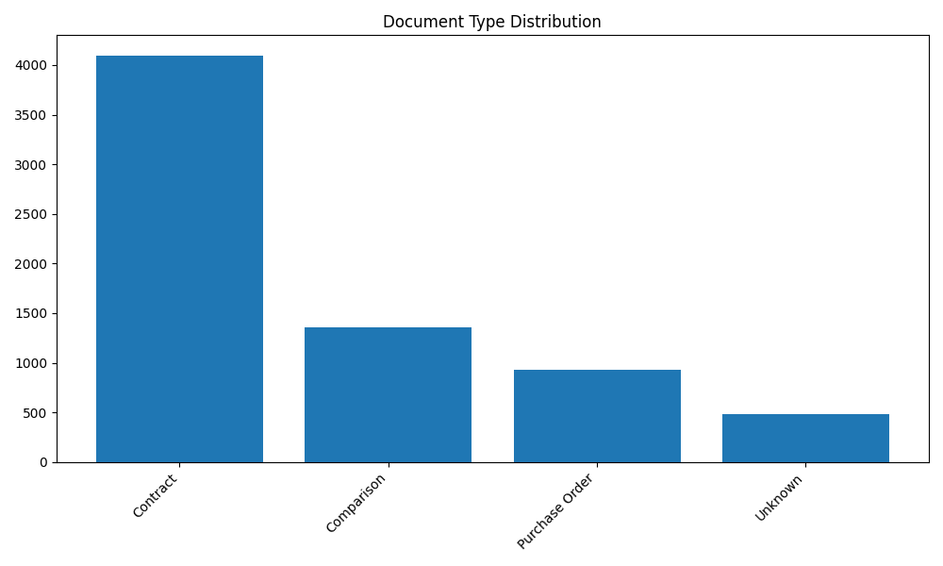

# Project Analysis

Top 10 projects by document count:

* • Bani suif power plant: 962 documents
* • Ministerial Building: 749 documents
* • Kayan 3: 525 documents
* • Olymbic Sports Hall: 353 documents
* • New Giza Hospital: 289 documents
* • Marassi Marina Promenade ( PKG 177 ): 188 documents
* • New Giza phase 2: 185 documents
* • Maxim: 172 documents
* • Marassi PKG 144: 168 documents
* • El Sweedy University: 142 documents

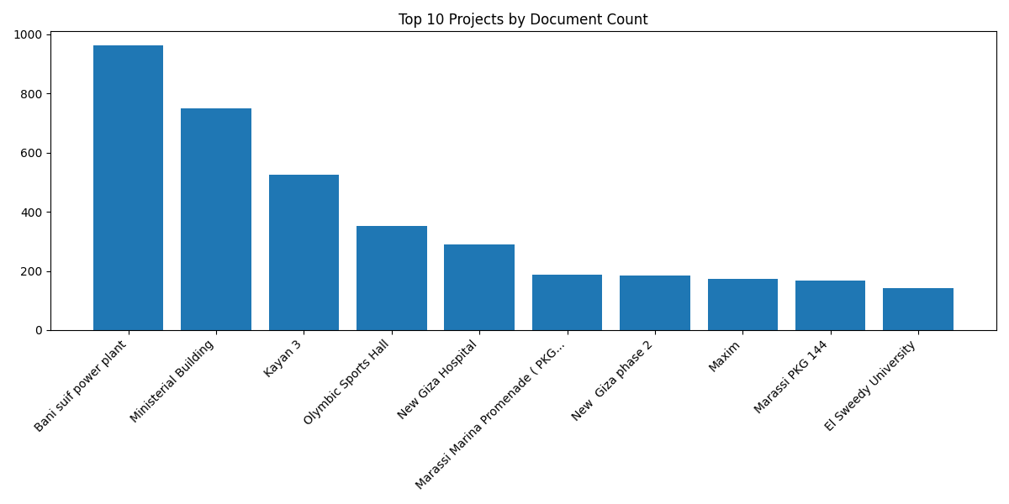

# Processing Timeline

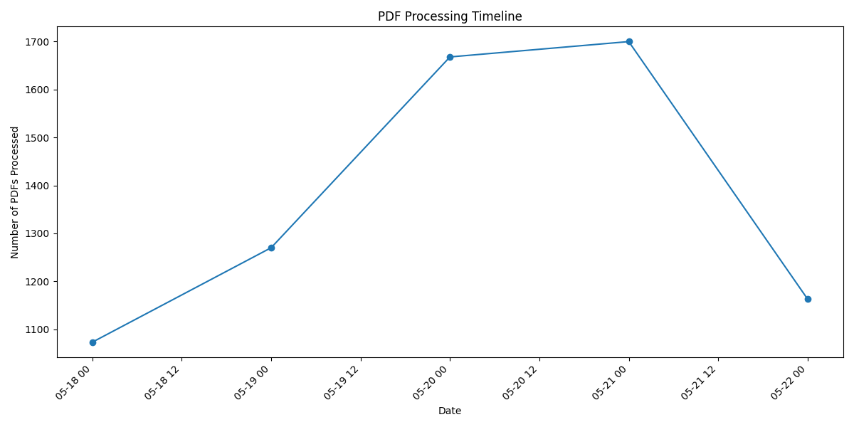

# Project-Document Type Matrix (Top 5 Projects)

#### Bani suif power plant:

* • Contract: 496 documents
* • Unknown: 313 documents
* • Comparison: 112 documents
* • Purchase Order: 41 documents

#### Ministerial Building:

* • Contract: 501 documents
* • Comparison: 157 documents
* • Purchase Order: 90 documents
* • Unknown: 1 documents

#### Kayan 3:

* • Contract: 405 documents
* • Comparison: 70 documents
* • Purchase Order: 50 documents

#### Olymbic Sports Hall:

* • Contract: 244 documents
* • Comparison: 68 documents
* • Purchase Order: 41 documents

#### New Giza Hospital:

* • Contract: 148 documents
* • Comparison: 82 documents
* • Purchase Order: 59 documents