Convert multiple corrupt XLS files to XLSX | Python in Finance #5



Edward Jones
·
Follow
Published in

Geek Culture

·
2 min read
·
May 27, 2021

5
2

In this article you will learn how to convert a batch of corrupt XLS files to an XLSX file.
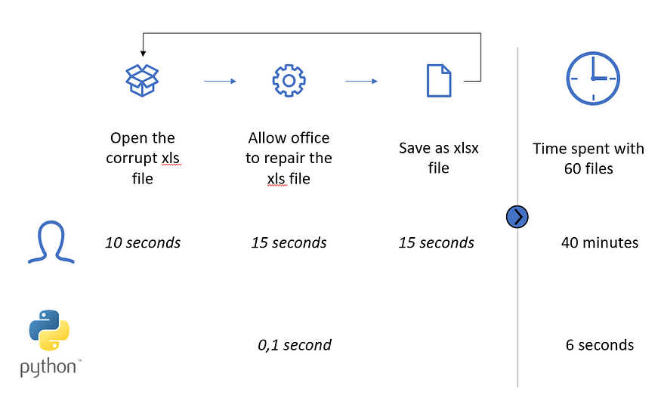
Trade-off of automating this process
In this article, you will learn how to automate the conversion process from (corrupt) xls files to normal xlsx files.
Data can be found: here
Packages
- pywin32: This package is basically vba for python. It allows us to interact and automate Windows applications with python.
- os: This package allows us to use the operating system.
- glob: This package allows us to create a list with the different file locations
import win32com.client
import os
import glob
Initialization
- You initialize the win32com and let it run an excel application.
- Set the object “o.Visible = False” in order to hide the excel application you have created.
- Set the input directory: This is the directory where all your corrupt xls files are located.
- Set the output directory: This is the directory where you want to store the converted xlsx files.
- Create a list of file paths of the all the files in the input directory by using the glob.glob function
o = win32com.client.Dispatch("Excel.Application")
o.Visible = Falseinput_dir = r"C:\input_directory"
output_dir = r"C:\output_directory"
files = glob.glob(input_dir + "/*.xls")
Loop
For each file, you perform the following manipulations:
- Assign the filename to the object “file”
- Set the ouput filename by concatenating the output directory and the output filename replacing the xls extension with the xlsx extension.
- Open the xls files by the excel application
- Save the xls file as an xlsx file using the output path as previously specified
- Close the file

for filename in files:
file = os.path.basename(filename)
output = output_dir + '/' + file.replace('.XLS','.xlsx')
wb = o.Workbooks.Open(filename)
wb.ActiveSheet.SaveAs(output,51)
wb.Close(True)
Using these bits of code, you just quickly automated a task that would cost you normally 40 minutes.
Happy programming!
Cheers,
Ewoud

