Path Planning Assignment
Solution Documentation
Omar Ahmed El-Gharably

1. Overview
The planner receives the car pose (x, y, yaw) and a small set of cones. Blue cones (color 1) mark the left edge of the track and yellow cones (color 0) mark the right edge. It returns a list of (x, y) points in world coordinates that the car can follow between the two edges.
The solution is implemented in src/path_planning.py inside PathPlanning.generatePath(). It uses only the Python standard library (math). The same algorithm runs on every scenario; nothing is tuned for a specific test case.
The idea in one sentence: find points on the centre line of the track, then draw a smooth spline from the car through those points that starts in the direction the car is already moving.

2. How to Run
Create a virtual environment, install the requirements, and run a scenario:
python3 -m venv .venv
source .venv/bin/activate
pip install -r requirements.txt
python -m src.run --scenario 21
Scenarios 1 to 20 are the provided ones. Scenarios 21 to 24 were added for Part 2.

3. Assumptions
- Car heading is the initial velocity. The red arrow is the direction the car is already moving, so the path must leave the car along that arrow and turn smoothly. It cannot jump straight to a target.
- Missing cones are mirrored. When a cone has no partner on the other side of the track, a virtual partner is placed one track width across from it.
- Track width. Measured as the average distance between real blue/yellow pairs. If there are no pairs, a default of 3 m is used (the minimum track width in the Formula Student rules).
- Cone order. Cones are processed from nearest to farthest from the car, which is the order the car would reach them.
- Path length. The path is extended to at least 6 m and cut at 10 m, with a point every 0.25 m, which satisfies the 5 to 10 m length and 0.5 m maximum step requirements.
- No cones. If no cones are visible, the only information is the car heading, so the path continues straight ahead.

4. Part 1: Centre-Line Spline

4.1 Algorithm steps
- Sort the cones. Split the cones into blue and yellow and sort each list by distance from the car.
- Pair the cones. Pair the nearest blue cone with the nearest yellow cone, the second with the second, and so on.
- Mirror missing cones. A cone without a partner gets a virtual cone one track width across the track. The direction across the track is perpendicular to the line through the cones on that side, or perpendicular to the car heading if that side only has one cone.
- Find centre points. Each pair (real or mirrored) gives one target point at its midpoint. The track direction at that point is perpendicular to the line from the yellow cone to the blue cone.
- Set the directions. The first point is the car itself, with the car heading as its direction. Every other point takes the direction from its previous neighbour to its next neighbour, which keeps the curve smooth. Points closer than 0.5 m to the previous one are dropped.
- Draw the spline. A cubic Hermite spline is drawn through the points. Unlike a straight line or a plain Catmull-Rom spline, a Hermite spline lets us fix the direction at every point, so the path is guaranteed to start along the car's velocity.
- Extend and resample. The path is continued straight in the last direction until it is at least 6 m long, then resampled to evenly spaced points every 0.25 m and cut at 10 m.

4.2 How each case is handled
Cones visible | Centre points
Blue and yellow | Midpoint of each blue/yellow pair
Blue only | Each blue cone is mirrored to the right; midpoint with its mirror
Yellow only | Each yellow cone is mirrored to the left; midpoint with its mirror
Unequal counts (e.g. 2 blue, 1 yellow) | Pairs are used where they exist; extra cones are mirrored
None | No centre points; the path follows the car heading

4.3 Why this approach
- It follows the author's note to keep things simple: around 200 lines with no external libraries.
- Midpoints between the two edges are the most natural definition of "staying between the cones".
- Mirroring handles every missing-cone case with one rule, instead of special code per scenario.
- The Hermite spline respects the car's initial velocity, so the car never has to turn on the spot.

5. Part 2: Three Cones on One Side

5.1 Approach
Three points define a circle, so three cones on one side tell us not only where the track edge is, but also how much it curves. This is used when one side has three or more cones and the other side has fewer.
- Fit a circle through the three nearest cones on that side (the circumscribed circle).
- Find the turn direction. If the cones go counter-clockwise around the circle centre, the track turns left; otherwise it turns right.
- Mirror the edge. The mirrored edge is a circle with the same centre, one track width closer to or farther from the centre. Blue on a left turn (or yellow on a right turn) is the inner edge, so its mirror is farther out; otherwise the mirror is closer in.
- Take the middle arc. The centre line is the arc halfway between the real and mirrored edges. Points are placed every 1 m along it, each with the arc tangent as its direction.
- Join from the car. The same Hermite spline as Part 1 connects the car, starting along its heading, to the arc.
If the three cones are in a straight line, no circle exists and the planner falls back to the Part 1 mirroring rule. If the other side has a few cones, their distance to the circle is used as the track width.

5.2 Why this approach
- With three cones the curvature of the track is known, so an arc predicts the track ahead better than straight lines between midpoints.
- A circle through three points has a closed-form solution, so it stays simple and fast.
- Mirroring keeps the idea consistent with Part 1: build the missing edge, then drive in the middle.

5.3 Limitations
- It assumes the curvature is constant, so S-bends or turns that tighten or open up are not modelled.
- The circle fit is sensitive to errors in cone positions, especially when the cones are close together.
- Continuing the arc past the last cone is a prediction, not something the cones confirm.
- It depends on the assumed track width when the other side has no cones.

5.4 New test scenarios
Scenario | Setup | What it tests
21 | 3 blue cones, car heading +x | Left turn, blue is the inner edge
22 | 3 yellow cones, car heading +y | Right turn, yellow is the inner edge
23 | 3 yellow cones, car heading +x | Left turn, yellow is the outer edge
24 | 3 blue cones in a straight line | Collinear cones, falls back to mirroring

6. Limitations of the Overall Solution
- Pairing by distance order can pair the wrong cones when the two sides are very uneven.
- When the car heading points away from the track (scenario 14) or across it (scenarios 12 and 13), the path has to make a tight turn that a real car may not manage.
- Curvature limits of the car are not checked.
- Only the cones given in one frame are used; there is no memory of earlier cones.
Possible improvements: Delaunay triangulation for pairing when more cones are visible (the usual Formula Student approach), a curvature check against the car's minimum turning radius, and smoothing the path over time as new cones appear.

7. Code Structure
Function | Purpose
generatePath | Runs the whole pipeline and returns the path
pair_waypoints | Pairs cones, mirrors missing ones, returns centre points with directions
arc_waypoints | Part 2: fits a circle, mirrors it, returns points on the middle arc
track_width | Average width of real blue/yellow pairs, or the 3 m default
side_direction | Direction along one side of the track, used for mirroring
circle_through | Circle through three points
drop_close_waypoints | Removes points closer than 0.5 m to the previous one
follow_neighbours | Points each target toward its neighbours for a smooth curve
hermite_spline | Cubic Hermite spline through points with fixed directions
extend_straight | Extends the path to the minimum length
resample | Evenly spaced points every 0.25 m, cut at 10 m

8. Results
Planned paths for all 24 scenarios. Blue and yellow dots are cones, the red arrow is the car heading, and the green line is the planned path. Scenarios 21 to 24 are the Part 2 cases.
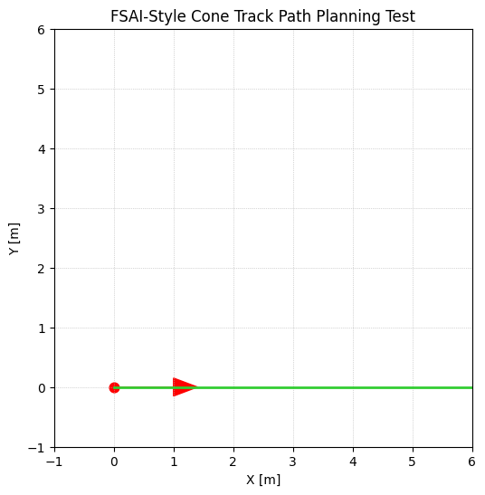  Scenario 1 | 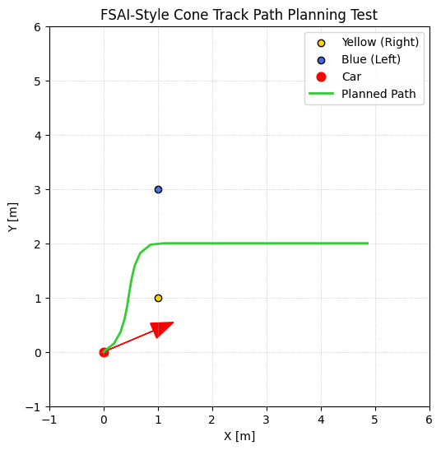  Scenario 2 | 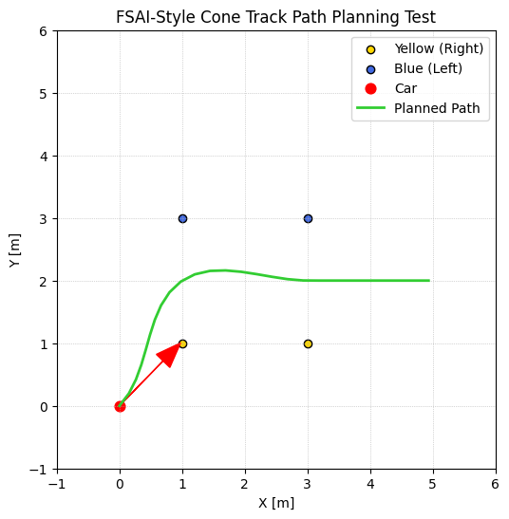  Scenario 3
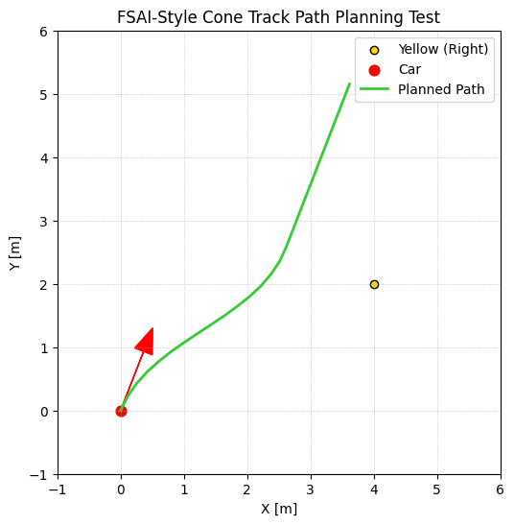  Scenario 4 | 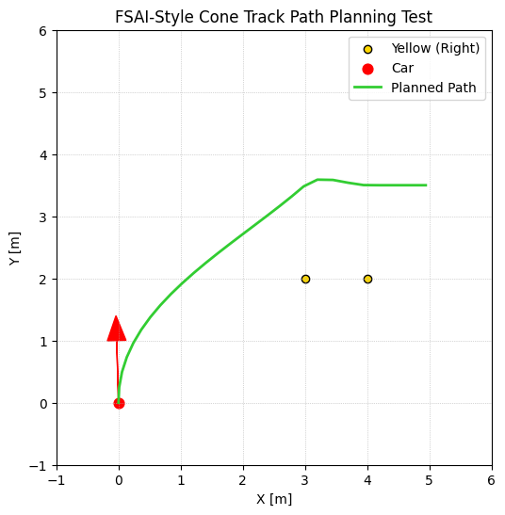  Scenario 5 | 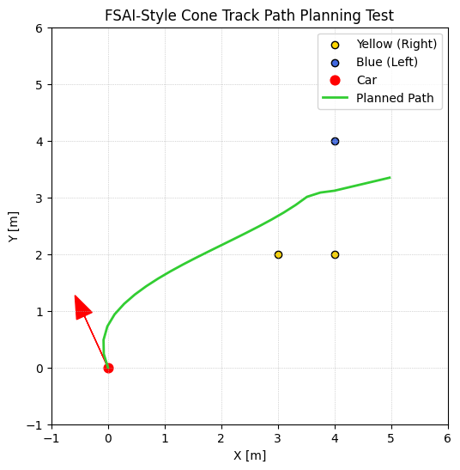  Scenario 6
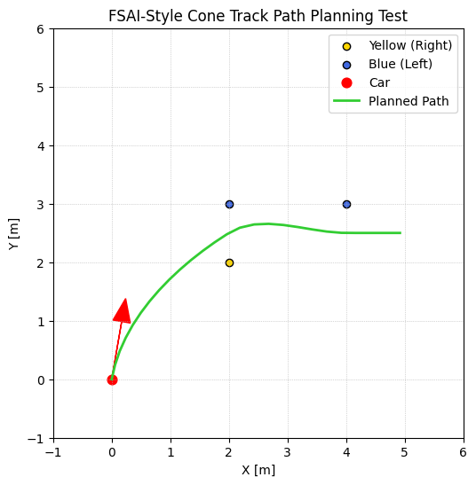  Scenario 7 | 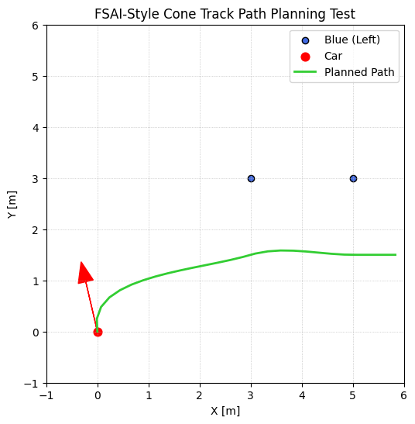  Scenario 8 | 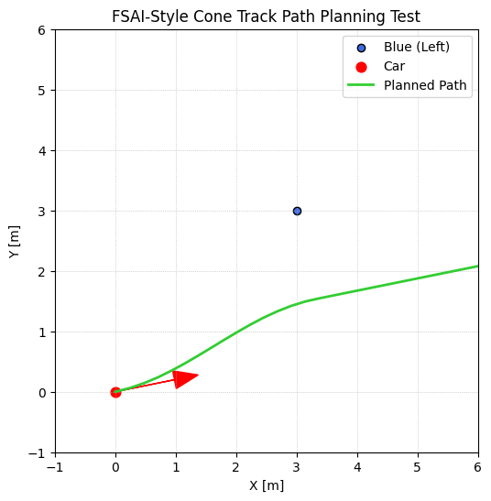  Scenario 9
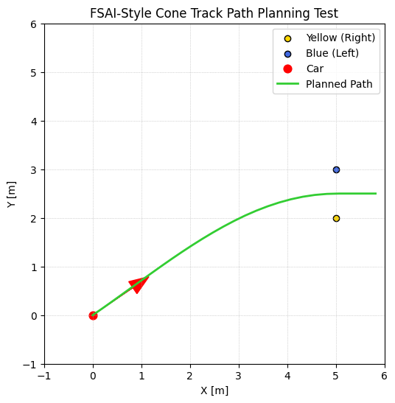  Scenario 10 | 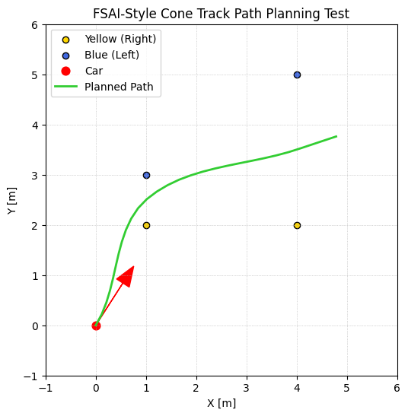  Scenario 11 | 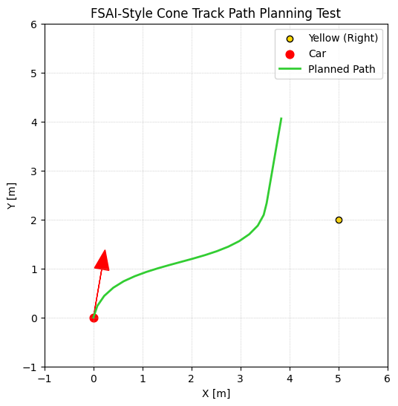  Scenario 12
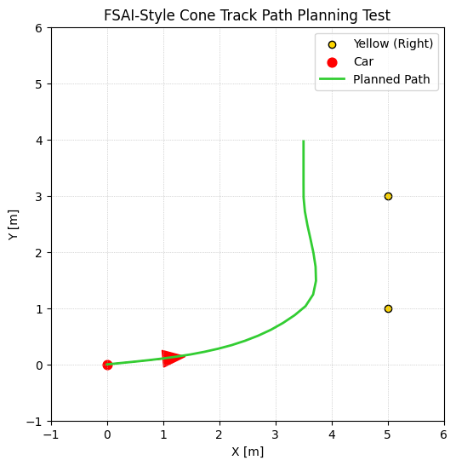  Scenario 13 | 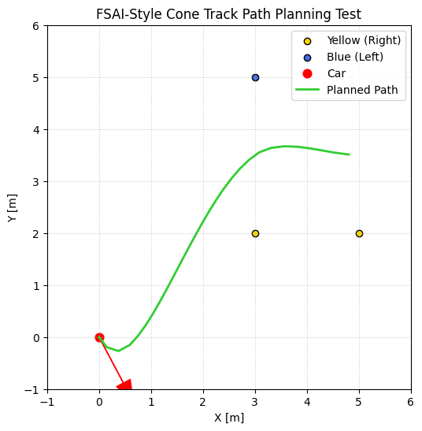  Scenario 14 | 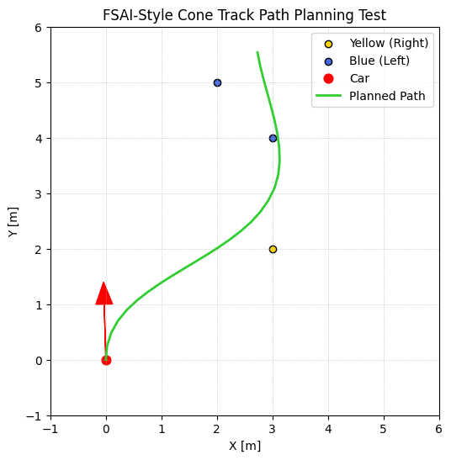  Scenario 15
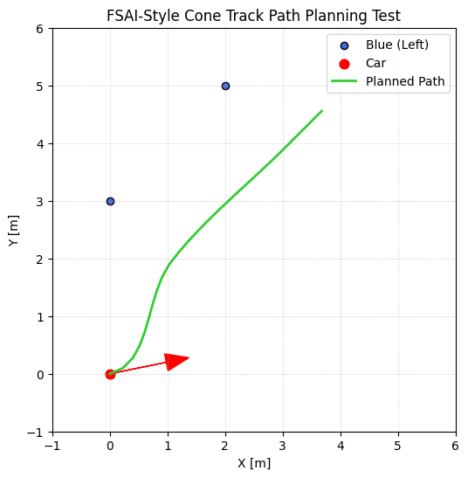  Scenario 16 | 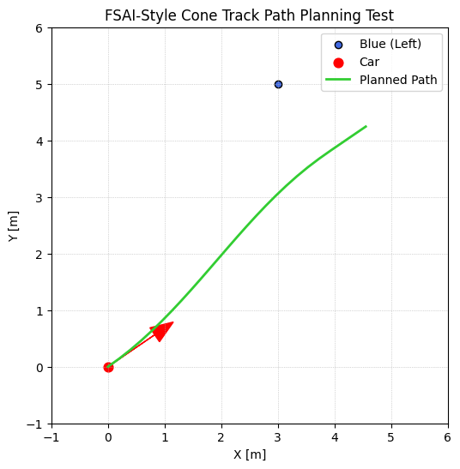  Scenario 17 | 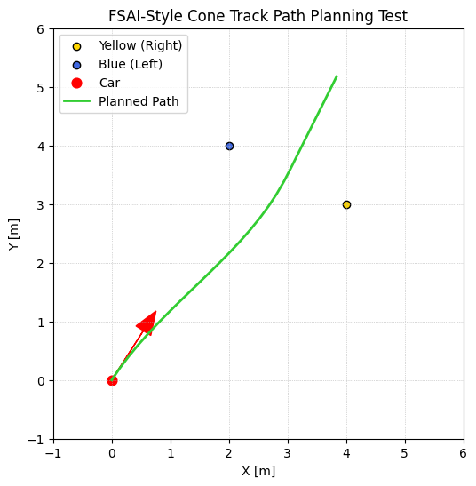  Scenario 18
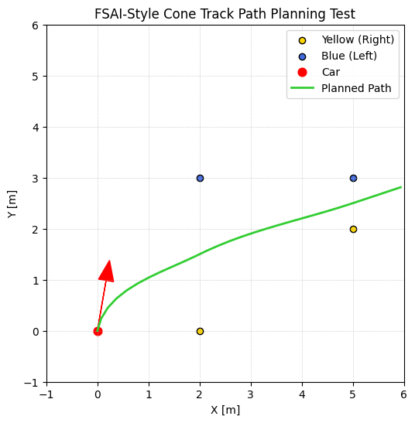  Scenario 19 | 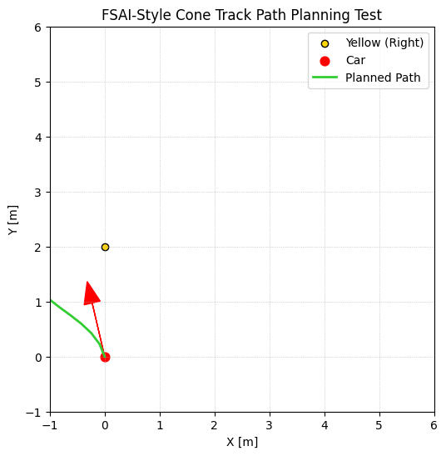  Scenario 20 | 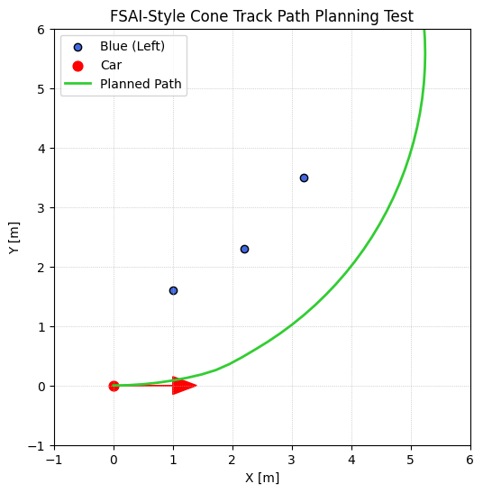  Scenario 21
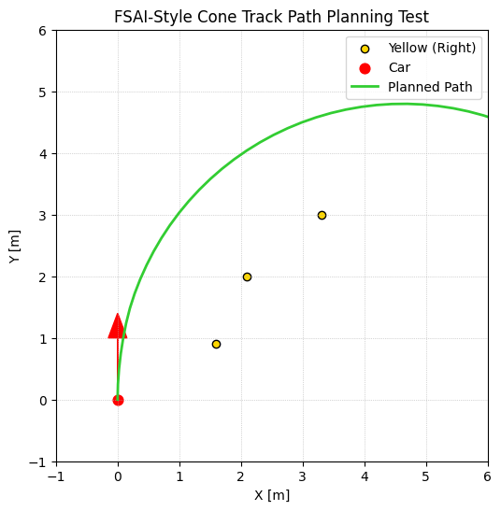  Scenario 22 | 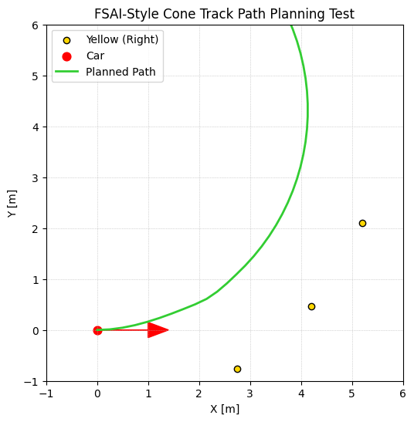  Scenario 23 | 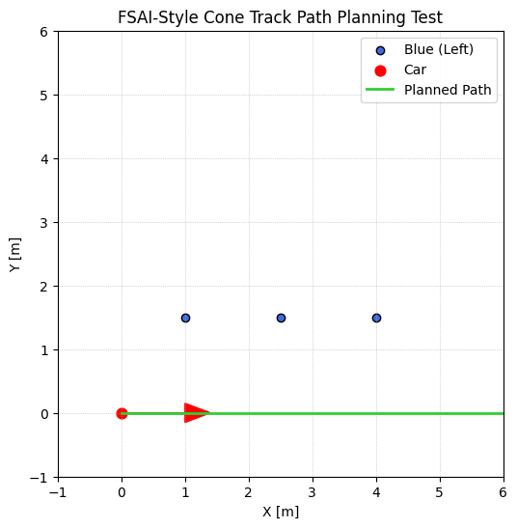  Scenario 24

