Project Planning

The goal of this project is to analyze retail supply chain sales, understand key business drivers, identify trends, and build a predictive model to forecast future sales. The project also includes building an interactive Power BI dashboard to support data-driven decision-making.
- Project Objectives
- Clean and prepare the dataset
- Perform exploratory data analysis (EDA)
- Design a star-schema database model
- Build a professional Power BI dashboard
- Create a machine learning model to predict future sales

- Scope
- Sales trends
- Customer segmentation
- Regional performance
- Profitability analysis
- Forecasting future sales

  - Tools & Technologies
- BI Platform: Microsoft Power BI
- Data Processing: Power Query, DAX
- Machine Learning: Python (Scikit-learn, Pandas)
- Database Design: Star Schema Methodology
- Documentation: Microsoft Word

Stakeholder Analysis

As illustrated in the following table:
Stakeholder | Interest | How They Use Dashboard
Sales Manager | Wants to boost sales | Overview KPIs, product performance
Inventory/Operations | Needs accurate forecast | Demand predictions, stock planning
Executives | Strategic insights | Profitability, top regions
Finance Team | Budget planning | Trends, YoY growth
Marketing | Promotion analysis | Discount impact on profit

- Database Source & Design
3.1- Dataset Details
- Source: Retail Supply Chain Sales Dataset
- Records: 10000 sales transactions
- Time Period: 2014-2017 (historical), 2018 (forecast)
- Key Tables: Sales transactions, customer data, product catalog
3.2- Star Schema Design
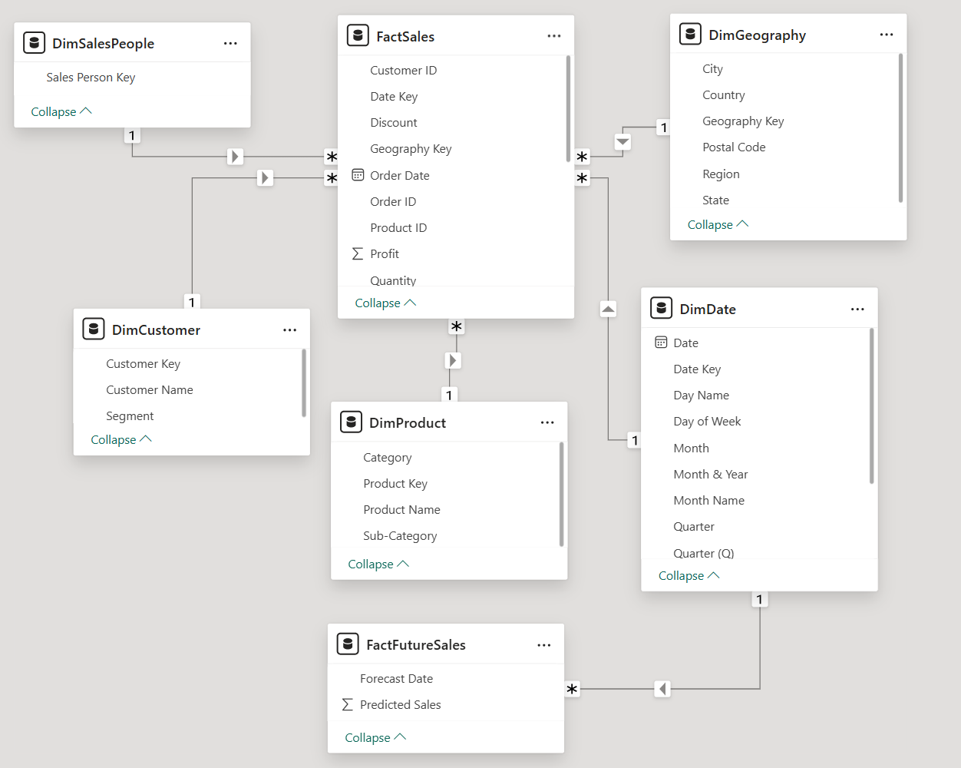

- Machine Learning Implementation
4.1- Model Performance
Model Evaluation Metrics:
- Algorithm: Random Forest
- Forecast Horizon: 12 months (2018)

4.3- Model Training & Validation
Validation Approach:
- Training Period: All data except for the last 12 months
- Testing Period: Most recent 12 months
- Methodology: Walk-forward validation simulating real-world forecasting
4.4- Matplotlib Chart
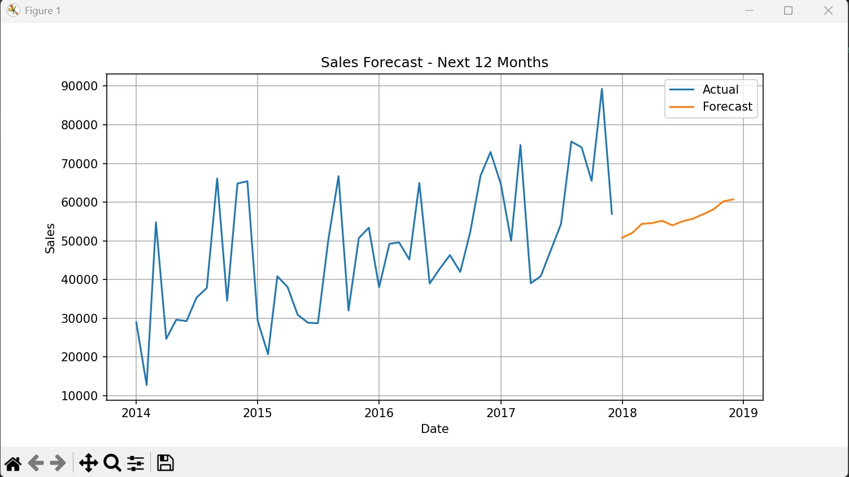
- UI/UX Design

5.1- Power BI Dashboard Layout
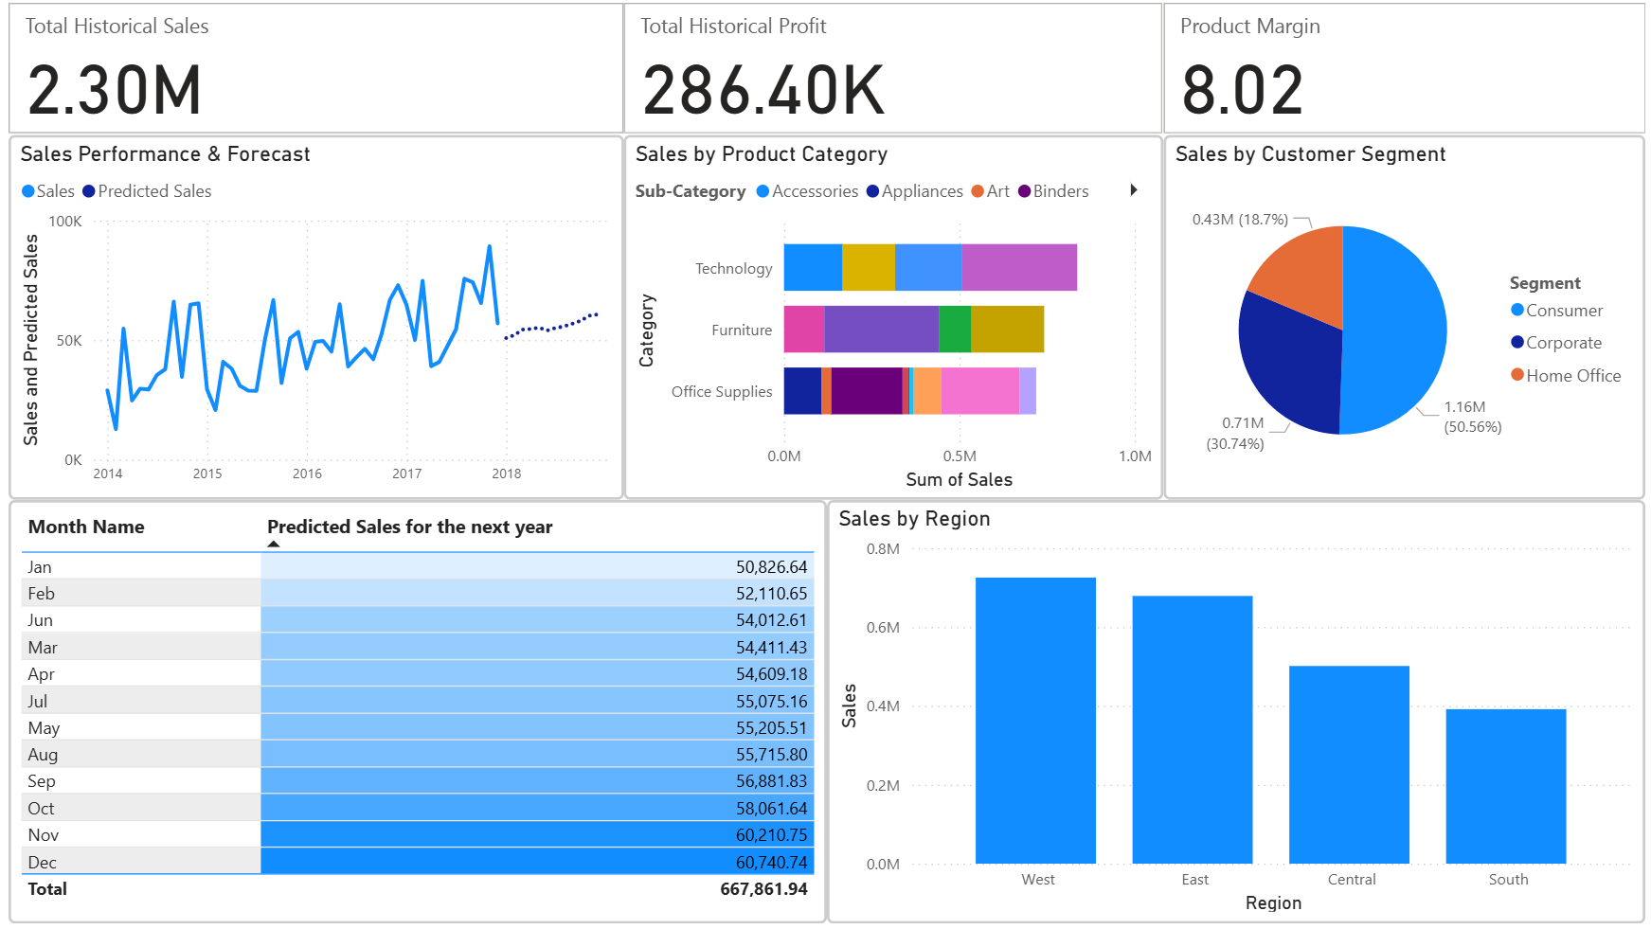

5.2- Visual Components
- KPI Cards: Total Sales, Profit, Margin
- Sales Trend: Historical + Forecast
- Product Analysis: Category performance
- Customer Insights: Segmentation analysis
- Regional View: Geographic performance
- Forecast Details: Monthly predictions

