8-Puzzle Solver
Project Report

Course
Reasoning and Agents

Team Members
# | Team Member Name | Student ID
1 | Omar Elsayed Ibrahim Aly | 2022170827
2 | Amr Hossam Aly Sayed | 2022170830
3 | Farah Ibrahim
4 | Abdelrhman Mahmoud Abdo | 2022170846

1. Project Overview
The 8-Puzzle Solver is an Artificial Intelligence project developed as part of the RA'26 curriculum. The project implements and compares multiple AI search algorithms applied to the classic 8-puzzle sliding tile problem. A comprehensive graphical user interface (GUI) was built using Streamlit, enabling interactive visualization of algorithm behavior and heuristic performance.

1.1 What Is the 8-Puzzle?
The 8-puzzle is a sliding puzzle consisting of a 3×3 grid containing tiles numbered 1 through 8 and one blank space (represented internally as 0). The objective is to slide tiles into the blank space until the grid reaches a defined goal configuration. It is a classic benchmark problem in AI research used to evaluate and compare search strategy effectiveness.

Start State: [1, 2, 3, 4, 0, 6, 7, 5, 8] → Goal State: [1, 2, 3, 4, 5, 6, 7, 8, 0] The blank tile (0) is in the center of the Start State. The challenge is to find the shortest or most cost-efficient sequence of moves to reach the Goal State.

1.2 Project Goals
- Implement 5 search algorithms: A*, UCS, Greedy Best-First, BFS, and DFS.
- Implement 3 admissible heuristic functions: Misplaced Tiles (h1), Manhattan Distance (h2), and Linear Conflict (h3).
- Prove the dominance chain: h3 >= h2 >= h1 >= 0.
- Build an interactive Streamlit GUI with real-time heuristic visualization.
- Compare algorithm performance in terms of optimality, completeness, and speed.

2. State Representation & Data Structures
The project uses a flat Python list of 9 integers to represent the 3×3 puzzle grid, read left-to-right and top-to-bottom. This design choice simplifies comparison, copying, and storage operations.

# Positions in the flat list:
# Index: 0 1 2
# 3 4 5
# 6 7 8

GOAL = [1, 2, 3, 4, 5, 6, 7, 8, 0] # 0 = blank tile
START = [1, 2, 3, 4, 0, 6, 7, 5, 8] # blank at center (index 4)

2.1 The Node Class
Each position in the search space is represented by a Node object. The Node stores all information required to evaluate, compare, and reconstruct the solution path.

class Node:
def __init__(self, value):
self.state = value # 9-element list (current grid)
self.parentstate = None # pointer to parent Node
self.action = None # 'Up', 'Down', 'Left', 'Right'
self.edgeCost = 0 # cost of this move (always 1)
self.gOfN = 0 # g(n): total cost from start
self.hOfN = 0 # h(n): heuristic estimate to goal

2.2 Move Generation — get_successors()
The get_successors() function identifies all valid moves from a given state by locating the blank tile, computing its row and column position, and attempting moves in all four cardinal directions. Each valid move generates a new state with the blank and adjacent tile swapped.

Important: Action names describe the TILE's movement direction, not the blank's. For example, if the blank swaps upward with a tile above it, that tile moves DOWN — so the action is labelled 'Down'.

3. Search Algorithms
All five algorithms share a unified search loop. The only difference between them is how they select the next node to expand — this is determined by the priority function f(n). A min-heap (Python's heapq) is used for informed searches, while BFS uses a FIFO queue and DFS uses a LIFO stack.

Algorithm | f(n) | Optimal? | Complete? | Speed | Use When
A* | g(n) + h(n) | Yes | Yes | Fast | Best overall
UCS | g(n) | Yes | Yes | Slow | No heuristic
Greedy | h(n) | No | Not always | Fastest | Speed over quality
BFS | — | Yes (unit) | Yes | Slow | Simple, guaranteed
DFS | — | No | Not always | Varies | Low memory

3.1 A* Search — f(n) = g(n) + h(n)
A* is the primary algorithm of the project. It balances the actual cost to reach a node g(n) with the estimated cost remaining to the goal h(n). By combining both, A* prefers paths that are both cheap so far and look promising ahead. When paired with an admissible heuristic, A* is guaranteed to find the optimal solution while exploring the fewest nodes.

# A* priority: g(n) + h(n)
f = next_node.gOfN + next_node.hOfN

3.2 UCS — Uniform Cost Search — f(n) = g(n)
UCS ignores the heuristic entirely and expands nodes in order of their actual path cost from the start. It is essentially Dijkstra's algorithm and always finds the optimal solution. However, since every move in the 8-puzzle costs 1, UCS behaves similarly to BFS but with higher memory usage.

# UCS priority: g(n) only
f = next_node.gOfN

3.3 Greedy Best-First Search — f(n) = h(n)
Greedy search uses only the heuristic estimate, ignoring the path cost incurred so far. This makes it the fastest algorithm in terms of nodes expanded, but it does not guarantee optimality and may get stuck or find suboptimal solutions. It is useful when speed is prioritized over solution quality.

# Greedy priority: h(n) only
f = next_node.hOfN

3.4 BFS — Breadth-First Search
BFS explores all nodes at the current depth level before moving deeper. It is guaranteed to find the optimal solution when all step costs are equal (as in the 8-puzzle). A standard FIFO queue (pop from front) is used. BFS is complete but can be slow and memory-intensive for deeper solutions.

3.5 DFS — Depth-First Search
DFS explores as deep as possible along each branch before backtracking. It uses a LIFO stack (pop from back). DFS uses much less memory than BFS but is neither optimal nor guaranteed to find a solution in graphs with cycles unless explored states are tracked.

3.6 Path Reconstruction
When the goal state is reached, the solution path is reconstructed by following the parentstate pointers backward from the goal node to the start node, then reversing the resulting list.

curr = goal_node
while curr:
path_actions.append(curr.action) # e.g., 'Down', 'Right'
path_states.append(curr.state) # full grid at each step
curr = curr.parentstate # traverse to parent
# Reverse both lists (traced backward from goal to start)

4. Heuristic Functions
A heuristic function h(n) estimates the remaining cost from a given state to the goal. For A* to guarantee optimality, the heuristic must be admissible — it must never overestimate the true cost. The project implements three increasingly powerful admissible heuristics.

Heuristic | Formula | Admissible? | Strength | Notes
h1 — Misplaced Tiles | Count of tiles not in goal | Yes | Weakest | Simple, fast to compute
h2 — Manhattan Distance | Sum of row+col distances | Yes | Moderate | Better lower bound than h1
h3 — Linear Conflict | Manhattan + conflict penalty | Yes | Strongest | Detects ordering conflicts

4.1 h1 — Misplaced Tiles
h1 counts the number of tiles that are not in their goal position (the blank tile is excluded). It is the simplest heuristic to compute and is always admissible because every misplaced tile needs at least one move.

def h1_misplaced(state, goal):
return sum(1 for i in range(9)
if state[i] != 0 and state[i] != goal[i])

4.2 h2 — Manhattan Distance
h2 sums the Manhattan (city-block) distances of each tile from its current position to its goal position. Manhattan distance is always admissible because tiles cannot move diagonally and each move only reduces the distance by 1. It is a tighter lower bound than h1 because it measures exact distances rather than just misplacement.

def h2_manhattan(state, goal):
total = 0
for i, tile in enumerate(state):
if tile != 0:
goal_idx = goal.index(tile)
total += abs(i // 3 - goal_idx // 3) \
+ abs(i % 3 - goal_idx % 3)
return total

4.3 h3 — Linear Conflict
h3 extends Manhattan distance by adding a penalty of +2 for every pair of tiles that are in the same row or column as their goal positions but in the wrong relative order. Such tiles are in 'linear conflict' — they must pass each other, which requires at least 2 additional moves beyond their Manhattan distances.

Example: In row 0, tiles [3, 1, 2] must reach goal [1, 2, 3]. Tile 3 is left of tile 1 but must end up right of it — they conflict → +2 added to Manhattan distance.

def h3_linear_conflict(state, goal):
conflict_count = 0
total = h2_manhattan(state, goal) # start with Manhattan
# Check rows: tiles in same row as their goal, but wrong order
for row in range(3):
... # count conflicting pairs → conflict_count += 1
# Same check for columns
return total + 2 * conflict_count # +2 per conflict

4.4 Dominance Chain: h3 >= h2 >= h1 >= 0
A critical theoretical result of the project is the dominance chain among the three heuristics. A more informed (higher-valued) admissible heuristic causes A* to expand fewer nodes, leading to faster solutions.

h3 >= h2 >= h1 >= 0 • h1 only counts misplaced tiles (binary: right or wrong) • h2 measures actual tile distances (always >= h1 since a misplaced tile has distance >= 1) • h3 = h2 + conflict penalty (always >= h2 since conflicts >= 0) All three remain admissible, so all give OPTIMAL solutions — but A* with h3 finds it fastest.

5. GUI & Running Demo
The project includes a fully interactive graphical user interface built with Streamlit. The GUI allows users to set puzzle states by clicking tiles, select algorithms and heuristics, and observe real-time heuristic feedback and step-by-step solution visualization.

5.1 How to Run the Project
Prerequisites
pip install streamlit

Run the GUI
streamlit run "SearchAlgorithms2 - Template .py"

Run Console Tests
python3 "SearchAlgorithms2 - Template .py"

5.2 GUI Features
Feature | Description
Clickable Grids | Click any tile adjacent to the blank to slide it — works on both Start and Goal state grids.
Algorithm Cards | 5 interactive cards showing f(n) formula, optimality, completeness, and memory usage.
Live Heuristics | Colored progress bars for h1, h2, h3 updating in real-time after every tile click.
Dominance Check | Real-time verification panel confirming h3 >= h2 >= h1 >= 0 after each move.
Solution Visualization | Step-by-step grid display with action arrows (up/down/left/right) and color-coded tiles.
Performance Metrics | Displays total moves, states visited, and solve time after each run.
Reset Buttons | Restores both Start and Goal grids to their default states.

5.3 Screenshots — GUI Overview
The following section provides screenshots of the running application. Insert your actual screenshots in the spaces provided below.

Application Launch / Home Screen
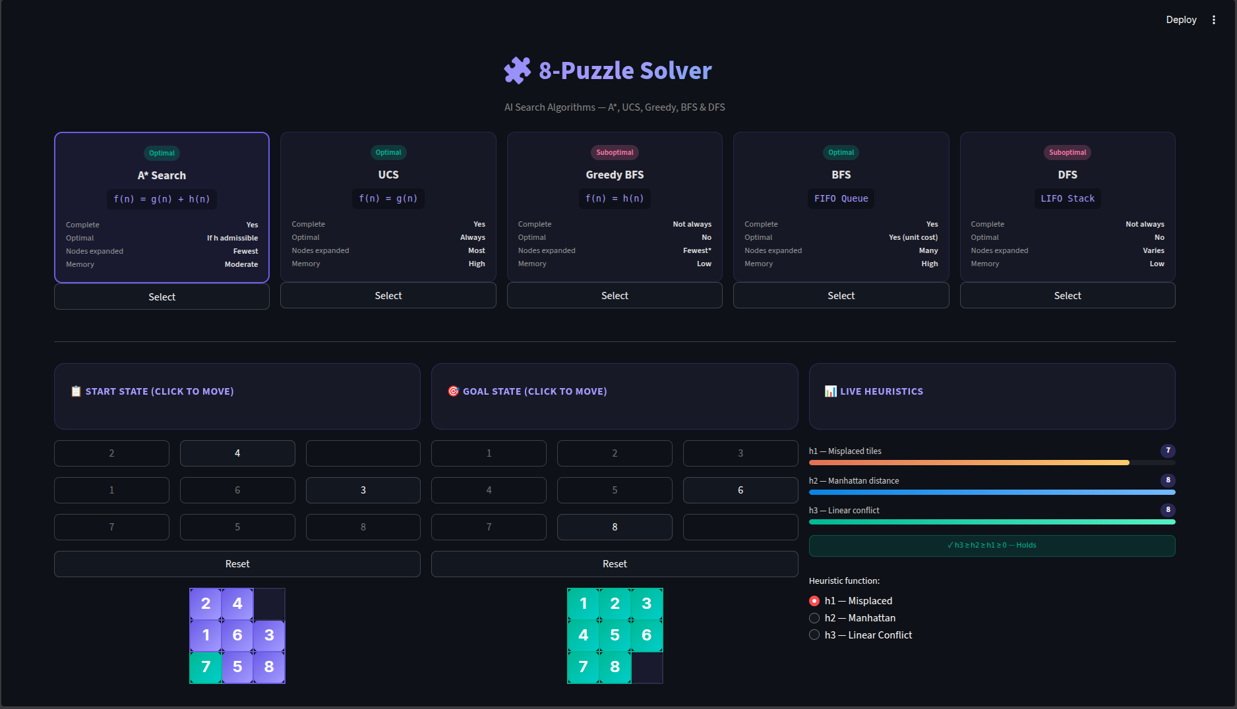
The initial view of the Streamlit GUI showing the default puzzle states and algorithm cards

Clickable Puzzle Grid & Live Heuristic Bars
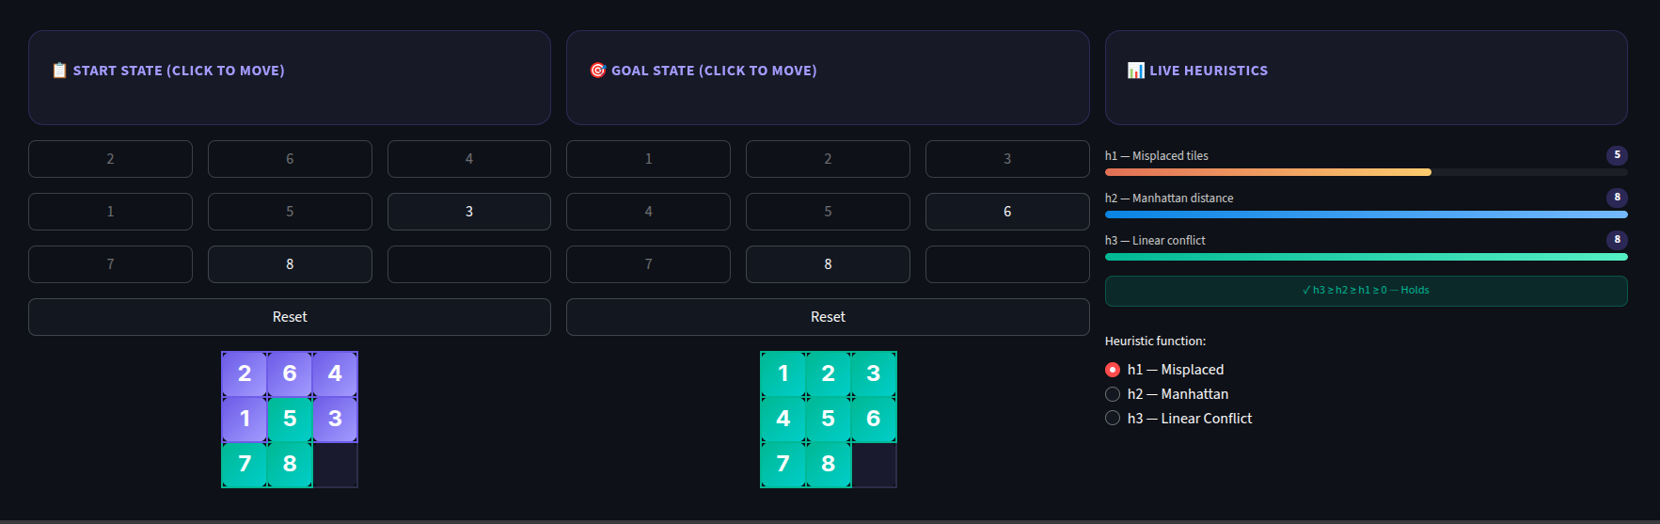
Demonstrating real-time h1, h2, h3 updates as tiles are clicked on the Start State grid

Algorithm Selection Cards
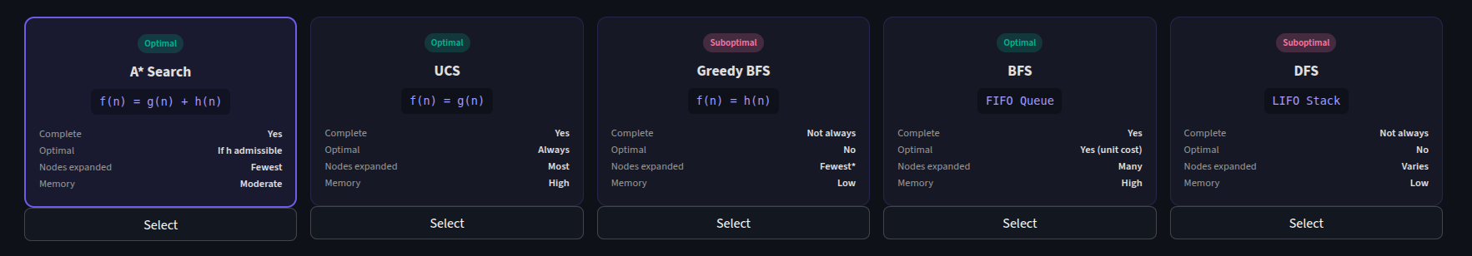
The five algorithm cards (A*, UCS, Greedy, BFS, DFS) with their properties displayed

Solve Button & Step-by-Step Solution
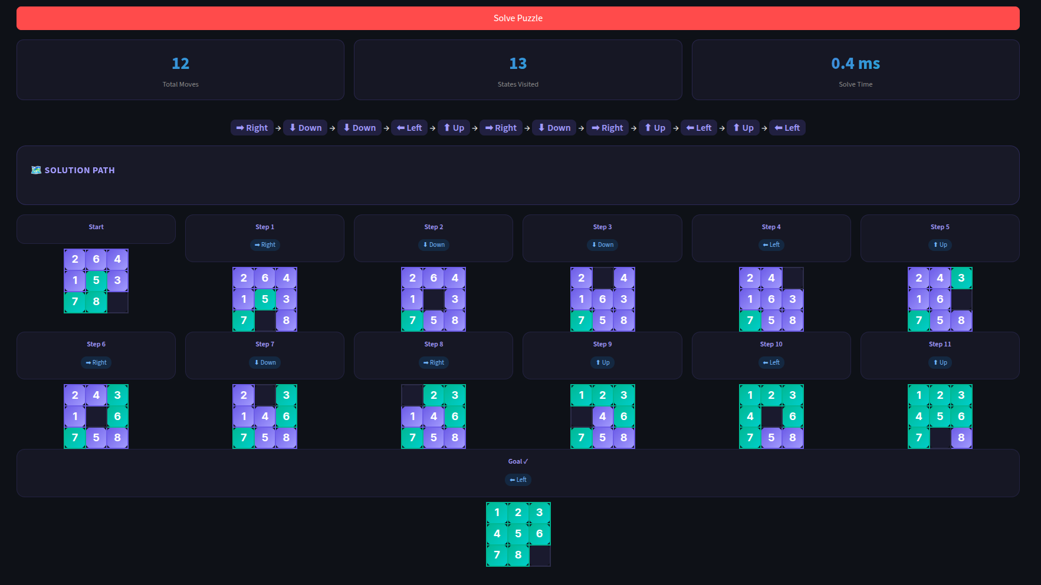
The solution visualization showing each step with action arrows and color-coded tiles

Performance Metrics Output
Results panel showing total moves, states visited, solve time, and dominance verification


6. Results & Algorithm Comparison
This section presents a comparison of the five algorithms based on theoretical properties and observed performance during testing. All informed algorithms were tested using the default start state [1,2,3,4,0,6,7,5,8] with goal state [1,2,3,4,5,6,7,8,0].

6.1 Algorithm Performance Summary
Algorithm | f(n) | Optimal? | Complete? | Speed | Use When
A* | g(n) + h(n) | Yes | Yes | Fast | Best overall
UCS | g(n) | Yes | Yes | Slow | No heuristic
Greedy | h(n) | No | Not always | Fastest | Speed over quality
BFS | — | Yes (unit) | Yes | Slow | Simple, guaranteed
DFS | — | No | Not always | Varies | Low memory

6.2 Heuristic Performance (A* Comparison)
When running A* with different heuristics, the dominance chain directly corresponds to nodes expanded. The stronger the heuristic, the fewer nodes A* must explore to find the optimal solution.

A* with h1 | A* with h2 | A* with h3
Most nodes expanded | Fewer nodes than h1 | Fewest nodes (best)

6.3 Screenshots — Demo Results
A* with h3 Solution Result
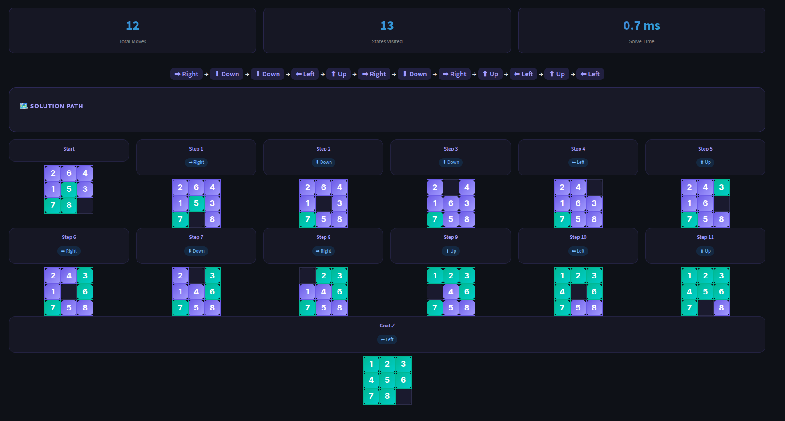
Showing nodes expanded, total moves, and solve time for A* with Linear Conflict heuristic

Algorithm Comparison Run


A* Search
UCS
Greedy
BFS
DFS

7. Code Structure
The entire project is implemented in a single Python file. Below is the file structure and a brief description of each section.

Lines | Component | Description
1–3 | Imports | heapq for priority queue, streamlit for GUI, time for performance measurement
4–14 | Node class | Data structure for each search tree node; stores state, parent, action, g(n), h(n)
16–35 | get_successors() | Generates all valid moves from a state by swapping blank with adjacent tiles
37–46 | h1, h2 heuristics | Misplaced tiles count and Manhattan distance implementations
48–71 | h3 heuristic | Linear conflict calculation built on top of Manhattan distance
73–173 | SearchAlgorithms class | Core search engine with unified search() method supporting all 5 algorithms
175–195 | main() | Console test function (unmodified from template)
197+ | Streamlit GUI | Interactive front-end with clickable grids, algorithm cards, and solution viewer

8. Conclusion
This project successfully demonstrates the application of classical AI search algorithms to the 8-puzzle problem. By implementing A*, UCS, Greedy Best-First, BFS, and DFS within a unified framework, the project highlights how the choice of search strategy and heuristic function directly impacts solution quality and computational efficiency.

The dominance chain h3 >= h2 >= h1 is validated both theoretically and empirically through the live GUI. A* paired with the Linear Conflict heuristic (h3) consistently achieves optimal solutions while expanding the fewest nodes — making it the recommended algorithm for this problem domain.

The Streamlit-based GUI provides an intuitive, interactive learning tool that allows users to explore puzzle states, observe heuristic changes in real time, and visualize algorithm behavior step by step.

References
1. Russell, S., & Norvig, P. (2020). Artificial Intelligence: A Modern Approach (4th ed.). Pearson.
2. Hart, P. E., Nilsson, N. J., & Raphael, B. (1968). A formal basis for the heuristic determination of minimum cost paths. IEEE Transactions on Systems Science and Cybernetics, 4(2), 100–107.
3. Streamlit Documentation. https://docs.streamlit.io
4. Python heapq library documentation. https://docs.python.org/3/library/heapq.html
5. RA'26 AI Course Materials and Project Template.

End of Report

