

Car showroom
Names
- Omar Mohamed Mahmoud 4230037
- Yehia Taher Najeeb 4230269
- Mohamed Adel Sayed 4230384
- Ramez Remon Ramses 4230219



Function Requirement:

1. Company
- The system stores company information (company_ID, name).
- Each company represents a supplier that provides cars to the showroom.
- Each company can supply multiple cars.

2. Branch
- The system stores branch information (branch_ID, address, street, city, building_no, contact_no).
- Each branch represents one showroom location.
- Each branch can display and sell multiple cars.

3. Employee
- The system stores employee data (emp_ID, emp_SSN, first_name, last_name, full_name, gender, birthdate, job_title, salary, commission_pct, phone_no, address).
- Each employee works in one branch.
- Each employee may supervise other employees.
- Employees handle customer orders and finalize contracts.
- Each employee has a job title

4. Customer
- The system stores customer data (customer_ID, customer_SSN, first_name, last_name, full_name, gender, birthdate, phone_no, address, street, city, building_no).
- Each customer can sign contracts.

5. Car
- The system stores car data (car_ID, model, year, color, price, status).
- Each car is supplied by one company.
- Cars can be included in contracts

6. Payment_method
- The system stores payment method data (method_ID, method).
- Payment methods are used to record payment transactions related to contracts or maintenance.

ERD
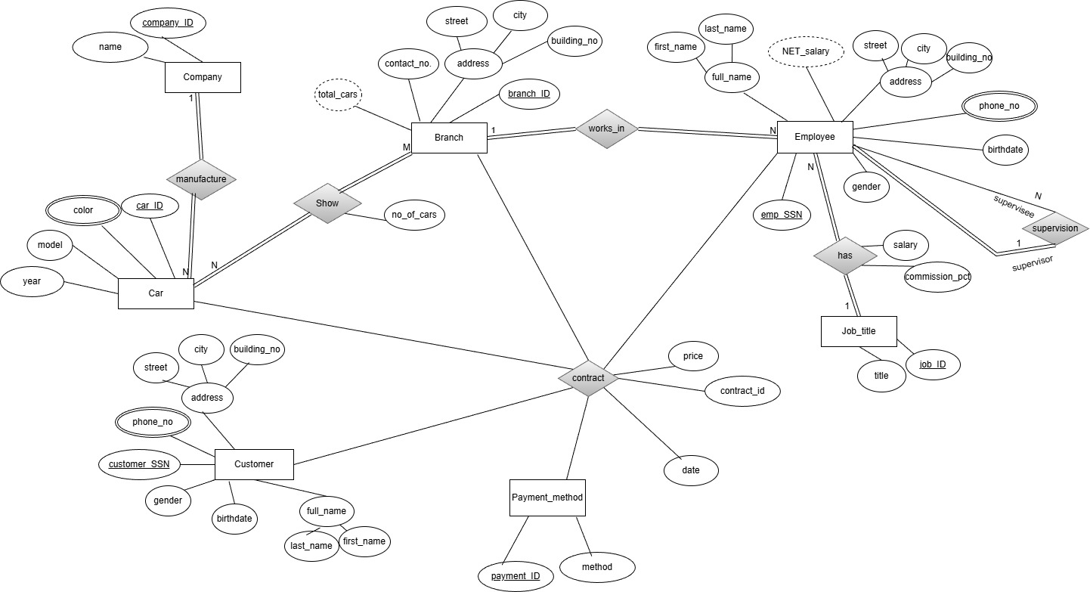
Mapping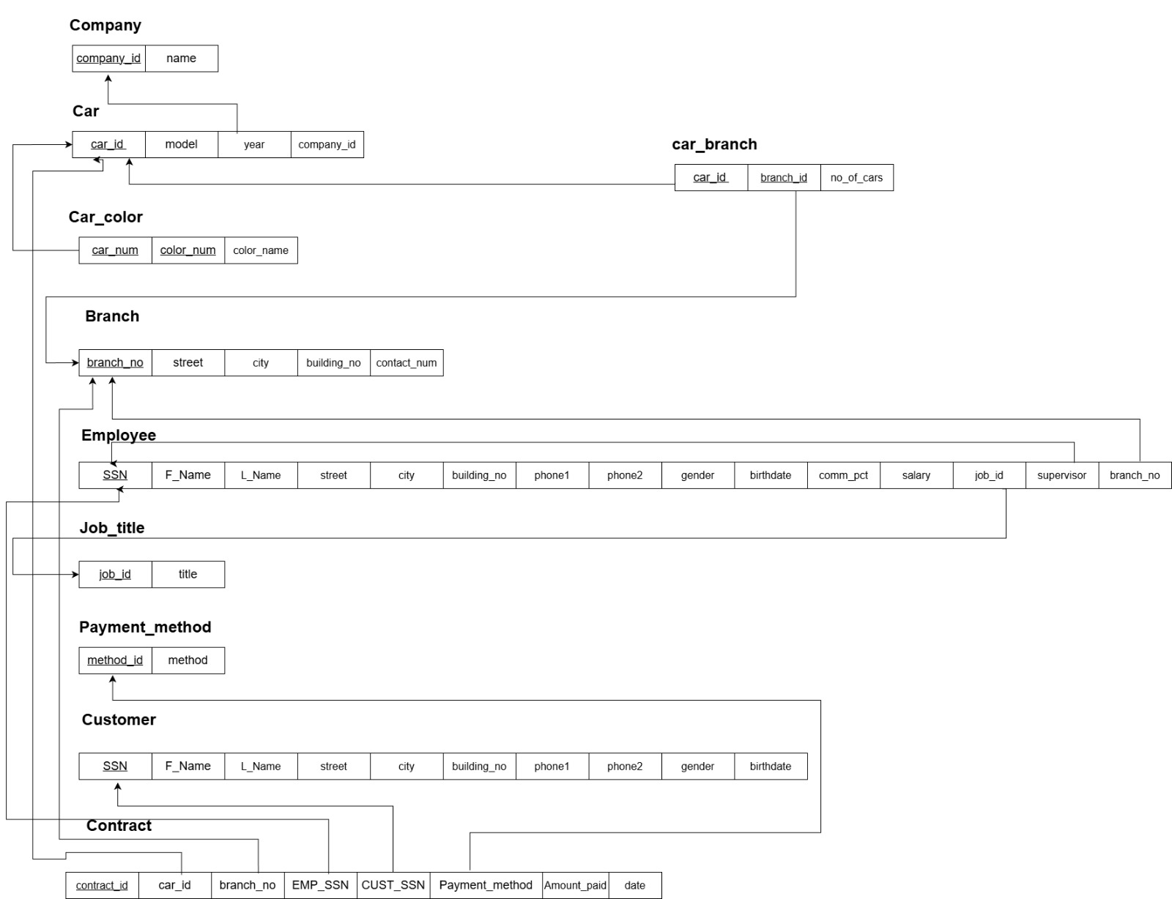

Normalization
1NF:

2NF:
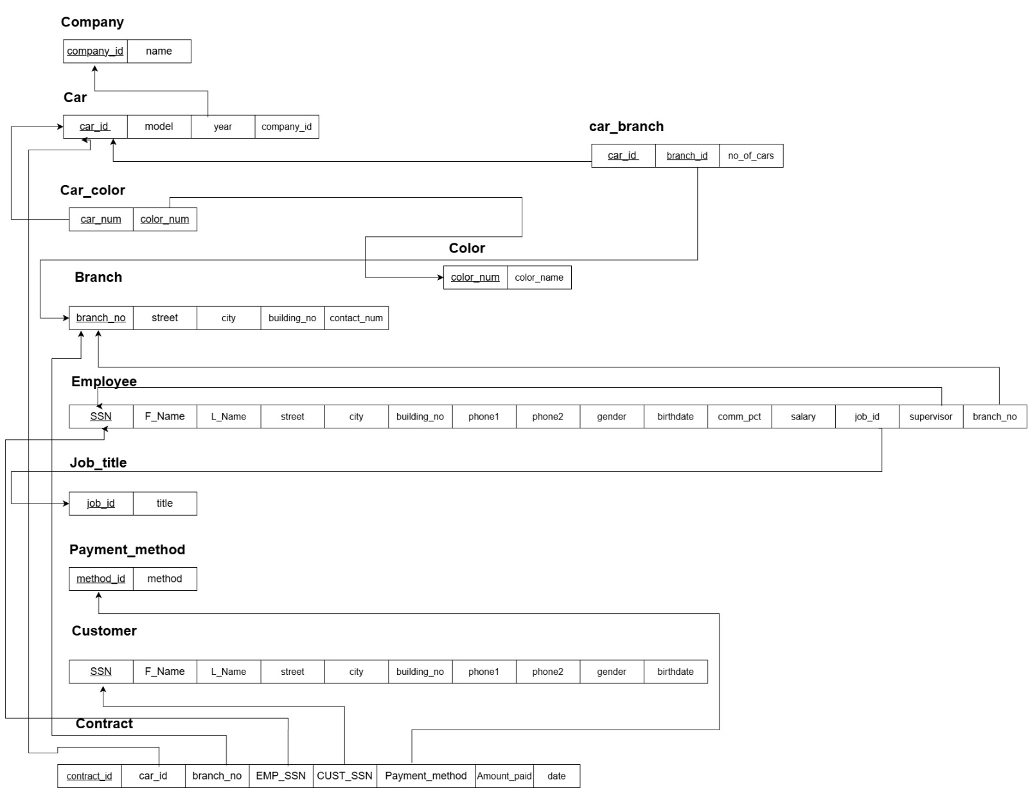

3NF:
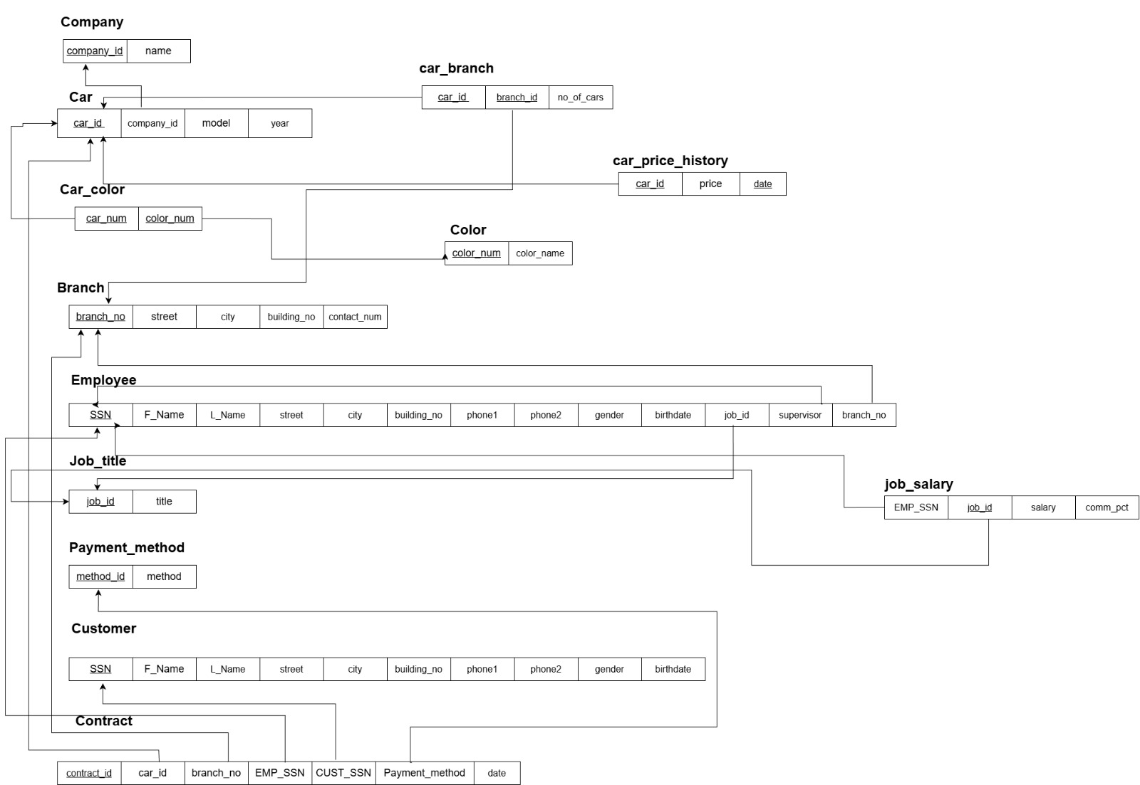

Schema : 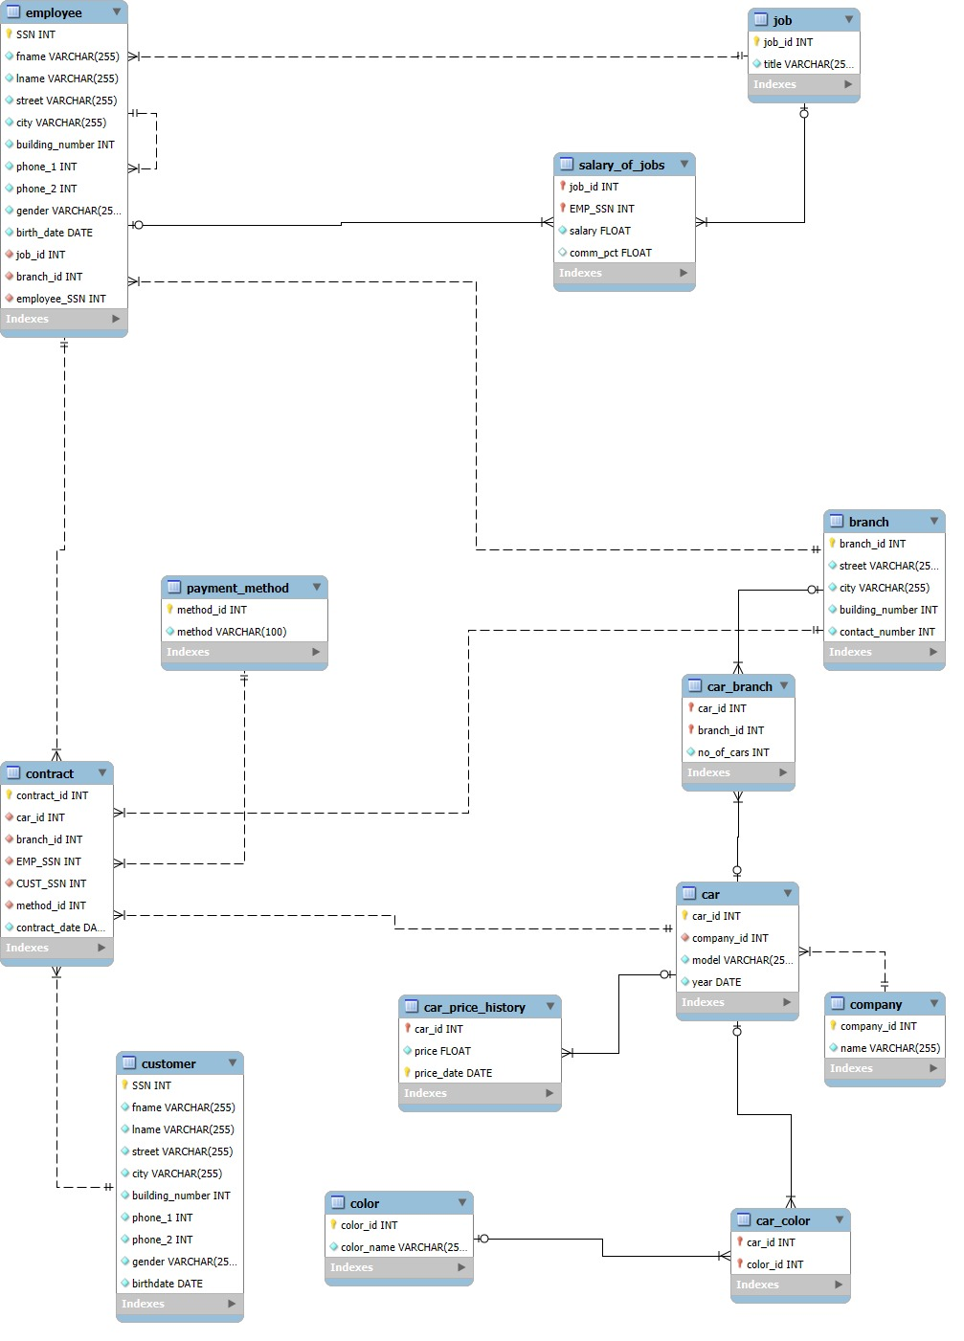

Queries:
The job of each employee and his manager and their respective salaries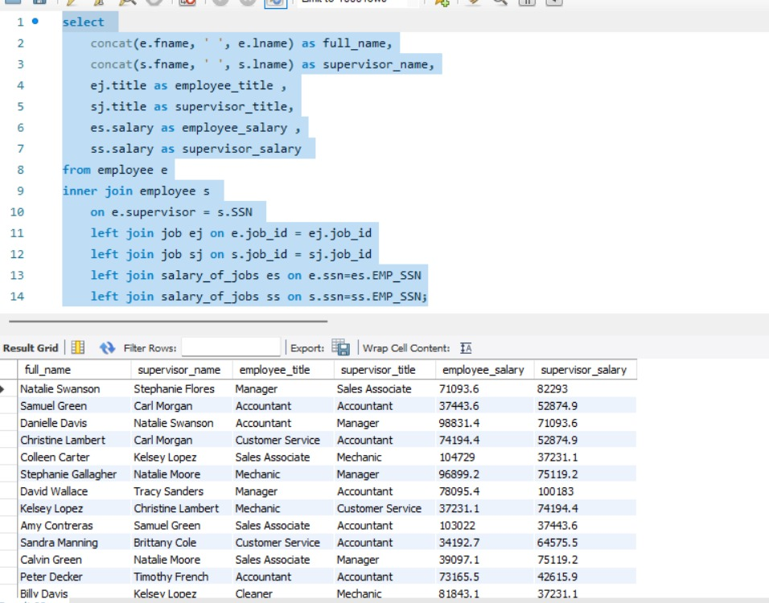

Cars whose price is higher than the average total price
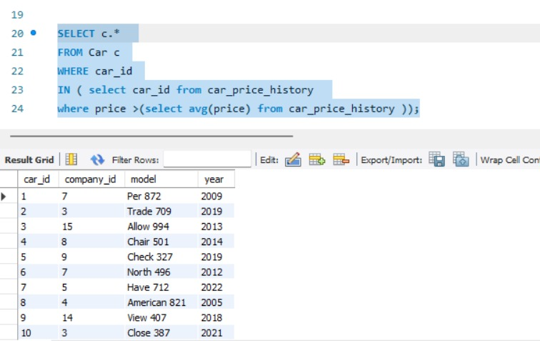

Latest price for each car.
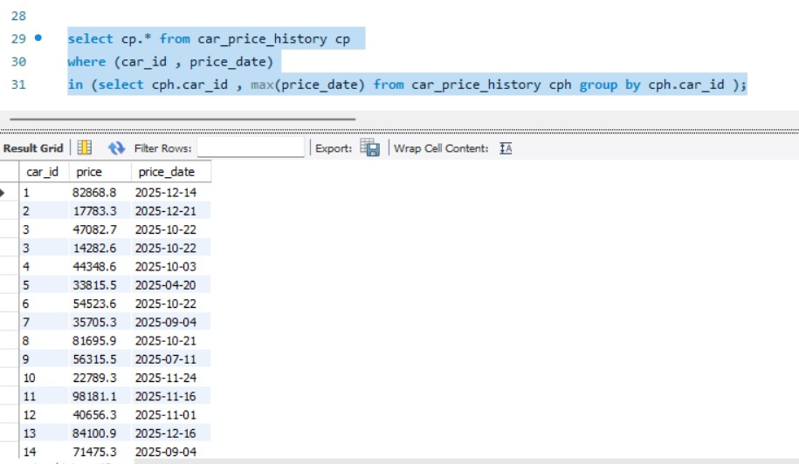

Display the cars on each lease with the name of the employee and customer Its manufacturer Average car price by model
